**Project #2**

**Numeric Integration with OpenMP Reduction**

**CHI CHIEH WENG**

**wengchic@oregonstate.edu**

1. **Machine:** OSU flip (Linux)
2. **The actual volume:** As the number of threads and nodes increases, the volume of the superquadric converges to approximately 0.44.

|  |  |  |  |  |  |  |  |  |  |
| --- | --- | --- | --- | --- | --- | --- | --- | --- | --- |
| **NUMBER OF THREADS** | **NUMBER OF NODES** | | | | | | | | |
|  | 4 | 8 | 16 | 32 | 64 | 128 | 256 | 512 |
| 1 | 1.99 | 4.35 | 5.18 | 2.75 | 5.43 | 6.75 | 6.65 | 6.61 |
| 2 | 2.8 | 3.97 | 3.77 | 4.37 | 6.11 | 11.11 | 13.28 | 13.21 |
| 4 | 2.69 | 5.1 | 6.21 | 6.88 | 9.1 | 14.99 | 23.1 | 22.84 |
| 8 | 2.4 | 6.61 | 10.6 | 11.6 | 14.42 | 21.87 | 39.97 | 41.27 |

3. **Performance as a function of NUMNODES with colored lines showing different NUMT values**

**Performance as a function of NUMT with colored lines showing different NUMNODES values**

4. **What patterns are you seeing in the speeds?**

8 threads and 512 nodes can achieve the maximum performance 41.27 MegaNodes / Second. The data shows that as the number of threads increases and the number of nodes increases, the performance will improve.

5. **Why do you think it is behaving this way?**

The larger data sets and more cores will improve performance to a certain extent.

6. **What is the Parallel Fraction for this application, using the Inverse Amdahl equation?**

**Speedup (S)** = 41.27/ 6.61= 6.24

(Performance with eight threads, 512 nodes) / (Performance with one thread, 512 nodes )

**Parallel Fraction:** = (8 / (8-1)) * (1 - (1 / 6.24)) = 0.96

7. **Given that Parallel Fraction, what is the maximum speed-up you could ever get?**

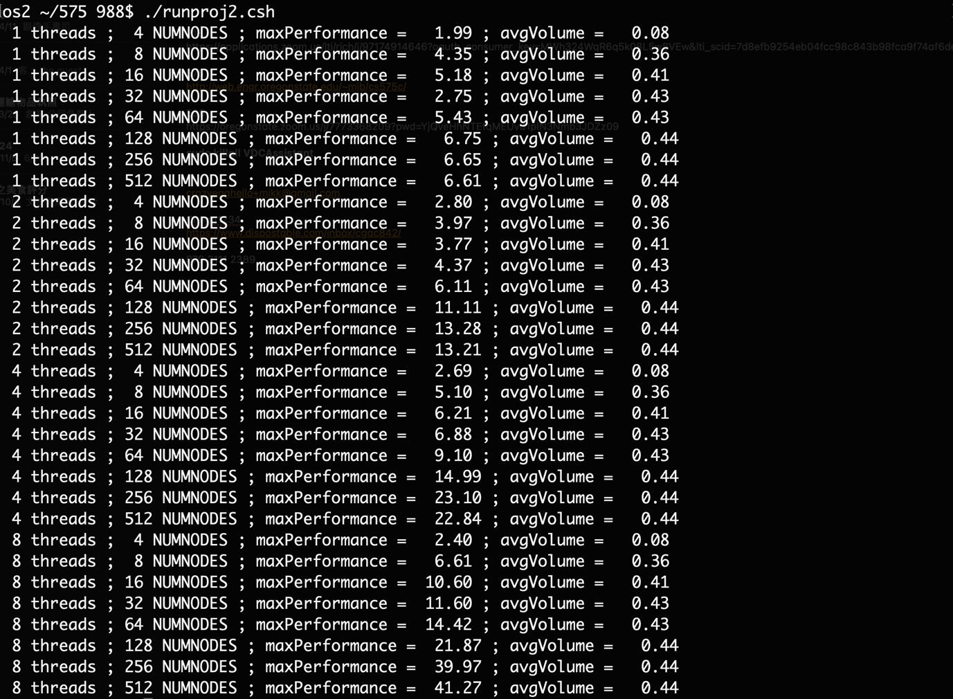

**maxSpeedUp** = 1/ (1-0.96) =25

Use 8 threads and 512 Nodes.