**Project #3**

**Functional Decomposition**

**CHI CHIEH WENG**

**wengchic@oregonstate.edu**

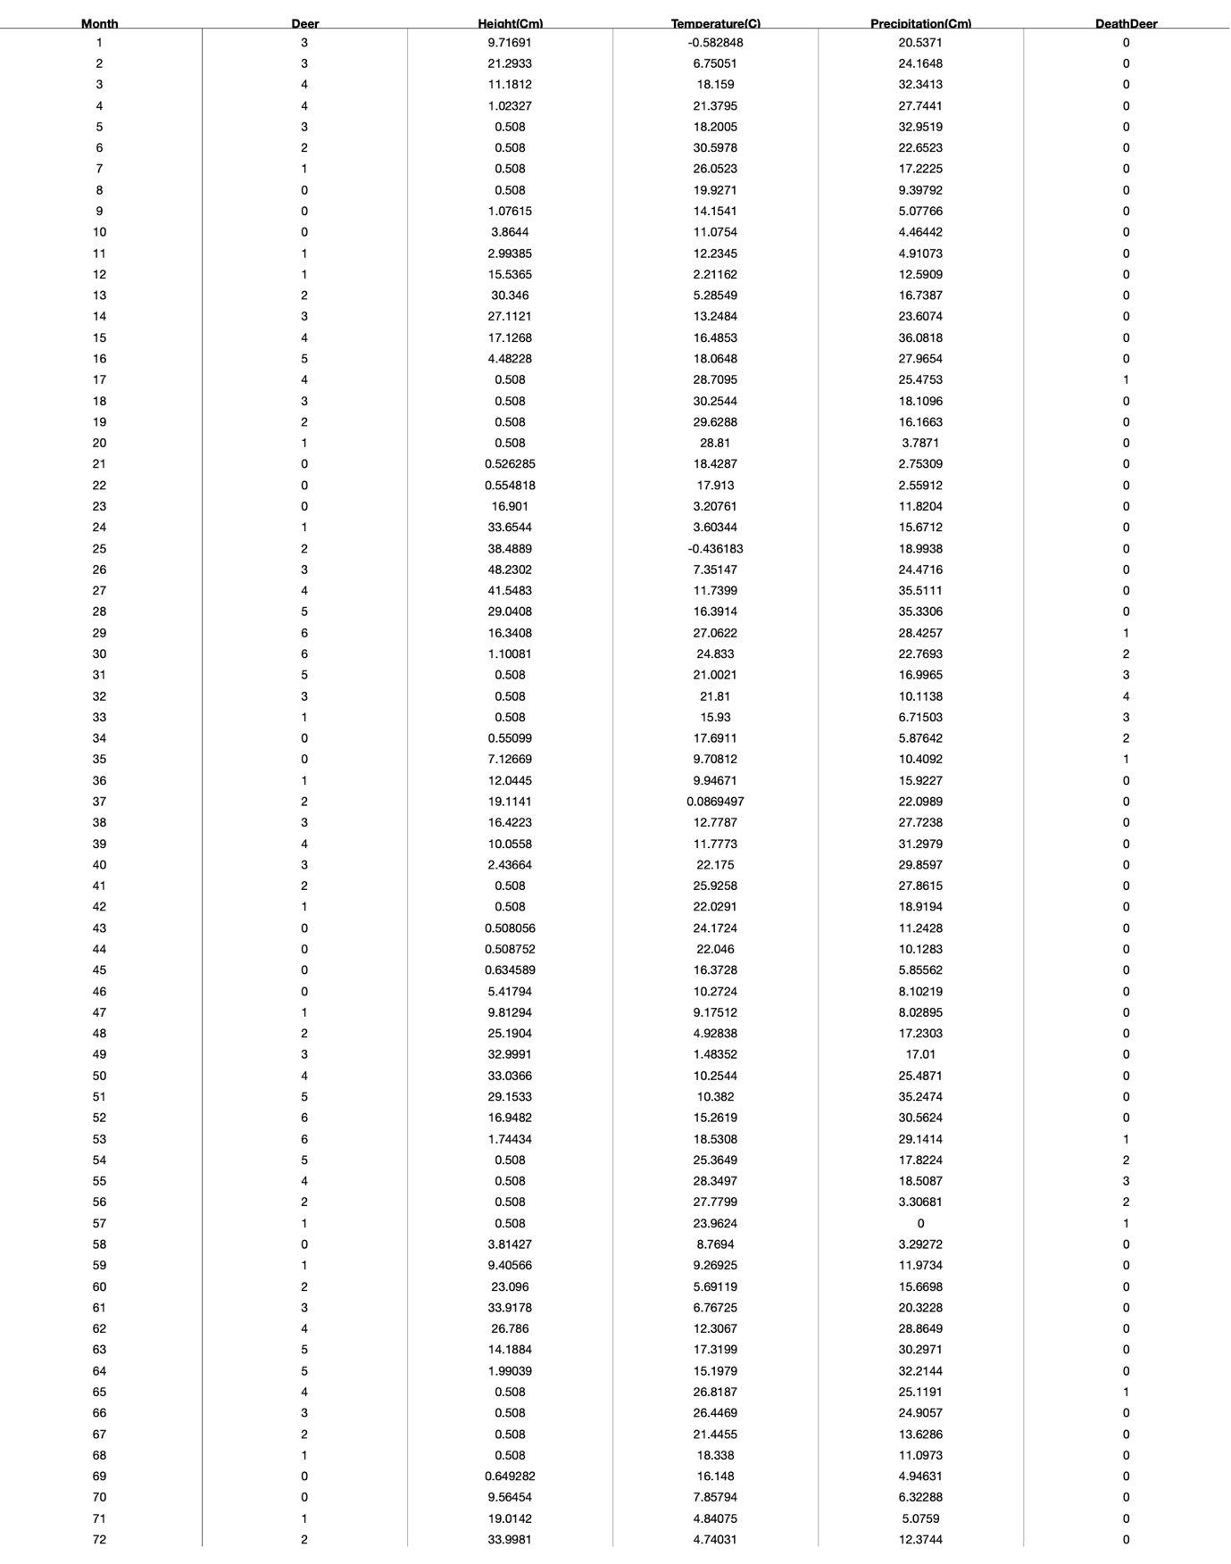

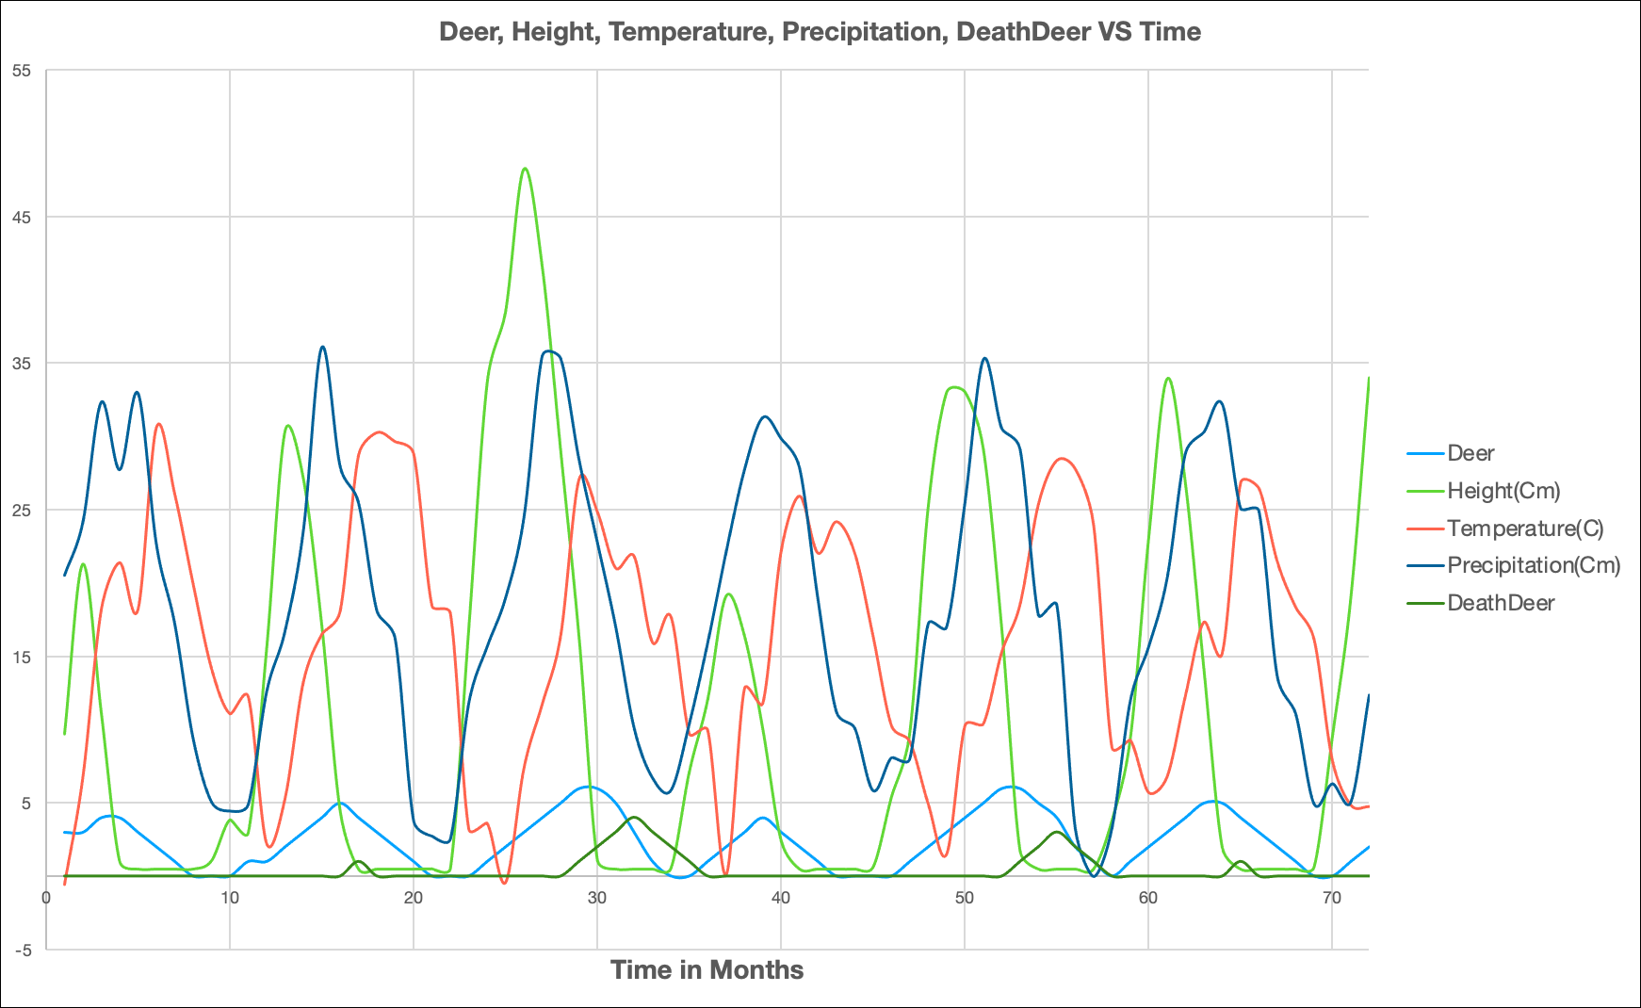

1. **What your own-choice quantity was and how it fits into the simulation.**

From April to September, if the number of NowNumDeer is greater than or equal to 5, the deer will have a chance to get injured 1 to 2 deer (may be natural elimination, hunting, fighting, disease). In the Deer function, if the number of injured is greater than or equal to 3, then 1 deer is subtracted.

1. **A commentary about the patterns in the graph and why they turned out that way. What evidence in the curves proves that your own quantity is actually affecting the simulation correctly?**

We can clearly see that climatic conditions affect the height of grains, and the height of grains affects the number of deer. Therefore, at the beginning of the year, the temperature and precipitation are lower, so the height of the grains and the number of grains are also lower. As the months increase to June and July, the temperature and precipitation peak, and then they gradually decrease until the end of the year. The number of deer also increases with the increase in grains, but between April and September, Deer may die from injury. Therefore, it can be clearly seen that when the number of deer deaths increases, the number of deer will decrease.