**外 文 翻 译**

**毕业设计题目：基于树莓派的“DIY气象站”**

**原文1：Weather Station Locations are Significant for Drought Insurance**

**译文1：气象站的位置对干旱保险的影响**

**原文2：Low cost embedded weather station with intelligent system**

**译文2：低成本的智能嵌入式气象站**

原文1

**Weather Station Locations are Significant for Drought**

**Insurance**

*Chad Van Orden , Brandon Willis, Ryan Bosworth, Ryan Larsen, Tanner McCarty, and Man-Keun*

**Keywords**: Crop insurance; Pasture, rangeland, and forage; Weather station

I. INTRODUCTION

The Pasture, Rangeland, and Forage (PRF) insurance program is designed to protect ranchers from poor grazing conditions caused by lack of precipitation. Rather than measure grazing conditions directly, the PRF program uses a weighted index of current-period rainfall recorded at nearby weather stations. Insurance payouts occur when the index indicates current rainfall to be below the historical average. The effectiveness of the PRF program depends on the ability of the index to accurately estimate forage availability in a given area.

Despite federal support and an arid climate, many ranchers in the Intermountain West are reluctant to utilize the PRF insurance program, expressing concern over a lack of payouts during periods of poor forage availability. These concerns, if accurate, suggest that the PRF program may not always achieve the goal of helping to cover the replacement cost of feed during times of poor forage conditions (U.S. Department of Agriculture, 2019a).

In the arid regions of the Intermountain West, altitude is a significant determinant of precipitation. Higher altitude weather stations typically record more precipitation than nearby lower altitude stations. Moreover, because weather stations are routinely added (and retired), sharp discontinuities in the local rainfall index can occur that are not necessarily caused by changes in rainfall patterns. If this is the case, the introduction of new weather stations in areas with substantial elevation variation can create problems for the PRF insurance program. In response, the U.S. Department of Agriculture (USDA) may want to reconsider how the program estimates forage availability. In this paper, we provide evidence that the addition of new weather stations at high elevation locations in the Intermountain West may sharply increase the rainfall index and cause a long-term shortfall in PRF insurance payouts.

II. PRF Insurance Background

The Risk Management Agency (RMA) of the USDA introduced PRF insurance as a pilot program in 2007. In 2019, nearly 140 million acres were enrolled in the PRF program (Willis, 2019). However, this amount represents less than 22% of the nearly 650 million acres of land qualifying for PRF insurance in the United States. Current enrollment percentages suggest that the program may continue to grow in importance over time, particularly in arid regions of the United States (Carlson et al., 2017).

The PRF program uses the National Oceanic and Atmospheric Administration’s grid system, which divides the 48 contiguous states into 0.25-degree-latitude by 0.25-degree-longitude grids (these grids are approximately 17 x 17 miles in area at the equator). Any pasture, rangeland, or forage ground within each individual grid qualifies for coverage policies determined by the local weather stations closest to the respective grid. Typically, the closest four to ten weather stations are integrated into the payout calculation (usually within an 18.6 mile radius). Indices cannot be traced back to the reported activity of any individual station (U.S. Department of Agriculture, 2019c) since each weather station’s data is weighted according to its proximity from the center of the specified grid, giving more weight to stations closest to the centroid of that grid..

Insurance payouts are determined by comparing current rainfall index levels within a grid over a given two-month period (e.g., May–June) to a 70-year rolling index average of the historical precipitation for those same two months. If precipitation for the period purchased is below the historical average, the rancher qualifies for a payout. (For more information see Westerhold et al., 2018, as well as the RMA’s PRF website, U.S. Department of Agriculture, 2019b).

III. Analysis

The rainfall patterns and weather station data for grid 26167 (located in northern Utah) suggests a sharp upward change in the level of recorded precipitation around 2011. This upward change corresponds to the introduction of a new weather station in the Raft River Mountains in November 2010. This new station (the George Creek, Utah, station) is located at a relatively high elevation of 9,005 feet. It also lies near the grid 26167 centroid, implying that the station measurements will be heavily weighted in the rainfall index.

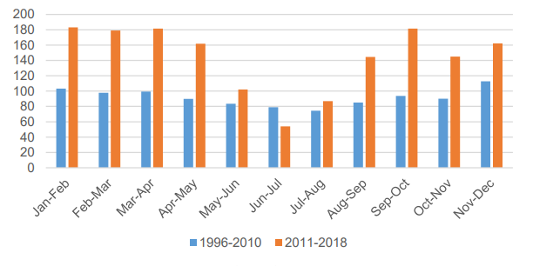

Figure 1 . Mean Rainfall Index for Grid 26167, 1996–2018

Figure 1 shows the change in rainfall patterns after the George Creek station came online. The average measured rainfall index was substantially higher for the years post–George Creek station (2011–2018) compared to prior periods. In Figure 1, we compare the rainfall index in these years to a prior period twice as long (1996–2010). We use a prior period twice as long to avoid small sample problems, but we also note that this result is not sensitive to the length chosen for the prior period..

One possibility is that the observed jump in the rainfall index at the time of the new weather station installation is simply a coincidence, and rainfall across the grid was in fact higher than historical averages. If this is the case, then other individual stations should have recorded similar increases in rainfall in the period after the George Creek station came online. To investigate this possibility, we examine measured rainfall pre– and post–George Creek station at the Rosette station, a nearby station in the same grid that operated for the entire period in question. This station is near Park Valley, Utah, and located on the valley floor (5,685 feet).

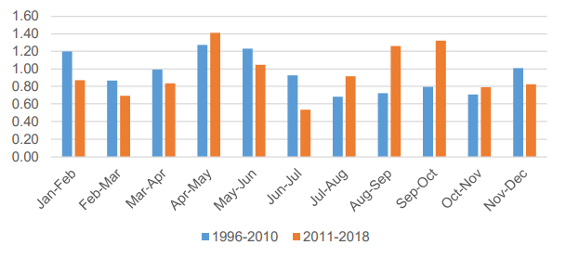

Figure 2 . Rosette Station Observed Rainfall Averages, 1996–2018

Figure 2 shows that average precipitation levels from the Rosette station do not display a similar increase in recorded precipitation after the installation of George Creek station. Although the addition of the new station provides a better and more comprehensive picture of actual weather patterns in grid 26167, it also provides an estimate that is not directly comparable to historical measurements. In this case, PRF insurance is less likely to pay out, even under adverse forage conditions,indicating that PRF insurance would be unattractive to producers within that grid.

A larger question is whether what we observe in grid 26167 is simply a local phenomenon or if it is indicative of a more widespread pattern. Answering this question requires applying the same analysis to additional grids containing high-altitude stations coming online in recent years. Grids with these properties are present in locations near Kalispell, MT; Ashton, ID; Afton, WY; and Pinedale, WY (grids 33663, 28875, 27077, and 27381, respectively).

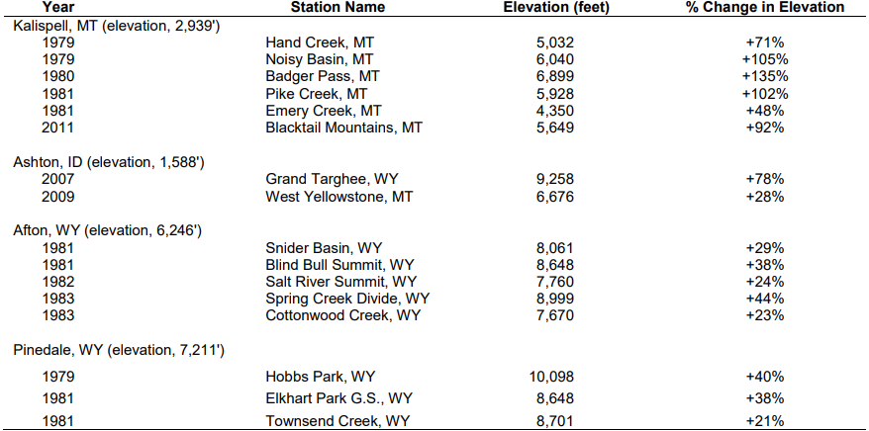

Table 1 Newly Introduced Weather Stations in High Altitude Grids

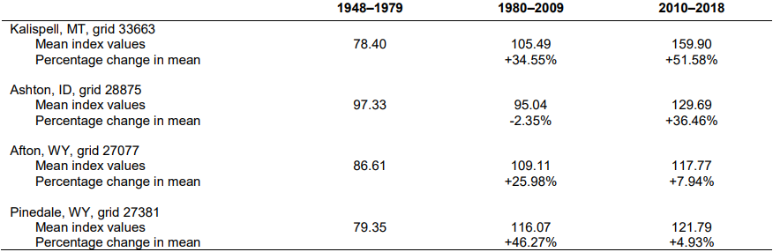

Table 2 . Changes in Average Index Values for Grids with Altitude Change, 1948-2018

Table 1 shows the dates that new high-altitude stations were added at our grids of interest and Table 2 reports changes in the average precipitation index levels across these time intervals. In each of these four grids, there appears to be a strong association between the implementation of a new high-altitude weather station (Table 1) and the measured index for that station (Table 2). For instance, higher elevation stations were added near Kalispell in both the 1980s and in the past decade; Kalispell’s average index jumped over both time intervals. Afton and Pinedale added high-altitude stations in the 1980s and experienced index jumps at the same time. Finally, Ashton added new high-elevation stations in the past decade and experienced index jumps during that same time.

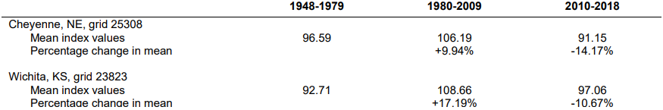

Table 3 Changes in Average Index Values for Grids with Constant Altitudes, 1948-2018

As an additional check, we analyze grids that have had new stations added, but in areas with less variation in altitude. Table 3 shows data for grids near Cheyenne, NE, and Wichita, KS, in the same fashion as the previous grids. Table 3 shows how the corresponding index estimates for those grids changed over time. Like the mountainous areas, these plains areas also added new stations over time. Unlike the high-altitude stations, however, these areas did not experience large changes in estimated indices beginning at the time of the new station installations.

Our findings suggest that the accuracy of the current PRF index could be vulnerable to changes in reporting stations in mountainous grids. Specific grids in the Intermountain West may experience issues when a new station’s altitude is out of line with historical stations within that grid. The arid climate of the Intermountain West makes discrepancies in rainfall estimates especially problematic. The difference between 10 and 20 inches of yearly rainfall has a larger impact on total forage than the difference between 40 and 50 inches (Huxman et al. 2004; Pickup, 1995). This means inaccuracies are more likely to occur in areas where PRF insurance could have the biggest impact.

IV.Policy Implications

In this section, we suggest policy adjustments that may improve the PRF program in the Intermountain West. These adjustments could be implemented by (i) making adjustments to the existing rainfall index; (ii) using an alternative measure of forage availability that is not based on rainfall; or (iii) reinforcing the rainfall index with a second measurement to test its accuracy.

We first consider modifying the rainfall index itself. While ranchers typically make planning decisions based on observed outcomes over the past several years, the rainfall index is based on a 70-year rolling average—a time period longer than the typical rancher’s planning horizon. Further, an index that has recently added highaltitude stations will take decades to correct itself under the current system. The PRF program could alleviate this problem by reducing the number of years used to calculate the historical average, increasing the rate at which the index responds to changes in weather data collection. Alternatively, the rainfall index could be modified to adjust for differences between the elevation of weather stations and the insured forage area or modified to differentiate between weather stations located in mountainous regions outside normal forage growth areas. These policy prescriptions have the advantage of keeping a relatively easy-to-understand index intact while increasing the effectiveness of the PRF program to pay ranchers in years with lower than average forage availability. An additional advantage is that none of these adjustments would add any burden to the USDA insurance agents who calculate payouts. Agents would only need to plug rainfall data within a grid into a different formula. However, the disadvantage is that neither prescription may entirely eliminate inaccuracies.

Until 2016, the PRF program gave ranchers the option of choosing between the rainfall index and a vegetation index. The vegetation index used satellite data to estimate forage availability. While considered an accurate measure of forage availability, the vegetation index had the drawback of a lack of understanding among ranchers about how the vegetation index worked (Willis, 2019). Reinstating the vegetation index and allowing ranchers the choice between the rainfall index and the vegetation index would allow ranchers in highaltitude regions access to a potentially more accurate measurement and subsequently more accurate insurance payouts. This would require extensive education to work with PRF insurers and ranchers to explain the intricacies of this system and build trust in it.

Finally, the USDA could adopt an insurance system that keeps the simplicity of the rainfall index intact, while still addressing inaccuracies stemming from altitude with a second index. Specifically, payouts could be based on rainfall, but the rainfall index could be tested against the vegetation index. If estimates are different by a predetermined amount, it would trigger an audit by USDA insurers. Forage data could then be approximated through either the vegetation index, averaging the rainfall index of surrounding grids, or collecting countylevel data on unirrigated alfalfa yields at harvest. This policy would cost more in terms of program overhead and payouts but would enhance accuracy in rancher payouts.

The preferred policy prescription ultimately depends on the pervasiveness of inaccurate insurance payouts. If the inaccuracy exists for only a select few grids, the current index may already be a sufficiently accurate proxy for forage. However, if the problem proves to be more widespread, it may be worth considering reinstating the vegetation index, either as a choice for producers or as a consistency check to be used by auditors.

IV. Conclusions and Suggestions for Further Research

We observe a substantial increase in rainfall indices in several grids following the installation of a high-altitude weather station. These observations are highly suggestive of a systematic problem that warrants further research and the attention of policy makers. However, our study is not comprehensive—we examine only a subset of selected grids that appear likely to exhibit problems. Further research using a larger sample of grids will be needed to determine the extent and degree of the problem. Additionally, while we have investigated situations in which the addition of a high-altitude weather station leads to undercompensated producers, the mirror image of the problem could also occur: The removal of a low-altitude weather station could overcompensate producers and put stress on limited federal resources. Additional research could reveal the extent of this problem.

Another suggestion for future research would be to test the grid-level accuracy of rainfall indices against the vegetation index or against observed forage yields. This research could improve the ability of the PRF program to estimate forage production in various regions. Our study suggests that the rainfall index is more robust to the addition and retirement of weather stations in the relatively flat land of the South or Midwest but is less reliable in the topographically diverse Intermountain West. Mitigating potential inaccuracies in estimates of forage availability would allow PRF insurance to better achieve the goal of covering replacement cost of feed for ranchers when lack of rain leads to poor forage conditions.

译文1

**作者**：*Chad Van Orden , Brandon Willis, Ryan Bosworth, Ryan Larsen, Tanner McCarty, and Man-Keun*

**部门**：犹他州立大学应用经济系，洛根，犹他州

**出版**：Choices Magazine.

气象站的位置对干旱保险的影响

**关键字**：农作物保险、草地、牧场、饲草、气象站

一、引言

草地、牧场、饲料保险项目（以下简称PRF项目）主要是为了保护牧场主免受因缺乏降水而造成匮乏的放牧条件的影响。该项目并不是直接测量放牧条件，而是通过对周围气象站降水量的不同权重来计算当前地区的降雨量指数，如果降水量指数低于历史平均降水量指数时，则可以享有PRF项目的补偿。PRF项目的补偿资格是依赖于降水量指数来确定该地区放牧条件是否满足要求。

尽管联邦政府已支持该项目并且可以对气候的干旱条件进行预测，但是许多西部山区的农场PRF项目仍不愿加入PRF保险，他们表示对PRF项目在牧草供应不足时获取补偿资存在担忧。这些担忧如果准确，则将表明PRF项目并不一定能达到补偿因匮乏的放牧条件的而造成损失的目的（美国农业部门 2019a）。

在西部山区的干旱地区，海拔是影响降水量的重要因素，高海拔区域气象站记录的降水量指数通常比低海拔区域气象站记录的降水量指数大。此外，由于气象站的时常变迁，当地的降水量指数可能出现跃变，这一现象不一定是由真实降水量引起的。如果这样，在海拔落差大的区域增加新的气象站将会为PRF项目带来的问题。作为回应，USDA（美国农业部门）可能需要重新考虑如何让预测放牧条件。本文提供的证据表明在西部地区的高海拔区域增加一个新的气象站可能会导致降水量指数出现跃增的现象并造成长期缺乏PRF项目补偿。

二、研究背景

RMA（美国农业部风险管理署）从2007年推出PRF作为试点项目。在2019年，有近1.4亿英亩土地参保了PRF。然而，美国有近6.5亿英亩的土地有资格参保PRF，即只有不到22%的土地享有PRF补偿。当前的参保率表明，随着时间的推移，项目的重要性可能会继续增长，特别是在美国的干旱地区。

PRF项目利用了美国国家海洋和大气管理局的网格系统，该系统将48个毗邻的州划分成经纬度各0.25度的方网格(这些网格在赤道的面积大约17 x 17英里)。任何在网格内的牧草、牧场、或饲料地都符合覆盖策略：以该网格最近的气象站预测该地降水量指数。通常选择最近的4到10个气象站是整合到补偿计算中(通常在一个18.6英里的半径)。计算的指数不能追溯到任何一个单独气象站的活动(美国农业部，2019c)。因为每个气象站的数据都是根据其离指定网格中心的距离加权的，给了最接近网格中心的站点更多的权重。

保险赔偿是通过比较给定两个月期间（例如5~6月）网格内的当前降水量指数与以两个为周期在过去70年的降水量的滚动平均指数来确定的。如果在参保期间，当前降水量指数低于历史平均降水量指数，农场主将享有保险赔付。

三、研究分析

26167号网格（位于犹他州北部）的降雨量指数与气象站数据表明在2011年前后记录的降水量出现跃增现象。这个跃增现象与2011年11月在筏河山脉新建的气象站相对应。这个新的气象站是位于海拔相对较高的地区，大约9005英尺；它也是位于26167网格，这表明该气象站在该网格的降雨量预测中占较大的权重。



图 3-1 26167网格的降雨指数, 1996–2018

图一显示了George站建立后降水量指数的变化。在George上线之后，即2011~2018年的平均实测降水量指数比之前年份有明显的增加。在图中我们将这几年的降雨指数与之前一段时间(1996-2010年)的两倍进行比较。我们使用两倍长的前一个周期来避免小样本问题，但是我们也注意到这个结果对前一个周期选择的长度不敏感。

一种可能是观测到的降雨量指数跃增与气象站的安装只是一个单纯的巧合，并且网格的降雨量事实上高于历史平均降雨量。如果这样的话，那么其他单独的气象站应该已经记录了该气象站引入之前的降雨量水平，同样该数据也应该出现类似的变化。为了研究这种可能性，我们获取了George站上线前后临近的Rosette站，这个气象站是在同一个网格并且一直正常运行的。这也气象站靠近犹他州的帕克谷，并位于海拔约为5685英尺区域。



图 二 Rosette气象站的历史平均降雨量

图二显示了Rosette站平均降水量名没有出现类似的增长在George站引入之后。虽然增加一个新的气象站可以为26167号网格提供更好、全面的数据，但是也提供一个不能直接与历史测量结果相比较的测量数据。在这种情况下，PRF保险即使在恶虐的放牧条件下赔偿的几率是很小的。这一数据表明PRF保险对网格内的生产者是没有吸引力的。

一个更大的问题是，我们在网格26167研究只是一个局部现象，或者说该现象是否具有普遍性。回答这一问题需要对其他新增的高海拔地区的网格用同样的分析，具有这种特性的网格有在kalispell的33663，Ashton的28875，Afton的27077，Pinedale的27381。



表 一 在高海拔地区新建的气象站



表 二 平均降雨量随海拔的变化

表一显示了在我们感兴趣的网格中添加新的高海拔站点的日期，表二报告了这些时间间隔内平均降水指数水平的变化。在这四个网格，似乎有在新建一个的高空气象站(表1)和站的测量指数(表2)之间具有很大的关联性。例如，在Kalispell的高海拔地区增加了气象站，导致在20世纪80年代和过去的十年里，Kalispell的平均降雨量在两个时间段都在剧增；Afton与Pinedale增加了高海拔气象站在20世纪80年代，与此同时经历了指数的跳跃；最后，Ashton在近十年也增加了高海拔气象站并同时经历了指数的跃增。



表 三 恒定海拔地区平均降雨量的变化

作为额外的研究，我们分析那些在海拔变化较小的地区增加了新的气象站站的网格。表三显示了位于NE Cheyenne和KS Wichita附近的网格数据，与前面的网格数据相同。表三显示了这些网格的相应索引估计是如何随时间变化的。像山区一样，随着时间的推移，这些平原地区也增加了新的气象站。然而，与高海拔台站不同的是，这些地区在新台站安装后的估计指数并没有发生大的变化。

研究结果表明，当前PRF指数的精度易受山地网格报站变化的影响。特别是当新站点的高度与该网格内的历史站点的高度不一致时，在西部山区的特定网格可能会更加明显。西部山区干旱的气候使得对降雨量的估算存在差异，这一点问题尤为突出。年降雨量10英寸和20英寸之间的差异比40英寸和50英寸之间的差异对总牧草的影响更大(Huxman et al. 2004;皮卡,1995)。这意味着在PRF保险可能产生最大影响的地区更有可能发生不准确的情况。

四、参考建议

在这一部分中，我们提出一些建议来完善PRF项目，使PRF在西部山区更加合理化。这些措施有：1. 调整已存在的降雨量指数；2. 使用一种不基于降雨的牧草可利用性替代衡量方法；3.通过多次测量来增加准确性。

我们首先考虑修正降雨量指数，农场主根据过去几年的情况来安排计划，而降雨量指数是依赖于70年的滚动平均为时间周期—这比典型牧场主的规划周期长。此外，在目前系统中下，一个最近增加高海拔气象站引起的指数误差需要经过几十年来修正，PRF计划可以通过减少计算历史平均值的年数，提高指数对天气数据收集变化的响应速度来缓解这一问题。或者，可以修改降雨指数，以调整气象站和保险牧草区之间的高程差异，或者修改降雨指数，以区分位于正常牧草生长区外山区的气象站。这些政策规定的优点是保持一个相对容易理解的指数不变，同时提高PRF计划的有效性，在牧草供应低于平均水平的年份补偿给牧场主。一个额外的优势是，这些调整不会增加任何成本，以美国农业部保险代理人谁计算支付。代理只需要将网格中的降雨数据插入到不同的公式中。然而，缺点是这两种方法都不能完全消除错误。

直到2016年，PRF项目都让农场主在降雨指数和植被指数之间进行选择。植被指数是利用卫星数据估算牧草可用性。虽然植被指数被认为是牧草可用性的准确衡量标准，但它的缺点是牧场主对植被指数的工作原理缺乏了解(Willis, 2019)。恢复植被指数，并允许牧场主在降雨指数和植被指数之间进行选择，将使高海拔地区的牧场主获得可能更准确的测量结果，随后获得更准确的保险赔付。这将需要广泛的教育，以与PRF保险公司和牧场主合作，解释这个系统的复杂性，并建立对它的信任。

最后，USDA可以采用一种保险系统，既能保持降雨指数的简单性，又能通过第二个指数来解决由海拔高度引起的不准确性。具体来说，补偿可以基于降雨，但降雨指数可以与植被指数进行测试。如果估计值有预先确定的不同，就会引发美国农业部保险公司的审计。牧草数据可以通过植被指数、周围网格的平均降雨指数或收集未灌溉苜蓿收获时的县级数据来近似计算。这一策略将在项目管理费用和支出方面花费更多，但将提高牧场主支出的准确性。

首选的政策方案最终取决于不准确的保险赔付的普遍性。如果不准确仅存在于选定的几个网格，当前指数可能已经是饲料足够准确的代理。但是，如果问题证明更为普遍，则可能值得考虑恢复植被指数，作为生产者的选择，或作为审计员使用的一致性检查。

五、研究结论

我们观察到在安装了一个高海拔气象站后，降雨指数在几个网格中大幅度增加。这些观察高度暗示了一个系统问题，值得进一步研究和政策制定者的注意。然而，我们的研究并不是全面的——我们只检查可能出现问题的选定网格的子集。进一步的研究需要使用更大的网格样本来确定问题的程度和程度。此外，虽然我们已经调查了增加高海拔气象站导致补偿不足的生产者的情况，但相反的问题也可能发生:删除低海拔气象站可能会过度补偿生产者，并对有限的联邦资源造成压力。更多的研究可以揭示这个问题的严重程度。

未来研究的另一个建议是将降雨指数的网格精度与植被指数或牧草产量观测值进行比较。该研究可提高PRF计划对不同地区牧草产量的估算能力。我们的研究表明，在南部或中西部相对平坦的土地上，降雨指数对气象站的添加和退出更为稳健，但在地形多样的西部山间地区则不太可靠。减少对牧草可用性估计中可能出现的不准确性，将使PRF保险更好地实现在缺少雨水导致牧草条件不佳时为牧场主支付替代饲料成本的目标。

原文2

**Low Cost Embedded Weather Station**

**with Intelligent System**

*Adnan Shaoutl , Yulong Li2 , Mohan Zhou3 and Selim Awad4*

*The Department of Electrical and Computer Engineering*

*The University of Michigan-Dearbor*

*Dearborn, MI, 48124*

**Abstract** : This paper presents an embedded design of a low cost weather station. Three weather parameters; wind speed, wind directions and temperature are measured. The measured parameters are used to measure the wind chill temperature and dressing index through calculation and a build-in intelligent system. Only basic types sensors were used (a reflective optical sensor, potentiometer and a temperature sensor) so that the cost of this design is reduced. A small scale neural network was planted into the microcontroller for the post-processing. Taking the three measured data as inputs, the system gave out the dressing index as an output. All of the data were displayed on the LCD and also sent to computer from the serial port..

**Keywords**: Weather station; Wind speed sensor; Wind direction sensor; Embedded system; Wind chill temperature; Dressing Index; Intelligent system; Neural network.

1. Introduction

Normally, a weather forecasting merely tell people the weather conditions within a certain city or district, and within a certain period of time. However, the forecasting sometimes cannot be predicted precisely, especially in some particular cases. For example, strong wind during winter would make the actual feel temperature much lower than what it is. Therefore, this paper represents a design of a small-scale embedded intelligent weather station which can deliver real time weather conditions of surrounding environment. Three basic factors; wind speed; wind direction and temperature and two postprocessed elements; real feel temperature and dressing index would be shown on LCD and also could be sent to serial port of a personal computer. The whole system was built using Freescale Dragonl2-Plus2 board from HCS12 microcontroller family with MC9S12DG256 inside which uses 5V power supply. The wind speed and wind direction sensors were designed, tested and built in this paper which can get power supply from the board easily. These sensors cost much lower than the products on the market with respect to both the cost and power supply aspects. Most of the existing wind speed and wind direction sensors in the market are medium or large scale with external power supply, obviously not suitable for a small-scale embedded system with limited power supply.

Besides the basic weather parameters, the built-in intelligent system can process these data further. A small-scale neural network was implemented in the system to calculate the dressing index according to the real time temperature, wind speed and wind direction.

The paper is organized as follows: section II presents related work, section III presents the hardware design according to the requirement of the system, section IV describes the code structure of the system, section V introduces the data processing including formulas and the neural network, section Vi and VII presents the testing result, conclusion and future work, respectively.

1. Related Works

Most of the low-cost embedded weather stations exist in the market like [1], [2], [3] and [4] do not have the function to measure wind speed and wind direction. Indeed there are many papers that describe the different types of wind speed sensors, such as hot wire anemometers [5], [6], acoustic anemometers [7], however, most of them are large scale sensors. Besides, there are also some complicated and expensive sensors like ultrasonic anemometers [8], [9].

1. Hardware Imppementation

This section presents the target platform and the sensors of the weather station, and how they are connected with each other.

1. **Target Platform:** The target platform chosen for this design is the Free scale HCS12 family's Dragon12-Plus2, which is a low-cost, featurepacked training board, and the microcontroller is MC9S12DG256, consisting of a powerful 16-bit CPU, 256K bytes of flash memory, 12K bytes of RAM, 4K bytes of EEPROM and many on-chip peripherals [10].
2. **Sensors**:There are three sensors that are used in this weather station system; wind speed sensor, wind direction sensor, and temperature sensor. Excrept for the temperature sensor, the other two sensors are designed and built in this paper using basic types of sensors with peripheral circuits and structures. All the sensors are low-cost that uses power supply from the target board without external power source.

***Wind Speed Sensor:***The wind speed sensor consists of five parts:

(1). CNY70: Reflective optical sensor with transistor output. When it scans black paper, the output is around 4.8V, and when it scans the white paper, the output is around 0.8V.



Figure 1 Encoder

(2). Encoder: Twenty black and white cells as shown in figure 1.

(3). Rotor: Romoved from hard disc, this rotor can be easily spined which makes the wind speed sensor able to work at a low wind speed.

(4) Plastic sticks and bowls: They are used for the frame of the fan blades.

(5) Steel base: It is a heavy metal base to hold the rotor and keeps the whole wind speed sensor's center of gravity low.

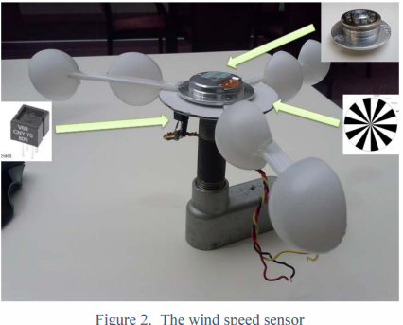

Figure 2 Wind Speed Sensor

The assembling model of the wind speed sensor is shown in figure 2.

When the wind drives the wind turbine to rotate, the reflective optical sensor will continuously scan the black and white cells of the encoder. When the sensor scans the black cell, the output of the sensor will be about 4.8V, and when it scans the white cell, the output will be about 0.8V. Therefore, if the output wire of the sensor is connected to the I/O port of the target board, the microcontroller will read "I" when black and "0" when white. The system counts the changes between "0" and "I" every 128 milliseconds, and save the number of the changes to a global counter. To transfer the value of the counter to the actual wind speed with the unit of MPH, the the values of the counter were collected at different wind speeds, and then a fitting curve was made as shown in figure 3 for the transformation. The transfer function which is derive is as follows:

Wind Speed = -0.0002451n2 + 0.896n,

where "n " is the value of the counter.

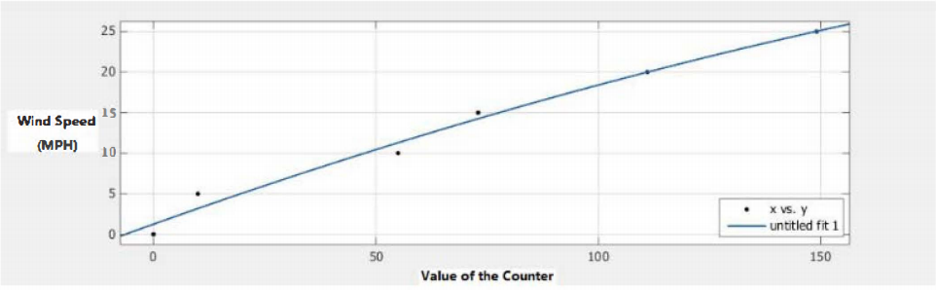

Figure 3 Fitting curve for wind speed

***Wind Direction Sensor:***The wind direction sensor is a I-turn continuous potentiometer; Bourns 6657S-I-I03. A I-turn continuous potentiometer means the resistance of the potentiometer does not accumulate when the axis turns cycle by cycle. So every position of the axis has a fixed value of resistance. Supplied with 5V power resource, the microcontroller can read the voltage of each direction through analog-to-digital converter (ADC). Figure 4 shows the ADC reading value for the eight directions.

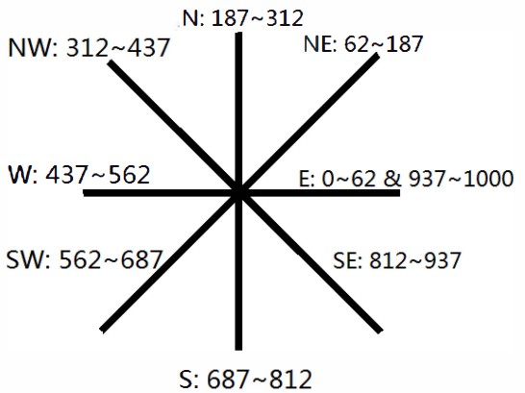

Figure 4 The ADC reading value for the eight directions of

the wind direction sensor

The finished wind direction sensor is shown in figure 5.

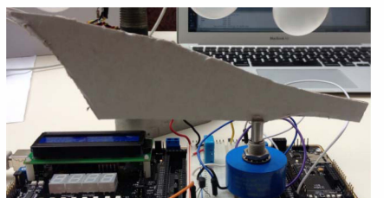

Figure 5 The wind direction sensor

***Temperature Sensor*** The temperature sensor chosen for this design is the Microchip's MCP9700, a low-power linear active thermistor. This tiny analog temperature sensor is optimized for analogto-digital converters and to drive large capacitive loads with wide temperature measurement ranges from -40°C to + 125°C and wide operating voltage ranges from 2.3V to 5.5V.

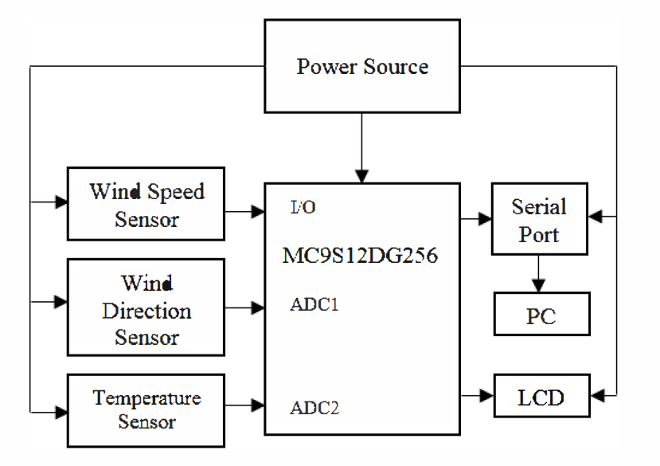

Figure 6 The hardware structure of the system

1. **Hardware Structure** Figure 6 shows the hardware structure of the system. The 5V power source supplies the microcontroller, all the three sensors, the serial port and the LCD. Wind speed sensor is connected to the 110 port, and the other two sensors are connected to two different ADCs on board. The outputs of the system are displaced on the LCD and sent to the serial port that can be read by a personal computer.
2. Software System Structure

The software system design includes two parts, the data input from hardware sensors and the data output to SCI connected to a computer and LCD.

The microcontroller reads the AID converter data from the wind direction sensor and temperate sensor. It then reads the 110 port data from the wind speed sensor and displays it on the on-board LCD of the Dragon 12 development board. The microcontroller is processing data that it receives from the AID converter with timer interrupt service routine (lSR) and then it saves it to a global location. The microcontroller then captures the data from global location with timer interrupt. The weather station will capture the wind direction signal and temperature signal through the AID converter and speed signal through an 110 port. The weather station will display this data on the LCD and sent data to a computer through SCI. Figure 7 shows the flowchart of how the weather station works.

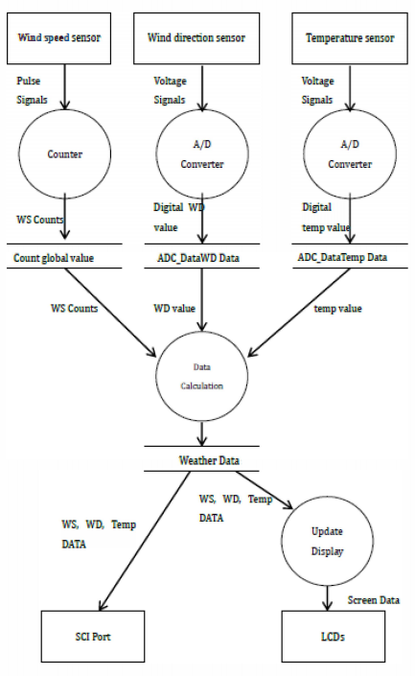

Figure 7 The flowchart for the weather design station.

**A/D Convertor:**There are two 10 bits AID converter units in the MC9S12DP256 microcontroller, the ADCl and ADCO. The successive approximation register (SAR) and the sample and hold amplifier (SHA) is the core unit of the microcontroller. For each ADC convertor, the input voltage signal, which will be in the range from OV to 5V, can be selected from 8 input ports. The SAR will convert a digital value which is based on the input voltage to an analogue voltage. That voltage will be compared with the input voltage from port ANO to AN7 in the comparator. The register will save the value depending on the result of comparison as can be seen in figure 8.

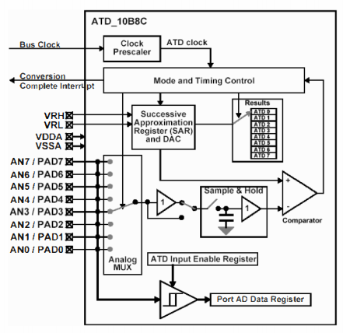

Figure 8 A/D

Data processing in an embedded system always need a timing engine. The timing engine used in ADC is End-of conversion interrupt which acts inside the AID converter. What the ADC interrupt does is running the ADC in the background and trigger the interrupt every time the ADC getting a 10 bits value. Applying the ISR to control the ADC will not need any call-up parameters and return values [11]. The interrupt will save the lO bits value on buffer as a global value. The output will capture the value at the buffer through the use of the timer.

following two ADC starting address in the interrupt vector table:

*ADCWD_ISR // vector Ox17 (ATD I)*

*ADCTemp_ISR // vector Ox16 (ATDO)*

The two AID converters A TDO and A TD 1 are named as ADCWD and ADCTemp by their signal types.

Timer Interrupt Output The timing engine drive the data shown on the LEDs and transmit it to a computer via SCI and under the timer interrupt control. The system extracts data from global values ADC_DataTemp for temperature and ADC DataWD for wind direction every 32ms. It also extracts the wind speed counter every 128ms through the use the interrupt handler timer7.

The following is a program segment that shows how to extract the data from global locations and calculate it to numbers that human can understand:

*PORTB ^= 0x01* ;

Toggle output bit (PBO)

*//sprint (temp, "%d", count_global);*

*// writeLine (temp, 1); // bottom line*

*if (count_timer == 3) {*

*count_global = count;*

*count = 0;*

*windspeed = -0.0002451 * count_global * count_global + 0.896 * count_global;*

*_itoa (windspeed, ws_char, 10);*

*}*

The following program segment shows how to display data on the LCD by calling a series of functions:

*LCDClearDisplay; // clear entire LCD.*

*LCDSetAddr (OxOO); // cursor to top line.*

*LCDPutString ("WS:");*

*LCDSetAddr (Ox03);*

*LCDPutString (" to );*

*LCDSetAddr (Ox03);*

*LCDPutString (ws_char);I // write string to top line.*

*LCDSetAddr (Ox06);*

*LCDPutString ("MPH");*

1. Data Processing

After the acquisition of the basic parameters, these data need to be post-processed to get further information; the wind chill temperature and dressing index.

Wind Chill Temperature In cold winters, usually people feel much colder than the actual temperature due to the chill wind blowing through the skin. Therefore, to get the real feel temperature, the system uses the obtained wind speed and actual temperature to calculate the wind chill temperature by the NWS Windchill Chart shown in figure 9 [12].

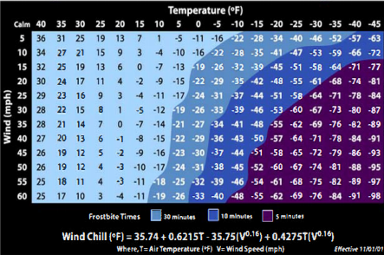

Figure 9 Wind-chill chart

NWS also gives the function to calculate the wind chill as follows:

*Wind Chill (℉) = 35.74 + 0.6215T - 35.75(V^0.16) + 0.4275T(V^0.16).*

where T is the air temperature (OF), and V is the wind speed (mph).

Considering that VO.16 will increase the work load and may degrade the performance of the system, VO.16 is replaced instead by a quadratic function obtained by curve fitting:

*V^0.16 = -0.0003195V2 + 0.02814V + 1.179*

Once the temperature is extracted, the wind chill temperature will be calculated and sent to LCD and serial port.

Dressing Index Dressing index is an integer equal or greater than zero, which can suggests how many clothes a person should wear according to the real time temperature, wind speed and wind direction. The larger the index is, the more clothes are suggested to dress. Table 1 shows a suggested dress index specification.

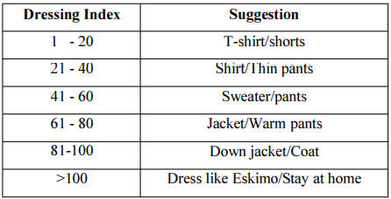

Table 1 Dress index specification

Considering the trade off between the system performance and the information accuracy, a small-scale neural network is implemented. The neural network has one hidden layer and five hidden nodes [13]. The three inputs to the neural network are the real time temperature, the wind speed and the wind direction. The output is the dressing index. The structure of the neural network is shown in figure 10.

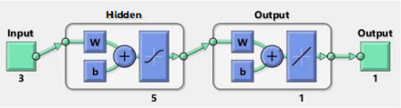

Figure 10 Neural Network Structure for the dressing index

A survey to build the data base for the neural network's training and testing was conducted. First, a 100 x 3 input matrix was randomly generated (three columns are for the three inputs and one hundred rows are for one hundred sets of inputs). This matrix was then assigned to ten people, five males and five females at different ages, and the participants gave out their dressing index based on their life styles. Finally the results from the ten participants were averaged to get a 100 x 1 target matrix. 80 sets of data were used for training. Validating and testing each got 10 sets of data. Figure 11 shows the best training, validating and testing results among 20 repeating times generated by MATLAB [14].

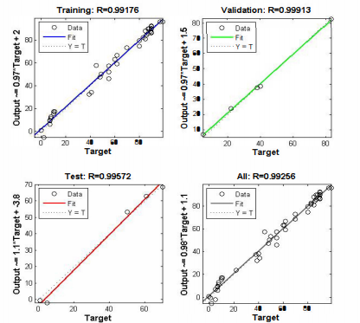

Figure 11 The best training

The weights and biases with the best performance were extracted as follows:

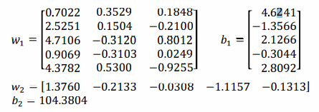

Finally, the dressing index was calculated as follows:

*Dressing Index = Wz • (W1 • input + b1) + bz*

1. Testing And Result

The prototype for the system is shown in figure 12.

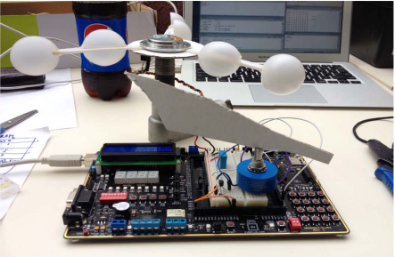

Figure 12 The system prototype.

A series of tests under different conditions were conducted at different temperatures, different wind speeds and different wind directions. The results are shown in table 2.

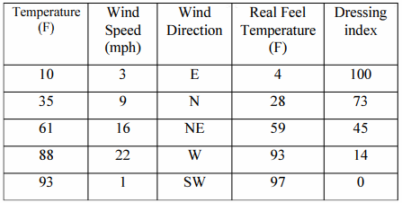

Table 2 Results

The LCD has two rows and sixteen columns. The first row will display the following information: "WS: 12 MPH T: 81 F" where "WS" means wind speed and the unit is mph and "T" means temperature with the unit F. The second row will display the following information: "WD: N RF: 82 DIl2", where "WD" means wind direction, "RF" means the real feel temperature (wind chill temperature), and "DI" means the dressing index.

Figure 13 shows a sample LCD display of information.

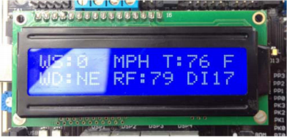

Figure 13 LCD display

The data that is sent through the serial port to a computer is arranged in the following order: temperature, real feel temperature, wind speed, wind direction and dressing index.

V. Conclusions And Future Work

The paper presented a low-cost embedded intelligent weather station design that can measure the real time wind speed, wind direction, temperature, and gives out information on wind chill temperature (real feel temperature) and dressing index. All the information can be shown on the LCD and also can be sent through the serial port to personal computer.

For the future work, the authors will focus on the data storing and analysis. The data obtained from the intelligent weather station will be stored on a personal computer and according to the history more useful information can be predicted.

译文2

**作者**： Adnan Shaout、Yulong Li、Mohan Zhou、Selim Awad

**部门**：密歇根大学的电气和计算机工程系

**地址**：迪尔伯恩（Dearborn），是密歇根州的一个城市。

低成本的智能嵌入式气象站

**摘要**：本文介绍了一种低成本的嵌入式系统的设计方案，该系统可以测量三个参数：风速、风向、温度。测量的参数通过内置的智能系统来预测风寒温度和修正数据。该系统仅使用了基本传感器（反射光学传感器、电位器、温度传感器），从而降低设计成本；之后通过MCU中的小型神经网络进行后续处理。系统将测量的参数作为输入，将着衣指数作为系统输出。所有的数据都可以在LCD上显示，也可以通过串口发送到计算机。

**关键词**：气象站、风速传感器、风向传感器、嵌入式系统、体感温度、着衣指数、智能系统、神经网络

1. **简介**

通常，天气预报只是告诉人们某一个城市或地区在某一段时间内的天气情况。然而，预测有时不是完全准确的，特别在某些特定的环境中。例如，冬天的强风会使人们体感温度比实际温度低很多。因此，本文提出了一种小型的智能嵌入式气象站的设计方案，该系统可以实时提供周围环境的天气情况。主要提供三个基本指数：风速、风向、温度以及经过系统处理的两个参数：体感温度与穿衣指数，这些数据可以显示在LCD，也可以通过串口发送给个人电脑。该系统是基于飞思卡尔HCS12单片机家族的Dragonl2-Plus2板，内部采用5V供电的MC9S12DG256的。本文设计的风速与风向传感器的供电可以通过板内提供，这些传感器的成本远低于市场上现有的产品，无论是成本还是功耗方面。市场上的风速与风向传感器大多为中、大型带外置电源的传感器；显然这些适用于供电有限的嵌入式系统。

除了基本的测量参数，嵌入式系统也提供其他参数指标；该系统通过微型神经网络，根据实际温度、风速、风向计算修正参数并给出穿衣指数。

本文的思路是通过第二部分介绍相关工作，第三部分介绍适合于系统硬件设计，第四部分描述系统的代码结构，第五部分介绍数据处理和圣经网络，第六与第七部分给出测试结果、结论和展望。

1. **相关工作**

市场上大多数嵌入式气象站都没有测量风速与风向的功能。

确实由很多文章描述了不同类型的的风速传感器，例如热线风速传感器、声波风速传感器，但是这一类传感器大多数都是大型传感器。除此之外，还有一些复杂且昂贵的传感器，例如声波风速传感器。

1. **硬件设计**

这一部分介绍气象站系统平台与传感器，并介绍它们之间的连接方式。

系统平台

该平台选择的是HCS12家族的Dragon12-Plus，这是一个低成本、功能齐全的开发板，采用的是16位MC9S12DG256的控制芯片、256B的flash、12KB的RAM、4KB的EEPROM和其他丰富的外设。

1. **传感器**

气象站需要三个传感器：风速传感器、风向传感器、温度传感器。对于温度传感器以及其他两种传感器都采用了基本类型的传感器和外围电路的结构设计。所有传感器都是低成本的，使用板内电源，无需外部供电。

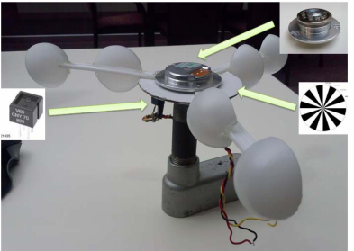

图 3-1 风速传感器

(1).风速传感器：共由5个部分组成；传感器的成品如上图。

***CNY70***：晶体管输出的反射光学传感器。扫描黑纸是输出4.8V，扫描白纸时输出0.8V。



图 3-2 编码器

***编码器***：由20个黑白条纹组成的圆盘。

***转子***：该部件从硬盘上拆卸下来，可以很轻松的转动，这使得在低风速的情况下也可以转动。

***转动风叶***：用于风扇叶片的框架。

***金属底座***：该底座用于保证整个风速传感器的稳定性。

当风力驱动传感器转动时反射式光学传感器将连续扫描编码器的黑白单元，当传感器扫描到黑色，传感器输出4.8V电压；扫描到白色，传感器输出0.8V。因此，如果传感器的输出连接到开发板的I/O端口，单片机将读取到黑色为高电平，白色为低电平。开发板将记录每128ms时间段内的电平变换次数，并将这个数值保存在全局计数器中。为了将计数器的数值转换为以MPH为单位的实际风速，需要采集不同时间的风速的计数值，然后绘制拟合曲线转化为具体的函数。

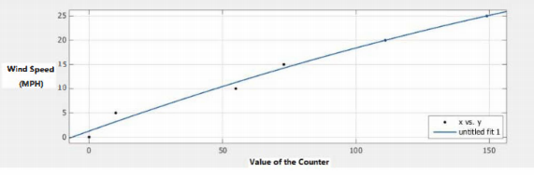

图 3-3 拟合曲线

拟合曲线的方程：(n是计数值)

*Wind Speed = -0.0002451n^2 + 0.896n*

(2). 风向传感器是一个i匝的连续电位器：Bourns 6657S-1-103。该电位器是指当转轴循环转动时不积累电阻，所以每一个轴的位置都有一个固定的电阻值；该传感器是由开发板提供一个5V的电源供电。通过ADC读取各个方向的电压，下图显示了8个方向的ADC读数值。

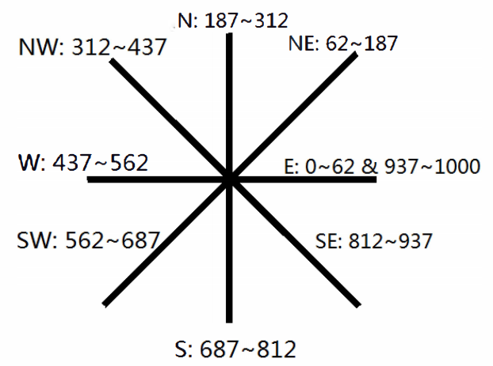

图 3-4 风向传感器的读数值

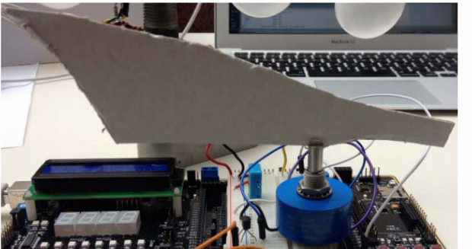

图 3-5 风速传感器

(3). 温度传感器：其芯片采用微星的MCP9700，一种低功耗的线性有源热敏电阻。这种微型模拟温度传感器可以满足模数转换器与大电容负载的要求，具有宽泛的温度测量范围：-40~120℃与工作电压范围2.3~5.5V。

1. **硬件结构**

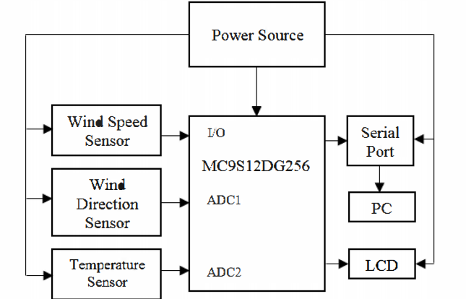

图 3-6 系统的硬件架构

如上图是系统的硬件架构。单片机由5V电源供电，传感器、I/O端口与LCD均由开发板供电，风速传感器连接在I/O端口，其他两个传感器连接在不同的ADC端口。系统的输出显示在LCD上，并通过串口发送给可识别的个人电脑。

1. **软件设计**

软件系统的设计包括两部分，从传感器读取数据以及输出数据到LCD和串口。MCU从ADC端口读取风向与温度数据，从I/O端口读取风速数据，并将结果显示在开发板上LCD。

MCU利用中断服务程序中接受来自ADC端口的数据并将其保存在内存中，之后MCU定时读取内存中数据即可。

气象站通过捕捉ADC端口的风向、温度数据以及I/O端口的风速数据，然后将数据显示在LCD和通过串口发送给个人电脑，下图显示了气象站的工作流程。

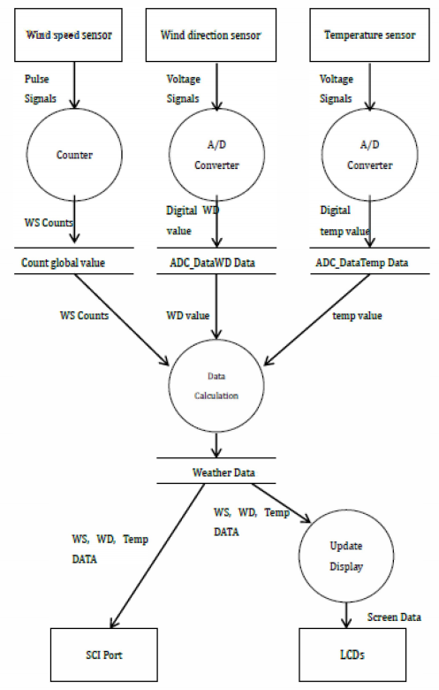

图 4-1 气象站的流程

**1. ADC转换**

在MC9S12DP256中有两个10位的ADC转换单元：ADC0与ADC1。SAR与SHA是其核心单元。对于每一个ADC转换器，可以从8个I/O端口中输入电压信号，电压的范围在0~5V之间。SAR会将输入的模拟电压与比较器的AN0~AN7输入的参靠电压进行比较，将输入的模拟电压转化位数字信号，存储在寄存器中，如下图所示：

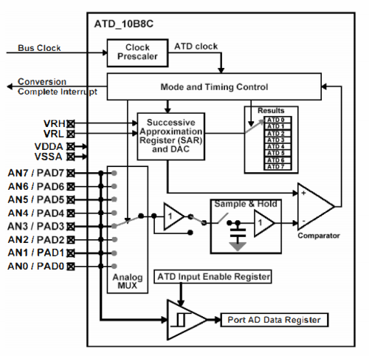

图 4-2 ADC转换器

在嵌入式系统中，数据的处理总是需要一个时间脉冲，ADC使用的时钟脉冲是在ADC转换结束后请求中断的，当ADC中断响应时，将会从ADC寄存器中读取到10位的数值。当然使用ISR来处理ADC是不需要参数与返回的。ISR将寄存器中的值存储在全局变量中。同时系统将通过定时来获取风速的的计数值。

在代码运行前需要在中断矢量表中加入两个起始地址(两个辅助ADC转换器的TD0与TD1根据信号类型定义为ADCWD_ISR与ADCTemp_ISR)：

*ADCWD_ISR /* vector 0X17(ATD1). */*

*ADCTemp_ISR /* vector 0X16(ATD0). */*

**2. 输出中断**

输出中断将实现LED的数据显示和通过SCI总线将数据传输给PC。在系统将每32ms读取全局变量ADC_DataTemp（温度）和的ADC_DataWD（风向）的数据，也通过定时器7的中断实现每128ms获取计数值（风速）。

下面的一个程序段，将展示如何从全局变量中读取数据，并将其计算为人类可以理解的数值。

***PORTB ^= OxOl; // Toggle output bit (PBO)***

***// sprint (temp, "%d", count_global);***

***// writeLine (temp, 1);// bottom line***

***if (count_timer == 3) {***

***count_global = count;***

***count = 0;***

***windspeed = -0.0002451 * count_global * count_global + 0.896 * count_global;***

***_itoa (windspeed, ws_char, 10);***

***}***

下面程序段展示了如何通过调用一些列函数在LCD上显示数据：

***LCDClearDisplay; // clear entire LCD.***

***LCDSetAddr (OxOO); // cursor to top line***

***LCDPutString ("WS:");***

***LCDSetAddr (Ox03);***

***LCDPutString (" to );***

***LCDSetAddr (Ox03);***

***LCDPutString (ws_char); // write string to top line***

***LCDSetAddr (Ox06);***

***LCDPutString ("MPH");***

1. **数据处理**

在获取完基本参数之后，需要对这些数据进行后续处理来进一步得到结果：穿衣指数与修正指标。

1. **体感温度**

在寒冷的冬天，由于寒风吹过皮肤，人们通常会感到比实际温度更冷。因此，为了得到真实的感觉温度，系统利用得到的风速和实际温度，通过NWS Windchill图来计算体感温度。

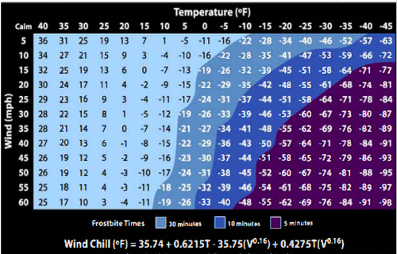

图 5-1 NWS Windchill

NWS也需要通过以下公式计算：（T是实际温度，V是风速）

Wind Chill（℉）= 35.74 + 0.6215T - 35.75(V^0.16) + 0.4275T(V^0.16),

考虑到指数运算会增加工作量以至于系统效率降低，所以通过拟合曲线来代替上式中的指数：

V^0.16 = -0.0003195V^2 + 0.02814V + 1.179

当获取到实际温度时，就会计算出体感温度显示在LCD并传输到PC。

1. **穿衣指数**

穿衣指数是一个等于或大于零的整数，它可以根据实时的温度、风速和风向来提示一个人应该穿多少衣服。指数越大，建议穿 的衣服越多。下图显示了建议的着装指标规范。

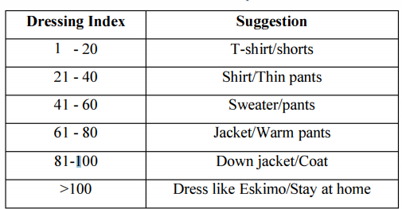

表 5-1 建议穿衣指数

考虑到系统性能和信息准确性之间的权衡，实现了一种小尺度的神经网络。该神经网络具有一个隐层和5个隐结点。神经网络的三个输入时实际温度、风速以及风向，输出穿衣指数，其结构如下图所示。



图 5-2 穿衣指数的神经结构

研究了建立神经网络训练与测试数据库的方法。首先，随机生成一个100×3的输入矩阵(三个列代表三个输入，100行代表100组输入)。然后，这个矩阵被分配给10个人，5男5女，年龄不同，参与者根据他们的生活方式给出他们的着装指数。最后将十位参与者的结果取平均值，得到一个100×1的目标矩阵。使用了80组数据进行训练。验证和测试每一个都得到了10组数据。图11为MATLAB[14]生成的20次重复中最好的训练、验证和测试结果。

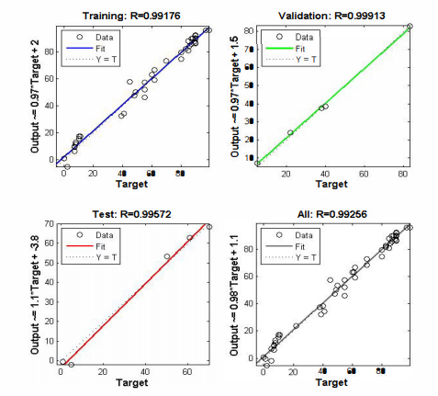

图 5-3 神经网络

提取性能最好的权重和偏差如下：

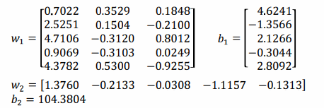

最终的穿衣指数的计算公式如下：

*Dressing Index = Wz • (W1 • input + b1) + b2*

1. **测试结果**

系统最终展示如下图：

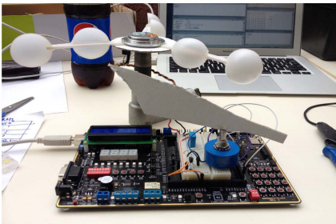

图 5-4 系统效果图

在不同的温度、不同的风速和不同的风向下进行了一系列不同条件下的试验。结果如下图所示。

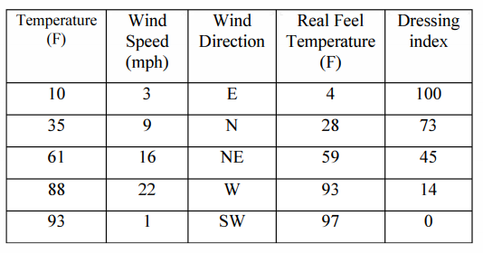

表 5-2 结果

LCD有两行十六列。第一行将显示以下信息：“*WS：12MPH，T：81℉*”WS是风速，T是实际温度；第二行显示一下信息：“*WD：N，RF：82，DI：I2*”，WD是风向，RF是体感温度，DI是穿衣指数。

下图是LCD显示的信息效果图：

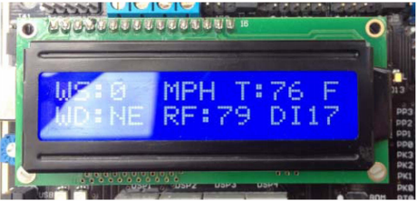

图 5-3 LCD显示效果

通过串口发送数据的顺序是：温度、体感温度、风速、风向、穿衣指数。

1. **结论总结**

本文提出了一种低成本的智能嵌入式气象站的设计方案。可以实时测试风速、风向、温度，并提供体感温度和穿衣指数的信息。所有的信息都可以显示在LCD上，也可以通过串口发送到PC。

在未来的工作中，作者将关注数据存储和分析。从智能气象站获得的数据存储在个人电脑中，根据历史记录可以预测更多有用的信息。