UECM3033 Assignment #1 Report

========================================================

- Prepared by: Lai Weng Key

- Tutorial Group: T3

-------------------------------------------------------------------------------

## Task 1 -- setup a github repository

The reports, codes and supporting documents are uploaded to Github at:

(https://github.com/wengkey95/UECM3033_assign1)

As follow the instruction, I need to setup a github repository. Therefore, I need to download the Github software and initialize the repository and configure my git account. I have signed up a Github account ID as “Wengkey95”. Then, I clicked “fork” button to copy the UECM3033_assign1 repository. Next, I need to fill the Google form to finish task 1. Before filling up the Google form, I had a problem to access into the Google form even I log in as UTAR email, after few attempts then I discussed with some of my friends about it. Eventually, we found out that, we have to log out the default account before log in to UTAR email.

------------------------------------------------------------------------------

## Task 2 -- setup python

Screenshot of the file (“python.png”)

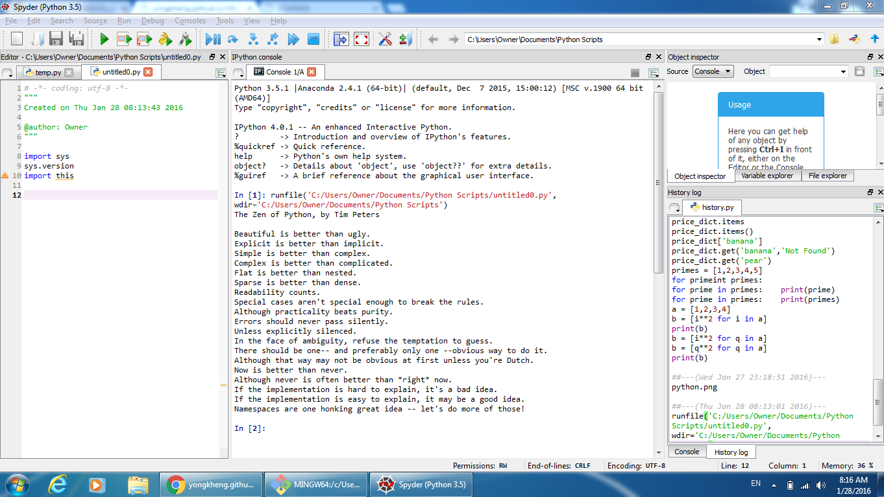

This task required us to download Anaconda version 3.5 and install it. After that, I have to open Spyder and execute the code given in the instruction page. The output is The Zen of Python and a list of poem which is shown above. Then, I have to clone the repository from my Github into a folder, UECM3033_assign1. The file “python.png” inside the folder is then replaced by the screenshot and uploaded to the Github by Gitbash. After a few times of fail to upload, I found that I need to change my own directory to the cloned folder, by the command “$ cd UECM3033_assign1”

--------------------------------------------------------------------------------------

## Task 3 -- modify and run Python script

This part is about some exercises of Python coding. Here are the results of the exercises:

1. The hexadecimal value of my student ID, 1304638, is 0x13e83e
2. The definite integral I chosen is $\int_{0}^{∞}{x^{2}e^{\frac{-x}{2}}}dx$, which is 240.
3. The system of linear equations that I set up is:

$$x_{0}+{2x}_{1}+{3x}_{2}+4x_{3}+{5x}_{4}+{6x}_{5}+{7x}_{6}+{8x}_{7}+{9x}_{8}+ {11x}_{9}=2$$

$$2x_{0}+{3x}_{1}+{4x}_{2}+{5x}_{3}+{6x}_{4}+{7x}_{5}+{8x}_{6}+{9x}_{7}+{11x}_{8}+x_{9}=4$$

$${3x}_{0}+{4x}_{1}+{5x}_{2}+{6x}_{3}+{7x}_{4}+{8x}_{5}+{9x}_{6}+{11}_{7}+x_{8}+{2x}_{9}=6$$

$${4x}_{0}+{5x}_{1}+{6x}_{2}+{7x}_{3}+{8x}_{4}+{9x}_{5}+{11x}_{6}+x_{7}+{2x}_{8}+{3x}_{9}=8$$

$${5x}_{0}+{6x}_{1}+{7x}_{2}+{8x}_{3}+{9x}_{4}+{11x}_{5}+x_{6}+{2x}_{7}+{3x}_{8}+{4x}_{9}=10$$

$${6x}_{0}+{7x}_{1}+{8x}_{2}+{9x}_{3}+{11x}_{4}+x_{5}+{2x}_{6}+{3x}_{7}+{4x}_{8}+{5x}_{9}=12$$

$$7x_{0}+{8x}_{1}+{9x}_{2}+{11x}_{3}+x_{4}+{2x}_{5}+{3x}_{6}+{4x}_{7}+{5x}_{8}+{6x}_{9}=14$$

$${8x}_{0}+{9x}_{1}+{11x}_{2}+x_{3}+{2x}_{4}+{3x}_{5}+{4x}_{6}+{5x}_{7}+{6x}_{8}+{7x}_{9}=16$$

$${9x}_{0}+11x_{1}+x_{2}+{2x}_{3}+{{3x}_{4}+4x}_{5}+{5x}_{6}+{6x}_{7}+{7x}_{8}+{8x}_{9}=17$$

$${2x}_{0}+{3x}_{1}+{5x}_{2}+{7x}_{3}+{11x}_{4}+{13x}_{5}+{17x}_{6}+{19x}_{7}+{23x}_{8}+{29x}_{9}=19$$

The solution of the system is:

$x_{0}≈13.49918779$

$x_{1}≈-10.12514726$

$x_{2}≈-0.62976412$

$x_{3}≈0.14254344$

$x_{4}≈0.21275322$

$x_{5}≈ 0.21913592$

$x_{6}≈ 0.21971617$

$x_{7}≈0.21976892$

$x_{8}≈0.21977372$

$x_{9}≈0.21977415$

-----------------------------------

Last modified: 29/1/2016