Prepared by: Lai Weng Key

Tutorial Group: T3

**Task 1 -- $LU$ Factorization or SOR method**

The reports, codes and supporting documents are to be uploaded to Github at:

<https://github.com/wengkey95/UECM3033_assign2>

**Explain your selection criteria here.**

The condition is set to be np.count_nonzero(A) > 1/2*len(A). Sparse matrix is a matrix where most of the elements are zeros, so in this case, if the non-zeros are greater than half of the length of matrix A then we will choose LU method. Iterative methods, which consist of SOR method are well-suited for sparse matrix.

**Explain how you implement your task1.py here.**

For LU method, two matrix will be created with is the lower matrix and upper matrix whereby A=LU, thus Ax=LUx=b, so will be define into Ly=b and Ux= y. So, we can get the x matrix after getting the y matrix.

For the SOR method, write down all the formula as A = D – L – U

$X_{k+1}$ = $Q^{-1}\left(Q-A\right)X_{k}+Q^{-1}b$// Q = $\frac{D}{ω}$– L // $ω=\frac{2[1-\sqrt{1-(ρ{(Kj))}^{2}}]}{(ρ{(Kj))}^{2}}$// Kj = $D^{-1}(L+U)$

Then compute the optimum omega for SOR to accelerate the iteration.

The solution of the 1st system is: x = ${[1.0,1.0,1.0]}^{T}$ The solution of the 2nd system is approximately: x = ${[1, -1, 4, -3.5, 7, -1.0]}^{T}$.

## Task 2 -- SVD method and image compression

My Picture File (image.jpg)



**How many non zero element in $\Sigma$?**

There are 800 non-zero elements in matrix.

**Put here your lower and better resolution pictures. Explain how you generate these pictures from task2.py.**

Lower resolution pictures

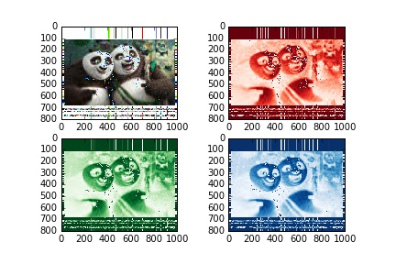

Higher Resolution pictures

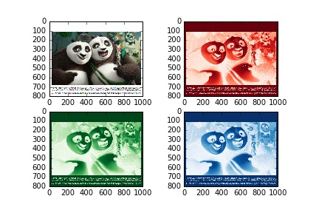

Firstly, split out the original image into its red, green and blue components. With help of sp.linalg.svd decomposition. Then decomposed the red, green and blur matrix into U, S, and V matrix as U_red,S_red,V_red. To create a lower or high resolution picture, input **n** as an input parameter to the function **quality(n,U,S,V)** for all the rgb components . Only the first n singular values in $\Sigma$ are not replace with zeros. Since a large amount of singular values are set to zeros, there will be a drop in the quality of the image. In the end, the picture will have different resolution which depends on how many elements are transferred from S to new S matrix.

**What is a sparse matrix?**

A sparse matrix is a [matrix](https://en.wikipedia.org/wiki/Matrix_(mathematics)) in which most of the elements are zero. By contrast, if most of the elements are nonzero, then the matrix is considered dense. The fraction of non-zero elements over the total number of elements (i.e., that can fit into the matrix, say a matrix of dimension of m x n can accommodate m x n total number of elements) in a matrix is called the sparsity (density)