**UECM3033 Assignment #3 Report**

* Prepared by: **Lai Weng Key**
* Tutorial Group: T3

**Task 1 -- Gauss-Legendre formula**

The reports, codes and supporting documents are to be uploaded to Github at:

https://github.com/wengkey95/UECM3033_assign3

Explain how you implement your task1.py here.

Explain how you get the weights and nodes used in the Gauss-Legendre quadrature.

First, obtaining the weights and nodes by using Gass-Legendre quadrature function.

After referring to: <https://math.okstate.edu/people/yqwang/teaching/math4513_fall14/Notes/gaussian.pdf>

I separate it into 2 cases, which are the integral is between [-1,1] and other arbitrary integral.

In the 1st condition, we can just apply the Gaussian Legende N-point formula, summation of w[i]*f[i], where w[i] is the i–th weights and x[i] is the i-th nodes.

In the 2nd condition, a simple linear transformation is applied.   
W[i]= w[i]*((b-a)/2)  
X[i] = ((a+b)/2 + (b-a)*(x[i])/2)

**Task 2 -- Predator-prey model**

Explain how you implement your task2.py here, especially how to use odeint.

Put your graphs here and explain.

Is the system of ODE sensitive to initial condition? Explain.

First of all, I define a function called system(), to generate the differential equation system and return it when called. Then, define the constant a and b, the initial condition of y0(0) and y1(0), generate out the linear spacing of t, and call the method odeint to solve the system.

odeint use to integrate a system of ordinary differential equations. Solve a system of ordinary differential equations using lsoda as well as the initial value problem for stiff or non-stiff systems of first order ode-s.  
Its function paramenter : function that generate differentia equation, y[initial condition] , and t (sequence of time points).

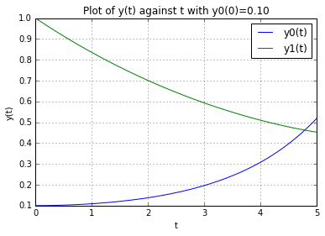

The graph above shows that y0 and the number of predator,y1 against year, t when the initial value condition y0(0)=0.1. We can see that the number of prey increase when the number of predator decreases.

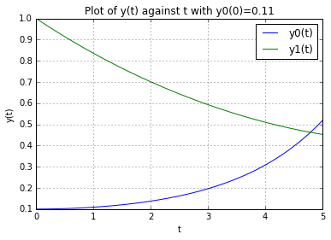

This system of ODE is not sensitive to the initial condition. There is only a small change in the graph when the initial value condition change from 0.1 to 0.11. Since, there is no significant difference by comparing both graph. Therefore, this system of ODE is not sensitive to the initial condition.