On the origin of citations

Wenhan

September 15, 2015

# Load the data

## using read.delim

counts_raw <- read.delim("data/df_all.txt")  
counts_norm <- read.delim("data/df_research_norm_transform.txt")

# Data exploration

What's the distribution of authors in all articles of our data set?

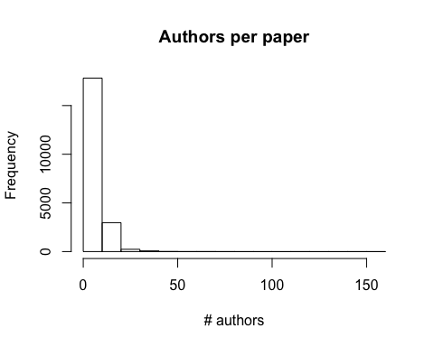

How popular are articles on Facebook?

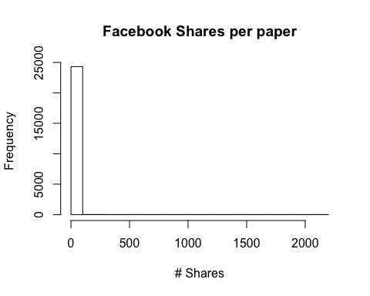

The average number of Facebook shares per paper in the data set is 0.6524187.