**Introduction on how to use the web adaptation tool**

**(will be incorporated with the scheme currently I’m developing …)**

Firstly, the user would specify the scale of the analysis, with options to upload their own customized boundary file.

Then, the user will choose from a list of basic information to be displayed in the background.

Following that will be control buttons for the user to launch the Urban Heat Island Analysis and participate in a survey for documentation and sharing purposes.

On the right would be a web-map section with basemap styles changeable, where the user can pan, zoom, and view the geographical areas of data in real time.

Below to the map is the reporting section that includes the Hazards, the Impacts, and the Adaptation area. Each of these areas will include a brief description that states the key issues related and data to be provided, and a Generate Report button that would launch the download of a PDF report that synthesizes the information related. In particular, the PDF report from the Adaptation Strategy section will generate a report that includes the geography of the user-defined focus area with a map, a summary of the pressing climate hazards that the area faces, and the potential impacts these hazards would impose on, as well as a list of actionable adaptation strategies that respond to the issues and delineate the specific action items to be implemented.

The survey button below the analysis button will lead to a separate page that allows the user to respond to the 6 questions pertaining user feedbacks on adaptation strategies.

**Description for the screenshots**

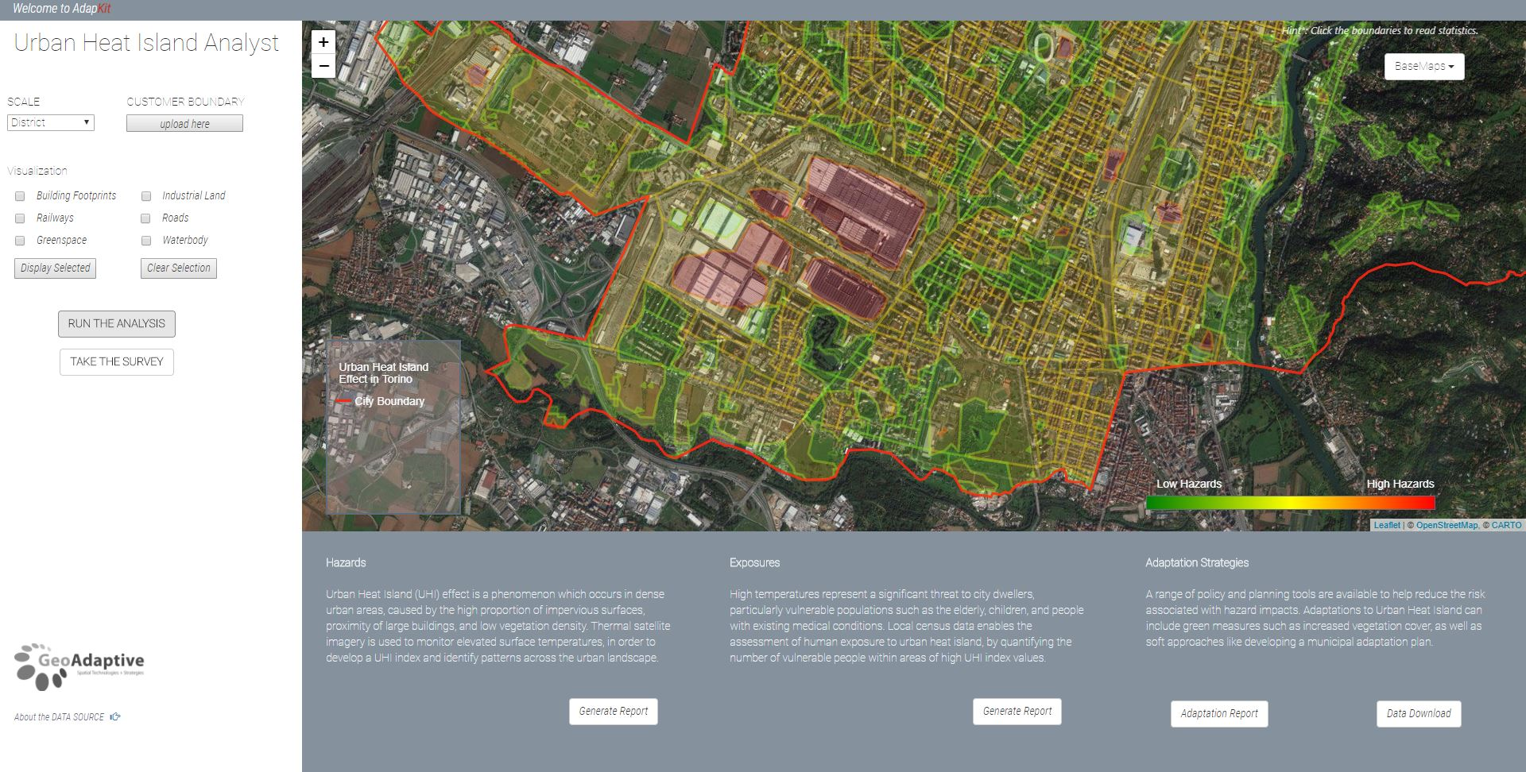

Here the level of hazards were shown on the aerial map. As a result of the Urban Heat Island Analysis, the level of hazards were represented in green for low hazards to red for high hazards. We can see some of the larger industrial blocks are in red, indicating a relatively high level of hazards.

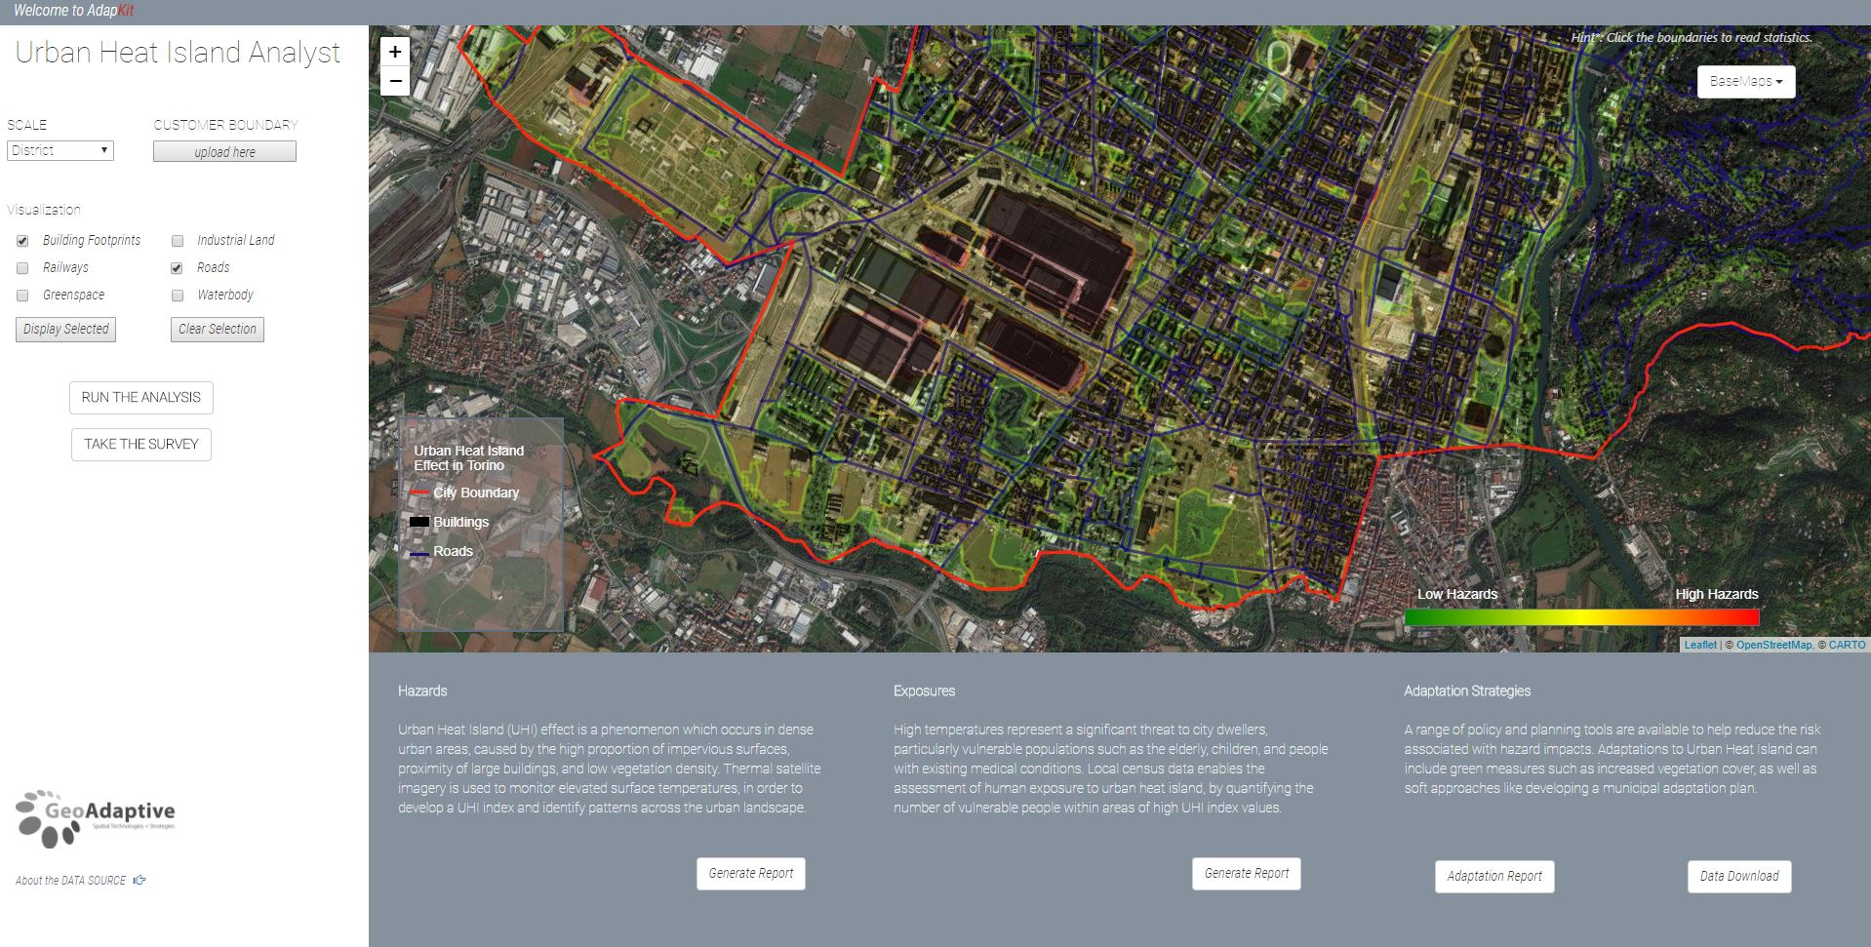

Here the hazards map were overlaid with the building footprints in black and the road network in dark blue. This type of analysis and visualization helps us to understand the relationship between the urban heat island effect and the built-out urban fabric.