Sonarqube local

By Victor Chang, 2014/01/07

Ref: <http://www.uml.org.cn/rjzl/201312132.asp>

Download “SonarQube” & “SonarQube Runner”

<http://www.sonarqube.org/downloads/>

My environment

Ubuntu 10.04, 32bits run in VMware

java version "1.7.0_45"

Mysql

Mysql Install guide

#sudo apt-get install mysql-server

#sudo apt-get install mysql-server --fix-missing (if need)

#sudo apt-get install mysql-client

#sudo apt-get install mysql-client --fix-missing (if need)

JAVA Install guide

#sudo add-apt-repository ppa:webupd8team/java

#sudo apt-get update

#sudo apt-get install oracle-java7-installer

#java -version

Database configure

#mysql -u root -p

**mysql>** CREATE DATABASE sonar CHARACTER SET utf8 COLLATE utf8_general_ci;   
**mysql>** CREATE USER 'sonar' IDENTIFIED BY 'sonar';   
**mysql>** GRANT ALL ON sonar.* TO 'sonar'@'%' IDENTIFIED BY 'sonar';   
**mysql>** GRANT ALL ON sonar.* TO 'sonar'@'localhost' IDENTIFIED BY 'sonar';   
**mysql>** FLUSH PRIVILEGES;

Put downloaded sonar and sonar-runner in the one folder and unzip its

#mkdir Sonarqube

#cd Sonarqube

#unzip sonarqube-4.0.zip

#unzip sonar-runner-dist-2.3.zip

Modify sonar configure

#cd /home/wenhsin/Sonarqube/sonarqube-4.0/conf

#vi sonar.properties (mark, else unmark)

sonar.jdbc.username=sonar

sonar.jdbc.password=sonar

#sonar.jdbc.url=jdbc:h2:tcp://localhost:9092/sonar

sonar.jdbc.url=jdbc:mysql://localhost:3306/sonar?useUnicode=true&characterEncoding=utf8&rewriteBatchedStatements=true

Modify sonar runner configure

#cd /home/wenhsin/Sonarqube/sonar-runner-2.3/conf

#vi sonar-runner.properties(unmark following)

#No information about specific project should appear here   
#----- Default SonarQube server   
sonar.host.url=http://localhost:9000   
#-- --- PostgreSQL   
#sonar.jdbc.url=jdbc:postgresql://localhost/sonar   
#----- MySQL   
sonar.jdbc.url=jdbc:mysql://localhost:3306/sonar?useUnicode=true&characterEncoding=utf8   
#----- Oracle   
#sonar.jdbc.url=jdbc:oracle:thin:@localhost/XE   
#----- Microsoft SQLServer   
#sonar.jdbc.url=jdbc:jtds:sqlserver://localhost/sonar ;SelectMethod=Cursor   
#----- Global database settings   
sonar.jdbc.username=sonar   
sonar.jdbc.password=sonar   
#----- Default source code encoding   
sonar.sourceEncoding=UTF-8   
#----- Security (when 'sonar.forceAuthentication' is set to 'true')   
sonar.login=admin   
sonar.password=admin

Create a shell script to set environment variables and source it

#vi /home/wenhsin/Sonarqube/env.sh

export SONAR_HOME=/home/wenhsin/Sonarqube/sonarqube-4.0

export SONAR_RUNNER_HOME=/home/wenhsin/Sonarqube/sonar-runner-2.3

sonar-runner

export PATH=$PATH:SONAR_RUNNER_HOME

export PATH=$PATH:/home/wenhsin/Sonarqube/sonar-runner-2.3/bin

#chmod +x env.sh

#source env.sh

Run Sonar as daemon

#cd /home/wenhsin/Sonarqube/sonarqube-4.0/bin/linux-x86-32

(Need root permission)

#./sonar.sh start

#./sonar.sh stop

#./sonar.sh restart

Shown in web

http://localhost:9000

Log in Sonar Dashboard

ID: admin

PW:admin

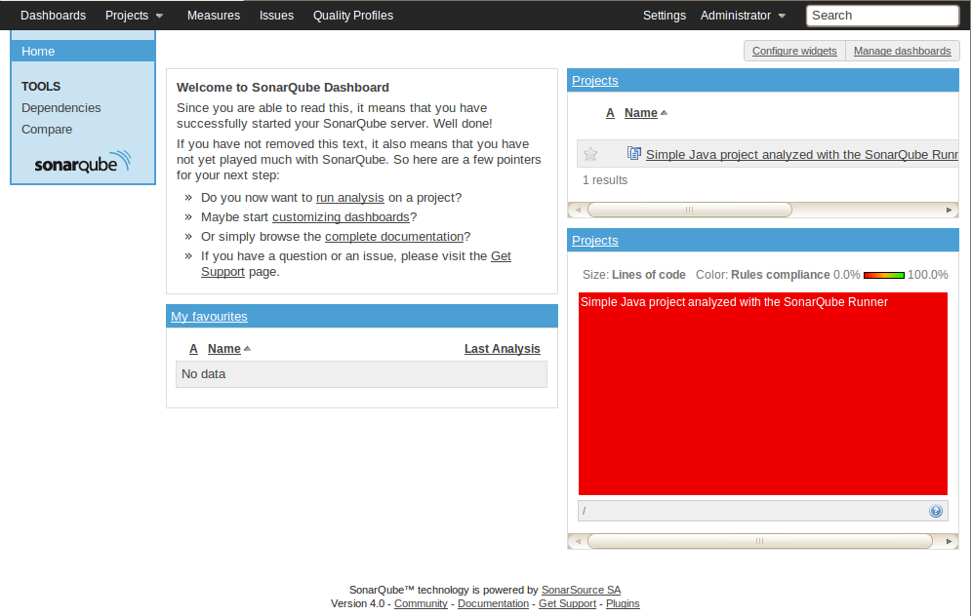

C/C++ project

~/Sonarqube/SonarSource-sonar-examples-984bd07/projects/languages/c/c-sonar-runner

#sonar-runner

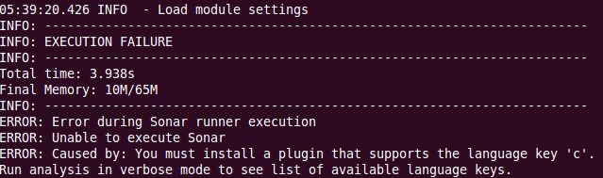

Solution

Settings -> Update Center -> Available Plugins -> Language -> enable C/C++

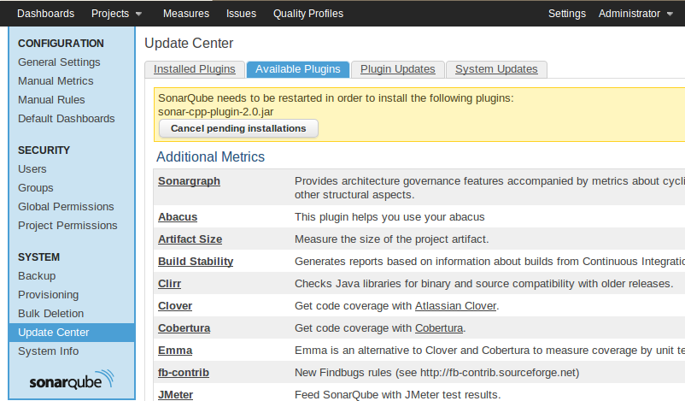

# sonar restart (with root permission) //symbolic link must be created see after…

But…

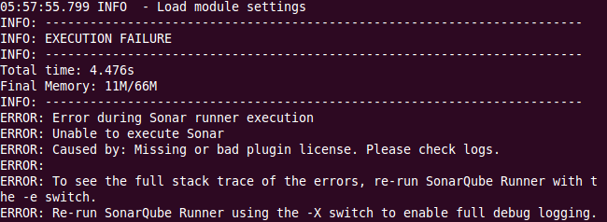

See following

<http://www.sonarsource.com/products/plugins/languages/cpp/installation-and-usage/>

and

<http://www.sonarsource.com/products/plugins/languages/cpp/>

(凸)

If u have license key in following:

Settings -> General Settings -> Licenses

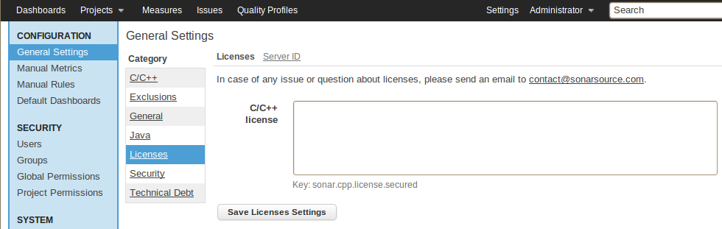

(淚)

Auto start up at Ubuntu 32

#sudo vi /etc/init.d/sonar

#!/bin/sh   
#   
# rc file for SonarQube   
#   
# chkconfig: 345 96 10   
# description: SonarQube system (www.sonarsource.org)   
#   
### BEGIN INIT INFO   
# Provides: sonar   
# Required-Start: $network   
# Required-Stop: $network   
# Default-Start: 3 4 5   
# Default-Stop: 0 1 2 6   
# Short-Description: SonarQube system (www.sonarsource.org)   
# Description: SonarQube system (www.sonarsource.org)   
# ## END INIT INFO /usr/bin/sonar $*

#sudo ln -s $SONAR_HOME/bin/linux-x86-32/sonar.sh /usr/bin/sonar

#sudo chmod 755 /etc/init.d/sonar

#sudo update-rc.d sonar defaults

But I found this method it doesn’t work, if want to use please use following

The symbolic link exist.

(with root permission)

#sonar start

Download the SonarQube project example at following url

<http://docs.codehaus.org/display/SONAR/SonarQube+Project+Examples>

#unzip SonarSource-sonar-examples-984bd07.zip

#cd ~/SonarSource-sonar-examples-984bd07/projects/languages/java/sonar-runner/java-sonar-runner-simple

Analysis the java code (free charge)

#sonar-runner

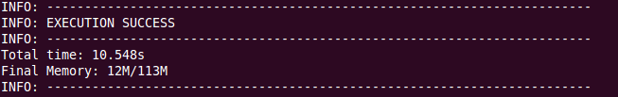

Result shown in http://localhost:9000

