CSC 413 Tank Game Doucmentation
Fall 2019
Cody Huang
917041832
CSC 0413-01 Summer 2021
https://github.com/csc413-su21/csc413-tankgame-wenhuang415

Table of Contents
1 Introduction 3
1.1 Project Overview 3
1.2 Technical Overview 3
1.3 Summary of Work Completed 3
2 Development Environment 4
3 How to Build/Import your Project 4
4 How to Run your Project 4
5 Assumption Made 4
6 Implementation Discussion 4
6.1 Class Diagram 5
6.2 GameObject Class…………………………………………………………………………………………………………………...
6.3
6.4 HUDObject Class…………………………………………………………………………………………………………………...
6.5
7 Project Reflection 5
8 Project Conclusion/Results 6

Introduction

Project Overview

Technical Overview

Summary of Work Completed

Development Environment
IntelliJ Ulitmate Version: 2021.1.2 Build: 211.7442.40
java version "1.8.0_281"
Java(TM) SE Runtime Environment (build 1.8.0_281-b09)
Java HotSpot(TM) 64-Bit Server VM (build 25.281-b09, mixed mode)

How to Build/Import your Project

How to Run your Project

Assumption Made

Implementation Discussion

Class Diagram
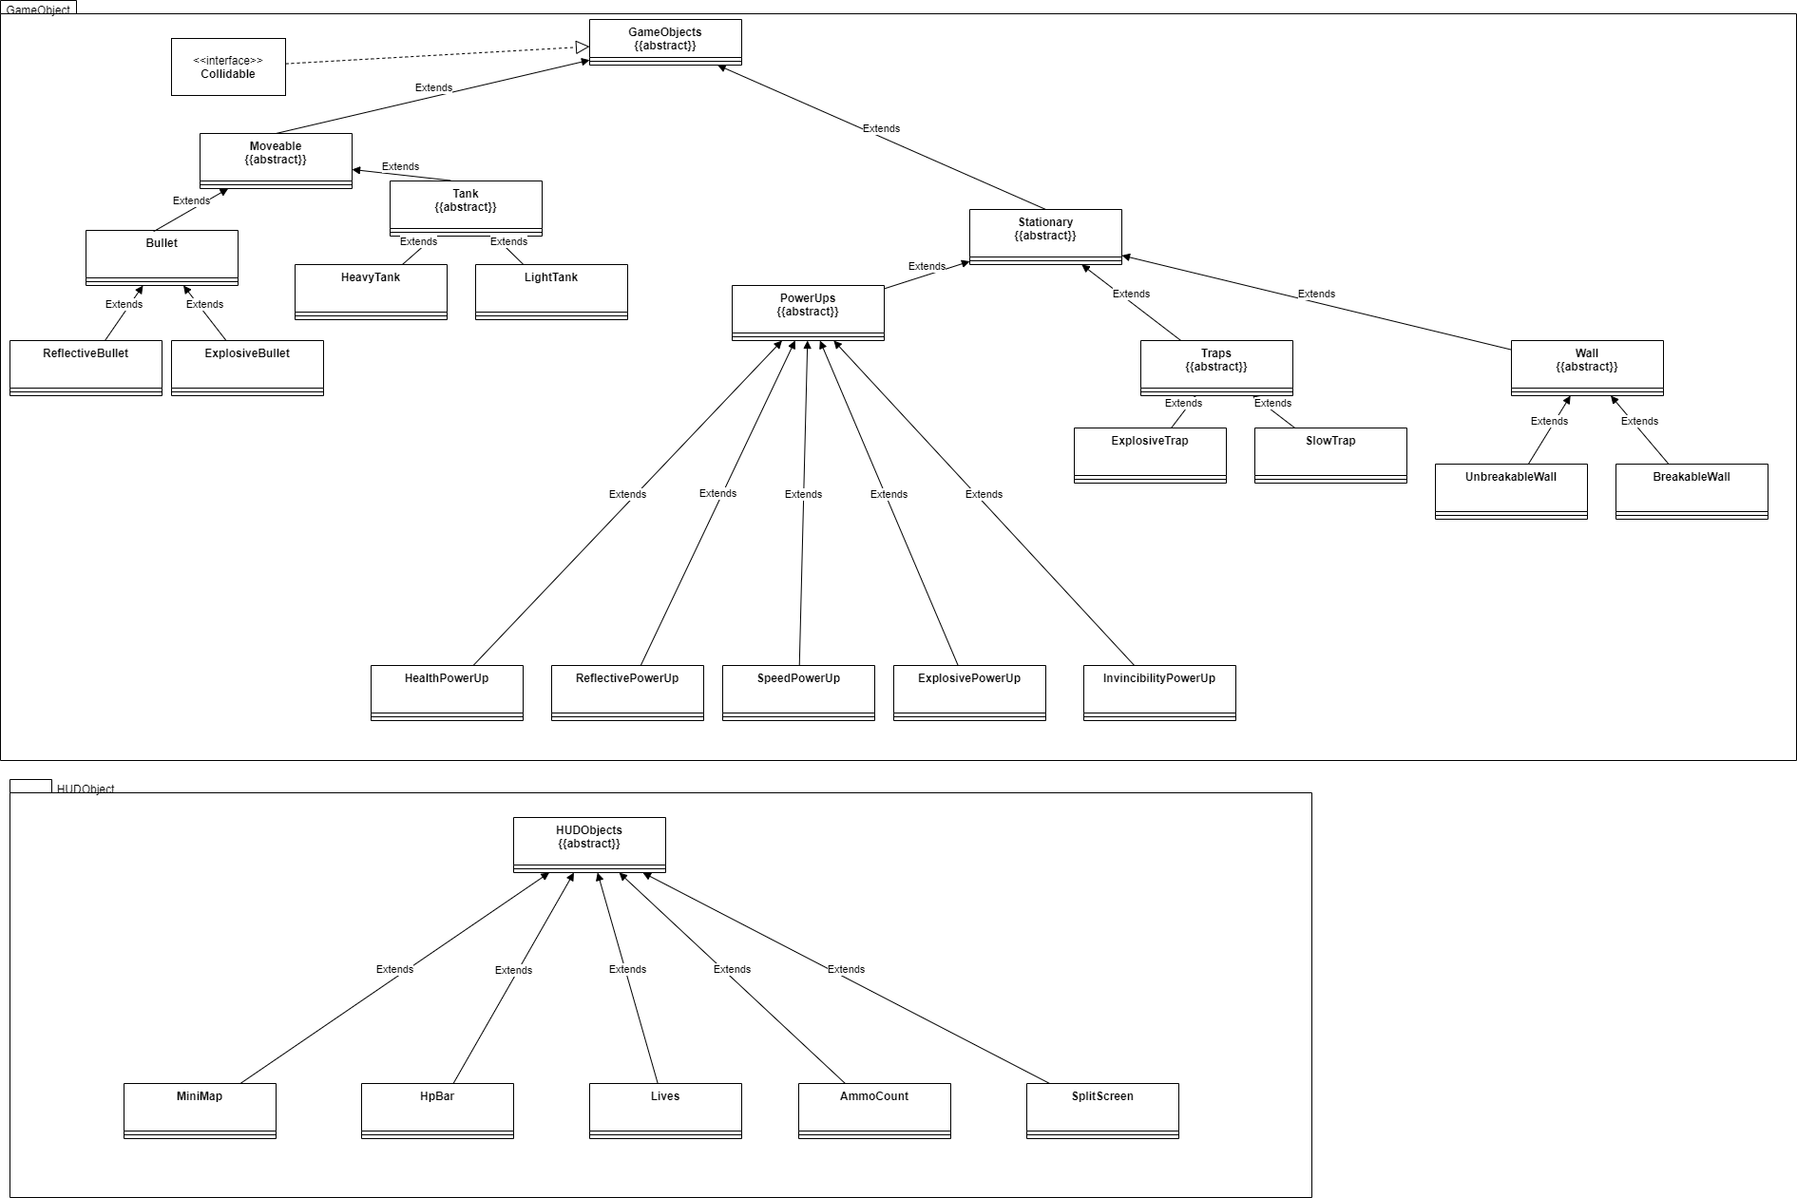

Project Reflection

Project Conclusion/Results

