**Development Environment:** Visual Studio 2022, .NET Core, C#, ASP.NET Identity Core, Entity Framework Core 8.0, Blazor, Web API 2.0, LINQ, SQL-Server, JavaScript.

* **Frontend Application**：

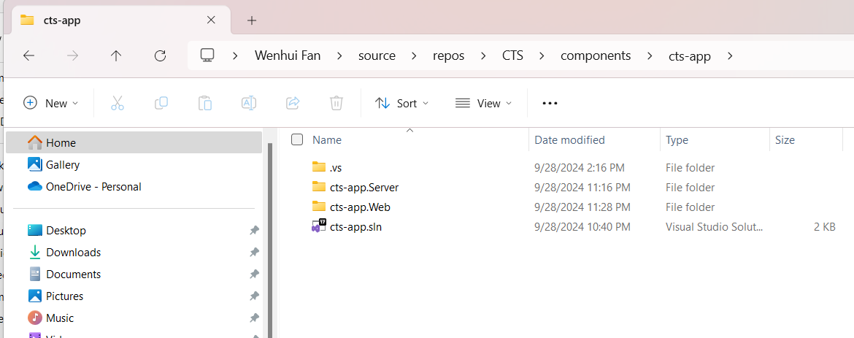

* **API service：**

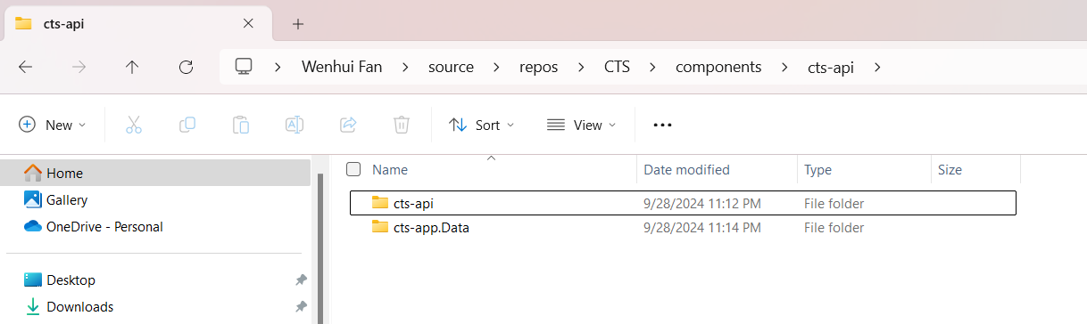

**How to run locally?**

1. Loading **cts-api solution** & got to **cts-app.Data** project, then use the following script to generate **WenhuiCTS** DB under SQL server



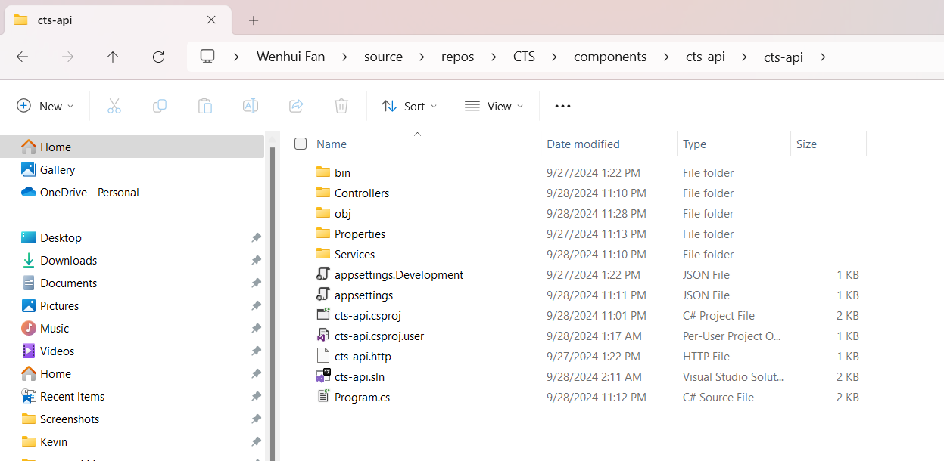

1. Then seed the data as follow under SSMS:



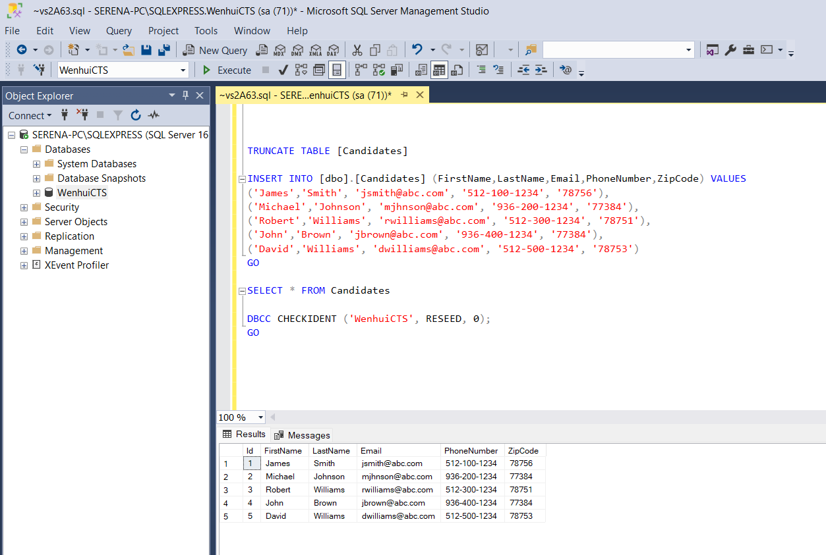

1. Under cts-api solution, run **cts-api** API service first

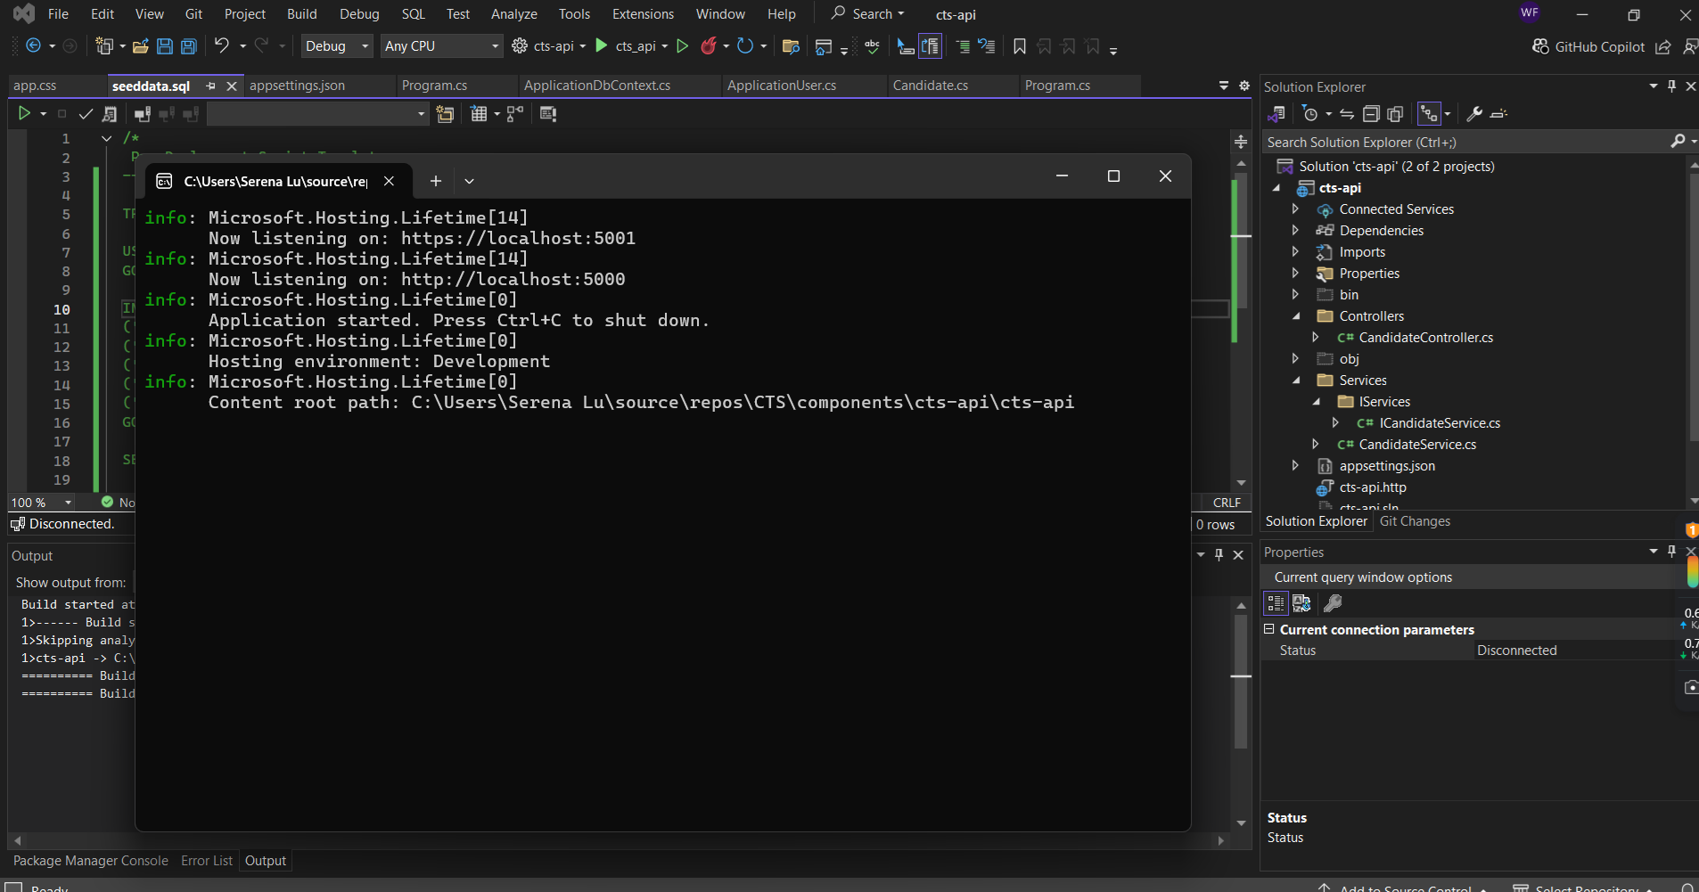

1. On the swagger you will be able to see some services provided as bellow:

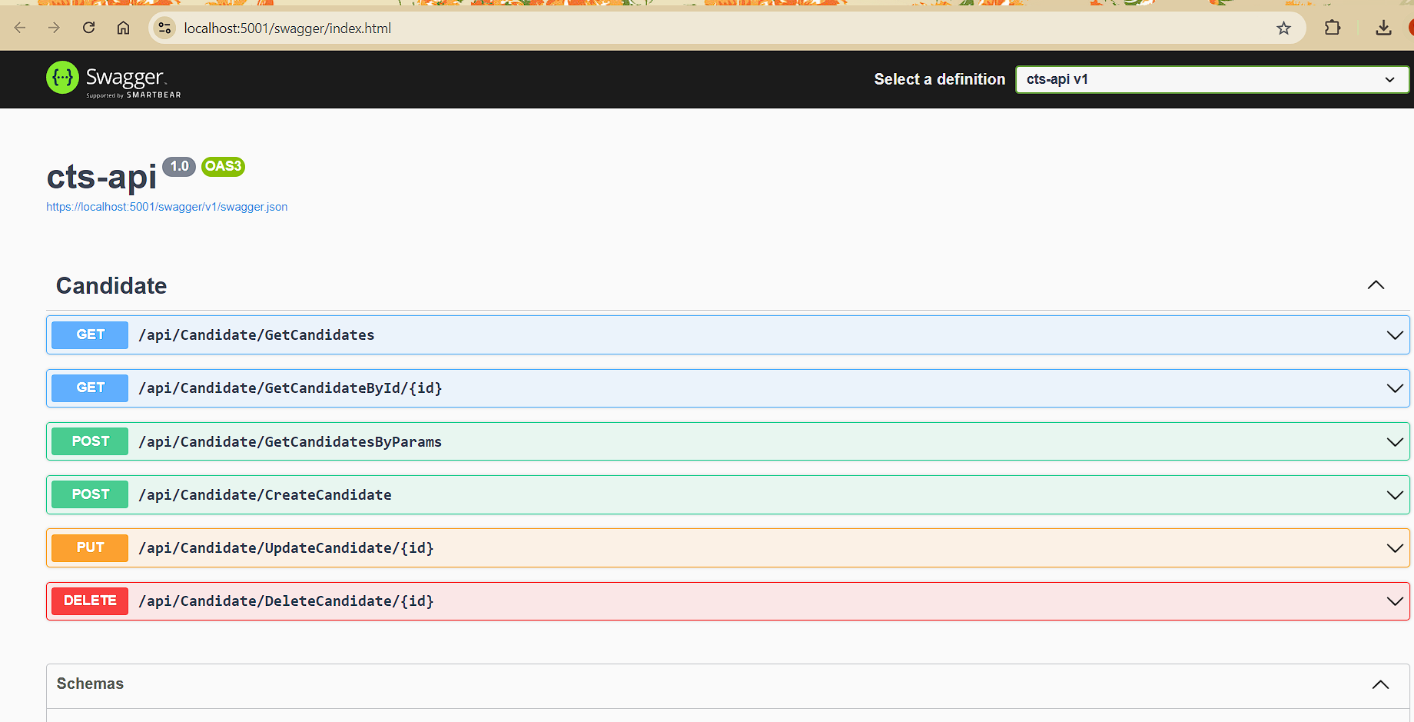

1. Then load **cts-app solution** & run **cts-app.Web** locally:



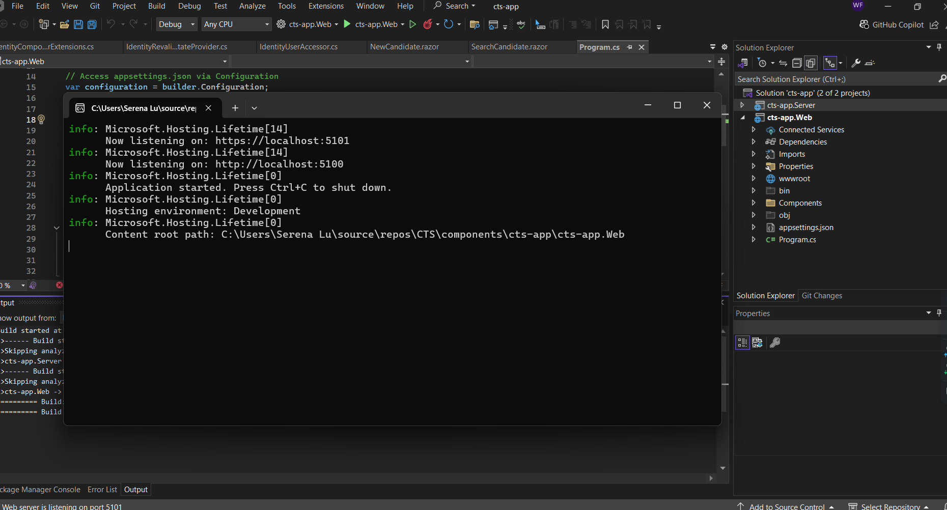

1. You should be able to see the UI as below:

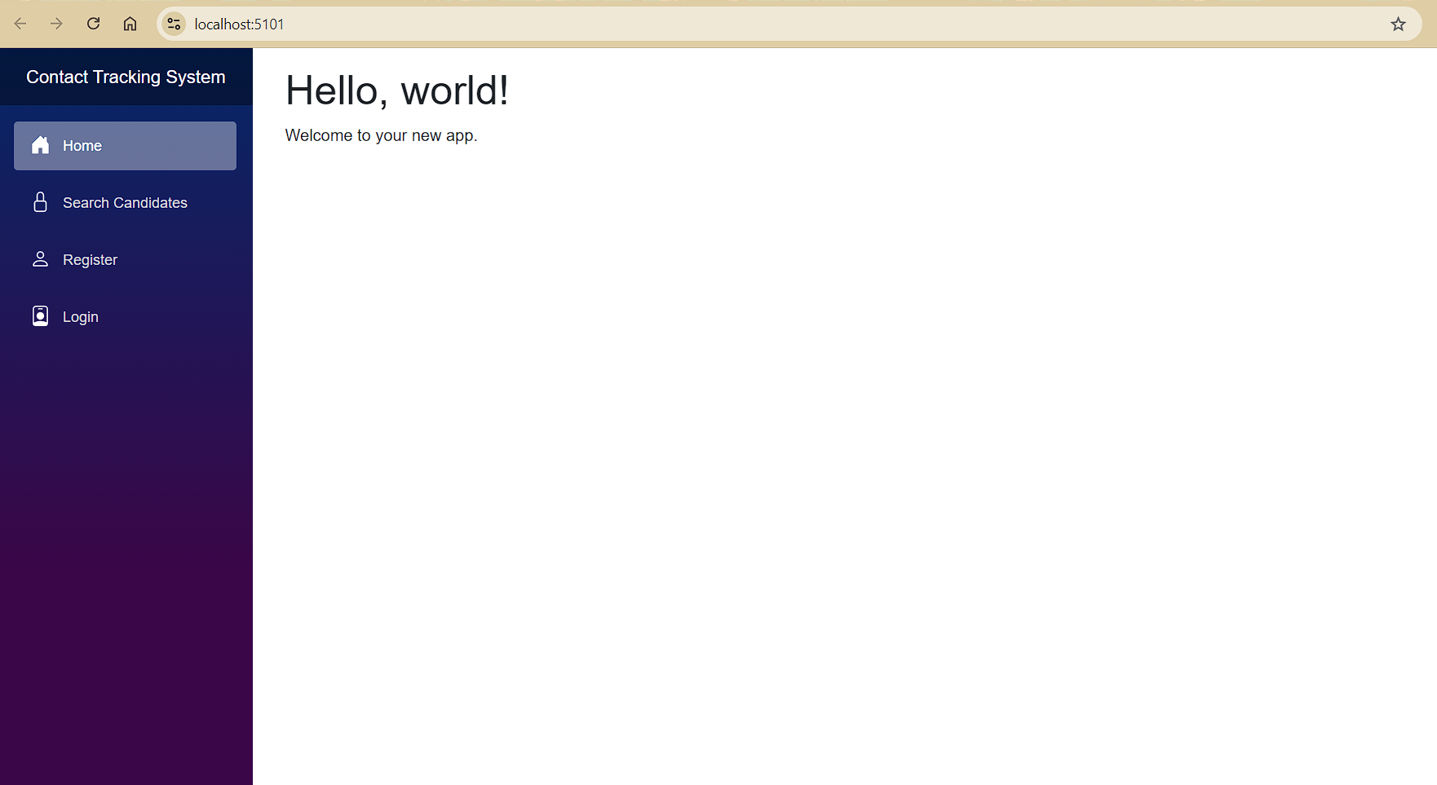

1. Here is the default search candidates page:

**Note**: Since the current version has not been implemented pagination function, so the search candidate page will display the latest **15** candidate records ONLY, I do this just don’t want to display a longer candidate list if currently there are a massive candidate records.

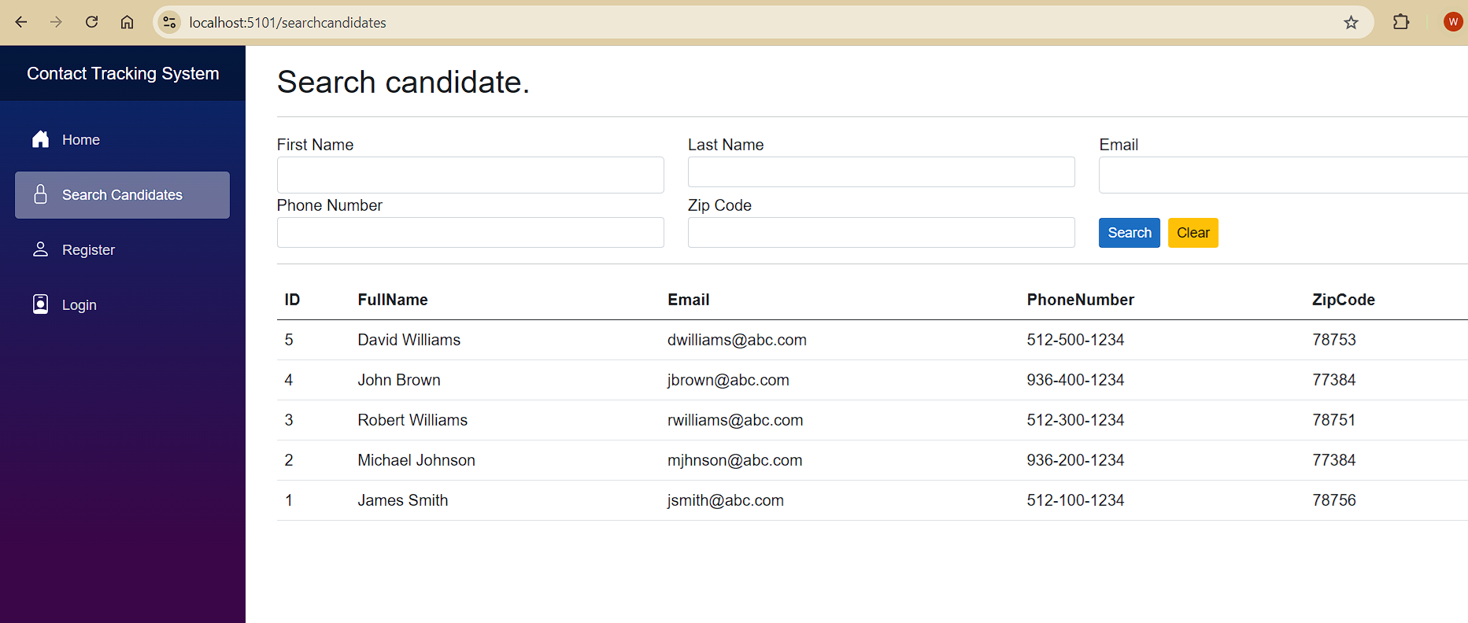

1. Here is one example of candidates search with multiple criteria simultaneously:

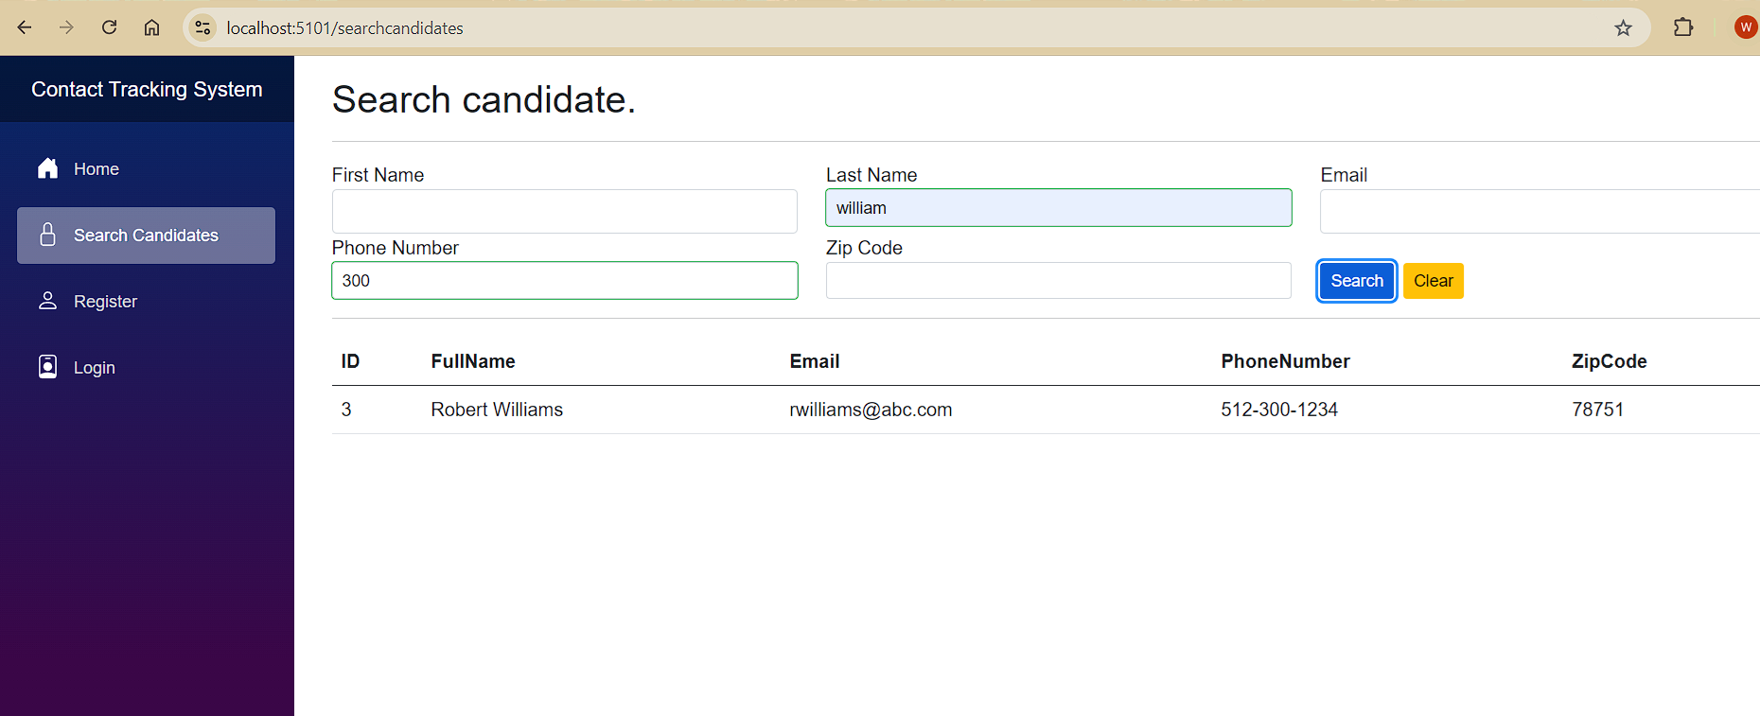

1. User account register function has been implimented with ASP.NET Identity Core as bellow:

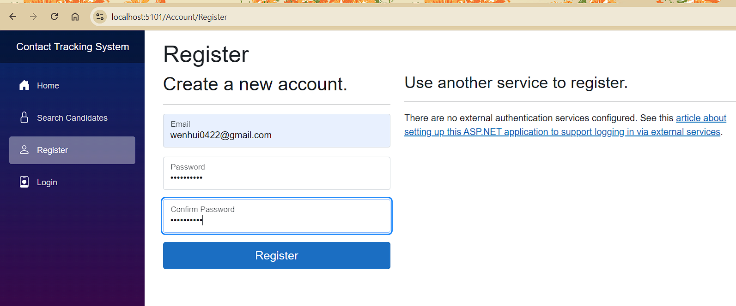

1. Basic login functionality has been implimented with ASP.NET Identity Core as bellow as well:

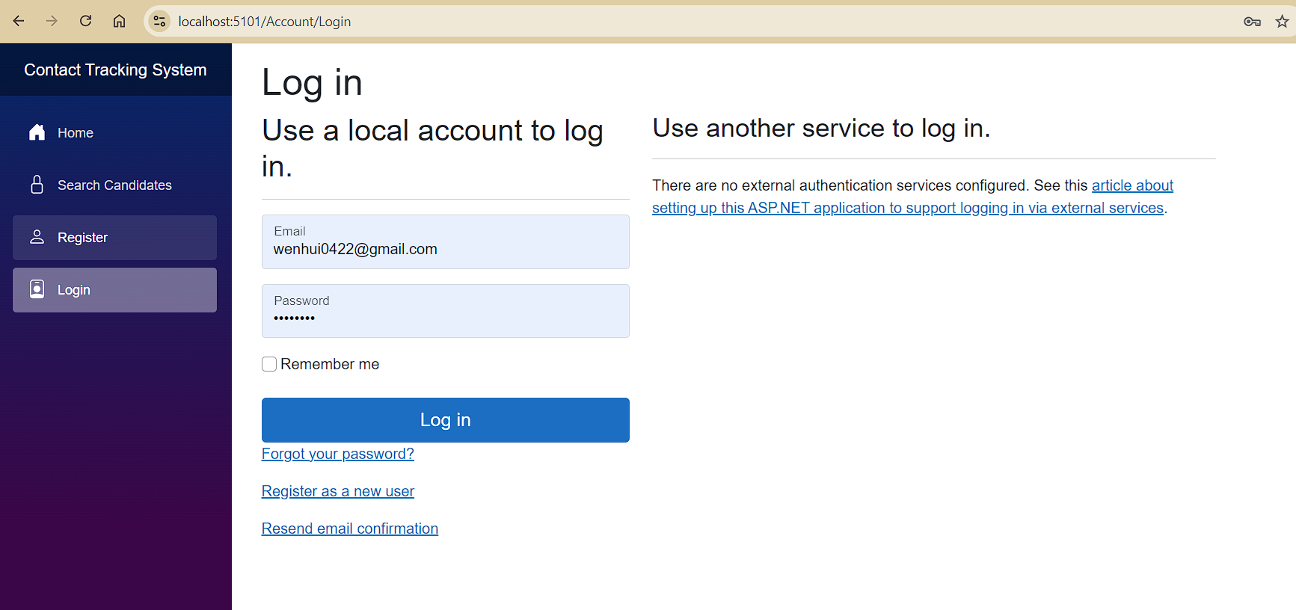

1. After user login, you will be able to see the menu is different from the pages before, as we can have a new function to add new candidate record after user login.

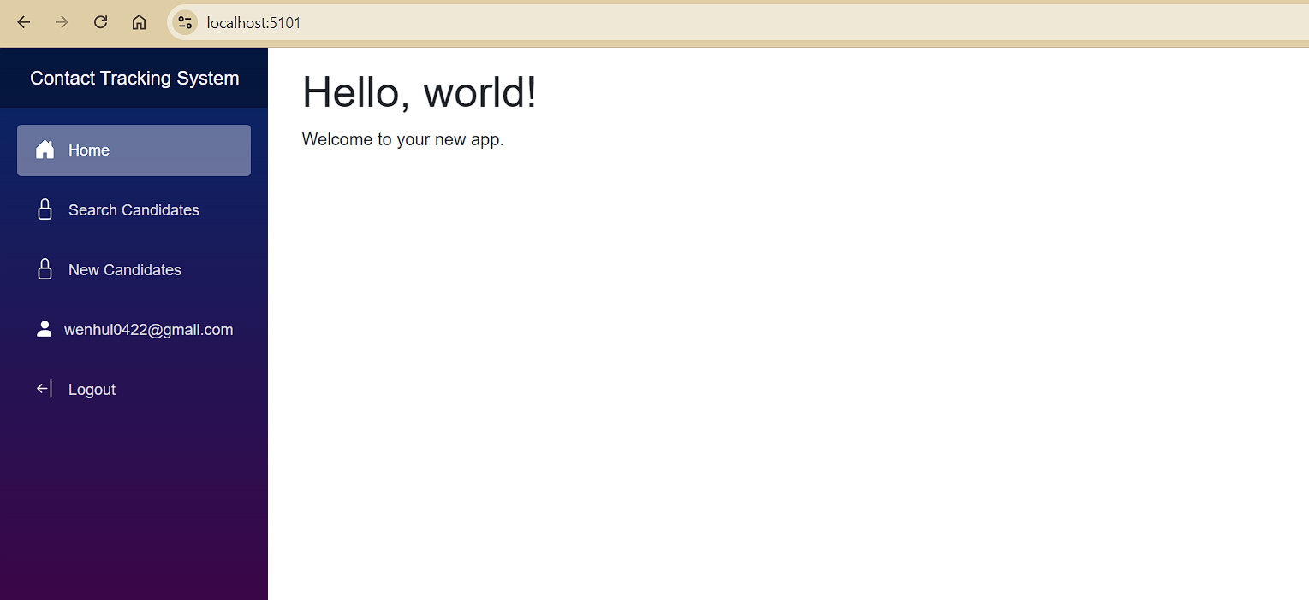

1. Adding new candidate with data validation function has been implemented

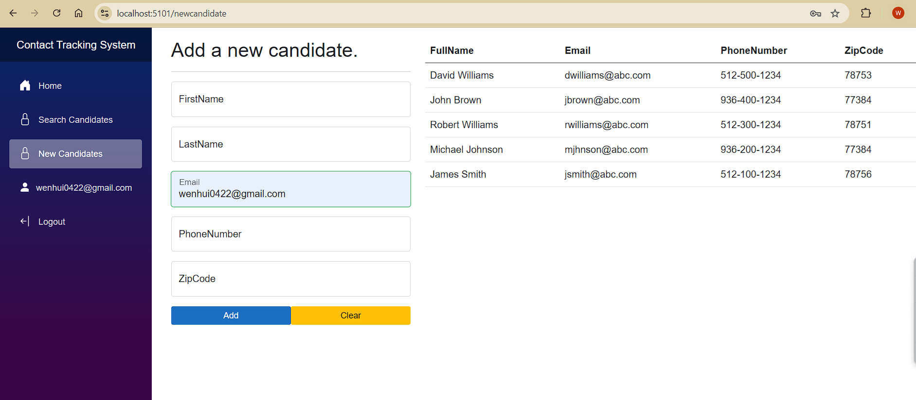

1. You can also manage your user account as below:

