


数据结构课程设计报告

课程名称__ 数据结构课程设计
题目名称 图书信息管理系统
学生学院__ 计算机学院______
专业班级 2022级软件工程3班
学 号___3222004641_
学生姓名____ 温惠兰 __
指导教师____黄剑锋__ __

2023年 12 月 23 日

需求分析
《图书信息管理系统》实现了用户可以通过图形界面输入图书的相关信息，通过合理的数据结构(如B树、链表、结构体)存储图书信息和借阅人信息，系统支持添加、删除，借书、还书、预约借书、检索、图书信息预览、操作日志和还书日期实时提醒等功能。系统会根据用户的输入输出相应的操作结果，如成功或失败的提示信息，并给出了用户输入的提示。
总结：《图书信息管理系统》除了实现了课程设计要求的基本功能外，同时实现了预约图书、借书逾期提醒和惩罚、以文件的方式保存图书信息的扩展功能，以及日志操作记录功能。
图书管理
1、输入形式：通过图形界面提示输入图书的相关信息，如书名、作者名、书号、借书证号、可借阅数量、价格、借阅天数等；
2、输入值范围：书名、作者名、价格为字符串型，书号、借书证号、可借阅数量、借阅天数为整数型，价格为浮点数型；
3、输出形式：通过图形界面或命令行输出操作结果，包括添加图书成功或失败等的提示信息；
4、程序所能达到的功能：添加图书、删除图书，借书、还书、预约借书、查询图书信息、查询作者、查询读者、全部图书信息预览、操作日志、还书日期实时提醒;
5、测试数据：
正确的输入及其输出结果，提示信息；
含有错误的输入及其输出结果，失败的提示信息。
1、存储结构定义

#include <stdio.h>
#include <malloc.h>
#include <stdlib.h>
#include <string.h>
#include <iostream>
#include <fstream>
#define MAXM 10 //定义B树的最大的阶数

int nowDate = 1; //现在是第data天
const int m = 3; //设定B树的阶数
const int Max = m - 1; //结点的最大关键字数量
const int Min = (m - 1) / 2; //结点的最小关键字数量
typedef int KeyType; //KeyType为关键字类型

typedef struct { //被借阅的书籍
int tag; //状态： 0->预约，1->借阅
int readerId; //读者id
int borrowTime; //出借时间
int backTime; //归还时间
char readerName[30]; //读者名字
char bookName[30]; //书籍名字
}LendBook, * LendBookP;

typedef struct linkNode {
int type; //类型：0->借阅记录、1->操作记录、3->作家的书
LendBook* lenBook; //借阅记录
char* log; //操作记录
char* book; //作家的书
struct linkNode* next;
}LinkNode, * LinkType;

typedef struct { //书籍
int id; //书籍id
char name[30]; //书名
double price; //价格
int authorId; //作者id
char authorName[30]; //作者
int totalNum; //书籍数量
int stockNum; //书籍库存
LinkNode* borrowList; //借阅列表
LinkNode* appointList; //预约列表
}Book;

typedef struct { //作者
int id; //作者id
char name[30]; //作者名字
LinkNode* bookList; //出版书籍
}Author;

typedef struct { //读者
int id; //读者id
char name[30]; //读者名字
LinkNode* borrowList; //借阅列表
LinkNode* appointList; //预约列表
}Reader;

typedef struct rcdNode {
int type; //结构体数据类型：
//0->书籍、1->作者、2->读者
Book* book; //书籍
Author* author; //作者
Reader* reader; //读者
}RcdNode, * RcdType;

typedef struct BTNode { //B树和B树结点类型
int keynum; //结点关键字个数
KeyType key[MAXM]; //关键字数组，key[0]不使用
BTNode* parent; //双亲结点指针
BTNode* ptr[MAXM]; //孩子结点指针数组
RcdNode* rcd[MAXM];
}BTNode, * BTree;

typedef struct { //B树查找结果类型
BTNode* pt; //指向找到的结点
int i; //在结点中的关键字位置;
int tag; //查找成功与否标志
}Result;

typedef struct LNode { //链表和链表结点类型
BTree data; //数据域
struct LNode* next; //指针域
}LNode, * LinkList;

typedef enum status { //枚举类型（依次递增）
TRUE,
FALSE,
OK,
ERROR,
OVERFLOW,
EMPTY
}Status;

2、关系图

3. 详细设计
源代码

//树

Status InitBTree(BTree& t) {
//初始化B树
if (t != NULL) {
return FALSE;
}
t = NULL;
return OK;
}

int SearchBTNode(BTNode* p, KeyType k) {
//在结点p中查找关键字k的插入位置i
int i = 0;
for (i = 0; i < p->keynum && p->key[i + 1] <= k; i++);
return i;
}

Result SearchBTree(BTree t, KeyType k) {
/*在树t上查找关键字k,返回结果(pt,i,tag)。若查找成功,则特征值
tag=1,关键字k是指针pt所指结点中第i个关键字；否则特征值tag=0,
关键字k的插入位置为pt结点的第i个*/

BTNode* p = t, * q = NULL; //初始化结点p和结点q,p指向待查结点,q指向p的双亲
int found_tag = 0; //设定查找成功与否标志
int i = 0;
Result r; //设定返回的查找结果

while (p != NULL && found_tag == 0) {
i = SearchBTNode(p, k); //在结点p中查找关键字k,使得p->key[i]<=k<p->key[i+1]
if (i > 0 && p->key[i] == k) //找到待查关键字
found_tag = 1; //查找成功
else { //查找失败
q = p;
p = p->ptr[i];
}
}

if (found_tag == 1) { //查找成功
r.pt = p;
r.i = i;
r.tag = 1;
}
else { //查找失败
r.pt = q;
r.i = i;
r.tag = 0;
}

return r; //返回关键字k的位置(或插入位置)
}

void InsertBTNode(BTNode*& p, int i, KeyType k, BTNode* q, RcdNode* rcd) {
//将关键字k和结点q分别插入到p->key[i+1]和p->ptr[i+1]中
int j;
for (j = p->keynum; j > i; j--) { //整体后移空出一个位置
p->key[j + 1] = p->key[j];
p->rcd[j + 1] = p->rcd[j];
p->ptr[j + 1] = p->ptr[j];
}
p->key[i + 1] = k;
p->rcd[i + 1] = rcd;
p->ptr[i + 1] = q;
if (q != NULL)
q->parent = p;
p->keynum++;
}

void SplitBTNode(BTNode*& p, BTNode*& q) {
//将结点p分裂成两个结点,前一半保留,后一半移入结点q
int i;
int s = (m + 1) / 2;
q = (BTNode*)malloc(sizeof(BTNode)); //给结点q分配空间

q->ptr[0] = p->ptr[s]; //后一半移入结点q
for (i = s + 1; i <= m; i++) {
q->key[i - s] = p->key[i];
q->rcd[i - s] = p->rcd[i];
q->ptr[i - s] = p->ptr[i];
}
q->keynum = p->keynum - s;
q->parent = p->parent;
for (i = 0; i <= p->keynum - s; i++) //修改双亲指针
if (q->ptr[i] != NULL)
q->ptr[i]->parent = q;
p->keynum = s - 1; //结点p的前一半保留,修改结点p的keynum
}

void NewRoot(BTNode*& t, KeyType k, BTNode* p, BTNode* q, RcdNode* rcd) {
//生成新的根结点t,原p和q为子树指针
t = (BTNode*)malloc(sizeof(BTNode)); //分配空间
t->keynum = 1;
t->ptr[0] = p;
t->ptr[1] = q;
t->key[1] = k;
t->rcd[1] = rcd;
if (p != NULL) //调整结点p和结点q的双亲指针
p->parent = t;
if (q != NULL)
q->parent = t;
t->parent = NULL;
}

void InsertBTree(BTree& t, int i, KeyType k, BTNode* p, RcdNode* rcd) {
/*在树t上结点p的key[i]与key[i+1]之间插入关键字k。若引起
结点过大,则沿双亲链进行必要的结点分裂调整,使t仍是B树*/
BTNode* q;
int finish_tag, newroot_tag, s; //设定需要新结点标志和插入完成标志
KeyType x;
RcdNode* xRcd;
if (p == NULL) //t是空树
NewRoot(t, k, NULL, NULL, rcd); //生成仅含关键字k的根结点t
else {
x = k;
xRcd = rcd;
q = NULL;
finish_tag = 0;
newroot_tag = 0;
while (finish_tag == 0 && newroot_tag == 0) {
InsertBTNode(p, i, x, q, xRcd); //将关键字x和结点q分别插入到p->key[i+1]和p->ptr[i+1]
if (p->keynum <= Max)
finish_tag = 1; //插入完成
else {
s = (m + 1) / 2;
SplitBTNode(p, q); //分裂结点
x = p->key[s];
xRcd = p->rcd[s];
if (p->parent) { //查找x的插入位置
p = p->parent;
i = SearchBTNode(p, x);
}
else //没找到x，需要新结点
newroot_tag = 1;
}
}
if (newroot_tag == 1) //根结点已分裂为结点p和q
NewRoot(t, x, p, q, xRcd); //生成新根结点t,p和q为子树指针
}
}

void Remove(BTNode* p, int i) {
//从p结点删除key[i]和它的孩子指针ptr[i]
int j;
for (j = i + 1; j <= p->keynum; j++) { //前移删除key[i]和ptr[i]
p->key[j - 1] = p->key[j];
p->rcd[j - 1] = p->rcd[j];
p->ptr[j - 1] = p->ptr[j];
}
p->keynum--;
}

void Substitution(BTNode* p, int i) {
//查找被删关键字p->key[i](在非叶子结点中)的替代叶子结点(右子树中值最小的关键字)
BTNode* q;
for (q = p->ptr[i]; q->ptr[0] != NULL; q = q->ptr[0]);
p->key[i] = q->key[1]; //复制关键字值
p->rcd[i] = q->rcd[1];
}

void MoveRight(BTNode* p, int i) {
/*将双亲结点p中的最后一个关键字移入右结点q中
将左结点aq中的最后一个关键字移入双亲结点p中*/
int j;
BTNode* q = p->ptr[i];
BTNode* aq = p->ptr[i - 1];

for (j = q->keynum; j > 0; j--) { //将右兄弟q中所有关键字向后移动一位
q->key[j + 1] = q->key[j];
q->rcd[j + 1] = q->rcd[j];
q->ptr[j + 1] = q->ptr[j];
}

q->ptr[1] = q->ptr[0]; //从双亲结点p移动关键字到右兄弟q中
q->key[1] = p->key[i];
q->rcd[1] = p->rcd[i];
q->keynum++;

p->key[i] = aq->key[aq->keynum]; //将左兄弟aq中最后一个关键字移动到双亲结点p中
p->rcd[i] = aq->rcd[aq->keynum];
p->ptr[i]->ptr[0] = aq->ptr[aq->keynum];
aq->keynum--;
}

void MoveLeft(BTNode* p, int i) {
/*将双亲结点p中的第一个关键字移入左结点aq中，
将右结点q中的第一个关键字移入双亲结点p中*/
int j;
BTNode* aq = p->ptr[i - 1];
BTNode* q = p->ptr[i];

aq->keynum++; //把双亲结点p中的关键字移动到左兄弟aq中
aq->key[aq->keynum] = p->key[i];
aq->rcd[aq->keynum] = p->rcd[i];
aq->ptr[aq->keynum] = p->ptr[i]->ptr[0];

p->key[i] = q->key[1]; //把右兄弟q中的关键字移动到双亲节点p中
p->rcd[i] = q->rcd[1];
q->ptr[0] = q->ptr[1];
q->keynum--;

for (j = 1; j <= q->keynum; j++) { //将右兄弟q中所有关键字向前移动一位
q->key[j] = q->key[j + 1];
q->rcd[j] = q->rcd[j + 1];
q->ptr[j] = q->ptr[j + 1];
}
}

void Combine(BTNode* p, int i) {
/*将双亲结点p、右结点q合并入左结点aq，
并调整双亲结点p中的剩余关键字的位置*/
int j;
BTNode* q = p->ptr[i];
BTNode* aq = p->ptr[i - 1];

aq->keynum++; //将双亲结点的关键字p->key[i]插入到左结点aq
aq->key[aq->keynum] = p->key[i];
aq->rcd[aq->keynum] = p->rcd[i];
aq->ptr[aq->keynum] = q->ptr[0];

for (j = 1; j <= q->keynum; j++) { //将右结点q中的所有关键字插入到左结点aq
aq->keynum++;
aq->key[aq->keynum] = q->key[j];
aq->rcd[aq->keynum] = q->rcd[j];
aq->ptr[aq->keynum] = q->ptr[j];
}

for (j = i; j < p->keynum; j++) {/将双亲结点p中的p->key[i]后的所有关键字向前移动一位
p->key[j] = p->key[j + 1];
p->rcd[j] = p->rcd[j + 1];
p->ptr[j] = p->ptr[j + 1];
}
p->keynum--; //修改双亲结点p的keynum值
free(q); //释放空右结点q的空间
}

void AdjustBTree(BTNode* p, int i) {
//删除结点p中的第i个关键字后,调整B树
if (i == 0) //删除的是最左边关键字
if (p->ptr[1]->keynum > Min) //右结点可以借
MoveLeft(p, 1);
else //右兄弟不够借
Combine(p, 1);
else if (i == p->keynum) //删除的是最右边关键字
if (p->ptr[i - 1]->keynum > Min) //左结点可以借
MoveRight(p, i);
else //左结点不够借
Combine(p, i);
else if (p->ptr[i - 1]->keynum > Min) //删除关键字在中部且左结点够借
MoveRight(p, i);
else if (p->ptr[i + 1]->keynum > Min) //删除关键字在中部且右结点够借
MoveLeft(p, i + 1);
else //删除关键字在中部且左右结点都不够借
Combine(p, i);
}

int FindBTNode(BTNode* p, KeyType k, int& i) {
//反映是否在结点p中是否查找到关键字k
if (k < p->key[1]) { //结点p中查找关键字k失败
i = 0;
return 0;
}
else { //在p结点中查找
i = p->keynum;
while (k < p->key[i] && i>1)
i--;
if (k == p->key[i]) //结点p中查找关键字k成功
return 1;
}
return 0;
}

int BTNodeDelete(BTNode* p, KeyType k) {
//在结点p中查找并删除关键字k
int i;
int found_tag; //查找标志
if (p == NULL)
return 0;
else {
found_tag = FindBTNode(p, k, i); //返回查找结果
if (found_tag == 1) { //查找成功
if (p->ptr[i - 1] != NULL) { //删除的是非叶子结点
Substitution(p, i); //寻找相邻关键字(右子树中最小的关键字)
BTNodeDelete(p->ptr[i], p->key[i]); //执行删除操作
}
else
Remove(p, i); //从结点p中位置i处删除关键字
}
else
found_tag = BTNodeDelete(p->ptr[i], k); //沿孩子结点递归查找并删除关键字k
if (p->ptr[i] != NULL)
if (p->ptr[i]->keynum < Min) //删除后关键字个数小于MIN
AdjustBTree(p, i); //调整B树
return found_tag;
}
}

void BTreeDelete(BTree& t, KeyType k) {
//构建删除框架，执行删除操作
BTNode* p;
int a = BTNodeDelete(t, k); //删除关键字k
if (a == 0) {} //查找失败
else if (t->keynum == 0) { //调整
p = t;
t = t->ptr[0];
free(p);
}
}

void DestroyBTree(BTree& t) {
//递归释放B树
int i;
BTNode* p = t;
if (p != NULL) { //B树不为空
for (i = 0; i <= p->keynum; i++) { //递归释放每一个结点
DestroyBTree(*&p->ptr[i]);
}
free(p);
}
t = NULL;
}

Status InitQueue(LinkList& L) {
//初始化队列
L = (LNode*)malloc(sizeof(LNode)); //分配结点空间
if (L == NULL) //分配失败
return OVERFLOW;
L->next = NULL;
return OK;
}

LNode* CreateNode(BTNode* p) {
//新建一个结点
LNode* q;
q = (LNode*)malloc(sizeof(LNode)); //分配结点空间
if (q != NULL) { //分配成功
q->data = p;
q->next = NULL;
}
return q;
}

Status Enqueue(LNode* p, BTNode* q) {
//元素q入队列
if (p == NULL)
return ERROR;
while (p->next != NULL) //调至队列最后
p = p->next;
p->next = CreateNode(q); //生成结点让q进入队列
return OK;
}

Status Dequeue(LNode* p, BTNode*& q) {
//出队列，并以q返回值
LNode* aq;
if (p == NULL || p->next == NULL) //删除位置不合理
return ERROR;
aq = p->next; //修改被删结点aq的指针域
p->next = aq->next;
q = aq->data;
free(aq); //释放结点aq
return OK;
}

Status IfEmpty(LinkList L) {
//队列判空
if (L == NULL) //队列不存在
return ERROR;
if (L->next == NULL) //队列为空
return TRUE;
return FALSE; //队列非空
}

void DestroyQueue(LinkList L) {
//销毁队列
LinkList p;
if (L != NULL) {
p = L;
L = L->next;
free(p); //逐一释放
DestroyQueue(L);
}
}

Status Traverse(BTree t, LinkList L, int newline, int sum) {
//用队列遍历输出B树
int i;
BTree p;
if (t != NULL) {
printf("[ ");
Enqueue(L, t->ptr[0]); //入队
for (i = 1; i <= t->keynum; i++) {
printf(" %d：", t->key[i]);
if (t->rcd[i]->type == 0) {
printf("《%s》", t->rcd[i]->book->name);
}
else if (t->rcd[i]->type == 1) {
printf("%s", t->rcd[i]->author->name);
}
else if (t->rcd[i]->type == 2) {
printf("%s", t->rcd[i]->reader->name);
}
Enqueue(L, t->ptr[i]); //子结点入队
}
sum += t->keynum + 1;
printf(" ]");
if (newline == 0) { //需要另起一行
printf("\n");
newline = sum - 1;
sum = 0;
}
else newline--;
}

if (IfEmpty(L) == FALSE) { //l不为空
Dequeue(L, p); //出队，以p返回
Traverse(p, L, newline, sum); //遍历出队结点
}
return OK;
}

Status PrintBTree(BTree t) {
//输出B树
LinkList L;
if (t == NULL) {
printf(" B树为空树");
return OK;
}
InitQueue(L); //初始化队列
Traverse(t, L, 0, 0); //利用队列输出
DestroyQueue(L); //销毁队列
return OK;
}

// 初始化链表
void initLend(LinkType& list) {
list = (LinkNode*)malloc(sizeof(LinkNode));
list->next = NULL;
}
// 添加节点,返回节点指针
LinkType addLinkNode(LinkType& list, int type) {
LinkNode* p;
p = list;
while (p->next != NULL) {
p = p->next;
}
p->next = (LinkNode*)malloc(sizeof(LinkNode));
p->next->next = NULL;
p->type = type;
return p->next;
}

// 输入数字
int inputInt() {
int a, result;
fflush(stdin);
a = scanf("%d", &result);
if (a == 0)
{
printf("\n【输入数字】输入错误，请重新输入: ");
result = inputInt();
}
return result;
}

// 添加作者
RcdNode* addAuthor(BTree& t, int id, const char* name) {
Result s2 = SearchBTree(t, id);
RcdNode* rcd = (RcdNode*)malloc(sizeof(RcdNode));
if (rcd == NULL) {return NULL;}
rcd->author = (Author*)malloc(sizeof(Author));
if (rcd->author == NULL) {return NULL;}
rcd->type = 1;
rcd->author->id = id;
strcpy(rcd->author->name, name);
initLend(rcd->author->bookList);
InsertBTree(t, s2.i, id, s2.pt, rcd);
return rcd;
}
// 给作者添加书籍
void addAuthorBook(Author*& author, const char* bookName) {
//LinkType addLinkNode(LinkType & list, int type);
LinkNode* p = addLinkNode(author->bookList, 3);
p->book = (char*)malloc(sizeof(char) * 20);
if (p->book == NULL) {
return;
}
strcpy(p->book, bookName);
}
// 给作者删除书籍
int deleteAuthorBook(Author*& author, char* bookName) {
LinkNode* p, * pre;
p = author->bookList;
while (p->next != NULL && strcmp(p->next->book, bookName) != 0) {
p = p->next;
}
if (p->next == NULL) {
return 0; // 找不到借书记录
}
pre = p;
p = p->next;
pre->next = p->next;
free(p);
return 1;
}
void writeBookInfoToFile(const std::string& filename,const char* name,int id,double price) {
std::ofstream file(filename, std::ios::app);
if (file.is_open()) {
file << id << " " << name << " " << price << std::endl;
file.close();
} else {
std::cout << "无法打开文件" << std::endl;
}
}

void readBookInfoFromFile(const std::string& filename) {
std::ifstream file(filename);
if (file.is_open()) {
std::string name;
double price;
int id;
while (file >> id >> name >> price) {
std::cout << "书号：" << id << ", 书名：" << name << ", 价格：" << price << std::endl;
}
file.close();
}else{
std::cout << "无法打开文件" << std::endl;
}
}
// 添加书籍
int addBookFun(BTree& t, int id, const char* name, BTree& author, int authorId,double price) {
Result s = SearchBTree(t, id);
if (s.tag == 1) {
Book* book = s.pt->rcd[s.i]->book;
book->totalNum++;
book->stockNum++;}
else {
RcdNode* rcd = (RcdNode*)malloc(sizeof(RcdNode));
if (rcd == NULL) {return 0;}
rcd->book = (Book*)malloc(sizeof(Book));
if (rcd->book == NULL) {return 0;}
rcd->type = 0;
rcd->book->id = id;
strcpy(rcd->book->name, name);
writeBookInfoToFile("books.txt",name,id,price);//写入书籍信息到文件
Result s2 = SearchBTree(author, authorId);
if (s2.tag == 0) {
RcdNode* rcd2 = addAuthor(author, authorId, "不知名作家");
addAuthorBook(rcd2->author, name);
strcpy(rcd->book->authorName, "不知名作家");}
else {
char* authorName = s2.pt->rcd[s2.i]->author->name;
Author* p2 = s2.pt->rcd[s2.i]->author;
addAuthorBook(p2, name);
strcpy(rcd->book->authorName, authorName);
}
rcd->book->totalNum = 1;
rcd->book->stockNum = 1;
rcd->book->authorId = authorId;
initLend(rcd->book->borrowList);
initLend(rcd->book->appointList);
InsertBTree(t, s.i, id, s.pt, rcd);
}
return 1;
}
// 添加读者
void addReader(BTree& t, int id, const char* name) {
//Result SearchBTree(BTree t, KeyType k);
//void initLend(LinkType & list);
//void InsertBTree(BTree & t, int i, KeyType k, BTNode * p, RcdNode * rcd);
Result s = SearchBTree(t, id);
if (s.tag == 1) {
Reader* reader = s.pt->rcd[s.i]->reader;
}
else {
RcdNode* rcd = (RcdNode*)malloc(sizeof(RcdNode));
if (rcd == NULL) {return;}
rcd->reader = (Reader*)malloc(sizeof(Reader));
if (rcd->reader == NULL) {return;}
rcd->type = 2;
rcd->reader->id = id;
strcpy(rcd->reader->name,name);
initLend(rcd->reader->borrowList);
initLend(rcd->reader->appointList);
InsertBTree(t, s.i, id, s.pt, rcd);
}
}
void init(BTree& book, BTree& author, BTree& reader, LinkNode*& Log) {
//void initLend(LinkType & list);
//初始化作者
addAuthor(author, 1, "曹雪芹");
addAuthor(author, 2, "天下霸唱");
addAuthor(author, 3, "南派三叔");
addAuthor(author, 4, "老子");
addAuthor(author, 5, "路遥");
addAuthor(author, 6, "刘同");
addAuthor(author, 7, "江南");
//初始化书籍
addBookFun(book, 1, "红楼梦", author, 1,36.5);
addBookFun(book, 1, "红楼梦", author, 1,36.5);
addBookFun(book, 1, "红楼梦", author, 1,36.5);
addBookFun(book, 1, "红楼梦", author, 1,36.5);
addBookFun(book, 1, "红楼梦", author, 1,36.5);
addBookFun(book, 2, "鬼吹灯", author, 2,30.8);
addBookFun(book, 3, "盗墓笔记", author, 3,40.5);
addBookFun(book, 4, "道德经", author, 4,42.6);
addBookFun(book, 5, "平凡的世界", author, 5,55.5);
addBookFun(book, 6, "你的孤独，虽败犹荣", author, 6,60.7);
addBookFun(book, 7, "龙族IV", author, 7,120.5);
//初始化读者
addReader(reader, 1001, "小A");
addReader(reader, 1002, "小B");
addReader(reader, 1003, "小C");
//初始化日志
initLend(Log);
}

// 操作日志
void addLog(LinkType& list, char* str) {
// LinkType addLinkNode(LinkType & list, int type);
LinkNode* p = addLinkNode(list, 1);
p->log = (char*)malloc(sizeof(char) * 50);
if (p->log == NULL) {
return;
}
strcpy(p->log, str);
}

void log(LinkNode*& Log) {
int i = 1;
LinkNode* p;
p = Log->next;
if (p == NULL) {
printf("\n【操作日志】暂无\n");
return;
}
printf("\n【操作日志】:\n ");
while (p != NULL) {
printf("\n %d、", i);
printf(" %s\n", p->log);
i++;
p = p->next;
}
printf("\n");
}

// 图书入库
void addBook(BTree& t, BTree& author, LinkNode*& Log) {
//Result SearchBTree(BTree t, KeyType k);
int id, authorId;
double price;
char name[30], authorName[30], str[50];
printf("\n【图书入库】请输入[书号]：");
id = inputInt();
Result s = SearchBTree(t, id);
if (s.tag == 1) {
Book* book = s.pt->rcd[s.i]->book;
printf("\n【图书入库】书籍《%s》——%s(书号: %d) 已经存在，是否增加库存数量（确定则输入1，否则输入其他）： ", book->name, book->authorName, book->id);
if (inputInt() == 1) {
book->totalNum++;
book->stockNum++;
printf("\n【图书入库】添加成功，书籍《%s》数量为 %d\n", book->name, book->totalNum);
sprintf(str, "第[%d]天，图书《%s》库存数量+1", nowDate, book->name);
}
else {
printf("\n【图书入库】取消成功\n");
sprintf(str, "第[%d]天，取消图书《%s》库存数量增加", nowDate, book->name);
}
}
else {
printf("\n【图书入库】请输入[书名]：");
fflush(stdin);
fgets(name, sizeof(name), stdin);
printf("\n【图书入库】请输入[价格]：");
price = inputInt();
printf("\n【图书入库】请输入[作者序号]：");
authorId = inputInt();
Result s2 = SearchBTree(author, authorId);
if (s2.tag == 0) {
printf("\n【图书入库】请输入[作者名字]：");
fflush(stdin);
scanf("%s", authorName);
addAuthor(author, authorId, authorName);
}
if (1 == addBookFun(t, id, name, author, authorId,price)) {
printf("\n【图书入库】添加书籍《%s》成功\n", name);
sprintf(str, "第[%d]天，添加书籍《%s》成功", nowDate, name);
}
else {
printf("\n【图书入库】内存空间分配失败\n");
}
}
addLog(Log, str);
}
//从文件里面删除对应书号的图书信息
void deleteBookFromFile(const std::string& filename, int idToDelete) {
std::ifstream inFile(filename);
if (!inFile.is_open()) {
std::cout << "无法打开文件" << std::endl;
return;
}
std::ofstream outFile("temp.txt"); // 创建一个临时文件
if (!outFile.is_open()) {
std::cout << "无法创建临时文件" << std::endl;
inFile.close();
return;
}
int id;
std::string name;
double price;
while (inFile >> id >> name >> price) {
if (id != idToDelete) {
outFile << id << " " << name << " " << price << std::endl;
}
}
inFile.close();
outFile.close();
if(std::remove(filename.c_str()) != 0) {
std::cout << "无法删除原文件" << std::endl;
return;
}
if(std::rename("temp.txt", filename.c_str()) != 0) {
std::cout << "无法重命名临时文件" << std::endl;
return; }
}
void clearFile(const std::string& filename) {
std::ofstream file(filename, std::ios::trunc);
if (file.is_open()) {
file.close();
std::cout << "文件已成功清空" << std::endl;
} else {
std::cout << "无法打开文件" << std::endl;
}
}
// 删除图书
void deleteBook(BTree& t, BTree& author, LinkNode*& Log) {
//Result SearchBTree(BTree t, KeyType k);
//void BTreeDelete(BTree & t, KeyType k);
int id;
printf("\n【删除图书】请输入[书号]：");
id = inputInt();
Result s = SearchBTree(t, id);
if (s.tag == 0) {
printf("\n【删除图书】此书不存在\n");
char str[50];
sprintf(str, "第[%d]天，删除图书[%d]失败，此书不存在", nowDate, id);
addLog(Log, str);
}
else {
Book* book = s.pt->rcd[s.i]->book;
printf("\n【删除图书】是否确定删除书籍《%s》——%s(书号: %d)（确定则输入1，否则输入其他）： ", book->name, book->authorName, book->id);
if (inputInt() == 1) {
if (book->borrowList != NULL) {
free(book->borrowList);
}
if (book->appointList != NULL) {
free(book->appointList);
}
Result s2 = SearchBTree(author, book->authorId);
if (0 == deleteAuthorBook(s2.pt->rcd[s2.i]->author, book->name)) {
printf("\n\n找不到该书记录\n\n");
}
char str[50];
deleteBookFromFile("books.txt",book->id);
sprintf(str, "第[%d]天，删除图书《%s》成功", nowDate, book->name);
addLog(Log, str);
free(book);
free(s.pt->rcd[s.i]);
BTreeDelete(t, id);
printf("\n【删除图书】删除成功\n");
}
else {
printf("\n【删除图书】取消成功\n");
char str[50];
sprintf(str, "第[%d]天，取消删除图书《%s》", nowDate, book->name);
addLog(Log, str);}
}
}

// 添加借阅记录节点
void addLendBook(LinkType& list, int readerId, char* readerName, char* bookName, int tag, int borrowTime, int backTime) {
//LinkType addLinkNode(LinkType & list, int type);
LinkNode* p = addLinkNode(list, 0);
if (p == NULL) {return;}
p->lenBook = (LendBook*)malloc(sizeof(LendBook));
if (p->lenBook == NULL) {return;}
p->lenBook->tag = tag;
p->lenBook->readerId = readerId;
p->lenBook->borrowTime = borrowTime;
p->lenBook->backTime = backTime;
strcpy(p->lenBook->readerName,readerName);
strcpy(p->lenBook->bookName, bookName);
}
// 匹配书籍
Result searchBook(BTree t, const char* str) {
int id;
id = inputInt();
Result s = SearchBTree(t, id);
if (s.tag == 0) {
printf("\n【%s】此书不存在, 请重新输入：", str);
s = searchBook(t, str);
}
return s;
}
// 匹配读者
Result searchReader(BTree t, const char* str) {
int id;
id = inputInt();
Result s = SearchBTree(t, id);
if (s.tag == 0) {
printf("\n【%s】该借书证号不存在, 请重新输入：", str);
s = searchReader(t, str);
}
return s;
}
// 搜索借阅记录
LinkType findLinkNode(LinkType& list, char* name, int type) {
LinkNode* p;
p = list;
// type: 搜索类型：
// 0->在书的阅读记录搜索读者
// 1->在书的阅读记录搜索书籍
if (type == 0) {
while (p->next != NULL && strcmp(p->next->lenBook->readerName, name) != 0) {
p = p->next;
}
}
else {
while (p->next != NULL && strcmp(p->next->lenBook->bookName, name) != 0) {
p = p->next;
}
}
if (p->next == NULL) {
return NULL; // 找不到，返回空
}
else {
return p; // 找到，返回上一个节点指针
}
}
// 删除借阅记录节点
int deleteLendBook(LinkType& list, char* name, int type) {
LinkNode* p, * pre;
p = findLinkNode(list, name, type);
if (p == NULL) {
return 0;
}
free(p->next->lenBook);
pre = p;
p = p->next;
pre->next = p->next;
free(p);
return 1;
}
// 还书之后成功预约
int appointSuccess(Book*& book, BTree& t) {
// Result SearchBTree(BTree t, KeyType k);
LinkNode* appoint = book->appointList;
if (appoint->next == NULL) {
return 0;
}
LinkNode* p = appoint->next;
LendBook* lend = p->lenBook;
int readerId = lend->readerId;
Result s = SearchBTree(t, readerId);
Reader* reader = s.pt->rcd[s.i]->reader;
printf("\n【预约借书】[%s]读者有《%s》的预约记录，现为他成功预约\n", lend->readerName, lend->bookName);
addLendBook(book->borrowList, readerId, lend->readerName, lend->bookName, 1, nowDate, nowDate + lend->backTime);
deleteLendBook(reader->appointList, book->name, 1);
addLendBook(reader->borrowList, readerId, lend->readerName, lend->bookName, 1, nowDate, nowDate + lend->backTime);
free(p->lenBook);
appoint->next = p->next;
free(p);
return 1;
}
// 天数输入
int dataNumInput() {
int res = inputInt();
if (res <= 0) {
printf("\n【借书】借书天数必须大于0天，请重新输入：");
res = dataNumInput();
}
return res;
}
// 预约
void appointBook(BTree& t, BTree& reader, LinkNode*& Log) {
printf("\n【预约借书】请输入[书号]：");
Result s = searchBook(t, "预约借书");
Book* book = s.pt->rcd[s.i]->book;
if (book->stockNum > 0) {
printf("\n【预约借书】无需预约，该书仍有库存，您可直接借书\n");
char str[50];
sprintf(str, "第[%d]天，预约借书《%s》失败, 该书仍有库存", nowDate, book->name);
addLog(Log, str);
}
else {
printf("\n【预约借书】请输入[借书证号](提示：111 / 222 / 333)：");
Result s2 = searchReader(reader, "预约借书");
Reader* p = s2.pt->rcd[s2.i]->reader;
if (findLinkNode(p->appointList, book->name, 1) != NULL) {
printf("\n【预约借书】抱歉[%s]，不能重复预约借书《%s》\n", p->name, book->name);
char str[50];
sprintf(str, "第[%d]天，[%s]预约借书《%s》失败，重复预约借书", nowDate, p->name, book->name);
addLog(Log, str);
return;
}
printf("\n【预约借书】你好，[%s]，请问你要预约借书《%s》(书号: %d)多少天： ", p->name, book->name, book->id);
int dataNum = dataNumInput();
addLendBook(book->appointList, p->id, p->name, book->name, 0, 0, dataNum);
addLendBook(p->appointList, p->id, p->name, book->name, 0, 0, dataNum);
printf("\n【预约借书】预约成功\n");
char str[50];
sprintf(str, "第[%d]天，[%s]预约借书《%s》成功", nowDate, p->name, book->name);
addLog(Log, str);
}
}
// 借书
void borrowBook(BTree& t, BTree& reader, LinkNode*& Log) {

printf("\n【借书】请输入[书号]：");
Result s = searchBook(t, "借书");
Book* book = s.pt->rcd[s.i]->book;
if (book->stockNum <= 0) {
printf("\n【借书】抱歉该书已经没有库存，若要借书烦请预约\n");
char str[50];
sprintf(str, "第[%d]天，借书《%s》失败, 没有库存", nowDate, book->name);
addLog(Log, str);
}
else {
printf("\n【借书】请输入[借书证号](提示：111 / 222 / 333)：");
Result s2 = searchReader(reader, "借书");
Reader* p = s2.pt->rcd[s2.i]->reader;
if (findLinkNode(p->borrowList, book->name, 1) != NULL) {
printf("\n【借书】抱歉[%s]，不能重复借书《%s》\n", p->name, book->name);
char str[50];
sprintf(str, "第[%d]天，[%s]借书《%s》失败，重复借书", nowDate, p->name, book->name);
addLog(Log, str);
return;
}
printf("\n【借书】你好，[%s]，请问你要借书《%s》(书号: %d)多少天： ", p->name, book->name, book->id);
int dataNum = dataNumInput();
addLendBook(book->borrowList, p->id, p->name, book->name, 1, nowDate, nowDate + dataNum);
addLendBook(p->borrowList, p->id, p->name, book->name, 1, nowDate, nowDate + dataNum);
book->stockNum--;
printf("\n【借书】借书成功\n");
char str[50];
sprintf(str, "第[%d]天，[%s]借书《%s》成功", nowDate, p->name, book->name);
addLog(Log, str);
}
}
// 还书
void backBook(BTree& t, BTree& reader, LinkNode*& Log) {
printf("\n【还书】请输入[书号]：");
Result s = searchBook(t, "还书");
Book* book = s.pt->rcd[s.i]->book;
if (book->stockNum == book->totalNum) {
printf("\n【还书】抱歉，该书没有借阅记录\n");
char str[50];
sprintf(str, "第[%d]天，还书《%s》失败，该书没有借阅记录", nowDate, book->name);
addLog(Log, str);
}
else {
printf("\n【还书】请输入[借书证号](提示：111 / 222 / 333)：");
Result s2 = searchReader(reader, "借书");
Reader* p = s2.pt->rcd[s2.i]->reader;
if (deleteLendBook(p->borrowList, book->name, 1) == 1) {
deleteLendBook(book->borrowList, p->name, 0);
book->stockNum++;
printf("\n【还书】你好，[%s],还书《%s》成功\n", p->name, book->name);
if (1 == appointSuccess(book, reader)) {
book->stockNum--;
}
char str[50];
sprintf(str, "第[%d]天，[%s]还书《%s》成功", nowDate, p->name, book->name);
addLog(Log, str);
}
else {
printf("\n【还书】还书失败[%s]没有借阅过《%s》\n", p->name, book->name);
char str[50];
sprintf(str, "第[%d]天，还书失败，[%s]没有借阅过《%s》", nowDate, p->name, book->name);
addLog(Log, str);
}
}

}

// 查询图书
// 打印借阅记录
void printLendBook(LinkType& list, int type) {
int i = 1;
LinkNode* p;
p = list->next;
if (p == NULL) {
printf("无\n");
return;
}
printf("\n");
while (p != NULL) {
LendBook* lend = p->lenBook;
printf("\n %d、", i);
if (lend->backTime < nowDate && lend->tag == 1) {
printf("【已逾期】");
}
if (type == 0) {
if (lend->tag == 1) {
printf("[%s (%d)]于第%d日借走，将于第%d日归还\n", lend->readerName, lend->readerId, lend->borrowTime, lend->backTime);
}
else if (p->lenBook->tag == 0) {
printf("[%s (%d)]预约借书%d天\n", lend->readerName, lend->readerId, lend->backTime - lend->borrowTime);
}
}
else {
if (lend->tag == 1) {
printf("《%s》于第%d日借走，将于第%d日归还\n", lend->bookName, lend->borrowTime, lend->backTime);}
else if (p->lenBook->tag == 0) {
printf("《%s》预约借书%d天\n", lend->bookName, lend->backTime - lend->borrowTime);
}
}
i++;
p = p->next;
}
}
// 功能函数
void bookData(BTree& t, LinkNode*& Log) {
//Result SearchBTree(BTree t, KeyType k);
int id;
printf("\n【查询图书】请输入[书号]：");
id = inputInt();
Result s = SearchBTree(t, id);
if (s.tag == 0) {
printf("\n【查询图书】此书不存在\n");
char str[50];
sprintf(str, "第[%d]天，查询图书[%d]失败，此书不存在", nowDate, id);
addLog(Log, str);
}
else {
Book* book = s.pt->rcd[s.i]->book;
printf("\n【查询图书】查找成功: \n");
printf("\n 书号：%d\n", book->id);
printf("\n 书名：《%s》\n", book->name);
printf("\n 作者：%s\n", book->authorName);
printf("\n 总数：%d\n", book->totalNum);
printf("\n 库存数量：%d\n", book->stockNum);
printf("\n 借阅情况：");
printLendBook(book->borrowList, 0);
printf("\n 预约情况：");
printLendBook(book->appointList, 0);
char str[50];
sprintf(str, "第[%d]天，查询图书[%d]成功——《%s》", nowDate, id, book->name);
addLog(Log, str);
}
}
// 打印作者全部书籍
void printAuthorBook(LinkType& list) {
int i = 1;
LinkNode* p;
p = list->next;
if (p == NULL) {
printf("无\n");
return;
}
while (p != NULL) {
printf("《%s》 ", p->book);
i++;
p = p->next;
}
printf("\n");
}
// 功能函数
void authorData(BTree& t, LinkNode*& Log) {
//Result SearchBTree(BTree t, KeyType k);
int id;
printf("\n【查询作者】请输入[作者序号]：");
id = inputInt();
Result s = SearchBTree(t, id);
if (s.tag == 0) {
printf("\n【查询作者】此作者不存在\n");
char str[50];
sprintf(str, "第[%d]天，查询作者[%d]失败, 该作者不存在", nowDate, id);
addLog(Log, str);
}
else {
Author* author = s.pt->rcd[s.i]->author;
printf("\n【查询作者】查找成功: \n");
printf("\n 序号：%d\n", author->id);
printf("\n 作者：%s\n", author->name);
printf("\n 著作：");
printAuthorBook(author->bookList);
char str[50];
sprintf(str, "第[%d]天，查询作者[%d]成功——%s", nowDate, id, author->name);
addLog(Log, str);
}
}

// 查询读者
void readerData(BTree& t, LinkNode*& Log) {
//void printLendBook(LinkType & list, int type);
//Result SearchBTree(BTree t, KeyType k);
int id;
printf("\n【查询读者】请输入[借书证号]：");
id = inputInt();
Result s = SearchBTree(t, id);
if (s.tag == 0) {
printf("\n【查询读者】该读者不存在\n");
char str[50];
sprintf(str, "第[%d]天，查询读者[%d]失败, 该读者不存在", nowDate, id);
addLog(Log, str);
}
else {
Reader* reader = s.pt->rcd[s.i]->reader;
printf("\n【查询读者】查找成功: \n");
printf("\n 借书证号：%d\n", reader->id);
printf("\n 名字：%s\n", reader->name);
printf("\n 借书情况：");
printLendBook(reader->borrowList, 1);
printf("\n 预约情况：");
printLendBook(reader->appointList, 1);
char str[50];
sprintf(str, "第[%d]天，查询读者[%d]成功——%s", nowDate, id, reader->name);
addLog(Log, str);
}
}

// 以凹入表的形式显示B树
void AoTuPrint(BTree t, int depth)
{

int i, j;
if (t == NULL) return;
printf("\t");
for (j = 0; j < depth; j++)
{printf("\t\t");}
for (i = 1; i <= t->keynum; i++)
{
printf("[ ");
printf("%d: ", t->key[i]);
if (t->rcd[i]->type == 0) {
printf("《%s》", t->rcd[i]->book->name);
}
else if (t->rcd[i]->type == 1) {
printf("%s", t->rcd[i]->author->name);
}
else if (t->rcd[i]->type == 2) {
printf("%s", t->rcd[i]->reader->name);
}
printf(" ]");
if (i != t->keynum)
{printf(",");}
}
putchar('\n');
for (i = 0; i <= t->keynum; i++)
{AoTuPrint(t->ptr[i], depth + 1);}
}

// 查看全部图书（打印B树）
void printBook(BTree& book, BTree& author, BTree& reader, LinkNode*& Log) {
printf("\n【全部图书】\n");
AoTuPrint(book, 0);
//PrintBTree(book);
printf("\n【全部作者】\n");
AoTuPrint(author, 0);
//PrintBTree(author);
printf("\n【全部读者】\n");
AoTuPrint(reader, 0);
//PrintBTree(reader);
}
// 功能表
void menu()
{
printf(" 班级：2022级软件工程3班 \n");
printf(" 姓名：温惠兰 \n");
printf(" 学号：3222004641 \n");
printf(" 题目：图书信息管理系统 \n");

printf("\n\n **请选择以下功能** \n\n");
printf(" |———————输入 && 功能————————|\n");
printf(" |---------------------a TO 图书入库----------------------|\n");
printf(" |---------------------b TO 删除图书----------------------|\n");
printf(" |---------------------c TO 预约借书----------------------|\n");
printf(" |---------------------d TO 借书--------------------------|\n");
printf(" |---------------------e TO 还书--------------------------|\n");
printf(" |---------------------f TO 查询图书----------------------|\n");
printf(" |---------------------g TO 查询作者----------------------|\n");
printf(" |---------------------h TO 查询读者----------------------|\n");
printf(" |---------------------i TO 查看全部（打印B树）-----------|\n");
printf(" |-——————————————————————————|\n");
printf(" |---------------------j TO 操作日志----------------------|\n");
printf(" |---------------------k TO 文件中存储的图书--------------|\n");
printf(" |---------------------l TO 退出--------------------------|\n");
printf(" |-—————————————————————————|\n");
printf(" 【日期提醒】今天是第 [ %d ] 天\n\n", nowDate);}

// 简化交互
void reactive()
{
printf("\n\n");
system("PAUSE");
system("cls");
nowDate++;
menu();
printf("\n【选择操作】输入: ");
}

1、调试过程中遇到的问题和解决过程

在实现《图书信息管理系统》时，遇到了以下几个问题：

（1）在文件读写时出现了乱码和数据不完整的情况。解决方法：使用二进制方式读写文件，并设置文件指针的位置。

（2）在B树的实现中，插入节点时出现了死循环和内存泄漏的问题。解决方法：检查代码逻辑，确保插入操作正确

（3）在删除节点时，由于没有正确处理节点前后指针的关系，导致程序崩溃。解决方法：重新设计节点结构体，并对删除操作进行修改。

通过调试、设断点、观测局部变量，成功解决了遇到的问题，使得程序能够正常运行，并且加深了自己对指针、b树、链表、队列等知识点的理解

2、算法的时空分析和改进设想

在《图书信息管理系统》中，使用了B树、链表、队列三种数据结构来存储图书信息。其中，B树用于查询和排序，链表用于添加和删除、队列用于实现图书预约

B树的基本操作时间复杂度为O(logn)，空间复杂度为O(n)；链表的基本操作时间复杂度为O(1)，空间复杂度为O(n)；队列表的基本操作时间复杂度为O(1)，空间复杂度为O(n)。

对于《图书信息管理系统》改进设想，可以考虑以下几个方面：

优化B树的查询效率，减少磁盘I/O操作。

使用哈希表等数据结构替代链表，提高数据插入和删除的效率。

引入缓存机制，减少文件读写次数，提高系统性能。

3、经验和体会

在实现《图书信息管理系统》的过程中，我深刻体会到了程序设计和调试的重要性。在编写代码时，需要认真思考数据结构的选择、算法的设计以及异常情况的处理。同时，在调试过程中，需要耐心和细心地进行问题排查，找出错误的原因，并采取合适的解决方法。

此外，我还学到了如何使用文件读写、B树和链表等C++语言的常用功能和数据结构。这些知识将对我的编程能力和实践经验产生深远的影响，有助于我在今后的工作和学习中更加游刃有余地处理各种问题。

1、初始界面
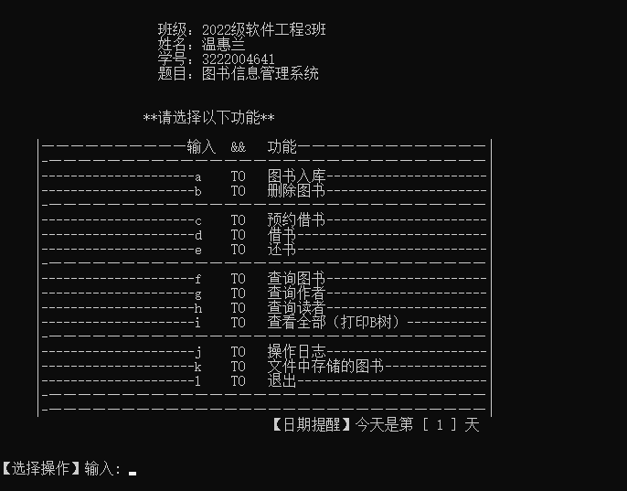
- 打印初始图书信息、读者信息
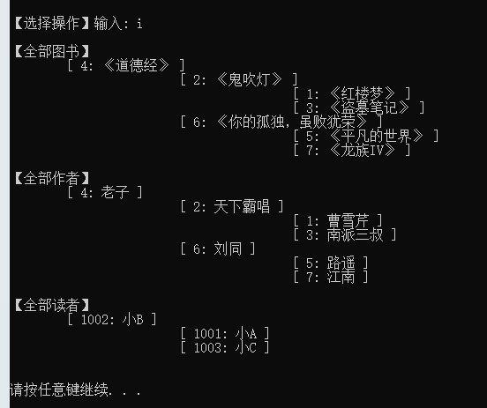
- 图书入库(添加)
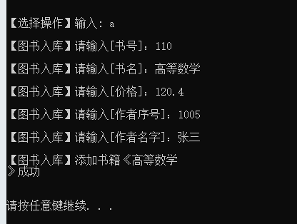
- 删除图书
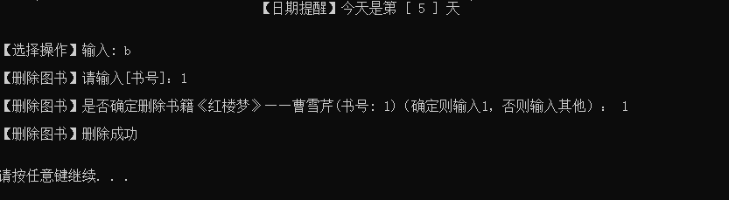
- 预约借书
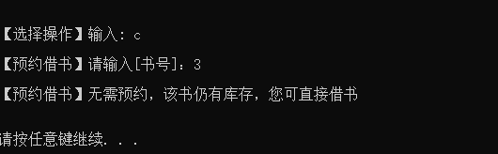

- 借书
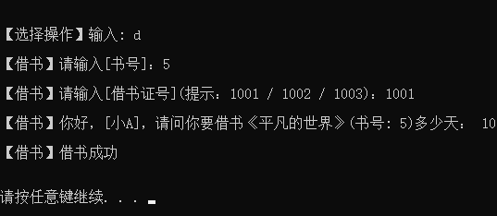
- 还书
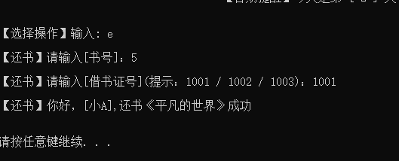

- 查询图书
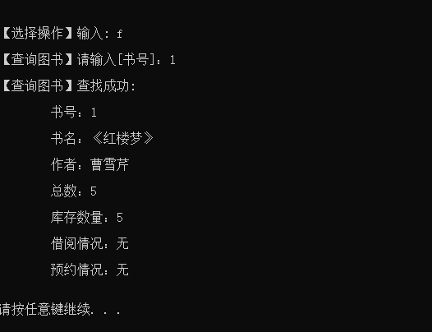
- 查询作者
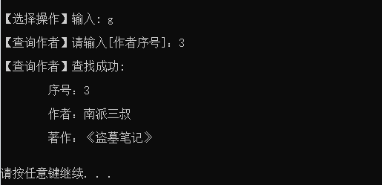
- 查询读者
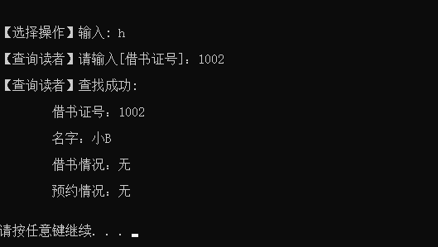
- 所有信息打印
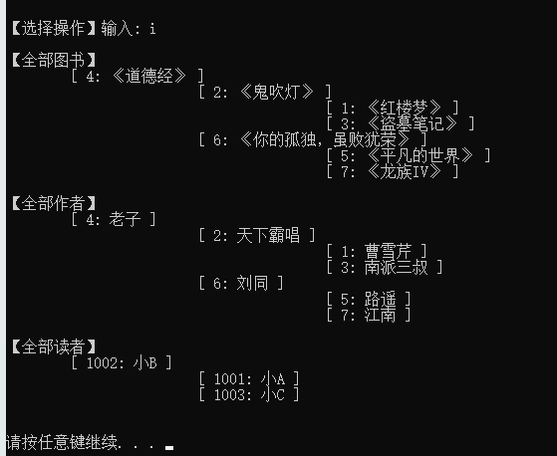
- 文件存储的图书
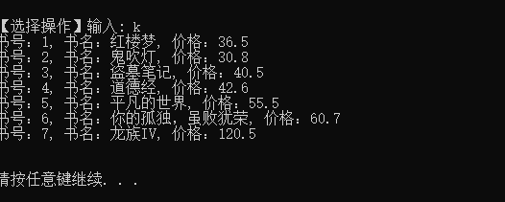
- 文件清空、退出
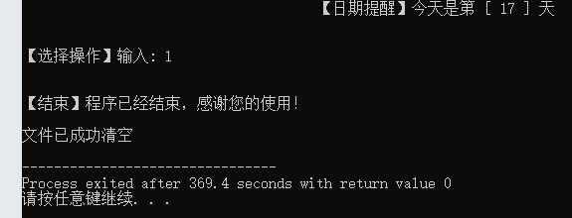
14、操作日志
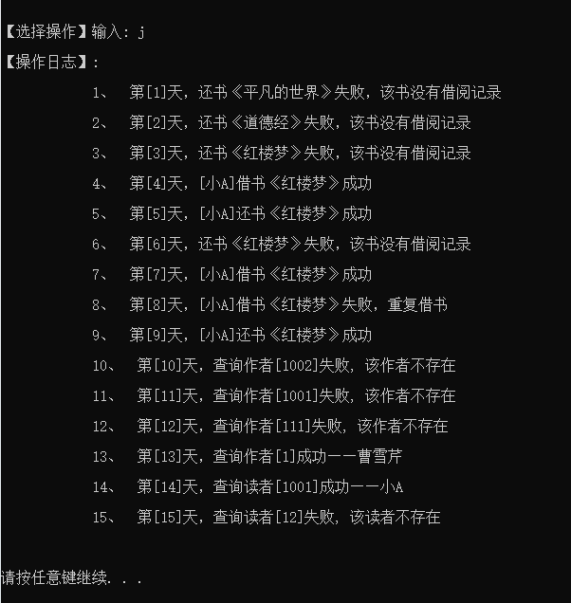

6. 测试结果
功能 | 输入 | 输出
图书入库 | 书号、书名、价格、作者序号、作者 | 不存在：添加书籍《xxx》成功。  已存在：确认是否增加图书库存，输入1则加入库存，显示当前库存数量，否则则取消该操作
删除图书 | 书号 | 不存在：输出该图书不存在。  存在：确认是否删除图书，输入1则删除，显示删除成功，否则则取消该操作
预约借书 | 书号 | 不存在：输出该图书不存在，请重新输入。  存在：显示无需预约，该书仍有库存，您课直接借书
借书 | 书号、借书证号、借书日期 | 成功：输出结束成功提示  失败：此书不存在，请重新输入。此借书证号不存在，请重新输入。抱歉[小A]，不能重复借书《红楼梦》
还书 | 书号、借书证号 | 成功：你好，[小A],还书《红楼梦》成功  书号不存在：此书不存在, 请重新输入。  书号不对：抱歉，该书没有借阅记录  借书证号：还书失败[小A]没有借阅过《盗墓笔记》
查询图书 | 书号 | 成功：输出该书书号、书名、作者、库存数量、借阅情况、预约情况等信息  失败：此书不存在
查询作者 | 作者序号 | 成功：显示作者序号、作者名、著作。  失败：该作者不存在
查询读者 | 借书证号 | 查找成功：显示读者的基本信息  失败：该读者不存在
打印所有图书，读者信息 |  | 分类打印所有的图书信息、读者信息
操作日志 |  | 打印每一天用户再图书系统的操作记录
文件存储 |  | 记录所有存储在文件里面的图书数据，删除图书时也删去文件中的记录
主页面 |  | 课设学生的班级、名字、学号、主题，以及功能模块目录、借书的归还日期提醒

一些输入错误测试示例
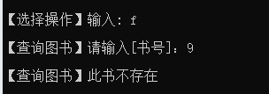
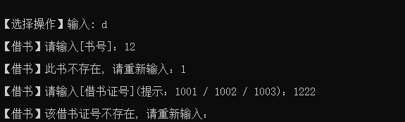


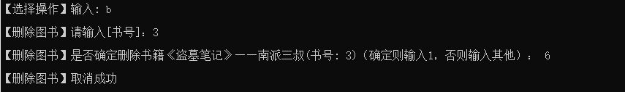
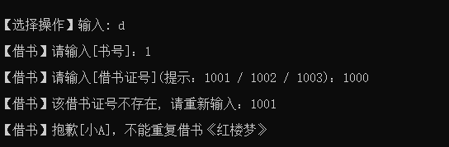
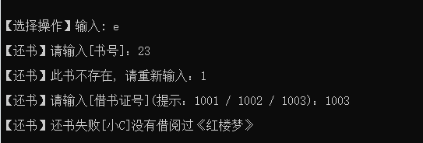



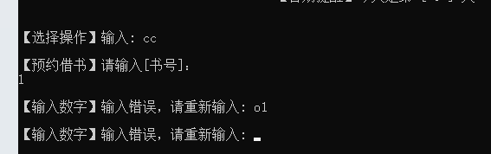

附录
提交的文件
代码：头文件<BTree.h>
源代码<main.cpp>
文件存储：books.txt
数据结构课程设计报告word文档

