Download Putty.Zip

http://the.earth.li/~sgtatham/putty/latest/x86/putty.zip
Extract the files and they can be run as is, no install needed.

Converting Your Private Key Using PuTTYgen
PuTTY does not natively support the private key format (.pem) generated by Linux. PuTTY has a tool named PuTTYgen, which can convert keys to the required PuTTY format (.ppk). You must convert your private key into this format (.ppk) before attempting to connect to your instance using PuTTY.
To convert your private key
- Start PuTTYgen (for example, from the Start menu, click All Programs > PuTTY > PuTTYgen).
- Under Type of key to generate, select SSH-2 RSA.
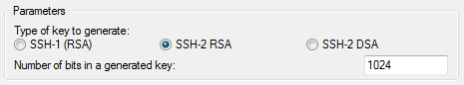
- Click Load. By default, PuTTYgen displays only files with the extension .ppk. To locate your .pem file, select the option to display files of all types.
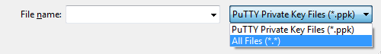
- Select your .pem file and click Open. Click OK to dismiss the confirmation dialog box.
- Click Save private key to save the key in the format that PuTTY can use. PuTTYgen displays a warning about saving the key without a passphrase. Click No, no passphrase needed for lab.
Note
A passphrase on a private key is an extra layer of protection, so even if your private key is discovered, it can't be used without the passphrase. The downside to using a passphrase is that it makes automation harder because human intervention is needed to log on to an instance, or copy files to an instance.
- Specify the same name for the key that you used for the key pair (for example, my-key-pair). PuTTY automatically adds the .ppk file extension.
Your private key is now in the correct format for use with PuTTY. You can now connect to your instance using PuTTY's SSH client.
To start a PuTTY session
- Start PuTTY (from the Start menu, click All Programs > PuTTY > PuTTY).
- In the Category pane, select Session and complete the following fields:
  - In the Host Name box, enter cloud_user@. Be sure to specify the appropriate user name for your AMI. For example:
    - For RHEL Instance, the user name is cloud-user
    - For a Fedora Instance, the user name is fedora
  - Under Connection type, select SSH.
  - Ensure that Port is 22.
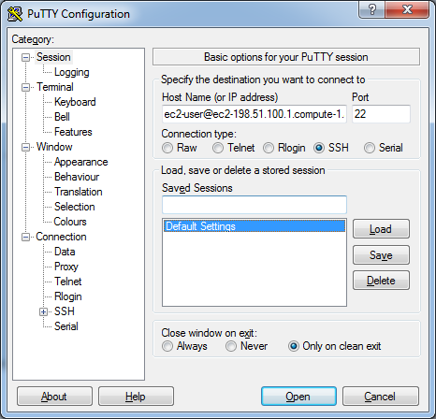
- In the Category pane, expand Connection, expand SSH, and then select Auth. Complete the following:
  - Click Browse.
  - Select the .ppk file that you generated for your key pair, and then click Open.
  - (Optional) If you plan to start this session again later, you can save the session information for future use. Select Session in the Category tree, enter a name for the session in Saved Sessions, and then click Save.
  - Click Open to start the PuTTY session.
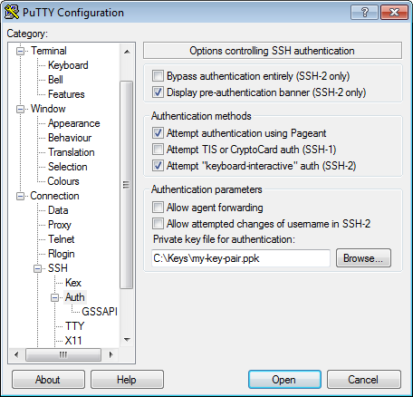
- If this is the first time you have connected to this instance, PuTTY displays a security alert dialog box that asks whether you trust the host you are connecting to.
- Click Yes. A window opens and you are connected to your instance.
Note
If you specified a passphrase when you converted your private key to PuTTY's format, you must provide that passphrase when you log in to the instance.

Transferring Files to Your Linux Instance Using the PuTTY Secure Copy Client
The PuTTY Secure Copy client (PSCP) is a command-line tool that you can use to transfer files between your Windows computer and your Linux instance. If you prefer a graphical user interface (GUI), you can use an open source GUI tool named WinSCP. For more information, see Transferring Files to Your Linux Instance Using WinSCP.
To use PSCP, you'll need the private key you generated in Converting Your Private Key Using PuTTYgen. You'll also need the public DNS address of your Linux instance.
The following example transfers the file C:\Keys\kp-tfuserxx.ppk. from a Windows computer to the /home/cloud-user directory on a Linux instance:
C:\> pscp -i C:\Keys\kp-tfuserxx.ppk C:\Keys\kp-tfuserxx.ppk cloud-user@209.132.185.xx:/home/cloud-user

