**方案一：题干区域和答题区域分开**

填空内容在答题区域作答，以;隔开，填写完毕后自动生成文本块，后面用户可以编辑文本块或删除。

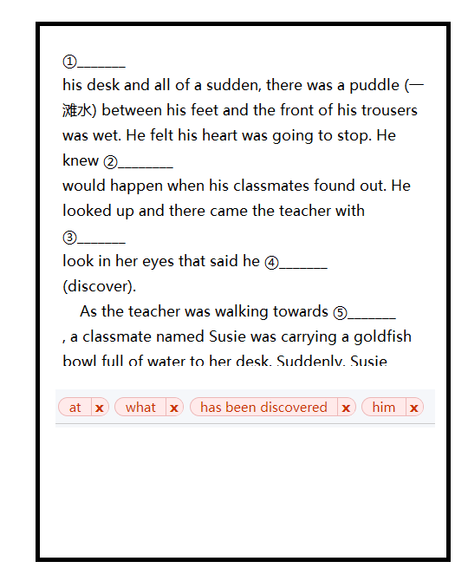

**方案二：直接在题干区域作答**

教师在录入题目的时候使用特定的占位符（比如__Fill.Replace__），前端用户获取试题题干的时候，后端或前端将占位符替换成输入控件。

需要讨论：这种情况下，如何提交用户的答案给后端？

题目录入样例：

This happened in a third-grade classroom. Jim sat ①__Fill.Replace__his desk and all of a sudden, there was a puddle (一滩水) between his feet and the front of his trousers was wet. He felt his heart was going to stop. He knew ②__Fill.Replace__would happen when his classmates found out. He looked up and there came the teacher with ③__Fill.Replace__look in her eyes that said he ④__Fill.Replace__(discover). As the teacher was walking towards ⑤__Fill.Replace__, a classmate named Susie was carrying a goldfish bowl full of water to her desk. Suddenly, Susie tripped (绊倒) and, ⑥__Fill.Replace__(strange), dumped the whole bowl of water in Jim’s lap. He pretended to be angry, but all the while he was saying deep in his heart, “Thank you!” Jim became the object of sympathy instead of ridicule. The teacher brought him gym shorts to put on. All the others crawled(爬) on their hands and knees, ⑦__Fill.Replace__(clean) up around his desk. But ⑧__Fill.Replace__life would have it, the ridicule that should have been his had been transferred (转移) to Susie. She tried to help, ⑨__Fill.Replace__they told her to leave the room ⑩__Fill.Replace__school was over, Jim walked over to Susie and whispered, “You did that on purpose, didn’t you?” Susie whispered back, “I wet my trousers once, too!”

前端或后端将占位符__Fill.Replace__替换成文本输入控件（比如：<input type="text" name="fillReplace" />）。