Fsck 命令检查文件系统错误

<https://www.linuxprobe.com/linux-fsck-command.html>

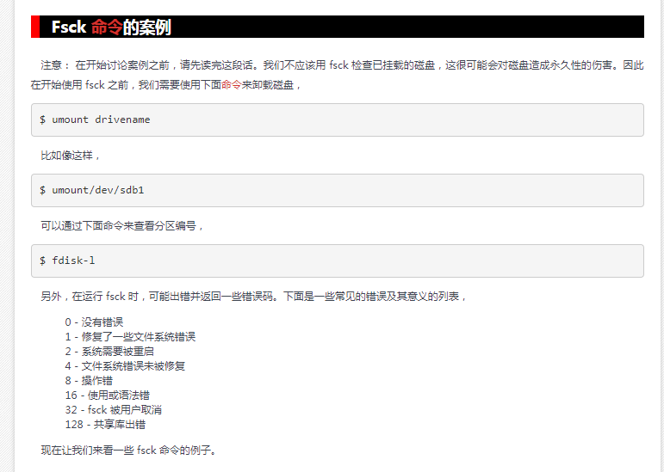

Debian 的fsck 相关

**NAME**

systemd-fsck@.service, systemd-fsck-root.service, **systemd-fsck** - File system checker logic

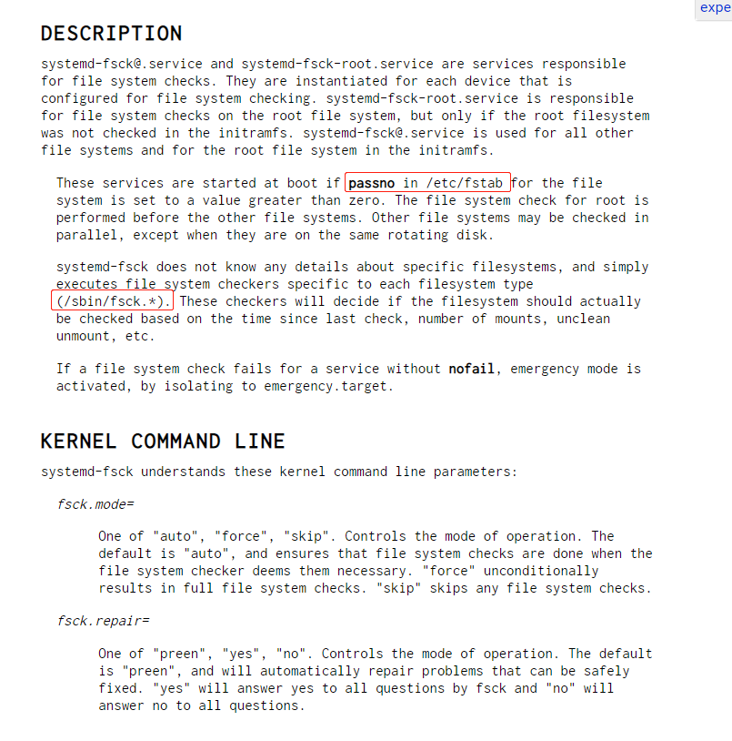

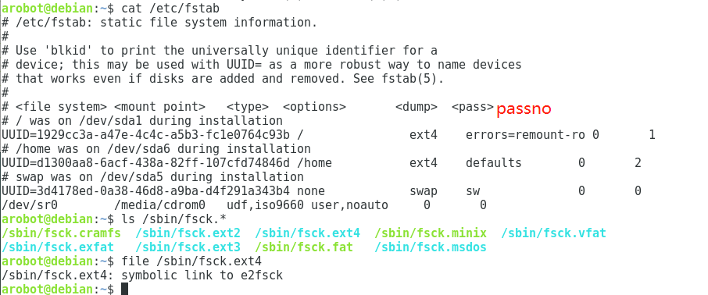

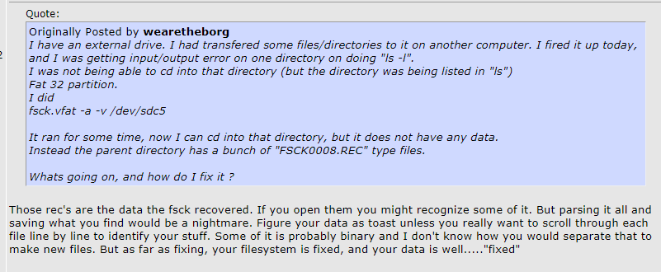

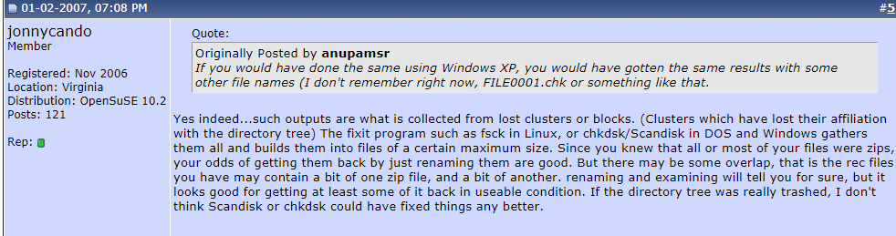

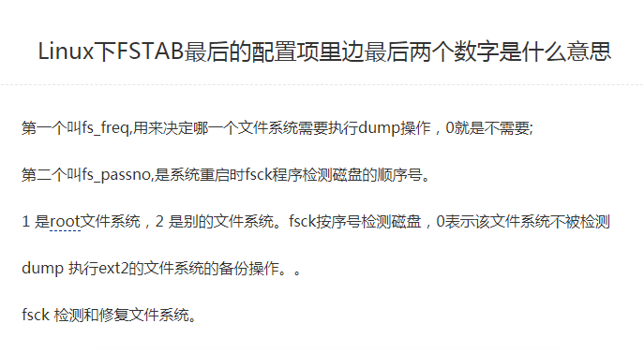

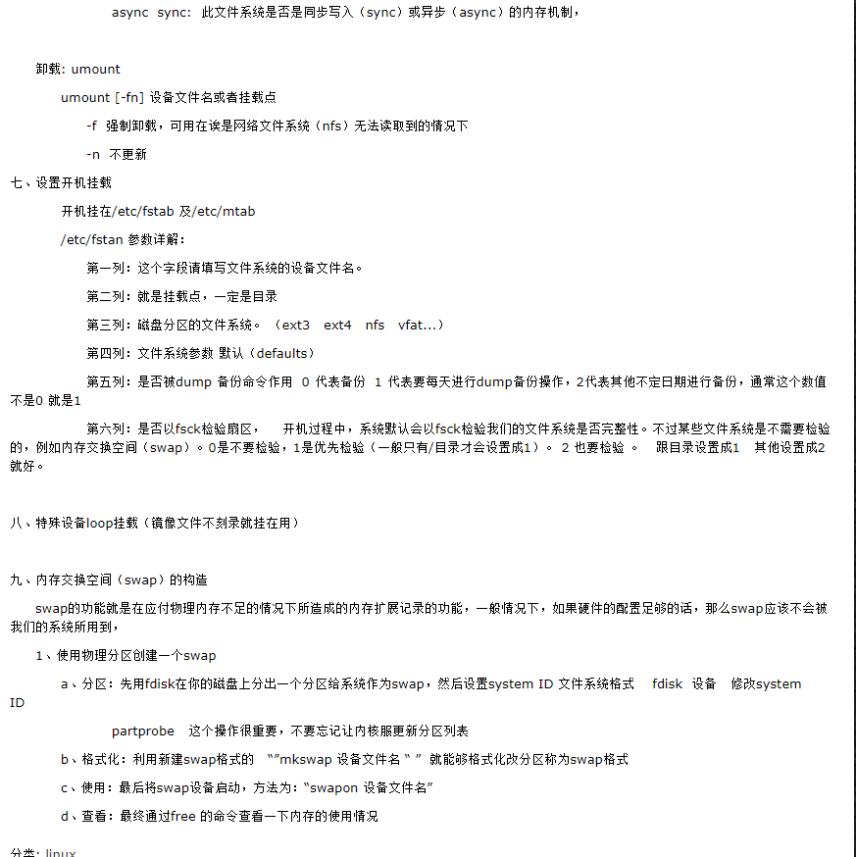

<https://www.cnblogs.com/lxc123/p/10146873.html>