**Akasa Cooling solutions**

Akasa’s Standard Intel product range presents over 32 total solutions. ZAP can provide all, direct from the original manufacturer. Here’s a few examples of Akasa’s Standard Intel quality.

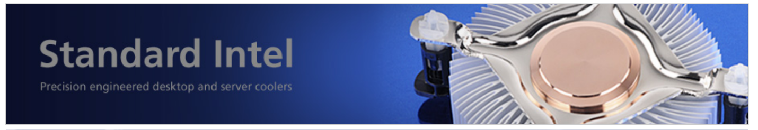

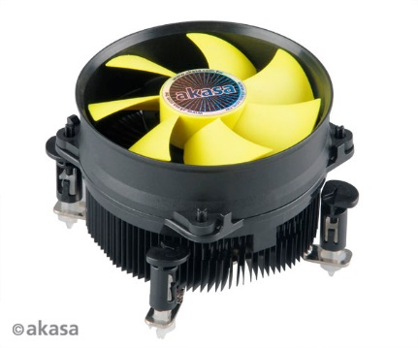

|  |
| --- |
| **The Akasa K32**  **Designed for Intel Pentium 4, Core2Duo, Core2Quad, Core i3, i5, i7 up to 95W**  The legendary K32 uses a high engineering omni-directional heatsink providing efficient CPU and motherboard zone cooling. Low noise 9.2cm PWM fan in killer Viper yellow uses Intel approved power management (PWM) where speed is regulated automatically by CPU usage. Under normal conditions the CPU fan speed is low ensuring low noise computing.  Intel approved pushpins ensure easy installation, reliable retention and maximum compatibility on both LGA775 and LGA115X platforms without any mounting adjustment, pushpins will automatically slide into correct position.  K32 is designed to work with CPU’s up to 95W but greater cooling efficiency can be attained with efficient case airflow. Pre-applied high performance thermal compound ensures clean and easy installation.  • **Designed for Intel LGA775, LGA1150, LGA1155, LGA1156** • **Supports Intel Pentium 4, Core2Duo, Core2Quad, Core i3, Core i5, Core i7** • **92mm low noise PWM fan** • **Intel reference push pin for reliable retention and easy installation** • **High performance thermal interface pre-applied** |

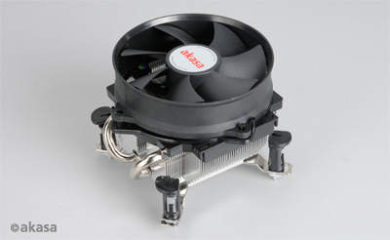

**The Akasa AK-CC092**

**High performance and compact cooler designed for INTEL Core2Quad, Core i3, Core i5 & Core i7, AMD Athlon, Athlon II, Phenom & Phenom II**

|  |
| --- |
| The low noise AK-CC092 is a high performance yet compact cooler designed for Intel and AMD processors. Two nickel plated copper heatpipes in direct CPU contact technology rapidly transfer the heat to 51 aluminium fine fins. The 9cm PWM fan is regulated automatically by CPU usage and temperature so under normal PC work load the fan speed is low, ensuring quiet computing but extra performance is available when needed.  Akasa Easy Select Clip with Intel reference push-pin retention is used for no-hassle mounting on Intel platforms, no backplate is needed. AMD Sockets are catered for with a cam-lever clip for safe and easy attachment. Performance thermal compound is supplied.  • **Two nickel plated copper heatpipes for rapid heat transportation** • **Fine-fin aluminium heatsink gives efficient heat dissipation** • **Low noise fan with PWM control** • **Intel LGA 775, 1150, 1155 & 1156 compatible** • **AMD Socket 939, AM2, AM2+ & AM3 compatible** • **Push-pins mounting (Intel) or cam-lever (AMD)** • **Performance thermal compound is supplied** |

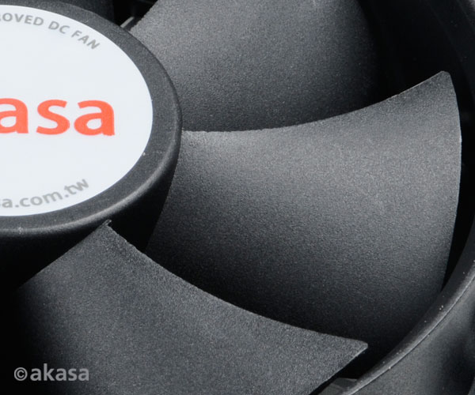

**The Akasa AK-CC7109EP01**

**Dual socket value cooler**

**Low noise cooler with PWM fan designed for Intel Core2Duo, Core i3 & Core i5 up to 73W**

|  |
| --- |
| AK-CC7109EP01 is a modern design value CPU cooler offering efficient and low noise cooling. High engineered multi directional aluminium heatsink with bi-ped fins maximizes heat dissipation, providing optimal CPU and motherboard VRM cooling. Intel approved 4pin PWM fan ensures the RPM is automatically regulated by the motherboard according to CPU usage and temperature. So under normal operating conditions, the CPU fan maintains low noise levels.  Intel approved pushpins ensure easy installation, reliable retention and maximum compatibility on both LGA775 and LGA115X platforms without any mounting adjustment.  AK-CC7109EP01 is designed to work with CPU’s up to 73W but greater cooling efficiency can be attained with efficient case airflow. Pre-applied high performance thermal compound ensures clean and easy installation.  **• High engineered aluminium heatsink for cost effective cooling  • Bi-ped fins maximise heat dissipation • Low noise PWM fan • Push-pins mounting provides easy and reliable retention • Intel LGA775 & LGA115X compatible  • Performance thermal interface is pre-applied  • Total height of only 54mm** |

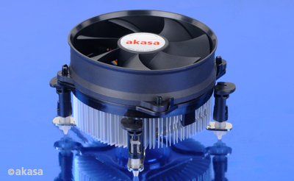

**The Akasa AK-CC7108EP01**

**Designed for Intel Core 2 Duo, Core i3 & Core i5 up to 77W**

|  |
| --- |
| AK-CC7108EP01 is a new design OEM CPU cooler combining low noise, efficient cooling with great value. High engineered omni directional aluminium heatsink with bi-ped fins maximize heat dissipation and provides optimal CPU and motherboard VRM cooling. Low noise 9.2cm PWM fan uses Intel approved power management (PWM) where speed is regulated automatically by CPU usage. Under normal conditions the CPU fan speed is low ensuring low noise computing.   Intel approved pushpins ensure easy installation, reliable retention and maximum compatibility on LGA775 / 115X platforms without any mounting adjustment, pushpins will slide into correct position.   AK-CC7108EP01 is designed to work with CPU’s up to 77W (Ivy Bridge) but greater cooling efficiency can be attained with efficient case airflow. Pre-applied high performance thermal compound ensures clean and easy installation.  **• High engineered aluminium heatsink for cost effective cooling performance • Bi-ped fins maximise heat dissipation  • Intel approved push pins provide reliable retention • Intel LGA775 / 1150 / 1155 and LGA1156 compatible • 92mm low noise PWM fan  • High performance thermal interface is pre-applied  • Total height of 58mm from CPU level** |

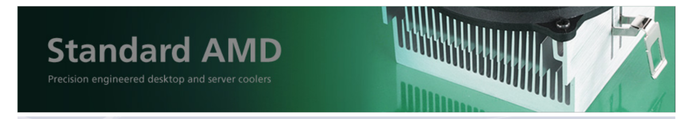

**Akasa’s Standard AMD range has 10 solutions that can be tailored to your IT needs. Contact us for the full range**

[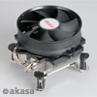](http://www.akasa.com.cn/update.php?tpl=product/cpu.product.tpl&no=181&type=CPU%20coolers&type_sub=Standard%20AMD&model=AK-CC092)

**The Akasa** [**AK-CC092**](http://www.akasa.com.cn/update.php?tpl=product/cpu.product.tpl&no=181&type=CPU%20coolers&type_sub=Standard%20AMD&model=AK-CC092) **Performance and compact cooler**

**Low noise, high performance and compact cooler designed for Intel and AMD processors. Two nickel plated copper heatpipes in direct CPU contact technology, 9cm PWM fan.**

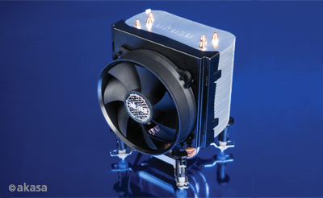

**The Akasa** [**AK-968**](http://www.akasa.com.cn/update.php?tpl=product/cpu.product.tpl&no=181&type=CPU%20coolers&type_sub=Standard%20AMD&model=AK-968)

**Performance multi-platform CPU cooler**

All new multi-platform CPU cooler developed from the hugely popular AK-965. New design akasa (Patented) Easy Select Clip is used for no-hassle mounting.

[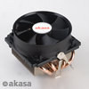](http://www.akasa.com.cn/update.php?tpl=product/cpu.product.tpl&no=181&type=CPU%20coolers&type_sub=Standard%20AMD&model=AK-875)

**The Akasa** [**AK-875**](http://www.akasa.com.cn/update.php?tpl=product/cpu.product.tpl&no=181&type=CPU%20coolers&type_sub=Standard%20AMD&model=AK-875) **Compact heatpipe cooler for AMD**

Performance cooler with 4 heatpipes and copper base. 92mm PWM fan for quiet operation and high airflow. Designed for quad core AMD processors.

[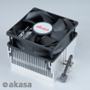](http://www.akasa.com.cn/update.php?tpl=product/cpu.product.tpl&no=181&type=CPU%20coolers&type_sub=Standard%20AMD&model=AK-860EF)

**The Akasa** [**AK-860EF**](http://www.akasa.com.cn/update.php?tpl=product/cpu.product.tpl&no=181&type=CPU%20coolers&type_sub=Standard%20AMD&model=AK-860EF)  **Value and Performance Cooler**

Low noise AMD cooler designed for great value and performance cooling, cam lever clipe provides easy mounting and safe retention. Thermal compound pre-applied.

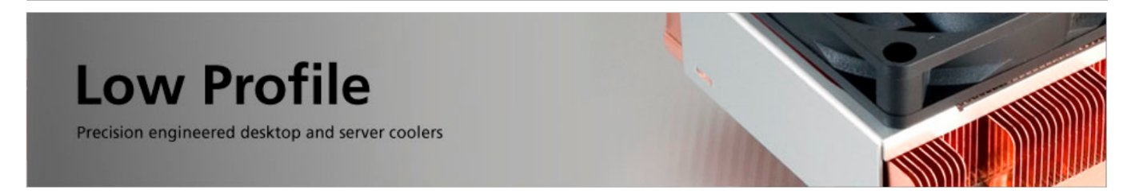

**Akasa’s Low Profile collection offers wide choice to meet your needs. Contact us for more model details.**

|  |
| --- |
| [http://www.akasa.com.cn/img/product/common/gallery/00/AK-CC1201SS04_g00.jpg](http://www.akasa.com.cn/update.php?tpl=product/cpu.product.tpl&no=181&type=CPU%20coolers&type_sub=Low%20Profile&model=AK-CC1201SS04)  **The Akasa** [**AK-CC1201SS04**](http://www.akasa.com.cn/update.php?tpl=product/cpu.product.tpl&no=181&type=CPU%20coolers&type_sub=Low%20Profile&model=AK-CC1201SS04)  **compact aluminium cooler for AMD AM1 platform**  A compact aluminium cooler for the AMD AM1 platform. The low profile design with a total height of 29.8mm makes it the perfect solution designed for mini-ITX and micro-ATX systems. |

|  |
| --- |
| http://www.akasa.com.cn/img/product/common/feature/00/AK-CC7124EP01_f00.jpg  **Designed for ultra compact Thin mini-ITX and mini-ITX chassis Core 2 Duo and Core i3 processors**  The ultra compact and low noise cooler for Intel Core 2 Duo and Core i3 CPU’s. The low profile design with embedded fan makes it a perfect solution for mini-ITX, HTPC and SFF systems.  The aluminium heatsink and enter bearing fan ensures high efficiency and long life. High engineered multi directional aluminium heatsink with copper core maximizes heat dissipation and the PWM fan provides optimal CPU, motherboard and VRM cooling with minimal noise levels.  Easy installation, reliable retention and maximum compatibility on both LGA775 and LGA115X platforms without any mounting adjustment, pushpins will automatically slide into correct position.  • **Hi-engineered aluminium heatsink with copper core** • **Multi-directional fins for maximum system cooling** • **Embedded 8cm PWM fan with long life Enter bearing** • **Intel approved push pins provide maximum compatibility** • **Dual mounting for Intel LGA775 and LGA115X platforms** • **High performance thermal interface is pre-applied** • **Total height only 23.5mm** |

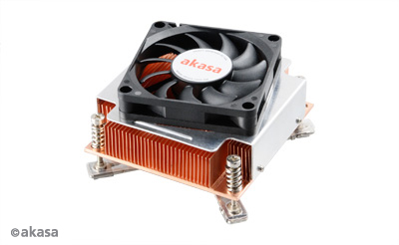

|  |
| --- |
| **The Akasa 2U Cooler for Intel LGA115X and 1366**  **100% copper heatsink with PWM fan designed for Intel Xeon Processor.**  2U chassis server cooling solution for Intel LGA115X and 1366 motherboards. Copper heatsink designed for rackmount or workstation chassis. Long life PWM fan provides accurate cooling. Pre-applied spring-loaded screws and motherboard backplate guarantee safe retention.  • **Active LGA115X and 1366 cooling solution for 2U chassis** • **Automatic PWM speed control** • **Solid copper heatsink** • **Reliable and long life twin ball bearing** |

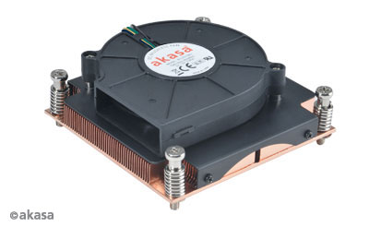

**Cooler for Intel LGA2011**

**Active cooling solution designed for Intel Xeon based Sandy Bridge EP Processor**

|  |
| --- |
| The long life two-ball bearing fan draws the cool air though the fins and extracts hot air to one side to support chassis airflow. Pre-applied spring-loaded screws guarantee safe retention.  • **Active LGA2011 cooling solution** • **Side blow PWM fan** • **Solid copper heatsink** • **Reliable and long life twin ball bearing fan** |



**Akasa’s Retail Cooler Collection is full of brilliant examples of IT excellence.**

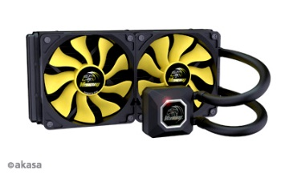

**Venom A20**

**DUAL RADIATOR LIQUID CPU COOLER**

• All-in-one liquid cooler design for easy installation  
• High precision CNC Copper base for high efficiency heat transfer  
• New low noise 4-pole pump reduces vibration  
• Durable large diameter tubes provide smooth and quiet flow  
• Low noise Viper fan with S-FLOW blades  
• Integrated white LED indicator

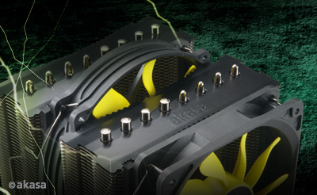

**Venom Medusa - Monster of all extremes!**

**Eight high capacity heatpipes for rapid heat transfer. Dual Viper Fans. Award winning S-Flow Fans provides 30% more airflow. Intelligent synced fan speed**

Optimised V shaped notches reduces airflow resistance and noise dual Viper fans for extreme cooling performance twin tower heatsink provides more heat dissipation area eight high capacity heatpipes for rapid heat transfer. 14cm Viper-R fan provides massive airflow for CPU and motherboard component nickel coated copper base

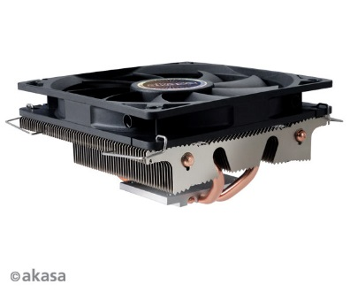

**The Akasa Nero LX - High performance low profile CPU cooler**Suitable for HTPC or slim system with limited space. High performance low profile four direct contact heatpipes cooler

|  |  |
| --- | --- |
| |  | | --- | | • **High performance low profile four direct contact heatpipes cooler     with only a 59mm height.** • **Suitable for HTPC or slim system with limited space** • **For all LGA1366, LGA1150, LGA1156, LGA1155, LGA775, LGA1356, AMD AM3+, AM3, AM2+, AM2, FM1, FM2** • **Low noise 12cm slim PWM fan** • **High performance thermal compound included** | |



**Akasa’s Blue Aurora**

**Big, Bad and Blue. Intel Pentium 4, Pentium D, Core 2 Duo & Core 2 Quad**

|  |
| --- |
| The Akasa Blue Aurora cooler brings together style, ultra quiet computing and hi-performance cooling. The Blue-LED 12cm fan provides massive airflow while Intel approved power management (PWM) ensure the noise levels are always on minimum. Our bright blue-LED will bring light and add colour to your system interior.  The technology underlying the Blue Aurora’s exceptional performance is the U-shape heatpipe system. Four extra long U heatpipes ensure rapid and even heat transfer from the copper base to the aluminium fins. 35 fine fins measuring 65x120mm provide a large dissipation area for the ultimate cooling performance.  Extra-safe cooler retention and perfectly even contact with CPU. The specific fan positioning enhances the VRM cooling (VRM - CPU Voltage Regulator Modules located on the motherboard). Hi-grade thermal compound is supplied.  • **Blue-LED 12cm fan with PWM** • **Four U-shape heatpipes give rapid heat dissipation** • **Copper base for maximum heat absorption** • **Thermal compound supplied** |

**­­­­­­­­­­­­­­­­­­­**