UECM3033 Assignment #3 Report

========================================================

- Prepared by: Kok Wen Jing

- Tutorial Group: T2

------------------------------------------------------------------------------------------------------------

## **Task 1** -- Gauss-Legendre formula

The reports, codes and supporting documents are to be uploaded to Github at:

[https://github.com/wenjingkok/UECM3033_assign3](<https://github.com/wenjingkok/UECM3033_assign3>)

***Explain how you implement your `task1.py` here.***

We find the integration using Gauss-Legendre quadrature.

The equation for Gauss-Legendre quadrature is defined as below.

$$\sum_{i=0}^{n-1}{w_{i} f(x_{i})}$$

where $w_{i}$ = the weights in Gauss-Legendre quadrature,

$x_{i}$ = the nodes in Gauss-Legendre quadrature,

$f(x_{i})$ = the equation which substituted the respecting nodes,

$n$ = the number of points for the Gauss-Legendre quadrature.

After we get the weights and nodes in Python, we perform summation and translate the values of $x_{i}$ and the final answer to the interval we predefined since the weights and nodes values we found are based on the default interval which is from -1 to 1.

The following formulas are using to translate the value of $x_{i}$ and the final answer.

$$t_{i}= \frac{1}{2} \left( x_{i }\left(b-a\right) +\left(b+a\right)\right)$$

$$final answer= \frac{1}{2}(b-a)(\sum_{i=0}^{n-1}{w_{i} f(x_{i}))}$$

where $t_{i}$ is the translated $x_{i}$ values.

***Explain how you get the weights and nodes used in the Gauss-Legendre quadrature.***

We get the weights and nodes using the predefined function in Python.

The predefined function is the *leggauss* function found in *numpy.polynomial.legendre.*

The *leggauss* function need an input value which is the number of points for the Gauss-Legendre quadrature which is the $n$ value we defined at above.

The *leggauss* function return two arrays which are the nodes and weights for the $n$-points Gauss-Legendre quadrature.

------------------------------------------------------------------------------------------------------------

## **Task 2** -- Predator-prey model

***Explain how you implement your `task2.py` here, especially how to use `odeint`.***

The *odeint* function required a predefined function in the Python module *scipy.integrate* that helps in solving ordinary differential equations with initial value problem.

The equations we used in this task is the transformed equations defined as below.

$$y_{0}^{'}=a\left(y_{0}- y_{0}y_{1}\right)$$

$$y_{1}^{'}=b(-y_{1}+ y_{0}y_{1})$$

where $a$ and $b$ are constants, $a=1.0$, $b=0.2$, $y_{0}$ is the number of prey while $y_{1}$ is the number of predator.

The initial value we use for $y_{0}$ and $y_{1}$ are 0.1 and 1.0 respectively where we defined as below.

$$y=[0.1, 1.0]$$

The above differential equations defined in a function named *deriv()* together with the initial value of $y_{0}$ and $y_{1}$.

We solve the ODE problem through a time period of year, from 0 to 5 and divided the time period into 100 points. The time is defined as t = np.linspace(0, 5, 100) where the *linspace()* function will divided the interval [0,5] into 100 points. We get the derivative solution using the *odeint()* function as mentioned above where we called the function by below.

solution = odeint(deriv, y, t, args(a, b))

After get the solution from *odeint()*, we plot the following graph.

***Put your graphs here and explain.***

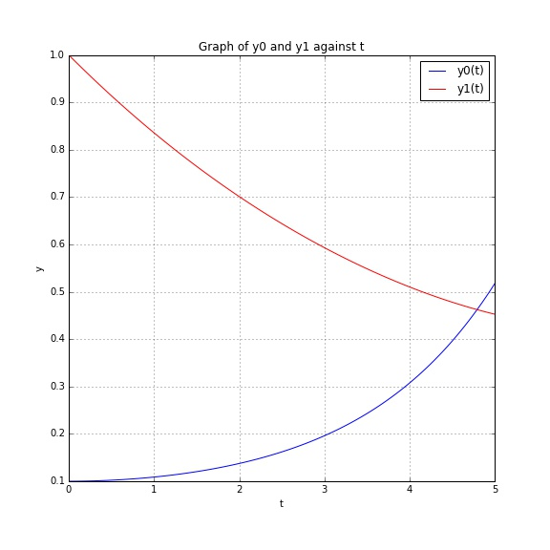

As time increase, the number of prey $y_{0}$ increasing while the number of predator $y_{1}$ decreasing.

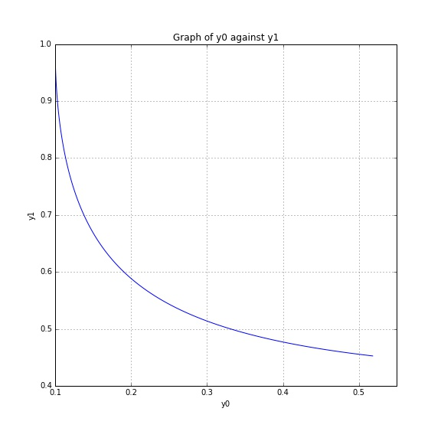

There is an inverse relationship between the number of prey and predator.

***Is the system of ODE sensitive to initial condition? Explain.***

This system of ODE is not sensitive to initial condition since the changes of initial value does not make much different for the solutions we get.

------------------------------------------------------------------------------------------------------------

Last modified: 17 April 2016