**EXAMPLE - SOP of Search Pubmed in a systematic way**

1. **Analyses your research question into aspects**

Is using antibiotic treatment for appendicitis in adults a safe and effective alternative to an appendectomy?

1. **PICO Format**

P（Problem/Population）appendicitis /adults

I (Intervention) antibiotic

C(Comparison) appendectomy

O(Outcome) effectiveness

1. **Search strategy Pubmed**
2. **MeSH-terms: in MeSH DataBase[https://www.ncbi.nlm.nih.gov/mesh/]**

|  |  |
| --- | --- |
| #1 Appendicitis | "Appendicitis"[Mesh] |
| #2 Antibiotics | "Anti-Bacterial Agents"[Mesh] OR "Anti-Bacterial Agents" [Pharmacological Action] |
| #3 Appendectomy | "Appendectomy"[Mesh] |
| ... | ... |

1. **Truncation: Helps you find plurals adjectives and variations of the word**

Appendicitis => appendicit*

Antibiotics => anti bacterial agent* OR antibacterial agent* OR antibiotic*

Appendectomy => appendectom* OR appendicectom*

1. **Tiab-terms**

|  |  |
| --- | --- |
| #1 Appendicitis | appendicit*[tiab] |
| #2 Antibiotics | anti bacterial agent*[tiab] OR antibacterial agent*[tiab] OR antibiotic*[tiab] |
| #3 Appendectomy | appendectom*[tiab] OR appendicectom*[tiab] |
| ... | ... |

1. **Combine MeSH and tiab into search blocks**

#1 "Appendicitis"[Mesh] OR appendicit*[tiab]

#2 "Anti-Bacterial Agents"[Mesh] OR "Anti-Bacterial Agents" [Pharmacological Action] OR "anti bacterial agent*"[tiab] OR "antibacterial agent*"[tiab] OR "antibiotic*"[tiab]

#3 "Appendectomy"[Mesh] OR "appendectom*"[tiab] OR "appendicectom*"[tiab]

#4 #1AND #2 AND #3

1. **Advance search**
2. **Copy and Paste the Search History**

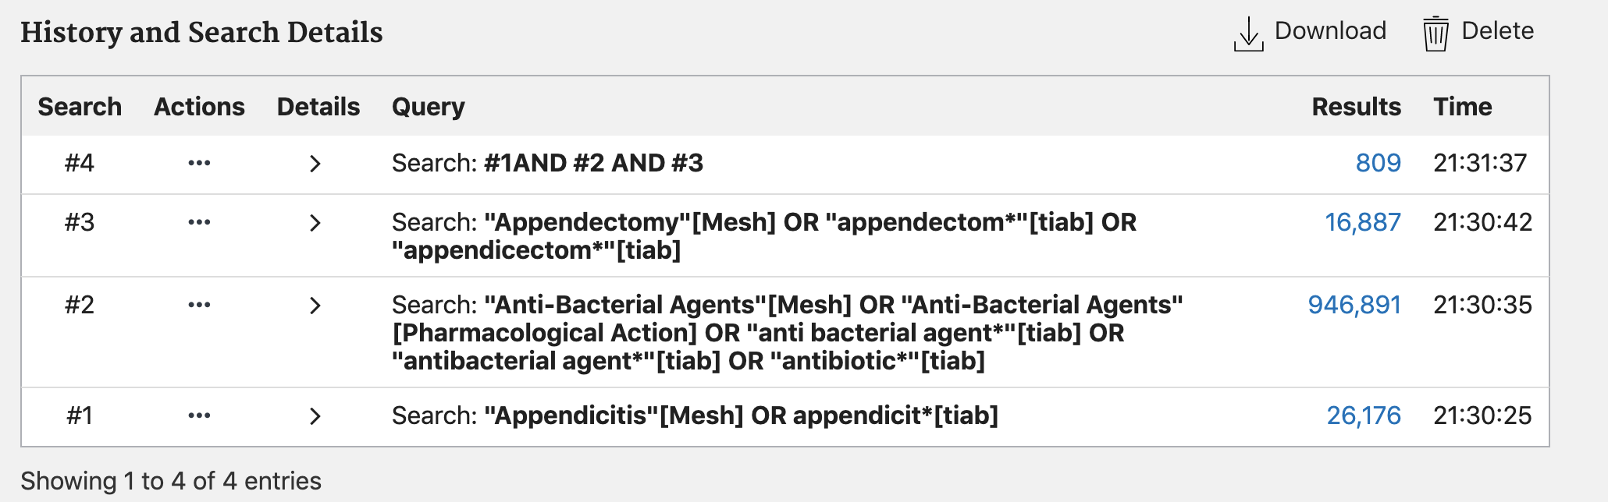

**TERMS:**

1. *MeSH data base : a list of indexed keywords.*
2. *Tiab: Title/Abstract/Author/Key Words*

**TO REFINE THE SEARCH:**

1. *Additional search blocks*
2. *Filters*

**Reference:**

1. <https://www.youtube.com/watch?v=1X8Su-w8coQ&t=300s>