ICDAR2015

|  |  |  |  |
| --- | --- | --- | --- |
|  | Precision | Recall | Hmean |
| PAN++ - Papper | 85.5 | 77.2 | 81.2 |
| 测试 | 84.4 | 78.2 | 81.2 |

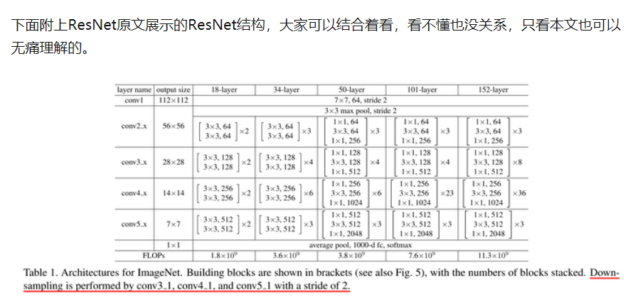

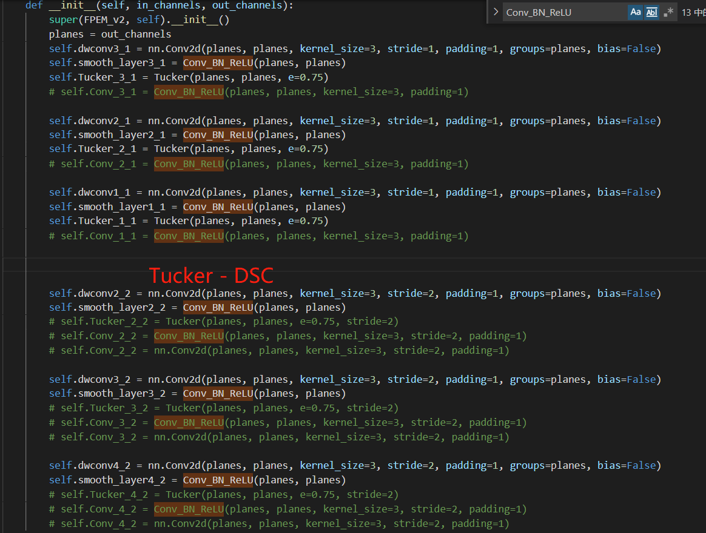

1. Tucker - dsc

510 recall: 0.764 precision: 0.849 hmean: 0.804

520 recall: 0.778 precision: 0.839 hmean: 0.807

523 recall: 0.779 precision: 0.84 hmean: 0.808

530 recall: 0.764 precision: 0.838 hmean: 0.799

540 recall: 0.764 precision: 0.832 hmean: 0.797

550 recall: 0.771 precision: 0.843 hmean: 0.805

560 recall: 0.772 precision: 0.845 hmean: 0.807

570 recall: 0.778 precision: 0.836 hmean: 0.806

580 recall: 0.766 precision: 0.837 hmean: 0.8

590 recall: 0.774 precision: 0.844 hmean: 0.807

600 recall: 0.763 precision: 0.832 hmean: 0.796

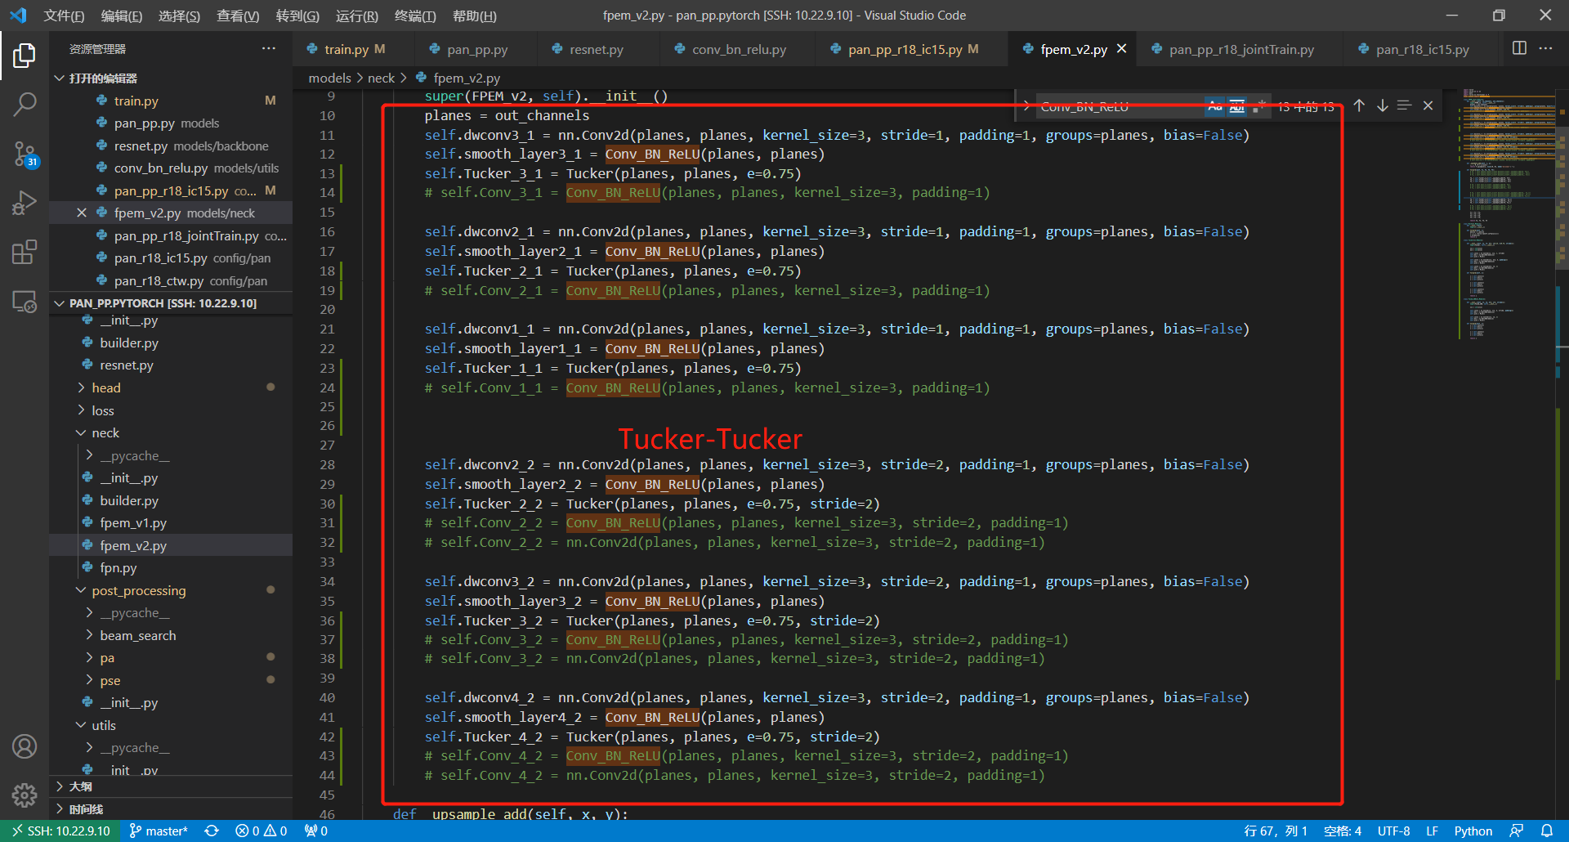

1. Tucker - Tucker

recall: 0.799 precision: 0.833 hmean: 0.816

510 recall: 0.786 precision: 0.84 hmean: 0.812

520 recall: 0.779 precision: 0.844 hmean: 0.81

530 recall: 0.782 precision: 0.836 hmean: 0.808

540 recall: 0.795 precision: 0.848 hmean: 0.821

550 recall: 0.789 precision: 0.832 hmean: 0.81

560 recall: 0.788 precision: 0.846 hmean: 0.816

570 recall: 0.786 precision: 0.843 hmean: 0.813

580 recall: 0.782 precision: 0.839 hmean: 0.81

590 recall: 0.785 precision: 0.845 hmean: 0.814

600 recall: 0.783 precision: 0.847 hmean: 0.814

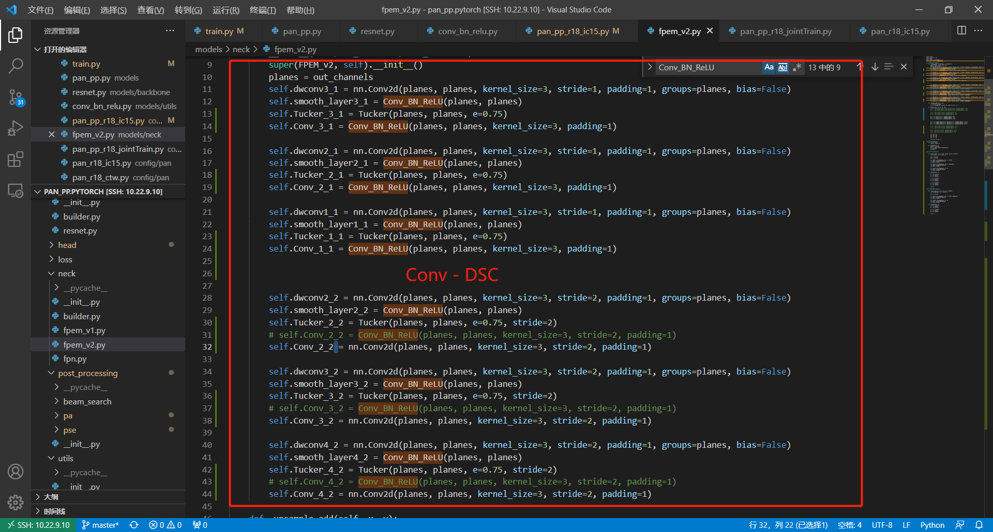

27 conv - dsc

510 recall: 0.779 precision: 0.827 hmean: 0.802

520 recall: 0.774 precision: 0.818 hmean: 0.795

530 recall: 0.775 precision: 0.823 hmean: 0.798

540 recall: 0.773 precision: 0.835 hmean: 0.803

550 recall: 0.77 precision: 0.825 hmean: 0.797

560 recall: 0.778 precision: 0.833 hmean: 0.805

570 recall: 0.778 precision: 0.832 hmean: 0.804

580 recall: 0.775 precision: 0.831 hmean: 0.802

590 recall: 0.78 precision: 0.834 hmean: 0.806

600 recall: 0.771 precision: 0.832 hmean: 0.8

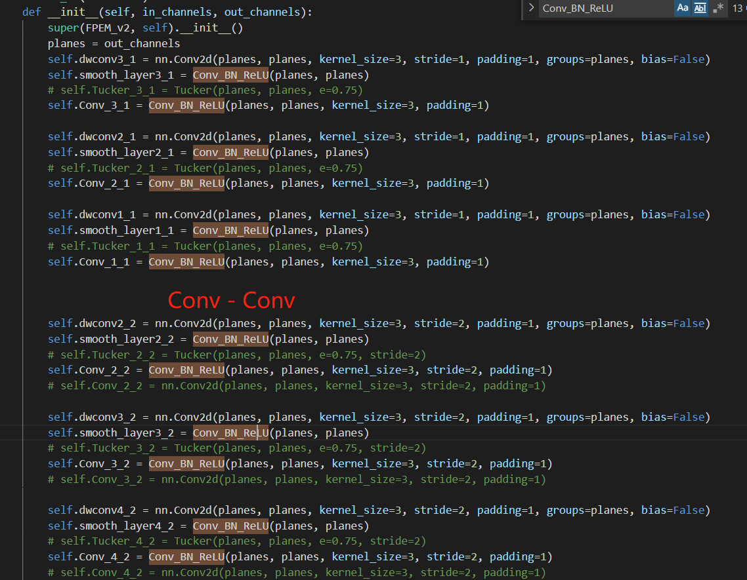

28 conv - conv

recall: 0.78 precision: 0.836 hmean: 0.807

510 recall: 0.774 precision: 0.856 hmean: 0.813

520 recall: 0.782 precision: 0.845 hmean: 0.812

530 recall: 0.79 precision: 0.831 hmean: 0.81

540 recall: 0.793 precision: 0.822 hmean: 0.807

550 recall: 0.795 precision: 0.835 hmean: 0.814

560 recall: 0.79 precision: 0.845 hmean: 0.817

570 recall: 0.789 precision: 0.848 hmean: 0.817

580 recall: 0.787 precision: 0.839 hmean: 0.812

590 recall: 0.78 precision: 0.843 hmean: 0.81

600 recall: 0.785 precision: 0.848 hmean: 0.815

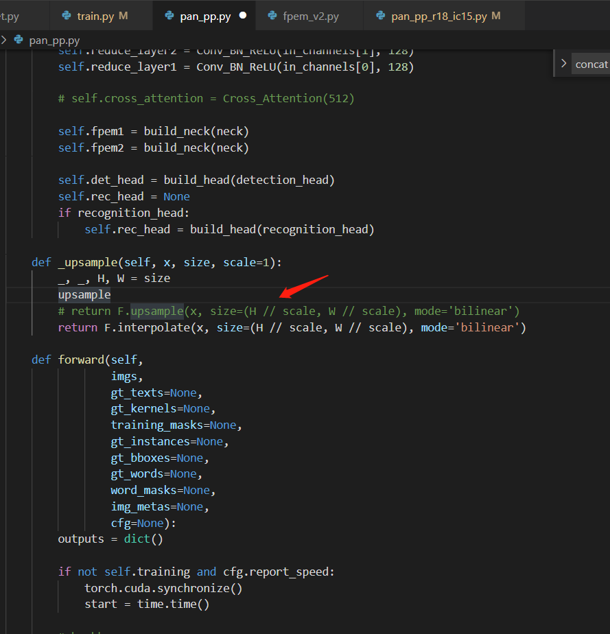

17 resnet34 Tucker - Tucker pretrained=False

recall: 0.792 precision: 0.829 hmean: 0.81

510 recall: 0.777 precision: 0.817 hmean: 0.797

520 recall: 0.772 precision: 0.825 hmean: 0.798

530 recall: 0.768 precision: 0.831 hmean: 0.798

540 recall: 0.765 precision: 0.838 hmean: 0.8

550 recall: 0.781 precision: 0.83 hmean: 0.805

560

570

580

590

600

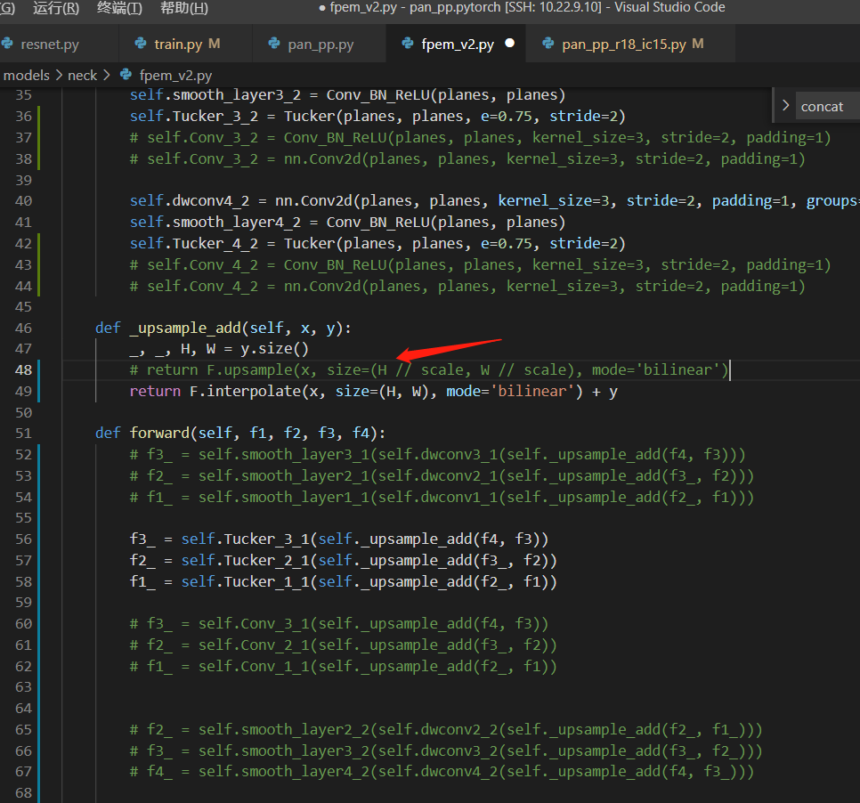

25 resnet34 FPEM_v2 - FPEM_v2

recall: 0.772 precision: 0.851 hmean: 0.809

recall: 0.783 precision: 0.842 hmean: 0.811

recall: 0.769 precision: 0.852 hmean: 0.809

510 recall: 0.77 precision: 0.839 hmean: 0.803

520 recall: 0.78 precision: 0.834 hmean: 0.806

530 recall: 0.772 precision: 0.841 hmean: 0.805

540 recall: 0.769 precision: 0.845 hmean: 0.805

550

560

570

580

590

600

27 resnet18 Tucker_Conv

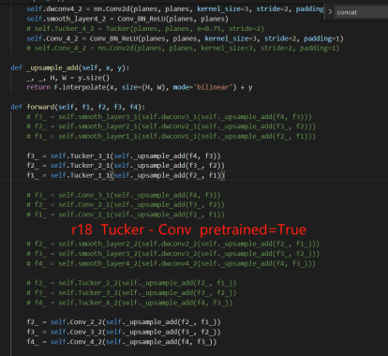

recall: 0.77 precision: 0.85 hmean: 0.808

recall: 0.771 precision: 0.862 hmean: 0.814

recall: 0.771 precision: 0.855 hmean: 0.811

recall: 0.77 precision: 0.855 hmean: 0.811

recall: 0.779 precision: 0.85 hmean: 0.813

recall: 0.78 precision: 0.844 hmean: 0.811

28 resnet34 Tucker-Tucker CAB pretrained=False

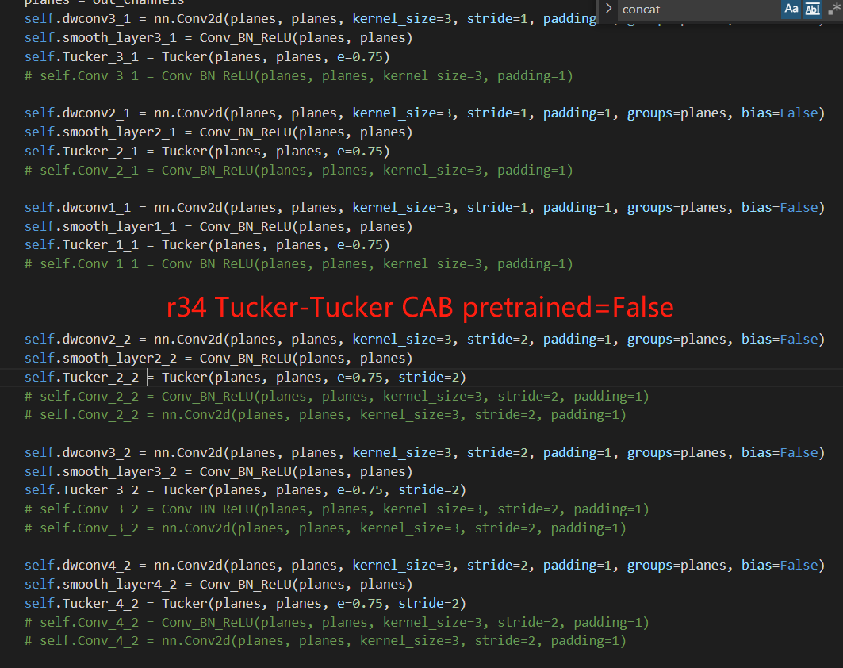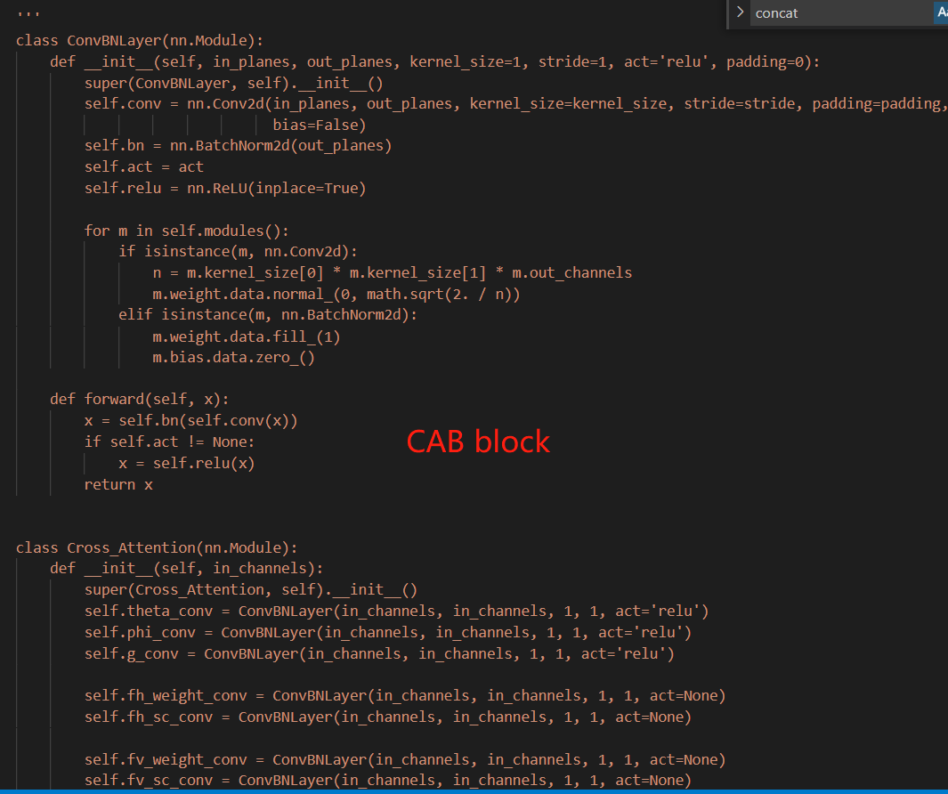

recall: 0.753 precision: 0.817 hmean: 0.783

recall: 0.757 precision: 0.821 hmean: 0.788

recall: 0.759 precision: 0.819 hmean: 0.788

****预处理－－>编译－－>优化－－>汇编－－>链接–>可执行文件****

****1.编译预处理****

读取c源程序，对其中的伪指令（以#开头的指令）和特殊符号进行处理,预编译程序所完成的基本上是对源程序的“替代”工作。经过此种替代，生成一个没有宏定义、没有条件编译指令、没有特殊符号的输出文件。这个文件的含义同没有经过预处理的源文件是相同的，但内容有所不同。

+++++++++++++++++++++++++++++++++++++++++++++++++++++++++++++++++++++

17 resnet34 Tucker-Tucker pretrained=True

+++++++++++++++++++++++++++++++++++++++++++++++++++++++++++++++++++++

17 resnet18_SE_Tucker_Tucker

recall: 0.773 precision: 0.858 hmean: 0.814

recall: 0.777 precision: 0.858 hmean: 0.816

recall: 0.78 precision: 0.85 hmean: 0.814

recall: 0.788 precision: 0.849 hmean: 0.817

25 resnet50_Tucker_Tucker

recall: 0.786 precision: 0.85 hmean: 0.817

recall: 0.791 precision: 0.853 hmean: 0.821

recall: 0.787 precision: 0.856 hmean: 0.82

recall: 0.791 precision: 0.853 hmean: 0.821

recall: 0.793 precision: 0.858 hmean: 0.824

+++++++++++++++++++++ CTW +++++++++++++++++++++++++++++++++++

CTW1500

|  |  |  |  |
| --- | --- | --- | --- |
|  | Precision | Recall | Hmean |
| PAN++ - Paper | 85.2 | 81.1 | 83.1 |
| 测试 | 83.90 | 80.83 | 82.34 |

p: 0.8419, r: 0.7950, f: 0.8178

p: 0.8753, r: 0.7800, f: 0.8249

p: 0.8588, r: 0.7927, f: 0.8244

p: 0.8590, r: 0.7943, f: 0.8254

p: 0.8710, r: 0.7920, f: 0.8296

p: 0.8644, r: 0.7728, f: 0.8160

p: 0.8710, r: 0.7813, f: 0.8237

p: 0.8615, r: 0.7927, f: 0.8257

p: 0.8777, r: 0.7881, f: 0.8305

p: 0.8712, r: 0.7852, f: 0.8260

p: 0.8764, r: 0.7901, f: 0.8310

p: 0.8663, r: 0.7917, f: 0.8273

p: 0.8736, r: 0.7904, f: 0.8299

p: 0.8614, r: 0.8022, f: 0.8307

p: 0.8591, r: 0.8008, f: 0.8289

p: 0.8568, r: 0.8057, f: 0.8305

p: 0.8841, r: 0.7836, f: 0.8308

p: 0.8715, r: 0.7979, f: 0.8331

p: 0.8664, r: 0.8031, f: 0.8336

p: 0.8750, r: 0.7937, f: 0.8323

p: 0.8562, r: 0.8038, f: 0.8292

p: 0.8586, r: 0.8077, f: 0.8324

p: 0.8616, r: 0.8054, f: 0.8325

Total_Text：

|  |  |  |  |
| --- | --- | --- | --- |
|  | Precision | Recall | Hmean |
| PAN++ - Paper | 89.2 | 80.3 | 84.5 |
| 测试 | 88.81 | 82.31 | 85.45 |