SIMULATION AND ANALYSIS OF SPECTRUM SENSING IN COGNITIVE RADIO

*G. Muni Venkatesh1, K. Swarna Latha2, Y. Narendra Reddy3, T. Vasaiah4, P. G. Varna Kumar Reddy5*

*UG Student1,2,3,4, Assistant Professor(Adhoc)5 Department of Electronics and Communication Engineering, JNTUA College of Engineering, Pulivendula, India,* [*g.m.venkateshmuni@gmail.com*1](mailto:g.m.venkateshmuni@gmail.com1),[*kavaliswarnalatha4817@gmail.com2,* *yadamanarendrareddy2000@gmail.com3, vasaiahthulsaningari@gmail.com*](mailto:kavaliswarnalatha4817@gmail.com2,%20yadamanarendrareddy2000@gmail.com3,%20vasaiahthulsaningari@gmail.com)*4,* [*varunkumarreddy.pg@gmail.com5*](mailto:varunkumarreddy.pg@gmail.com5)

**Abstract:** To satisfy future bandwidth demands, existing Cognitive Radio with Wireless Communication must be upgraded to make the best use of the bandwidth. The primary objective of the IEEE 802.22 standard is to determine vacant spectrum bands available in the Digital television channel (DTV) and to utilize them for wireless rural broadband connectivity. Cognitive Radio (CR) aims at maximizing the utilization of the limited radio bandwidth while accommodating the increasing number of services and applications in wireless networks. For cognitive radio networks to operate efficiently, Secondary users (SU) should be able to exploit radio spectrum that is unused by the primary network. A critical component of cognitive radio is spectrum sensing.There are many spectrum sensing algorithms available in the literature out of which energy detection is widely used because it is easy to implement and does not require prior information about PU (Primary User). However, the performance of the conventional energy detector deteriorates in the low SNR region. Double threshold CSS (Cooperative Spectrum Sensing) was introduced to increase the reliability of the decision but at the cost of some sense, information was lost. The detection performance is described through extensive simulation using the MATLAB simulation tool.

**Keywords**: Software Defined Radio, Cognitive Radio, Spectrum Allocation, Co-operative spectrum sensing (CSS), Spectrum sharing, Spectrum management, Energy detection, Double Threshold CSS, MATLAB, SIMULINK.

## 1.Introduction:

In the prosperous world, we are living right now, communications enter our daily lives in manifold ways that it is easy to overlook the multitude of its facets. Mobile phones, radio broadcasting, TV towers, satellite antennas, and PCs with access to the Internet seem to rule the communications world. Data communication networks are a crucial system to any modern city that is because they are used extensively in numerous applications such as financial transactions, social interaction, education, national security, and more. Although passive optical networks (PONs) may be the best solution for a complex network that requires high-speed data communication, the design of the system suffers from high costs and other fibre problems, thus wireless communications solve these troubles. However, there are some problems in wireless communications such as frequency-dependent, relatively low bandwidth, and tightly licensed by the government.

Mobile devices are only allowed to certain frequencies which are getting crowded. With cognitive radio technology, we can use all available frequencies even though those dedicated to TV or satellites. The intelligent devices negotiate to use the whole radio spectrum in the most efficient way, this way we can multiply the current network needs. By the word radio, we mean any kind of wireless communications, at the moment radios, can communicate only with other radios of the same kinds. Cognitive radio can understand the language of any radio, combined with new single radios embedded in any object, would allow any interaction any physical objects, this can also provide solutions for communications between people at different languages and cultures. 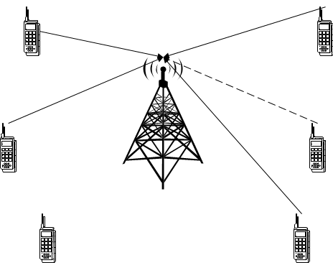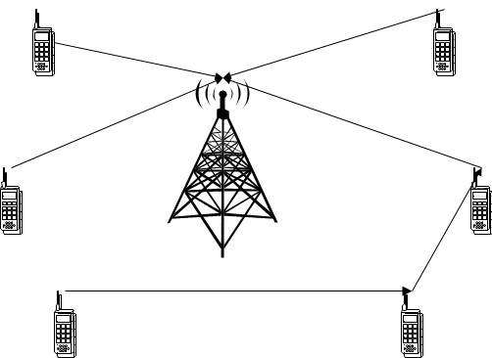

(a) Before Cognitive Radio (b) After Cognitive Radio

Fig. 1.1 Radio communications systems before and after cognitive radio

* 1. **Software Defined Radio (SDR):**

A Software Defined Radio may be a radio during which some or all of the physical layer functions are software-defined. The ideal (SDR) is shown in Fig. 1.2. The user data is mapped to the specified waveform within the microprocessor. After being converted into digital samples, the signal is sent directly to the antenna. The transmitted signal enters the receiver at the antenna, is sampled and digitized, and eventually processed in real-time by a general-purpose processor.

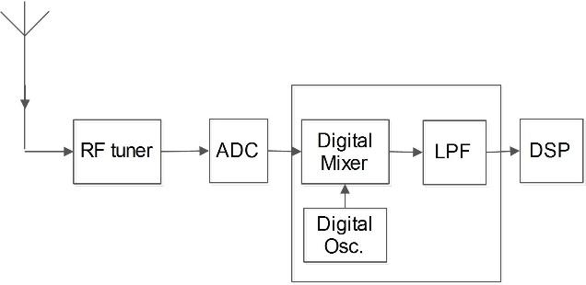

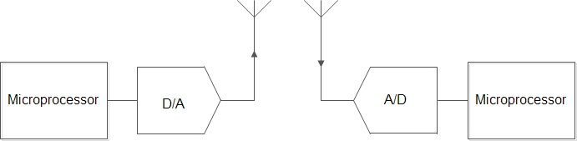

(a)Ideal SDR (b)Non-Ideal SDR Receiver

Fig. 1.2 Ideal SDR system versus Non-Ideal SDR Receiver

**1.2 Cognitive Radio (CR):**

Cognitive radio is the key technology that enables cognitive wireless terminals to dynamically access available spectral channels. For cognitive radio, an SDR can take advantage of the underutilized spectrum. The definition of cognitive radio by Mitola was generalized by the Federal Communications Commission (FCC) to be “a radio or system that sense its electromagnetic environment and can dynamically and autonomously adjust its radio operating parameters to switch system operation, like maximize throughput, mitigate interference, facilitate interoperability, access secondary markets".

Despite the differences in the last definitions, cognitive radio has two key features that distinguish it from a traditional radio: *cognition capability* (intelligent adaptive behavior) and *reconfigurability.*

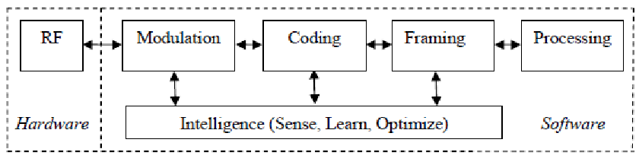

Fig. 1.3 Scientific block diagram of Cognitive Radio

### 1.3 Monte Carlo Simulation Technique:

Simulation Monte Carlo may be a mathematical technique used to generate random sample data for numerical experiments that are supported by some known distribution. This method is applied to risk quantitative chemical analysis and decision-making problems. The method is used by professionals in a variety of fields, including finance, project management, energy, manufacturing, engineering, and research, etc.

### 1.4 MATLAB:

Matrix Laboratory or [MATLAB for](https://www.educba.com/what-is-matlab/) brief could also be a multi-paradigm numerical computing environment and proprietary programing language developed by MathWorks. It combines computation, visualization, and programming in an easily usable environment and is all expressed in mathematical equations. Written in C, [C++, and Java](https://www.educba.com/c-plus-plus-vs-java/), MATLAB was initially released in 1984. the newest version has been released in March 2018.

Applications of MATLAB is formed around the MATLAB scripting language and revolves supported the next mathematical concepts:

* Variables
* Vectors and matrices
* Structures
* Functions
* Function handles
* Classes and object-oriented programming

### 2. Spectrum Sensing

The first step of spectrum sensing is that it determines the presence of a primary user on a band. The cognitive radio is in a position to share the results of its detection with other cognitive radios after sensing the spectrum. The goal of spectrum sensing is to seek out the spectrum status and activity by periodically sensing the target waveband. Particularly, a cognitive radio transceiver detects the spectrum which is unused or spectrum hole and also determines the method of access without interfering with the transmission of licensed. Two types of spectrum sensing techniques are there; those are 1. Signal processing techniques (or) non-Cooperative Spectrum Sensing 2. Cooperative Spectrum Sensing.

**2.1 Non-Cooperative Spectrum Sensing Techniques:**

In a realistic spectrum sensing scenario, there are situations during which just one sensing terminal is out there or during which no cooperation is allowed thanks to the shortage of communication between sensing terminals. In this section, we will explore the most single-user sensing schemes, several of which can function as the basis for the event of cooperative ones. Single user spectrum sensing approaches are heavily studied within the literature, partially due to the connection to signal detection. There are several classical techniques for this purpose, Mainly the energy detector (ED), Matched-filter detection, and Cyclostationary detection.

**2.2** **Cooperative Spectrum Sensing Techniques:**

The cooperative spectrum sensing can be:

* Centralized, during which a central entity gathers all information from all secondary receivers to form a choice about the medium status, which is then transmitted back to the receivers
* During the distribution phase, the receivers exchange their information to make their own decision"

## 3. Energy Detection based Non-cooperative Spectrum Sensing Technique for Cognitive Radio

**3.1 Energy Detection:**

It is a non-coherent and non-cooperative detection method that detects the first signal supported by the sensed energy. thanks to its simplicity and no requirement on a priori knowledge of primary user signal, energy detection (ED) is that the foremost popular sensing technique in cooperative sensing.

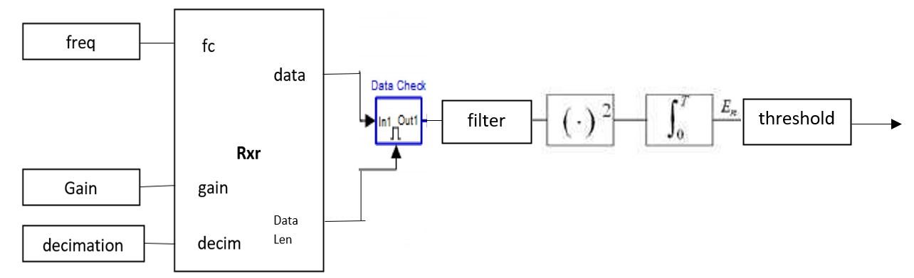

Fig.3.1 Energy detector diagram

The diagram for the energy detection technique is shown in **Figure 2.1** it's composed of 4 main blocks:

1. Band Pass Filter
2. Squaring Device
3. Integrator
4. Threshold device

**3.2 Binary Hypothesis Testing Problem**

Depending on the idle state or busy state of the primary user, with the presence of the noise, the signal detection at the secondary are often modeled as a Binary Hypothesis Testing Problem, given as:

Hypothesis 0 (H0): signal is absent

Hypothesis 1 (H1): signal is present

If the received signal, **y,** is sampled, the nth (n= 1, 2, 3 ) sample, y(n) can be given as:

*y(n)* = w(n)……H0

*y(n)* = *x(n)* + w(n)……H1

where x(n) is the signal transmitted by the PU, x(n)= h s(n) where his channel gain and w(n) is the noise sample which is assumed to be Gaussian random variable with mean zero

(IE[w(n)] = 0) and variance *2a* i.e., w(n) - *N (O,* 2a).

Then a **decision rule** can be stated as:





where *E* is the test statistic. Energy detection differentiates between the two hypotheses H0 and H1 by comparing *E* with threshold voltage *Vt* as shown*.* It is essential to set the correct threshold value**. Fig. 2 shows the key issue here.** which shows the probability density functions of the received signal with and without active PU.

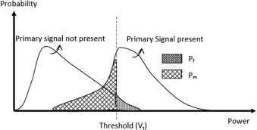

Fig. 3.2 Threshold setting in ED: trade-off between missed detection and false alarm

Hence if selected *Vt* is too low, the false alarm probability i.e.,

*Pf* = *Pr (ε* > *Vt | H0)* increases, which results in low spectrum utilization. A high Vt, however, can result in missed detections, so the risk must not be overstated

*Pm= Pr (ε < Vt | H1 )* is increased which may result in interference with an active PU. Setting the threshold for ED requires careful consideration of trade-offs.

**3.3 Test Statistic**

The test statistic of the energy detector is often given as

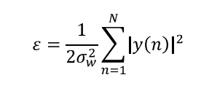

where *2σw2 is* the noise variance, N is the sample number such that N=2TW, where TW is the time-bandwidth product.

The **performance of the energy detector** is characterized by using the following metrics, which are introduced supported the test statistic under the binary hypothesis:

* **The false alarm probability (Pf)** is defined as the likelihood of deciding the signal is present while the true condition is met.



where *Vt* is the detection threshold, and Pr[.] stands for an event probability.

* **The PMD (missed-detection probability**) represents the probability of determining the signal is not present



which is like identifying a spectrum hole where there is no one. As a result, large Pmd can cause unexpected interference to primary users.

* **The probability of detecting the signal (Pd)** is the probability of determining that H1 is true when a signal is present.



Among the benefits of the spectrum sensing technology built into cognitive radio is both reliability and efficiency; it is preferred that Pd (or Pmd) is higher and Pf is lower.

## 4. Double Threshold Based Cooperative Spectrum Sensing Technique for Cognitive Radio Network using MATLAB

### 4.1 Cooperative Spectrum Sensing (CSS):

To overcome the problem of node failure and fading, CSS was discussed earlier. CSS is illustrated in figure 3.1. This diagram shows the FC receiving local decisions from each SU. A fusion rule is then applied to the outcome of each CR, such as the OR rule, the AND rule, and the Majority rule. The probability of detection (Qd) and probability of false alarm (Qf) for the cooperative scheme under the OR rule is given

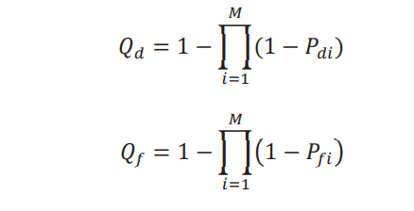

The Pd and Pf refer respectively to the probability of false alarm and detection for each SU, and M represents the number of CRs participating.

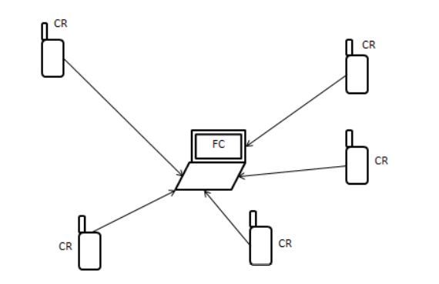

fig. 4.1. Cooperative spectrum sensing

### 4.2 Proposed Double Threshold Cooperative Spectrum Sensing Technique

In a conventional energy detector, as already discussed, each CR makes its local decisions based on a single threshold as shown in figure 3.2. (a). If the energy calculated X (or observed energy Oi) is more than threshold λ then hypothesis H1 is true otherwise H0. The double threshold energy detection method can be illustrated with the help of figure 3.2. (b). Here hypothesis H1 is true if X is more than λ2 and hypothesis H0 is true when X is less than λ1 and in the case observed energy X lies in between the two thresholds i.e., λ1<X<λ2, no decision is taken and CR will go for sensing again.

Threshold λ can be calculated

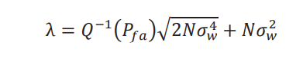

And thresholds λ1and λ2 can be found as:

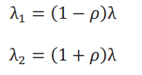

Here ρ is the uncertainty parameter.

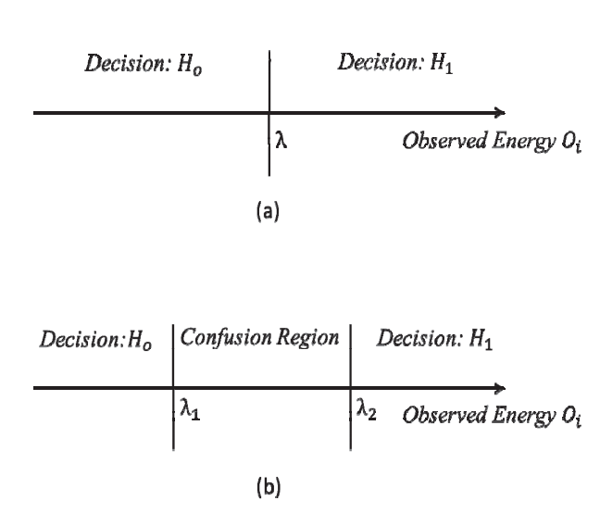

Fig. 4.2. (a) Conventional energy detector with a single threshold.

(b) Double threshold-based energy detector

In this paper, we have developed a simulation model for double threshold CSS which works as follows:

1. Each SU (i=1……M) will decide if and only if observed energy *Xi* lies above λ2 or below λ1 which is given by
   1. Xi € H0

Li = {

* 1. Xi Σ H1

1. If X lies between λ1 and λ2, then SU does not make a decision and reports the observed energy *Xi* to the FC.
2. Let us assume that FC receives K local decisions and M-K energy values. FC will now take the average of all the energy values received and compare it with the threshold λ to make a decision *Ho* or *H1* as

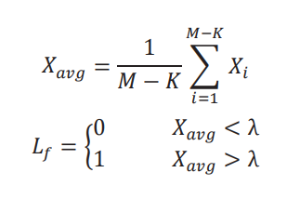

* 1. 4. Now FC will be having K+1 decision: K decisions from the SUs which have made the decisions and one from the FC itself based on the observed energy received from the confused SUs.
  2. Now FC can combine these K+1 decisions by OR fusion rule with the help of equations 6 and 7.

In this way, no sensing information is lost (every CR is contributing to the final decision) and the problem of sensing failure is also removed. Figure 3.3 shows the flowchart of the proposed scheme.

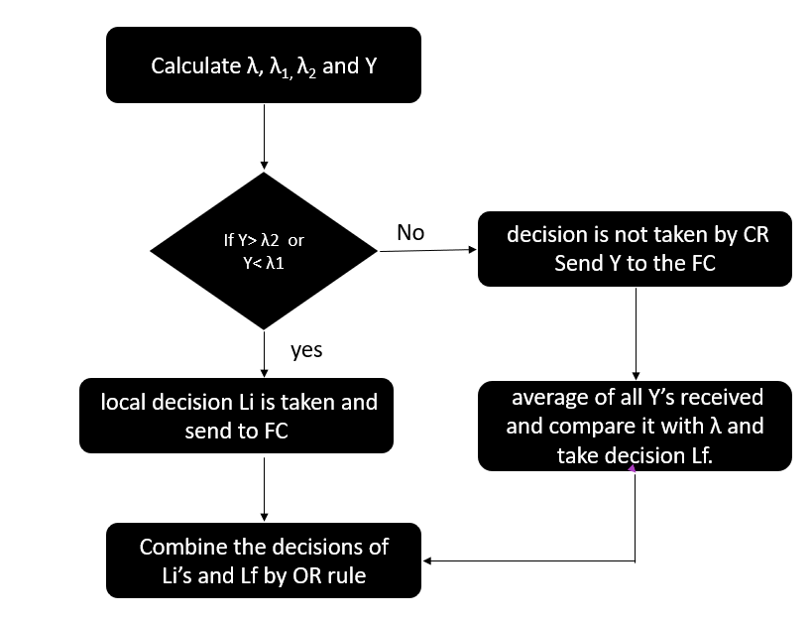

Fig 4.3 Flowchart of the proposed scheme

**5. Simulation results:**

In this section, we have performed a simulation study to evaluate the performance of the proposed scheme. First, we developed a simulation model in MATLAB for a single threshold energy detection method and compared the results with the theoretical results to validate the simulation model Figure 3.4 shows the ROC (Receiver Operating characteristics) for the theoretical and simulation model with N=500 & 1000. This shows that the developed simulation model is very close to the theoretical model. Then this simulation model is extended for the proposed scheme to evaluate the performance. We have assumed a BPSK modulated signal.

Figure 3.5 shows the ROC (curve between Pd vs Pfa) for the single and double threshold at -5 dB SNR with 200 samples. In this case, the confused region is not considered. For simplicity, we have assumed that every CR is using the same value of threshold λ with uncertainty parameter, q= 0.1. Figure 3.6 shows the ROC for the conventional and proposed scheme. Based on the number of participating states, M=5, we have assumed that the number of cooperative states would be five. This figure clearly shows that the proposed scheme outperforms the conventional CSS. Based on 100 samples at -8dB SNR, this curve is illustrated. It has been observed from the graph that the proposed scheme is giving an almost 10% improvement in the probability of detection at Pfa=0.1.

Figure 3.7 shows the graph between Qd and SNR by fixing Pfa=0.1 and it has been observed from the graph that at low SNR, the proposed scheme performs better. Figure 3.8 shows the curve between the probability of decision error (Pe) and SNR and it has been observed that the proposed scheme is minimizing the decision error in the low SNR region.

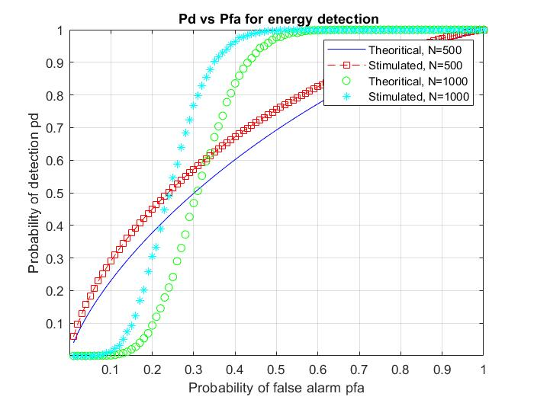

Fig. 5.1. Pd vs Pfa for energy detection

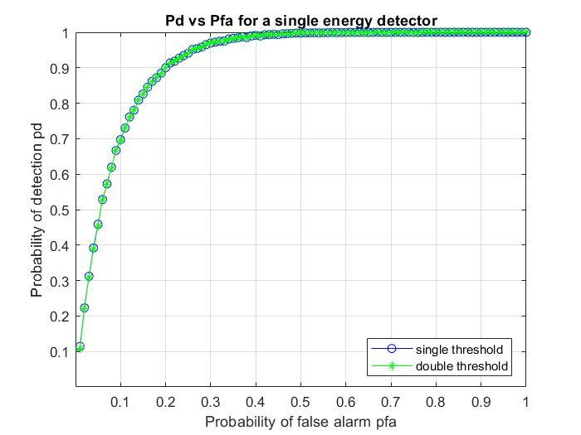

Fig. 5.2. Pd vs Pfa for a single energy detector

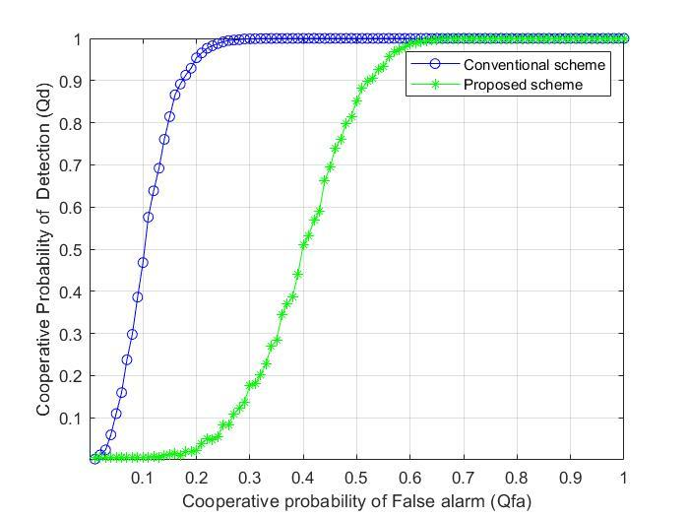

Fig. 5.3. Pd vs Pfa for conventional CSS and Proposed CSS.

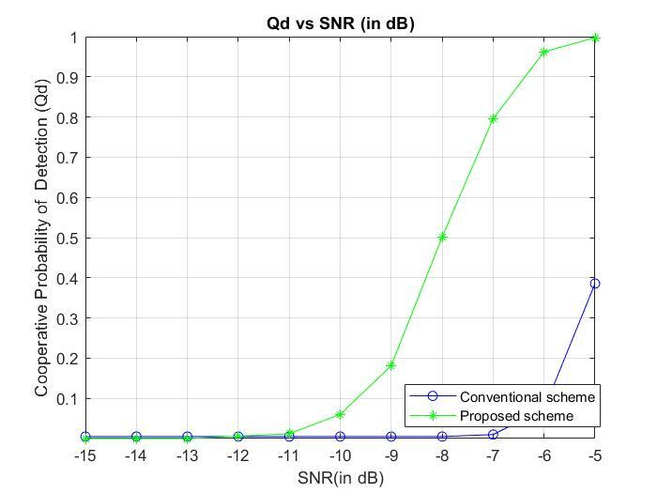

Fig. 5.4 Qd vs snr (in dB)

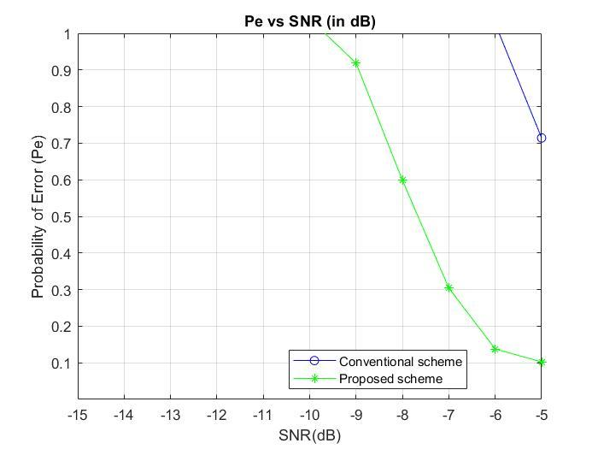

Fig. 5.5. Pe vs snr (in dB)

## 6.Result Analysis:

Observed energy values and local decisions are the two types of decisions FC receives. We have proposed a scheme under which FC averages the observed energy values and compares them with threshold λ to make a decision Lf. Then FC combines all the local decisions received from SUs and decision Lf by OR rule of fusion to make a global decision. Employing the proposed scheme resulted in a significant improvement in detection performance. Furthermore, the problem of sensing failure has been eliminated. In the future, optimization between the spectrum sensing performance and overhead burden because of sending the energy values to the FC can be explored.

## 7. Conclusion:

Studies have been carried out on spectrum sensing based on energy detection in Cognitive Radio Networks. Simulations were carried out and graphs of the probability of detection vs. the probability of false alarm were observed and analysed. The detection probability increases for the increase in false alarms. A significant reduction in the probability of missed detection has been achieved with this sensing technique as evidenced from the simulation results. SNR affects the detection probability as well. Detection probability is greatly influenced by SNR. Detection probability increases with an increase in SNR. Hence, we almost obtain the final result on energy detection according to our expectations. By using the previous Energy detector, we implemented the concept in co-operative spectrum sensing for better performance. It is well-known that the energy detector's performance is susceptible to uncertainty in noise power under such cases alternate detection schemes such as Cyclic feature detection.

By this paper, we conclude that the double threshold cooperative spectrum sensing is based on the conventional energy detection technique is the best technique where it can reduce the total error rate by finding 2 thresholds in the conventional energy detection.

**References:**

1. Mitola, Joseph (2000), ["Cognitive Radio](http://kth.diva-portal.org/smash/record.jsf?pid=diva2:8730) - [An Integrated Agent Architecture for Software Defined Radio"](http://kth.diva-portal.org/smash/record.jsf?pid=diva2:8730), *Diva* (Ph.D. Dissertation), Kista, Sweden: [KTH Royal Institute of Technology](https://en.wikipedia.org/wiki/Royal_Institute_of_Technology), [ISSN](https://en.wikipedia.org/wiki/ISSN_(identifier)) [1403-5286](https://www.worldcat.org/issn/1403-5286)
2. V. Valenta et al., ["Survey on spectrum utilization in Europe: Measurements, analyses and observations"](http://hal.inria.fr/docs/00/49/20/21/PDF/paper9220_valenta.pdf), Proceedings of the Fifth International Conference on Cognitive Radio Oriented Wireless Networks & Communications (CROWNCOM), 2010
3. ["Cognitive Functionality in Next Generation Wireless Networks"](https://web.archive.org/web/20081118234117/http:/grouper.ieee.org/groups/scc41/files/Communications_Magazine_article_on_SCC41.pdf)(PDF)*. Archived from*[the original](http://grouper.ieee.org/groups/scc41/files/Communications_Magazine_article_on_SCC41.pdf)(PDF)*on 18 November 2008*. Retrieved 6 June 2009*.*
4. H. Sun, A. Nallanathan, C.-X. Wang, and Y.-F. Chen, ["Wideband spectrum sensing for cognitive radio networks: a survey"](http://ieeexplore.ieee.org/xpl/articleDetails.jsp?reload=true&arnumber=6507397), IEEE Wireless Communications, vol. 20, no. 2, pp. 74–81, April 2013
5. Carlos Cordeiro, Kiran Challapali, and Dagnachew Birru. Sai Shankar N. IEEE 802.22: An Introduction to the First Wireless Standard based on Cognitive Radios JOURNAL OF COMMUNICATIONS, VOL. 1, NO. 1, APRIL 2006
6. Z. Li, F.R. Yu, and M. Huang, ["A Distributed Consensus-Based Cooperative Spectrum Sensing in Cognitive Radios"](http://ieeexplore.ieee.org/xpl/freeabs_all.jsp?arnumber=5229125), IEEE Trans. Vehicular Technology, vol. 59, no. 1, pp. 383-393, Jan. 2010.
7. H. Uchiyama, K. Umebayashi, Y. Kamiya, Y. Suzuki, T. Fujii, F. Ono and K. Sakaguchi "Study on cooperative sensing in cognitive radio-based ad-hoc network", Proc. IEEE PIMRC 2007, pp.1 -5 2007.
8. S. Zarrin and T. J. Lim "Belief propagation on factor graphs for cooperative spectrum sensing in cognitive radio", Proc. IEEE DySPAN 2008, pp.1 -9 2008
9. E. Visotsky, S. Kuffner and R. Peterson "On collaborative detection of TV transmissions in support of dynamic spectrum sharing",
10. C. R. Stevenson, G. Chouinard, Z. Lei, W. Hu, S. J. Shellhammer, and W. Caldwell "IEEE 802.22: The first cognitive radio wireless regional area network standard", IEEE Commun. Mag., vol. 47, no. 1, pp.130 -138 2009
11. P. Verma and B. Singh, "Simulation study of double threshold energy detection method for cognitive radios," 2015 2nd International Conference on Signal Processing and Integrated Networks (SPIN), 2015, pp. 232-236, DOI: 10.1109/SPIN.2015.7095276.
12. Ay, A. M. (2020). Energy Detection-based Spectrum Sensing In Cognitive Radio Networks. *Academic Perspective Procedia*, *3*(1), 576–582. https://doi.org/10.33793/acperpro.03.01.109