**PAL – Princeton Academic Linker**

Perhaps one of the most important academic tools at Princeton is Blackboard. It provides students a number of different ways to get information about their courses, and also facilitates interaction between professors and their class. However, while Blackboard has these features, they are poorly presented to the user, thus making for a frustrating online experience.

Also, the Princeton academic experience online today has a number of other tools tied into it. Students also use the Integrated Course Engine (ICE), to select classes and coordinate with friends about them, and Piazza, which many classes use as an online discussion forum. Students also use a separate website called SCORE to sign up for courses.

In an increasingly interconnected world, and rising stress levels for students at Princeton, it becomes important to easily access their course information online. Thus, we present PAL – Princeton Academic Linker, your friend through your online academic experience at Princeton. PAL not only makes the frustrating Blackboard interface user friendly and easy to navigate, it also connects users with their other online academic tools – ICE, Score and Pizza.

**The Story of Mo**

***The Blackboard Frustrations***

Meet Mo. Mo is a high achieving Princeton student, who has no time to deal with unnecessary delays because of bad user interfaces. Let us meet Mo on the day before her ENG 385: Children’s Literature final exam. Mo is frantically looking for her notes to finish last minute reading and study. She obviously logs on to Blackboard to find her readings.

This is the page she sees:

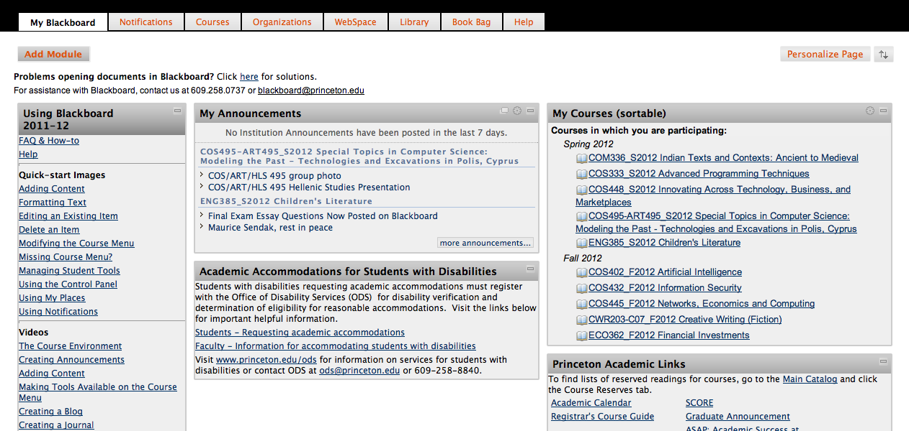

The unaesthetic look of Blackboard slightly rankles her already stressed mind, but she pushes it back and clicks on the course from the panel on the right. This takes her to the Announcements page of the course.

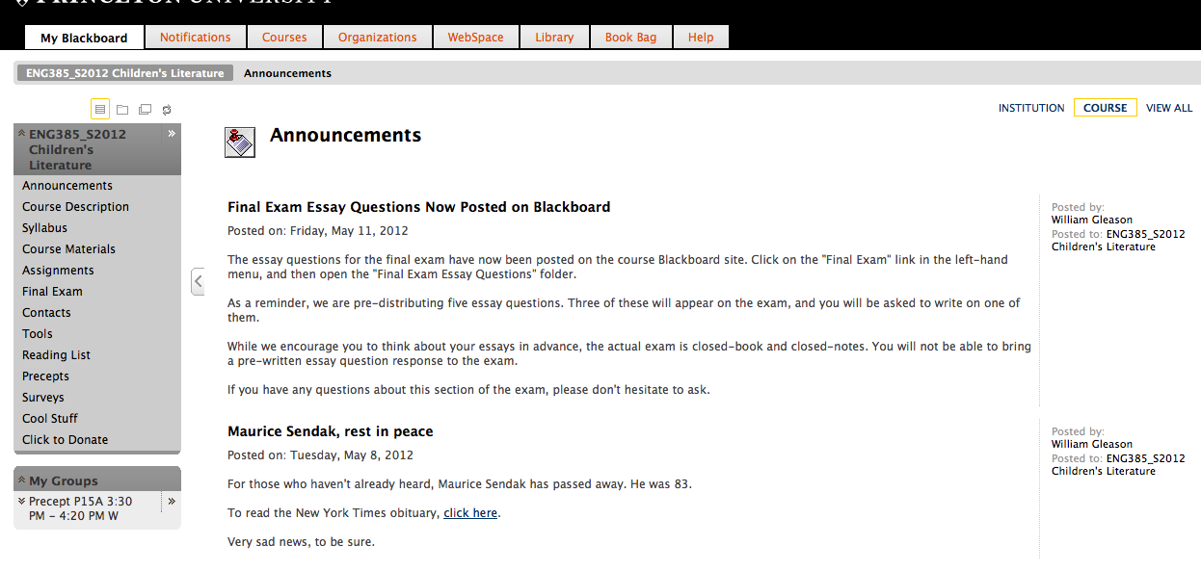

She sees that the professor has posted final exam questions under the final exam tab. She starts looking through the tab trying to find this new one the professor just decided to put up. With each tab, her frustration levels begin to rise, until she finally finds the final exam tab.

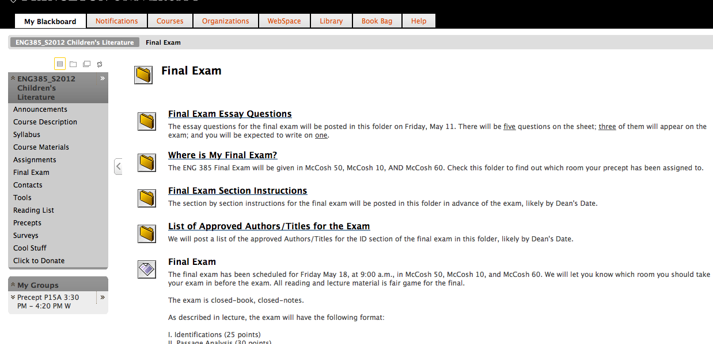

After going through the relevant files, Mo decides to go back to her readings and tries to find the course materials tab. She once again goes through the same bout of frustration, knowing she has accessed course materials countless times and yet cannot find it in a millisecond. As she browses through tabs, she finds tabs she never uses such as “Cool Stuff”. Mo likes cool stuff, but not the night before her exam.

After course materials, Mo decides to look through the Assignments tab, to find previous assignments and review them. Once again, the same bouts of frustration attack her.

After finally getting information, she decides she has a question to ask her classmates and tries to go to Piazza. She opens up the tenth tab in her cluttered Chrome browser, and wishes, for a second, that she could have simply pulled up Piazza inside Blackboard. After a series of intense discussions on Piazza, Mo thinks she needs a break from literature and decides to procrastinate the way every Princeton student does at the end of the year – looks at courses for the next semester. She pulls up ICE in another tab and reworks her schedule. But now, before getting back to work, she must fix her course schedule on Score. This would also give her a chance to take another look at her mid-term grades for her class. She cannot be bothered to look through grades on Blackboard because they are buried deep within the treacherous trenches of the Tools tabs, amongst countless tools no one at Princeton has ever used or thinks about using. Princeton students are brave, but not brave enough to waste valuable time navigating the treacherous tools.

Finally, after Mo’s mentally exhausting endeavours, she decides to return to Blackboard and continue studying for the final. And, once again, she faces the tragically unaesthetic and frustrating creature called the Blackboard interface.

As one can see, life as a Princeton undergraduate is difficult, and Mo’s story is familiar, in some form or the other, to most of us here. COS 333 provided us the perfect opportunity to revamp this story, so studying and stress becomes just a little easier for all of us to handle.

Enter PAL – Princeton Academic Linker, who is Mo’s friend through her online academic journey. Let us now lead Mo through PAL, showing her just how it can help make her journey a little simpler.

***Mo’s New PAL***

Mo had trouble dealing with ENG 385: Children’s Literature. PAL will now walk her through the same course, and show how it can make the navigation easier and more intuitive.

After installing PAL and logging in, the first page Mo sees is the following:

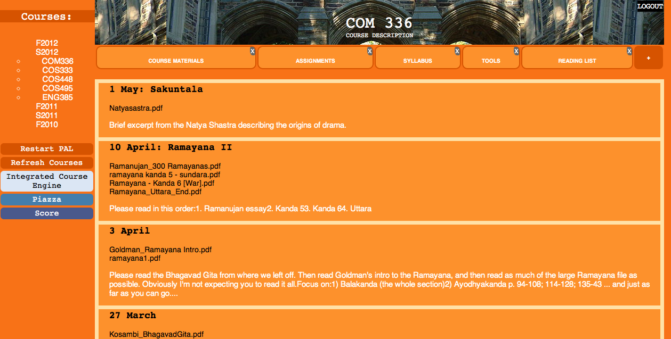

The current semester tab (Spring 2012) will be open and the very first course in the semester (in alphabetical order) will be displayed. To switch to her desired course, Mo simply needs to click on it from the left hand tab, in which each semester is displayed in reverse chronological order, with the latest semester on top.

If she looks carefully, Mo will see that though Fall 2012 is displayed above Spring 2012, since she has signed up for classes for that semester, it is closed, since it is not currently needed. Thus, PAL is highly intuitive, giving Mo all her semester and courses in an ordered, easy to access manner. Also, ordered alphabetically on the side, finding the required course is easier.

When Mo clicks on ENG 385, here’s what she sees:

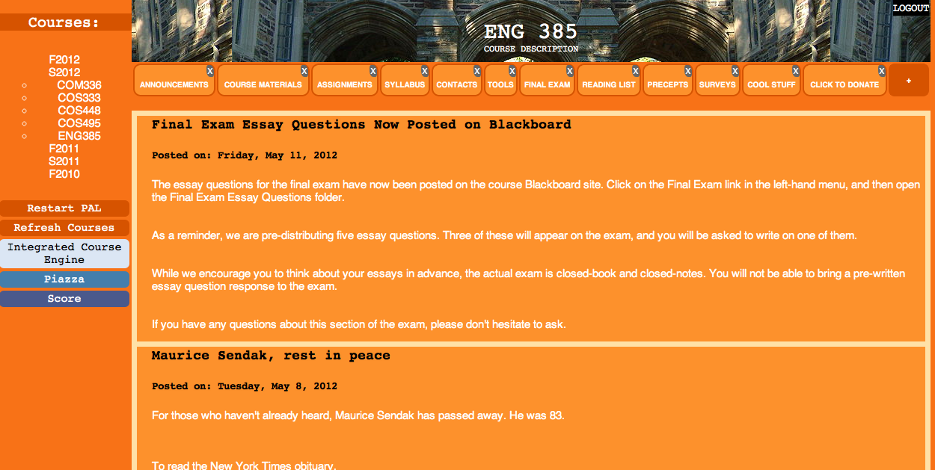

The tab bar on top consists of each of the tabs in the right of the course page from the original Blackboard interface. Since the course has so many tabs, the bar currently looks cluttered. However, as we know, Mo does not use more than half of these tabs on a regular basis and would rather have a tab bar which only consists of resources she frequently uses. PAL helps her do just that.

Clicking on the little gray ‘X’es on the top right corner of each of the tabs gets rid of the tabs, un-cluttering the tab bar and leaving only those which Mo uses regularly. Here is what her tab bar looks like, once she removes tabs she doesn’t really need.

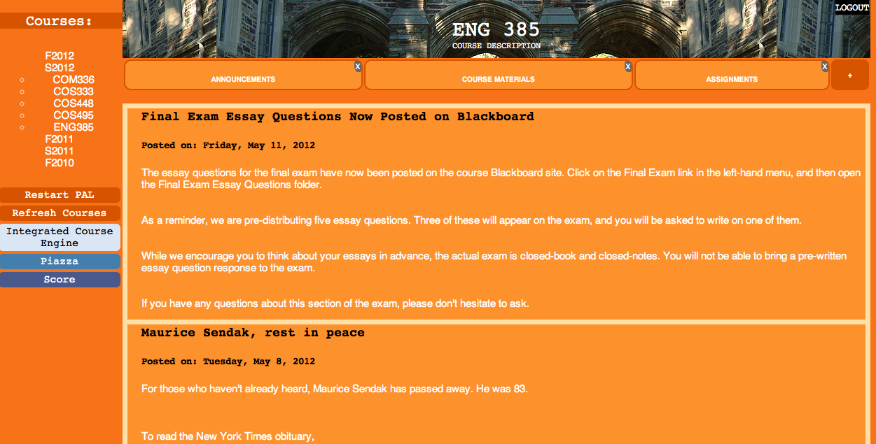

The screen now only contains the 3 most frequently used tabs for Mo, and looks cleaner and is much easier to navigate.

Now, Mo suddenly remembers she might like to have her Tools tab up there, since the treacherous tools contain her grades, and she might need to navigate through to check those, especially grades for individual assignments which aren’t posted on Score.

No problem, Mo simply hovers on the little plus sign at the end of the tab bar towards the right, which reveals a drop down menu consisting of removed tabs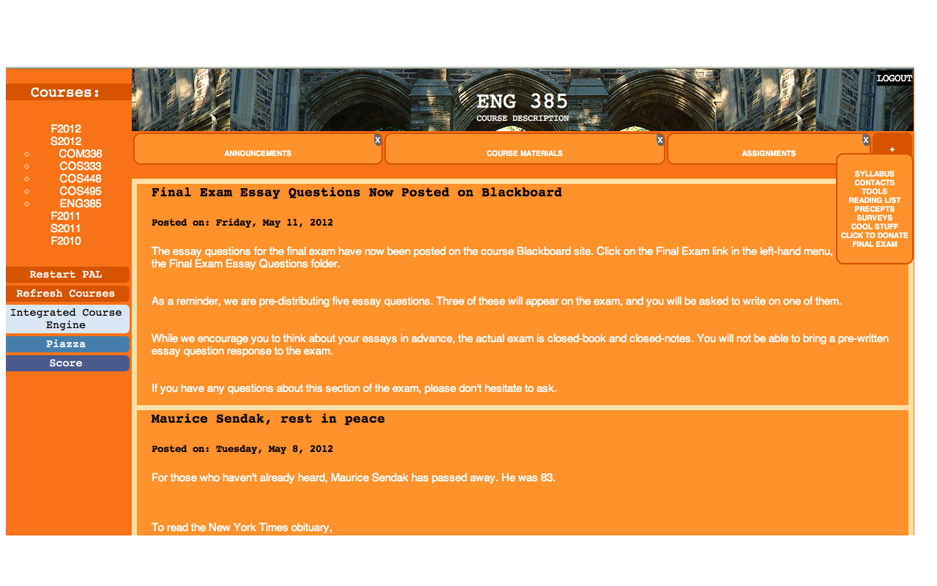

Mo simply clicks on the Tools tab and Tools is back on top. But wait, PAL can make life even easier for Mo. She no longer has to fear the Treacherous Tools. Upon opening Tools, Mo sees that each of the tools has been placed in a relatively simpler list, unlike the previous jumble.

*Old Tools*

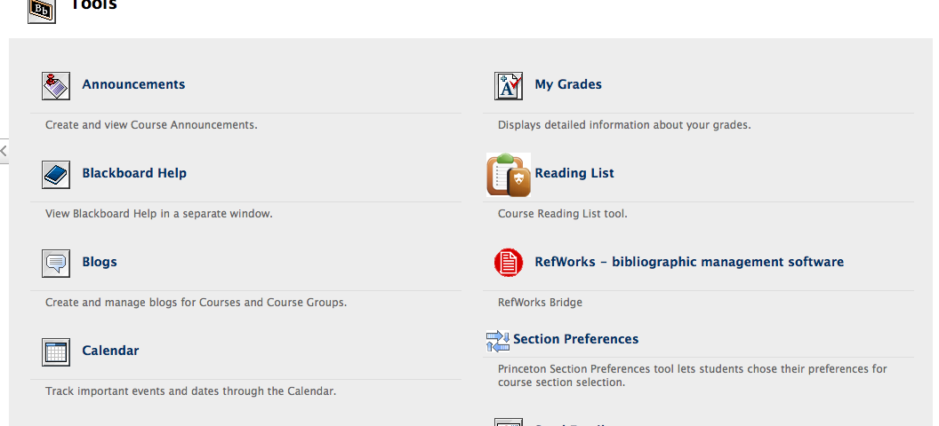

*New Tools*

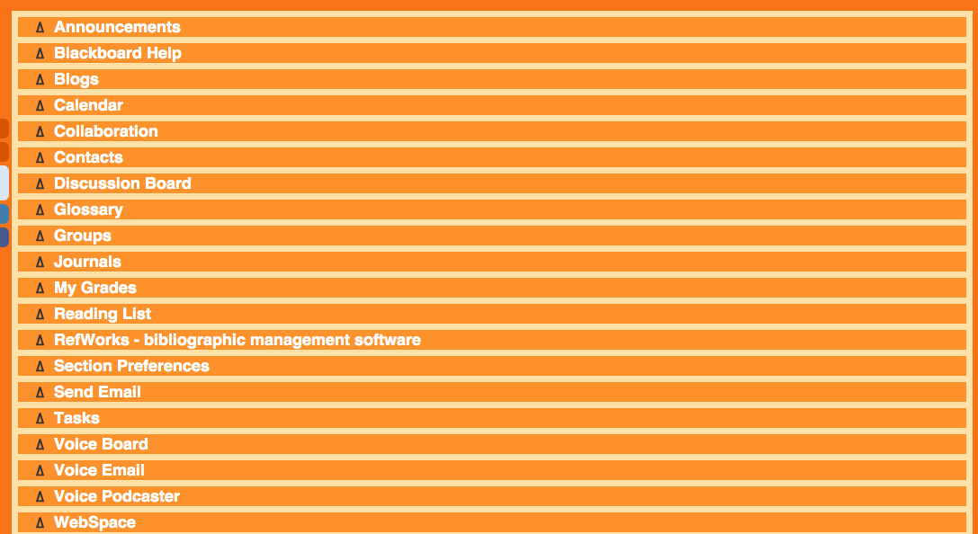

But life can be even better. PAL gently asks Mo to click on the tiny triangle or delta next to the tools she uses most. Naturally, Mo chooses to click on the triangle next to My Grades.

Lo and behold! My Grades has now been transferred into its own tab in the tab bar!

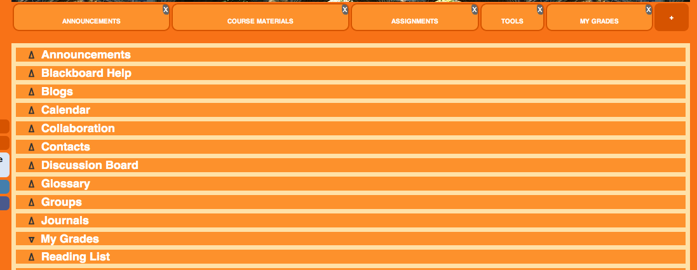

Now Mo can simply get rid of the Tools tab and clean up her tab bar. No longer does she have to navigate the Treacherous Tools to access any one of them. PAL also gives her the choice to remove any of the tool tabs either by going back to Tool and clicking on the (now) inverted triangle next to the tool, or simply clicking on the ‘X’ and removing it.

Mo is very happy. Blackboard seems a lot simpler to deal with now that she has a PAL to help her. But, there are a few more things PAL needs to show her. After all, it is called the Princeton Academic LINKER. How can PAL ever live up to its name if it doesn’t link her with the rest of her online academic life.

The next time Mo decides she needs to ask a question on Piazza while working on her assignment on Blackboard, PAL gives her a simple way to do this. All Mo needs to do is click on the Piazza button at the bottom of the semester tabs on the right. This opens Piazza in the PAL frame.

*Piazza*

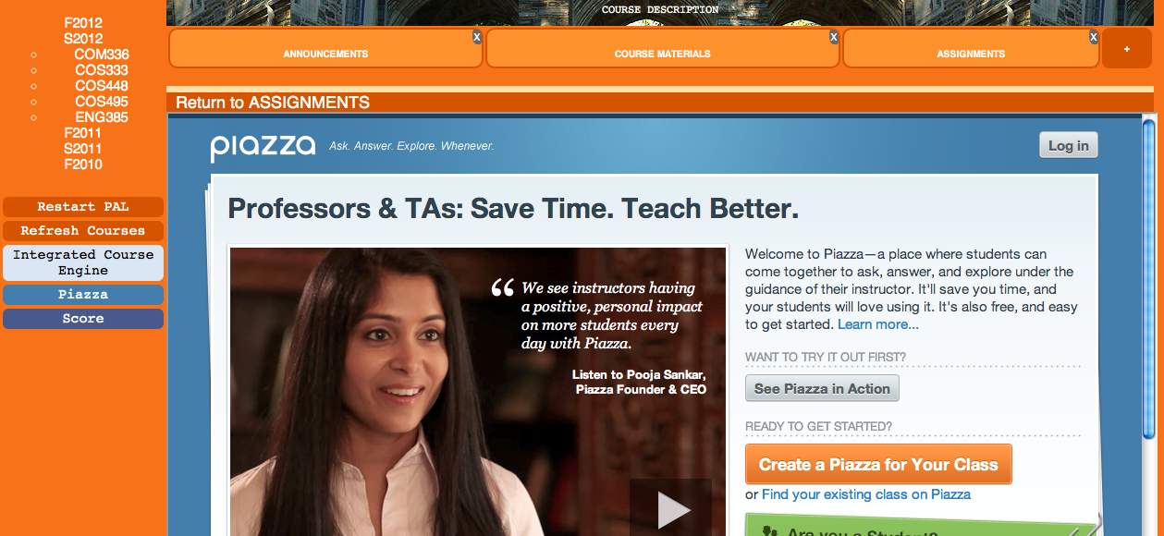

All Mo needs to do is log onto her Piazza account and participate in the discussion, all through the PAL frame. When she needs to return to the Assignments page, she simply clicks on Return to ASSIGNMENTS at the top of the frame and it takes her back.

PAL also aids Mo in her constructive procrastination, as she reworks course schedules on ICE, and checks Score. All she needs to do is click on the Integrate Course Engine button (the Icy blue) or the Score button.

*ICE*

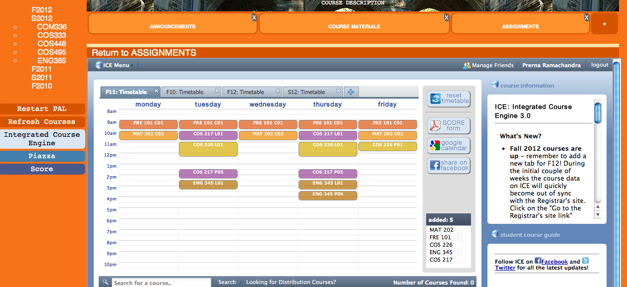

*SCORE*

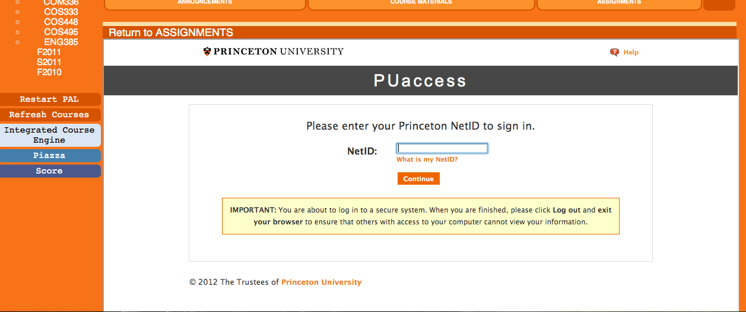

The Score button also takes Mo directly to the Score login page, rather than the registrar’s page which contains a link to the login page, where the URL for score originally takes her if she tried to go through the regular browser window.

Mo is now very happy. Studying for her final, she can now concentrate on what is important – the studying, rather than dealing with an interface that is clunky, unintuitive and just plain frustrating to navigate. Not only does PAL provide simpler navigation tools, it also gives the user a clean interface, keeping only those elements that are necessary and important. The orange adds a touch of color, without bombarding the user with multiple rainbow hues, but also preventing the screen from looking drab and boring. After all, a touch of brightness to continuous hard work helps makes the hard work a little more fun, no matter how interesting or tedious the coursework.

**A True PAL to Help Navigate the Online Academic Experience**



PAL helps make the online academic experience easier and more intuitive. As students deal with the daily pressures of everyday life, a large part of which are academic, PAL is an attempt to reduce those pressures, in an avenue which need not be a source of pressure. It makes the task of interacting with a course online a pleasant process, one which is informative and useful, cutting out unnecessary and often unaesthetic interfaces and tools.

PAL thus brings together the very best features of Blackboard, recognizing their purpose and importance, and creates around them a platform through which students can quickly and easily access course information. It further connects students with the most common resources in the online academic toolkit and brings them all together under one common, user friendly portal. Hence, PAL is a friend which makes life a little easier for Princeton Tigers.