Multipoint Test Report

Basic Information

ESSID: HAN-Employee

Vendor: [ALCATEL LUCENT ENTERPRISE]

Terminal Model: Xiaomi MI8

Terminal MAC: 94:87:E0:1B:94:EF

Start Time: 2020-03-04 11:11:56

End Time: 2020-03-04 11:13:30

Number of Points: 3

Points Test Pass Rate: 0%

Roaming Lines: 1

Test Map



Point Test

Point 1

**Basic Information**

BSSID: DC:08:56:34:7B:88

AP Manufacturer: ALCATEL LUCENT ENTERPRISE

Testing Time: 2020-03-04 11:12:00

Aggregated Test Result: unqualified

**Signal Strength Test**

None

**Ping Test**

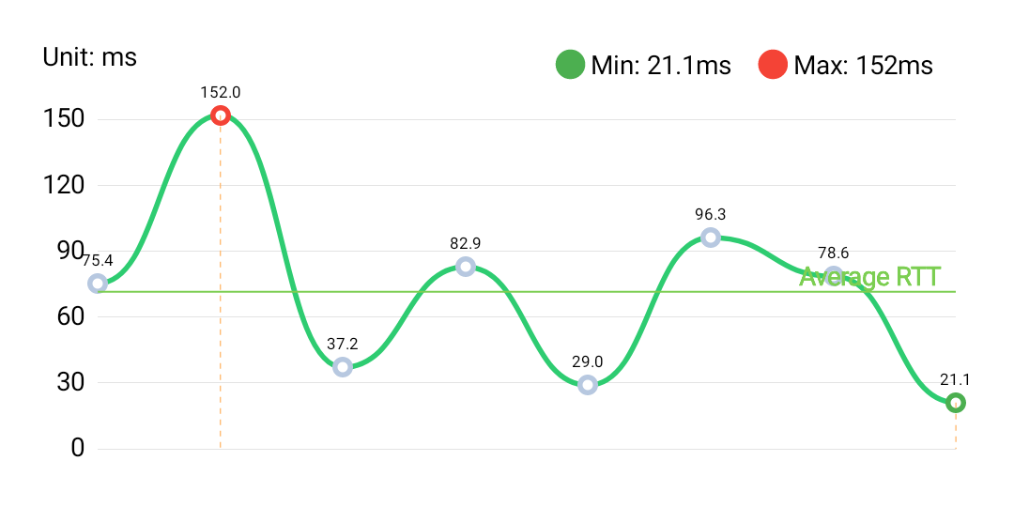

|  |  |  |  |  |
| --- | --- | --- | --- | --- |
| **Ping Address** | **Sent Packets** | **Average RTT** | **Lost Rate** | **Max/Min RTT** |
| 192.168.65.254 | 8 | 71.56ms | 0% | 152 / 21.1 ms |

Note: standard average RTT: 50ms, standard lost rate: 0.03%.

**Throughput Test**

None

Point 2

**Basic Information**

BSSID: DC:08:56:34:7B:88

AP Manufacturer: ALCATEL LUCENT ENTERPRISE

Testing Time: 2020-03-04 11:12:14

Aggregated Test Result: unqualified

**Signal Strength Test**

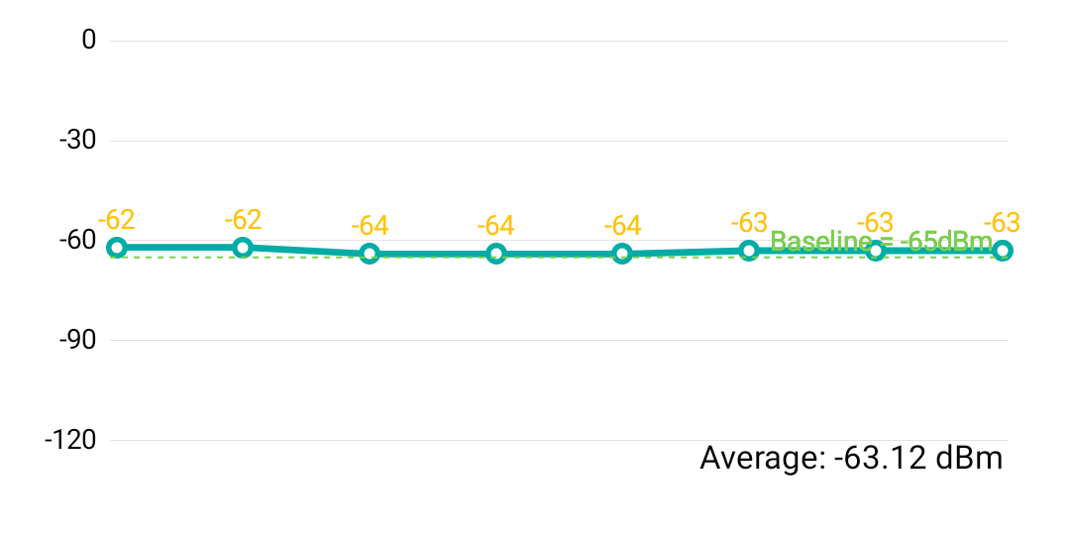

Testing Times: 8

Average value: -63.1 dBm (Better than standard value: -65 dBm)

**Ping Test**

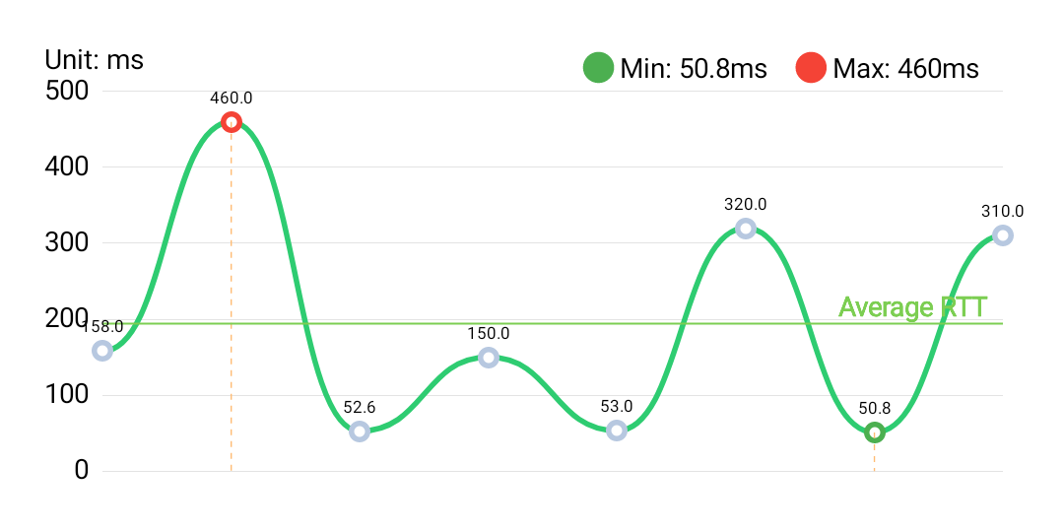

|  |  |  |  |  |
| --- | --- | --- | --- | --- |
| **Ping Address** | **Sent Packets** | **Average RTT** | **Lost Rate** | **Max/Min RTT** |
| 192.168.65.254 | 8 | 194.3ms | 0% | 460 / 50.8 ms |

Note: standard average RTT: 50ms, standard lost rate: 0.03%.

**Throughput Test**

Test Server:

Average download speed: 0 Mbps (Worse than standard value: 2.0 Mbps)

Average upload speed: 0 Mbps (Worse than standard value: 2.0 Mbps)

Point 3

**Basic Information**

BSSID: DC:08:56:34:7B:88

AP Manufacturer: ALCATEL LUCENT ENTERPRISE

Testing Time: 2020-03-04 11:12:44

Aggregated Test Result: unqualified

**Signal Strength Test**

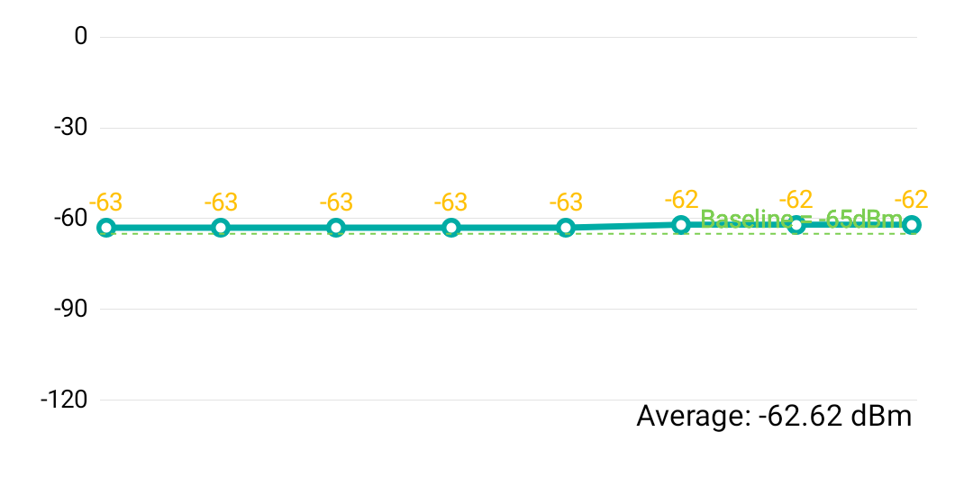

Testing Times: 8

Average value: -62.6 dBm (Better than standard value: -65 dBm)

**Ping Test**

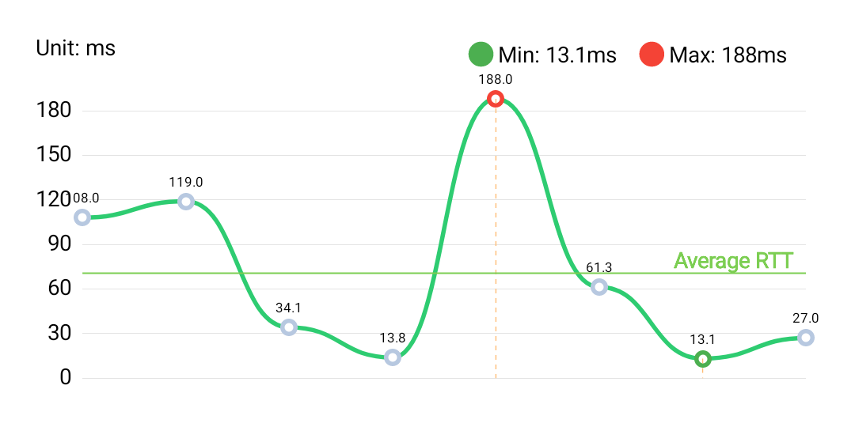

|  |  |  |  |  |
| --- | --- | --- | --- | --- |
| **Ping Address** | **Sent Packets** | **Average RTT** | **Lost Rate** | **Max/Min RTT** |
| 192.168.65.254 | 8 | 70.54ms | 0% | 188 / 13.1 ms |

Note: standard average RTT: 50ms, standard lost rate: 0.03%.

**Throughput Test**

Test Server:

Average download speed: 0 Mbps (Worse than standard value: 2.0 Mbps)

Average upload speed: 0 Mbps (Worse than standard value: 2.0 Mbps)

Roaming Test

Line 1

Start and End Points: Point 2 → Point 3

Start Time: 2020-03-04 11:12:42

End Time: 2020-03-04 11:12:44

Roaming occurs: No

Disconnection occurs: No

Average RSSI: -62.3 dBm

Min RSSI: -63 dBm



Powered by WeiYi