**Proposed level of achievement**

Gemini

**Scope**

One sentence version:

We provide an online booking system for all the seminar/meeting rooms and facilities at Ridge View Residential College.

Long descriptive version:

The website provides information regarding the state of rooms and facilities inside. Upon login, the student is able to make or cancel his/her booking of the room on behalf of his/her group. The administration staff is able to keep track of the room usage and booking requests easily.

**Motivation**

At the end of the semester, you, a RVRC student, are about to prepare for your oral presentation for your group project, which you did with your fellow RC mates. The discussion rooms in RVRC are the best choice for your practices. They are equipped with facilities that can help simulate a similar environment for the actual presentation. However, you are not the only one eyeing at the discussion rooms. At the same time, more than fifty other groups are thinking the same as you. To secure the precious 2-hr usage of the discussion room, you will have to go to each discussion room, and check the hand-written booking schedule pasted onto the door of the room. 5 minutes have past and you finally finish checking all the doors with false hope. While telling your groupmates about the bad news, you are not aware that there is another group who made full use of the rule that one person can only book the room for 2 hours each day --- the group successfully booked the room for the whole day using different names.

Above is a scenario that frequently happens to a RVRC student during the presentation season. From the scenario, we can see that there are several problems with the system above:

For the students:

1. It is time consuming
2. It is easily exploited without any cost:
   1. Multiple bookings by the same group
   2. Inability to regulate and monitor bookings and cancellations (e.g. some people use other people’s names to book the room without asking for permissions or cancel your booking by striking it through)
3. The room resources are allocated unfairly
4. It is insecure --- the paper schedule is easily lost or tampered with

For the administration staff:

1. It is strenuous to monitor the state of the rooms (e.g. compare the booking schedules for different rooms to check for repetitive booking; maintain a log for room usage and the state of facilities etc.)

**Aim**

We aim to build a website that allows for online booking and monitoring of the state of the rooms during the presentation season.

**Features**

Below are the features we would like to implement:

|  |  |  |  |
| --- | --- | --- | --- |
| Feature | User role | Desired outcome and benefit | Remark |
| 1. RVRC students and staff login | Current RVRC students and staff are to login to the system using NUSNET ID | * To prevent outsiders from manipulating the system * To allow for group registration (Feature 2) * To allow the staff to monitor the booking made by groups | Implemented    Fig1. Page before login    Fig2. Login page |
| 1. Group Registration | RVRC students are to register their groupings on the system | * To prevent multiple booking by a single group | To be implemented |
| 1. Indication of state of rooms | RVRC students and staff are able to check which rooms are still available | * To allow for viewing of the availability of the room | Implemented    Fig3. Showing room status |
| 1. Make a booking | RVRC students are able to book the room | * To allow a group to book a room for 2hr each day; any member of the group can make the booking | Implemented    Fig4. Booking page    Fig5. Confirmation page    Fig6. Status after booking |
| 1. Cancellation of booking | RVRC students are able to cancel their booking of the room | * To allow a group to cancel their booking; any member of the group can cancel the booking | Implemented    Fig7. Cancellation page |
| 1. Report of irresponsible room usage | RVRC students and staff are able to report the irresponsible behaviors when using the rooms. The report will then be processed by admin. | * To maximize the room usage * If the report is accepted, the group being reported will receive a warning (Feature 10) | To be implemented |
| 1. Display of number of warnings that the group receives | RVRC students are able to view the number of warnings their own group has received. | * To deter irresponsible room usage | To be implemented |
| 1. Management of the state of the room and facilities by admin | RVRC admin is able to change the state of the rooms and facilities displayed on the website | * To update the state of rooms quickly | To be implemented |

**Testing**

We have mainly tested out 3 features.

1. **Login using NUSOPENID**

Sign in to RVRC booking system using our NUSOpenID.

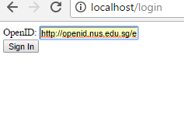

Fig1.

Authentication page

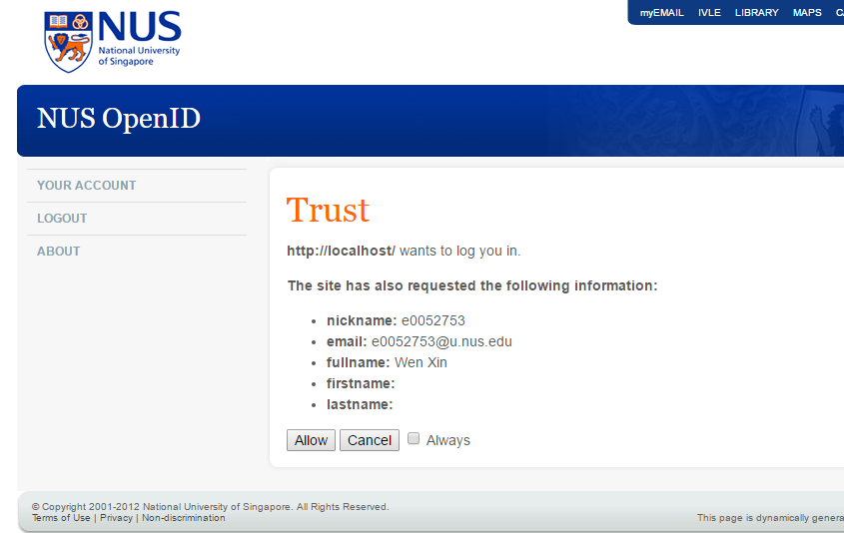

Fig2.

After authentication, you will be directed to this personal information page. If you want to continue with booking, click the book button.

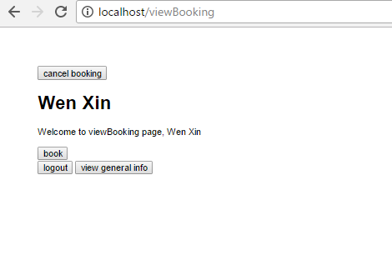

Fig3.

1. **Booking**

After clicking the book button on the personal information page, you will be directed to this booking info page. There is a book bottom below every room. If you want to book the room, just click the book bottom below the room number.

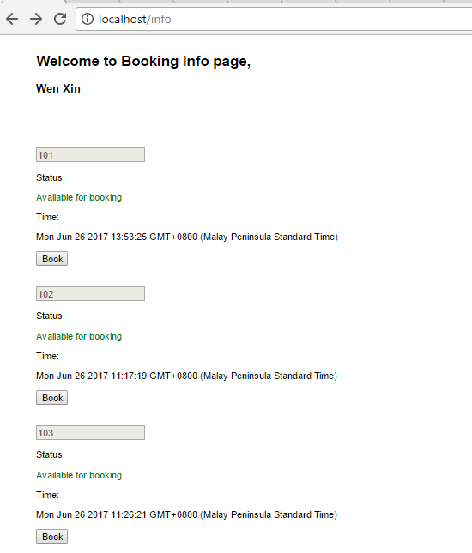

Fig4.

After clicking the book bottom, you will be directly to this page for confirmation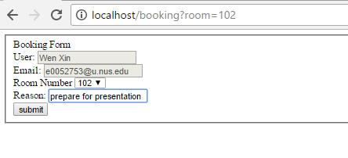

Fig5.

Page for successful booking

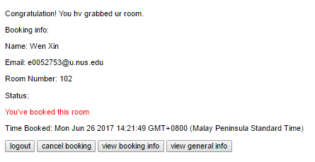

Fig6.

If you return to the personal information page, the booking status will be updated

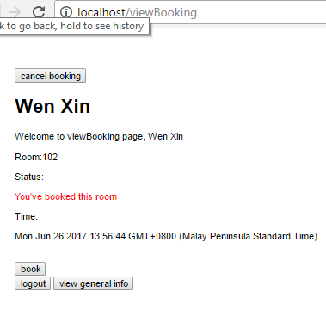

Fig7.

If room 105 is booked by another user (as shown by the database in fig8), then the booking status for room 105 will be updated to unavailable for booking (shown by fig 9), and you can no longer find room 105 in the booking options (shown by fig 10).

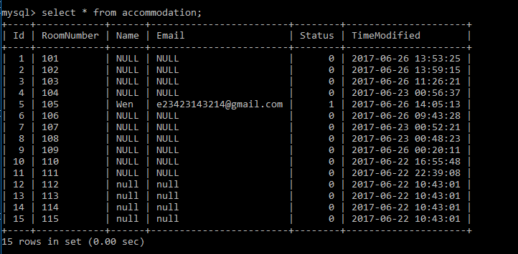

Fig 8.

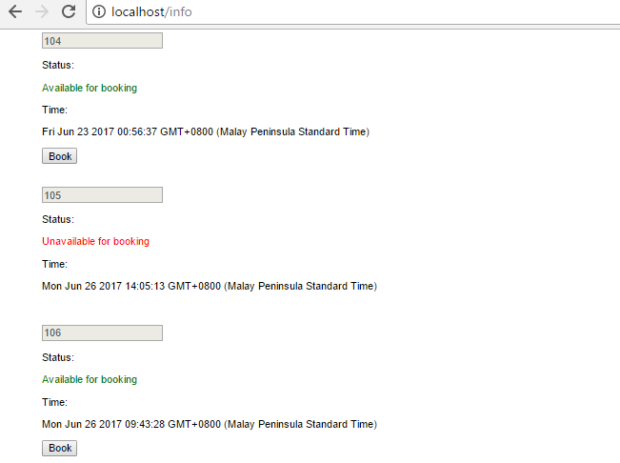

Fig 9.

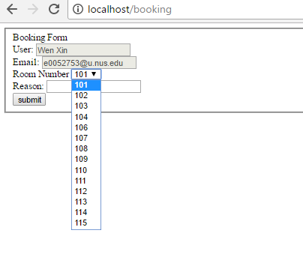

Fig 10.

1. **Cancellation**

One can cancel the booking by clicking the cancel button at the top of the page.

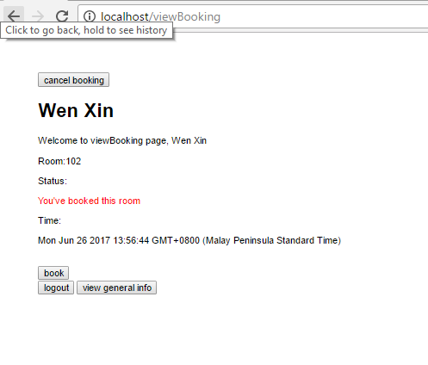

Fig 11.

After clicking the cancel booking button, you will be directly to the cancellation page for confirmation.

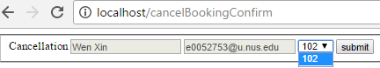

Fig 12.

After cancellation, the booking status for room 102 will be updated to available for booking on the booking information page.



Fig 13.

**A development plan**

|  |  |
| --- | --- |
| 1st and 2nd week of July | Adding other features to the system   * Make the system run on RVRC’s server * Allow the administration team to view the booking record and manage booking * Allow only group registration during the peak season * Reporting system * Display warning * Design and beautify the webpage |
| 3rd week of July | Testing and debugging  Testing will be carried out for RVRC students and admin team separately   * For admin team, we will test out the system by  1. Login using ID to our system 2. Checking the booking record after each booking to ensure the information is updated 3. Sending warnings to the irresponsible teams 4. Collecting the personal information and NUSID for 20 RVRC students (with consent) and make them into 5 groups. Then test out the group booking system  * For students, we will test out the system by  1. Login using NUSID to the system 2. Checking the rooms available for booking 3. Booking a room and checking if the status of the room is updated 4. Booking more than one room and checking whether a warning will be received 5. Students from the same group will try to book two different rooms during the peak season and check whether this will be successful 6. Reporting irresponsible usage of rooms and unfunctional facilities |
| 4th week of July | Final enhancement (if any) |