TFlexiSwitch

Properties
Action : The Action associated with the control
Align : Specifies the placement of the control inside its Parent
Anchors : The set of anchor definitions for this control
BestTextHeight : Automatically adjusts the text height to the size of the control
BidiMode : Customization (of text controls) in bidirectional reading environments
BorderColor : The color of the border (clNone = no Border)
BorderSpacing : Determines the inner and outer border spacing for this control
ButtonColor : The color of the button, Rollimage only visible when ButtonColor = clNone
CaptionAlignment : Alignment of the text in the caption (left, center, right)
CaptionHorMargin : The horizontal distance of the text in the text rectangle (only effective with taLeftJustify)
CaptionLayout : Alignment of the text in the caption (top, center, bottom)
CaptionVerMargin : The vertical distance of the text in the text rectangle (only effective with tlTop)
Checked : Checked corresponds to the Direction Right, inserted for compatibility with radiobuttons. Only at Runtime!
Constraints : The minimum and maximum Width and Height for the control
Cursor : Contains the shape for the mouse pointer when the mouse is over the control
Direction : Specifies whether the button is on the right or left at the start
DisabledColor : The colour at Enable:=false, only at runtime!
DragCursor : The cursor shape shown while the control is dragged
DragKind : The operation when the control is dragged - Drag or Dock
DragMode : Allows the user to drag the control
Enable : Determines whether the control reacts on mouse or keyboard input
EnabledBlendFaktor : How translucent is the DisabledColor (1=opaque,0=transparent), only at runtime!
FocusColor : The color when the Control has the focus (clNone = no focus is shown)
FocusBlendFaktor : How translucent is the focusColor (1=opaque,0=transparent)
Font : The font to be used for text display in this button
GroupIndex : Indicates when the button has focus, switches on off
Height : The vertical size of the control.
HelpContext : The ID for context-sensitive Help on this control
HelpKeyword : The keyword for context-sensitive Help on this control
HelpType : Determines whether context-sensitive Help is selected by numeric ID or keyword
Hint : The text to show in the Hint window for the control
HoverBlendFaktor : How translucent is the HoverColor (1=opaque,0=transparent), only at runtime!
HoverColor : The color of a hoverevent (clNone = no hover)
ImgSizeFactor : To compensate if images with <>64px are loaded with LoadfromFile
Left : The client coordinate of the left edge of the control
LeftBgrdColor : The Left background colour
LeftCaption : The caption that is displayed when the button is on the left
LeftImageIndex : The Index of the loaded left image
NewRollImage : Starts the property editor to select loaded images
PopupMenu : A context-sensitive menu that pops up when the right mouse button is clicked over this control
RightBgrdColor : The Right background colour
RightCaption : The caption that is displayed when the button is on the right
RightImageIndex : The Index of the loaded right image
Roll : Determines whether the RollButton (Image) rotates
Rotation : The steps by rotation
Speed : The speed at which the button moves
SwitchMode : Der Modus mit dem der Schalter betätigt wird, klicken oder schieben
TabOrder : Determines the sequence of control navigation when the user presses the Tabkey
TabStop : Allows the user to navigate to this control, by pressing the Tabkey
Top : The client coordinate of the top edge of the control
Visible : Allows to show or hide the control, and all of its children
Width : The horizontal size of the control.

Public procedures
procedure LoadImagesfromFile(LeftFilename,RightFilename: string);

Events
OnChange : Returns the Index of the checkbox
OnClick : Notification handler for mouse clicks
OnDirection : Returns the direction of the switch, aLeft and aRight return true or false.
OnDragDrop : This handler determines the action on an drop onto this control, in a drag-drop operation
OnDragOver : Event handler for a control being dragged over this control
OnEndDrag : Notification handler for the end of a dragging operation
OnEnter : Handler for control receiving the focus
OnExit : Handler for control loosing the focus; This is a good place for checking the finished user input
OnKeyDown : Handler for keyboard key pressed
OnKeyPress : Handler for a character entered by the user
OnKeyUp : Handler for keyboard key released
OnLeft : Returns a true value if the button arrives on the left-hand side.
OnMouseDown : Event handler for mouse button going down
OnMouseEnter : Event handler for mouse entering the area of the control
OnMouseLeave : Event handler for mouse leaving the area of the control
OnMouseMove : Event handler for mouse movement within the control
OnMouseUp : Event handler for mouse button going up
OnRight : Returns a true value if the button arrives on the right-hand side.
OnStartDrag : Event handler for the start of a dragging operation

Description
You can find the FlexiSwitch in the Misc tab:
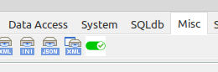

The idea for this switch originated in a contribution from the German Lazarus Forum:
https://www.lazarusforum.de/viewtopic.php?p=137567#p137567

If you place the FlexiSwitch on the form, it looks like this:


It has a width of 60px and a height of 26px. This aspect ratio is always retained when scaling. All loaded images in the scroll button (here the grey cross) have a size of 64px.The maximum size is 175x76px. The images I loaded into the resource are from Roland Hahn (aka "Ally").
Many thanks to Roland!
https://www.lazarusforum.de/viewtopic.php?f=1&t=14263

The FocusColor property can be used to set the colour of the focus frame. FocusAlphaBValue can be used to control the transparency of the focus frame can be regulated. The value 0 means transparent and 1 opaque. FocusFrameWidth determines the thickness of the frame.

Value 0: Value 50: Value 200:




The Direction property can be used to set whether the scroll button is initially on the left or right.
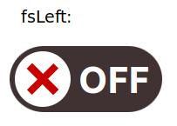
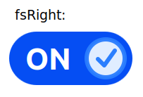

SwitchMode toggles between clicking and sliding to switch the switch.
If you select msClick, a click on the switch is enough to change the status. If msSlide is set, you must drag the scroll button to the other side with the mouse. You can recognise that msSlide is active by a hand cursor.

If the switch has the focus, it can be switched with the enter button!

When changing the scroll button from one side to the other, the button starts to rotate around itself. If you do not want this to happen, you can set the Roll property to false.

With Speed you can set the rotation speed in ms. Rotation sets the angle by which the scroll button rotates per step.

LeftCaption sets the text that is displayed when the Rollbutton is on the left:


RightCaption sets the text that is displayed when the Rollbutton is on the right:

If the BestTextHeight property is true, an attempt is made to display the text as high as possi ble. If the text is too long, you can set BestTextHeight to false and set the font size under Font. The colour of the Font can also be changed there.



The LeftBgrdColor and RightBgrdColor properties can be used to change the background colour of the control. Left and Right always refer to the position of the Rollbutton.



If you change BorderColor to <> clNone, a border is drawn in the selected colour.


If you do not want to use a roll image, but rather a single-colour button, you must set ButtonColor to <> clNone. The button is then drawn in the selected colour.
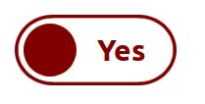

To get a hover effect, set HoverColor to <> clNone. The transparency of the hover colour can be changed with HoverBlendFaktor. Where 0 is transparent and 1 is opaque.

Without Hover Blendfactor 0.2 Blendfactor 0.5
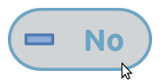
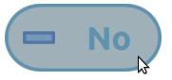

If you set Enable to false so that the switch no longer reacts to inputs, this is indicated by a different colour. The colour can be set with DisabledColor and the transparency with EnabledBlendFaktor. Both properties are only available at runtime!
Enabled: Disabled:



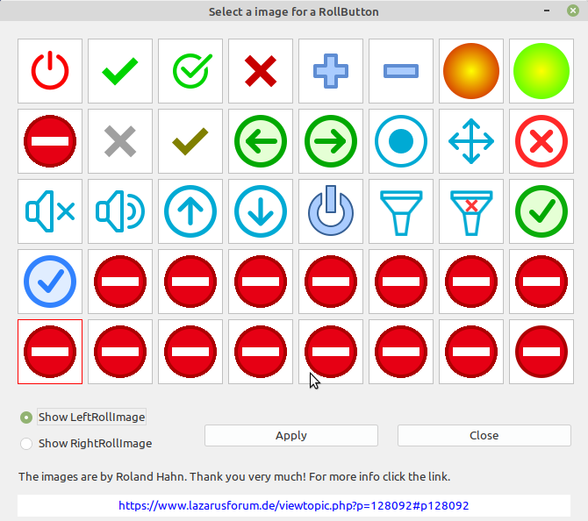
Roll images can be loaded using the property editor. To do this, click on NewRollImage in the object inspector.

The editor opens:

First select the side for which you want to select an image at the bottom left. Click on Apply to transfer the image to the FlexiSwitch and display it immediately.
As you can see, there are still some free spaces to load your own images.
The resource file is loca ted in the Multis directory.

Of course, you can also simply enter the relevant index of the desired image in the OI under LeftImageIndex or RightImageIndex (if you know it).

With LoadImagesfromFile(LeftFilename,RightFilename: string) images can be loaded from a directory. It is important that both images must have the same size! Preferably you should use images with 64px. The ImgSizeFactor property can be used to adjust the size of the loaded images (only at runtime).

If you want a group of FlexiSwitches of which only one should be switched at a time, you must set the GroupIndex to <> 0.
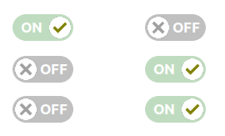
The FlexiSwitch, which initially stands alone, determines the switching direction.

To achieve compatibility with radio buttons, the Checked property is available at runtime.
Checked corresponds to fsRight, not checked to fsLeft.

In addition to the usual events, there are also three special FlexiSwitch events.
The OnLeft event returns a true value when the scroll button arrives on the left-hand side of the control.
The OnRight event returns a true value when the scroll button arrives on the right-hand side of the control.
The OnDirection event returns the direction (i.e. msRight or msLeft) and one Boolean value each for aLeft and aRight.

