**NAMA : WENNY PRASTIWI NIM 18050623024**

**PRODI : D3 MANAJEMEN INFORMATIKA 2018**

**MATA KULIAH JARINGAN KOMPUTER LANJUT**

Menjadikan Linux sebagai server PDC (Primary Domain Controller) dengan client bisa menggunakan OS selain linux misalkan windows, macOS, dan linux sendiri.  
  
ikuti tautan berikut untuk menjadikan Linux sebagai PDC dengan menggunakan samba:  
1. <https://linuxize.com/post/how-to-install-and-configure-samba-on-ubuntu-18-04/>

# How to Install and Configure Samba on Ubuntu 16.04

We’ll create the following Samba shares and users.

Users:

* **sadmin** - An administrative user with read and write access to all shares.
* **hallowen** - A regular user with its own private file share. Shares:
* **users** - This share will be accessible with read/write permissions by all users.
* **hallowen** - This share will be accessible with read/write permissions only by users josh and sadmin.

1. **Installing Samba on Ubuntu**

**Start by updating the apt packages index:**

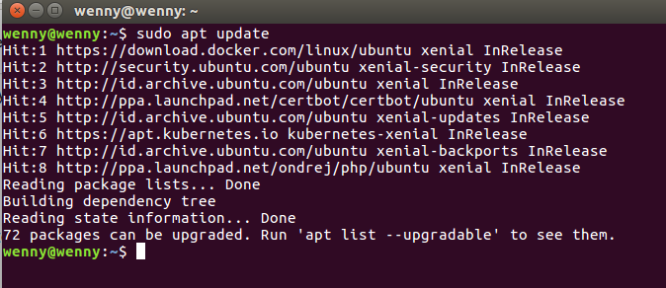

**Install the Samba package with the following command:**

sudo apt install samba

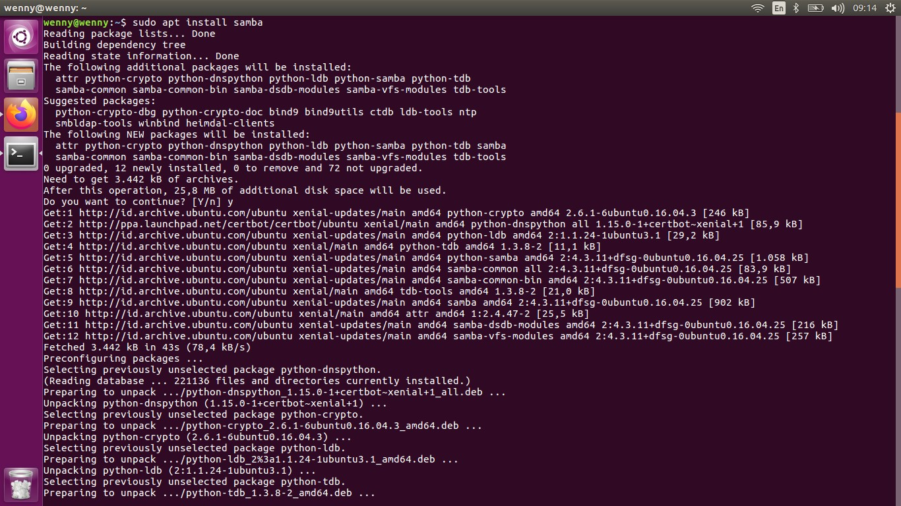

**Once the installation is completed, the Samba service will start automatically. To check whether the Samba server is running, type:**

**sudo systemctl status smbd**

**The output should look something like below indicating that Samba service is active and running:**

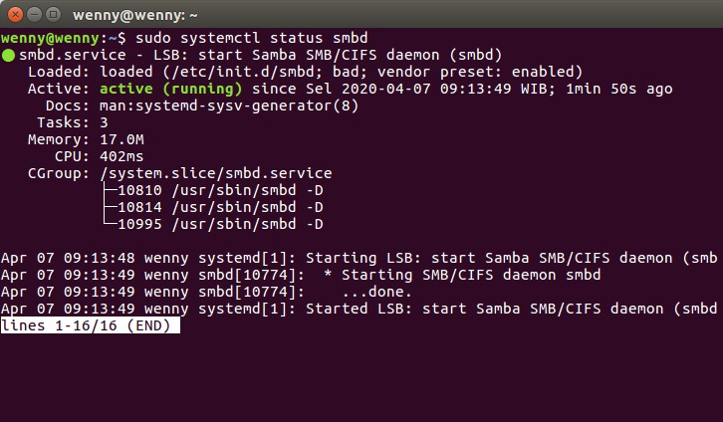

1. **Configuring firewall**

**Assuming you are using** [**UFW**](https://linuxize.com/post/how-to-setup-a-firewall-with-ufw-on-ubuntu-18-04/) **to manage your firewall, you can open the**

**ports by enabling the ‘Samba’ profile:**

sudo ufw allow 'Samba'

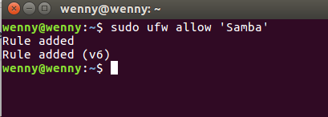

1. **Configuring Global Samba Options**

Before making changes to the Samba configuration file, create a backup for future reference purposes:

sudo cp /etc/samba/smb.conf{,.backup}

The default configuration file that ships with the Samba package is configured for standalone Samba server. Open the file and make sure server role is set to standalone server

sudo nano /etc/samba/smb.conf

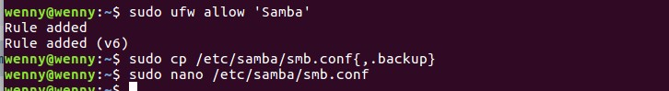

By default, Samba listens on all interfaces. If you want to restrict access to the Samba server only from your internal network uncomment the following two lines and specify the interfaces to bind to:

interfaces = 127.0.0.0/8 eth0

bind interfaces only = yes

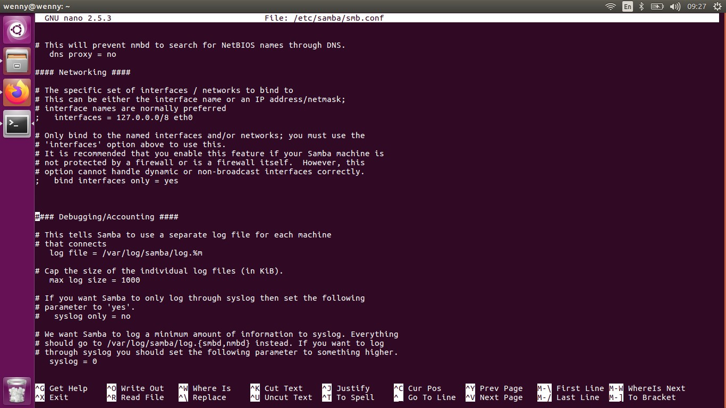

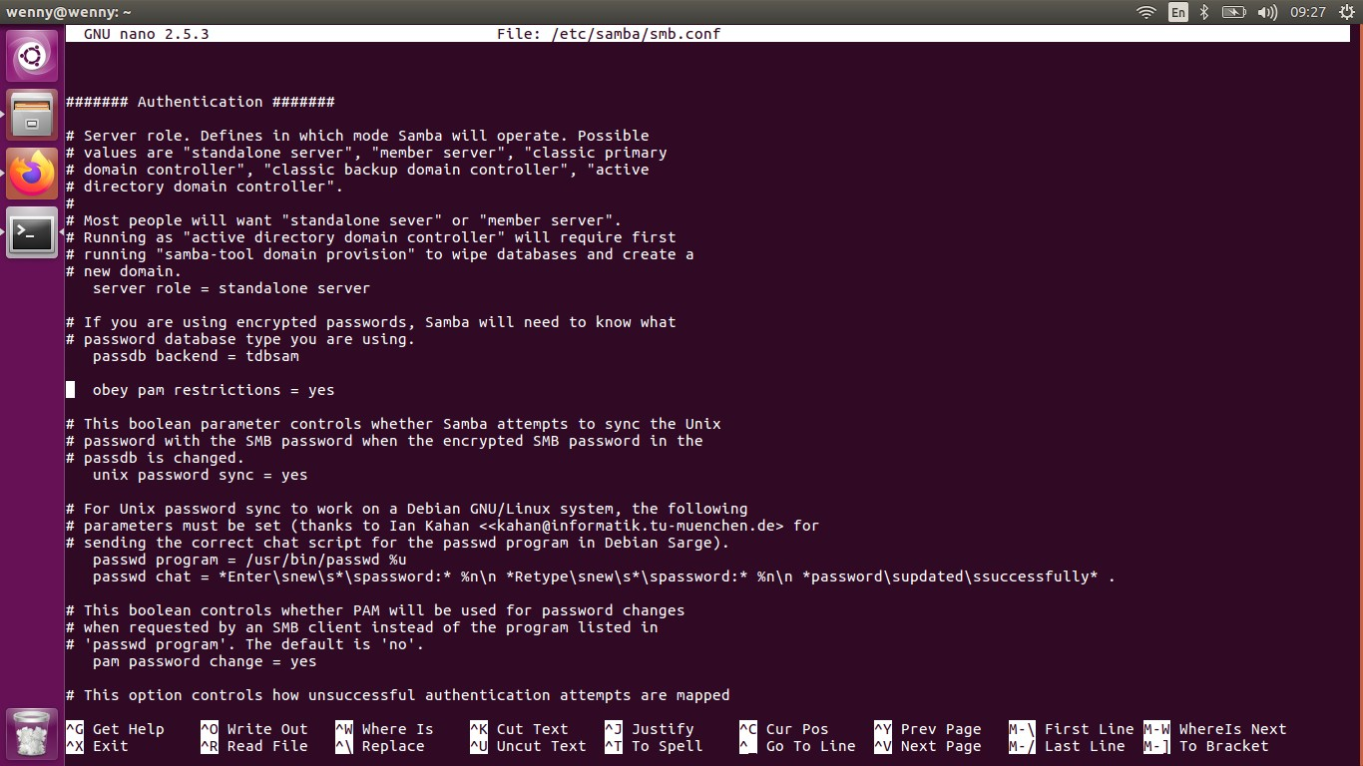

**Finally, restart the Samba services with:**

Once done run the testparm utility to check the Samba configuration file for errors. If there are no syntax errors you will see Loaded services file OK.

sudo systemctl restart smbd

sudo systemctl restart nmbd

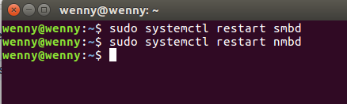

1. **Creating Samba Users and Directory Structure**

For easier maintainability and flexibility instead of using the standard home directories (/home/user) all Samba directories and data will be located in the /samba directory.

To create the /samba directory type:

sudo mkdir /samba

Set the [group ownership](https://linuxize.com/post/chgrp-command-in-linux/) to sambashare. This group is created during the Samba installation, later we will add all Samba users to this group.

sudo chgrp sambashare /samba

Samba uses Linux users and group permission system but is has its own authentication mechanism separate from the standard Linux authentication. We will create the users using the standard Linux useradd tool and then set the user password with the smbpasswd utility.

As we mentioned in the introduction, we’ll [create a regular user](https://linuxize.com/post/how-to-create-users-in-linux-using-the-useradd-command/) that will have access to its private file share and one administrative account with read and write access to all shares on the Samba server.

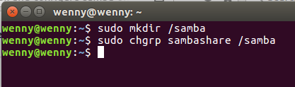

1. **Creating Samba Users**

sudo useradd -M -d /samba/hallowen -s /usr/sbin/nologin -G sambashare hallowen

The useradd options have the following meanings:

* -M -do not create the user’s home directory. We’ll manually create this directory.
* -d /hallowen/wenny - set the user’s home directory to /hallowen/wenny
* -s /usr/sbin/nologin - disable shell access for this user.
* -G sambashare - add the user to the sambashare group.

[Create the user’s home directory](https://linuxize.com/post/how-to-create-directories-in-linux-with-the-mkdir-command/) and set the directory ownership to user hallowen and group sambashare:

sudo mkdir /samba/hallowensudo chown wenny:sambashare /hallowen/wenny

The following command will add the setgid bit to the /hallowen/wenny directory so the newly created files in this directory will inherit the group of the parent directory. This way, no matter which user creates a new file, the file will have group-owner of sambashare. For example, if you don’t set the directory’s permissions to 2770 and the sadmin user creates a new file the user josh will not be able to read/write to this file.

sudo chmod 2770 /hallowen/wenny

Add the wenny user account to the Samba database by setting the user password:

1. You will be prompted to enter and confirm the user password

sudo smbpasswd -a wenny

1. Once the password is set to enable the Samba account run:

sudo smbpasswd -e wenny

1. To create another user repeat the same process as when creating the user wenny

Next, let’s create a user and group sadmin. All members of this group will have administrative permissions. Later if you want to grant administrative permissions to another user simply [add that user to the sadmin group](https://linuxize.com/post/how-to-add-user-to-group-in-linux/).

Create the administrative user by typing:

sudo useradd -M -d /samba/users -s /usr/sbin/nologin -G sambashare sadmin

The command above will also create a group sadmin and add the user to both sadmin and sambashare groups.

Set a password and enable the user:

sudo smbpasswd -a sadminsudo smbpasswd -e sadmin

1. Next, create the Users share directory:

sudo mkdir /samba/users

[Set the directory ownership](https://linuxize.com/post/linux-chown-command/) to user sadmin and group sambashare:

sudo chown sadmin:sambashare /samba/users

This directory will be accessible by all authenticated users. The following [chmod](https://linuxize.com/post/chmod-command-in-linux/) command gives write/read access to members of the sambashare group in the /samba/users directory:

sudo chmod 2770 /samba/users

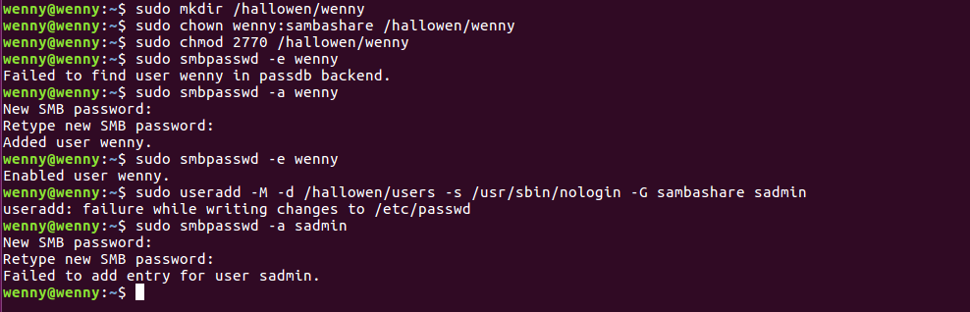

1. **Configuring Samba Shares**

**Open the Samba configuration file and append the sections:**

sudo nano /etc/samba/smb.conf

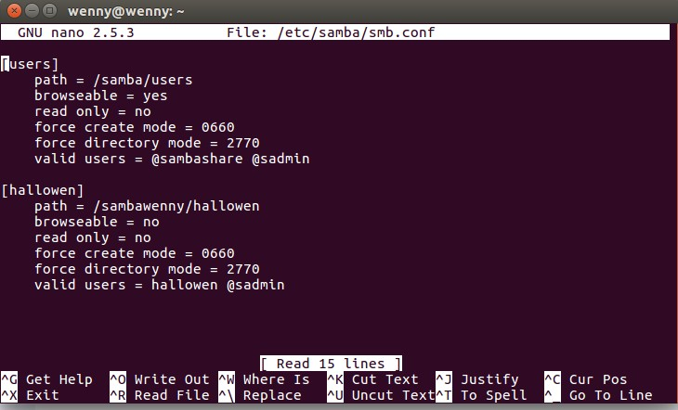

The options have the following meanings:

* [users] and [hallowen] - The names of the shares that you will use when logging in.
* path - The path to the share.
* browseable - Whether the share should be listed in the available shares list. By setting to no other users will not be able to see the share.
* read only - Whether the users specified in the valid users list are able to write to this share.
* force create mode - Sets the permissions for the newly created files in this share.
* force directory mode - Sets the permissions for the newly created directories in this share.
* valid users - A list of users and groups that are allowed to access the share. Groups are prefixed with the @ symbol.

For more information about available options see the [Samba configuration file](https://www.samba.org/samba/docs/current/man-html/smb.conf.5.html) documentation page.

Once done, restart the Samba services with:

sudo systemctl restart smbdsudo systemctl restart nmbd

In the following sections, we will show you how to connect to a Samba share from Linux, macOS and Windows clients

1. **Using the smbclient client**

### Using the smbclient client

smbclient is a tool that allows you to access Samba from the command line. The smbclient package is not pre-installed on most Linux distros so you will need to install it with your distribution package manager.

To install smbclient on Ubuntu and Debian run:

sudo apt install smbclient

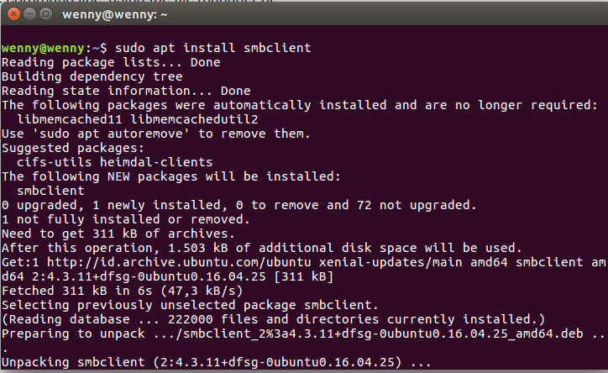

The syntax to access a Samba share is as follows:

smbclient //samba_hostname_or_server_ip/share_name -U username

For example to connect to a share named josh on a Samba server with IP address 127.0.0.1/hallowen as user hallowen you would run:

smbclient //127.0.0.1/hallowen -U hallowen

You will be prompted to enter the user password.

1. **Mounting the Samba shared**
2. To [mount](https://linuxize.com/post/how-to-mount-and-unmount-file-systems-in-linux/) a Samba share on Linux first you need to instal the cifs-utils package.

On Ubuntu and Debian run:

sudo apt install cifs-utils

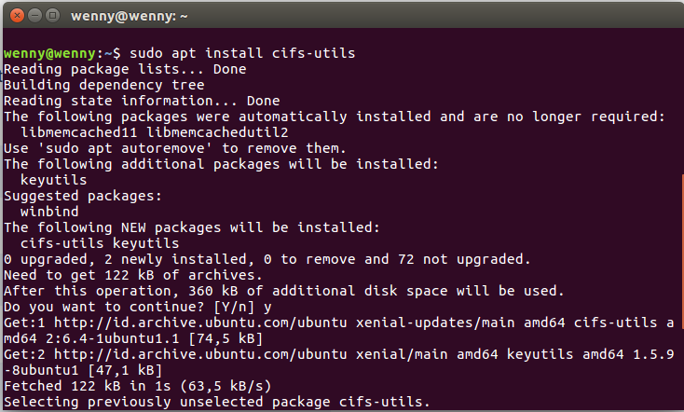

1. Next, create a mount point:

sudo mkdir /mnt/smbmount

1. Mount the share using the following command:

sudo mount -t cifs -o username=username //samba_hostname_or_server_ip/sharename /mnt/smbmount

1. For example to mount a share named josh on a Samba server with IP address 192.168.121.118 as user josh to the /mnt/smbmount mount point you would run:

sudo mount -t cifs -o username=josh //192.168.121.118/josh /mnt/smbmount

You will be prompted to enter the user password.