About Tracks

- Track Line

- Track Types

- Track Kinds

A Track defines the three-dimensional run of a route, the track line, in space. Tracks are usually intended for providing a virtual guideway for vehicles. For example, automotive vehicles follow the track line by means of a control mechanism that imitates the driver's behavior, e.g. Control Element 128: Simpack Driver. Rail vehicles are steered by their rails, that follow the Track, see Rail-Wheel Pairs. Since the Track only provides a theoretical guidance and not a mechanical constraint, the vehicles may also leave the Track, they may miss the road or derail.

The following Modeling Elements use the data from a Track. They either reference it automatically or indirectly via a Track Joint specified in their parameters:

- The so-called Track Joints 7: General Rail Track Joint, 9: Driven Rail Track Joint (for rail vehicles) and 19: Automotive Track Joint (for automotive vehicles) use the track line for their coordinates (states) description.

- Joint 91: Wheel/Rail Track Sleeper does the same, however following a Track Joint and with a limited number of degrees of freedom.

- Road 83: Track Road needs a Track to be graphically represented when referenced by Primitive 80: Road.

- Marker -98: Follow Track Connection/Joint follows a Track Joint along the track line.

- Marker -78: Rail-Wheel Profile Reference also follows a Track Joint along the track line and, additionally, provides track excitations (irregularities).

- Control Elements 168: Automotive Track Sensor, 151: Track Controller and 128: Simpack Driver use the track line for steering an automotive vehicle.

- Primitive 41: Track displays the Track in the 3D Page and Animation.

All these elements use the Track as reference for their own coordinate definitions. In particular, the Joints and Markers span a local coordinate system at the position along the Track where they are currently located, see Figure 1.

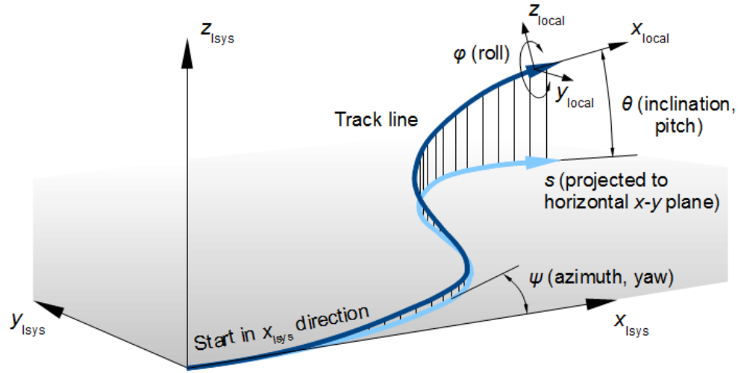

Note: A Simpack model may contain more than one Track, also from Substructures. However, only one Track can be used at a time and is referenced by the aforementioned Modeling Elements. This is called the 'active Track'. See Activating Modeling Elements on how to make a Track active.

Track Line

Figure 1. Track line in three-dimensional space, here with its horizontal projection, the orientation angles and a local coordinate system of a Joint or Marker.

The track line is represented by six functions:

The position coordinates x(s), y(s), z(s) with respect to the Global Reference System Isys Marker, $M_Isys

and the orientation angles in Aerospace Convention Sequence:

1. ψ(s), the yaw or azimuth angle about the inertia system's z-axis, then
2. θ(s), the pitch or inclination angle about the new y-axis, and finally
3. φ(s), the roll angle about the new x-axis

See Figure 1 for a graphical clarification.

The independent coordinate s is either the approximated curve length along the track line or its horizontal projection (into the x-y plane), dependent upon which of the Track Kinds is used. Positions and orientations usually arise from the three main directions of the Track layout, see Figure 2 and Figure 3:

- Horizontal layout, given by the horizontal radius or curvature

- Vertical layout, given by the vertical slope, the vertical radius or curvature

- Superelevation, given by the level difference along a lateral baseline, the superelevation reference length

- Camber (alternatively to superelevation), given by the lateral tangent

The superelevation has again three different kinds, see Figure 3.

Alternatively, the track line positions can also be given directly by (x,y,z) data points instead of a horizontal and vertical layout, see format 2, 3 and 4 in Measured Track (.trm) Files.

Figure 2. Horizontal (left) and vertical (right) layout. The inclination angle θ=arctan(p), with p the slope.

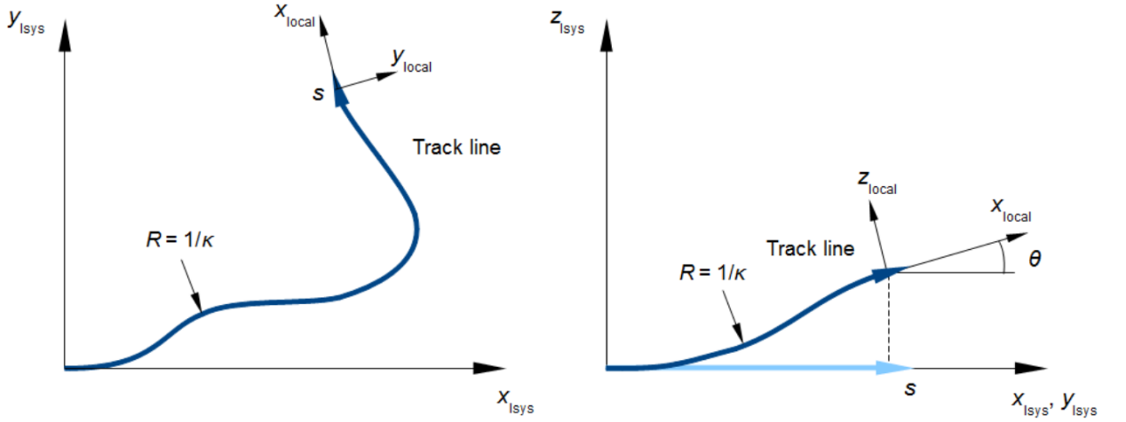

Figure 3. Definitions of superelevation (left) and camber (right). The roll angle of the track line is either φ=arcsin(u/b), with u the superelevation value and b the reference baselength, or φ=arctan(c), with c the camber. Note the lifting or lowering of the local track system by ±u/2 with superelevation about inner or outer side.

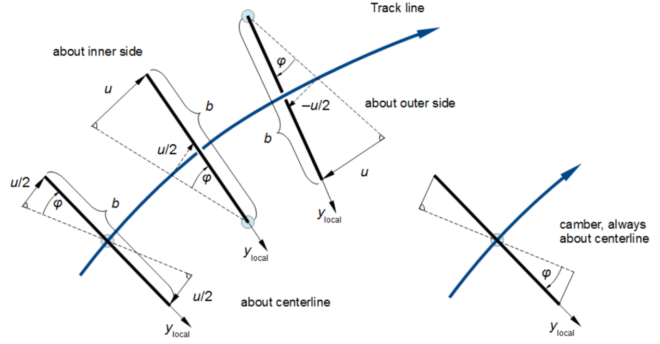

Note: The lateral inclination angle, when specified by superelevation or camber, cannot reach nor exceed ±90°.

The six coordinate and angle functions are internally represented by splines. The spline discretization can be defined by the user, see the description of the Track kinds and the user interface below.

Track Types

There are two Track types, 'Rail' and 'Automotive', which differ in their coordinate definition and the way how they are displayed by Primitive 41: Track.

By convention, the z-axis direction of the Global Reference System Isys is upwards in automotive models and downwards in rail models (according to [UIC5182009a], for example), which also influences the Track's z-axis. Additionally, the 'Rail' type stores information not only about the layout but also about the track irregularities or excitations, see About Track Excitations. In automotive models, the road irregularities are defined in Roads.

Track Kinds

Since there are different ways to describe a track layout, Simpack provides the following Track kinds, which also bring their own respective user interface:

- Cartographic Track: The Track Line is assembled from various segments in the three directions 'horizontal', 'superelevation' and 'vertical' that are stringed together (e.g. 100 m straight → 50 m clothoid → 500 m circular arc etc.);

- Measured Track: The track line defined by a series of (in the ideal case equidistant) curvature values or data points;

- Measured CRG Track: (Only available for 'Automotive' Tracks) The track line is defined by the road course read from a OpenCRG® Road (.crg) file. The actual road surface can be read in by means of Road 82: CRG Curved Regular Grid.

我更加关心 Rail中的 Cartographic Track。介绍如下：  
About Cartographic Track

- Horizontal Direction

- Superelevation Direction

- Widening Direction

- Vertical Direction

The Cartographic Track assembles the track line from so-called segments in the three directions 'horizontal', 'superelevation', 'widening', and 'vertical'. The directions are handled independently, i.e. the segments in the different directions do not have to have the same lengths. The segments are stringed together in the sequence defined by the user. To avoid discontinuities in the derivatives of the track line functions and their derivatives, additional smoothing sections are overlaid to the the segments' boundaries, see Figure 1.

Figure 1. Cartographic Track segments with overlaid smoothing sections of length L_smo. The smoothing lengths are not added to the segment lengths. There is no smoothing section at the end of the last segment.

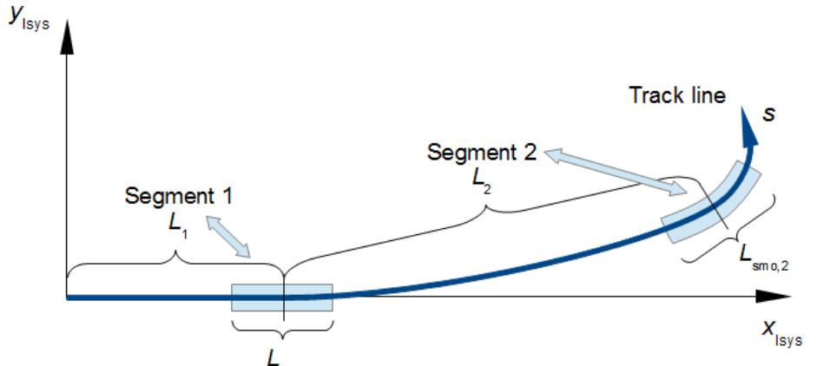

The following tables Table 1, Table 2, Table 3, and Table 4 show the available segment types and their parameters.

Note:

In Cartographic Tracks, the s coordinate is counted along the projection of the track line to the ground (the x,y plane).

Since this projection to the ground s must be unique, vertical slopes or loopings cannot be modeled with a Cartographic Track. Use Measured Track format 4 for this purpose.

The same holds for the lateral inclination (superelevation) angle, which cannot reach nor exceed ±90°.

The Cartographic Track can be defined directly in the Track dialog (see Cartographic Track: User Interface below) or read from a Cartographic Track (.trc) file in different formats, see Cartographic Track (.trc) files.

The track line ends after the last segment and is continued by a sudden straight track line. Since this may lead to unwanted effects it is recommended not to exceed the defined track line in the simulation; a warning message is output in this case. If the three directions do not have the same lengths the last segments of the shorter directions are extrapolated. This may lead to unwanted effects, too. We recommend you give all directions the same length or add a straight or constant segment at the end of the shorter directions.

Horizontal Direction

Curvature can be defined by radius or by degree of curvature.

- L is the segment length, projected in the horizontal x-y plane.

Curvature defined by radius:

- R is the radius.

- R1 and R2 are the initial and end radius of a transition segment, see also Figure 2.

Curvature defined by degree of curvature (see also Figure 3)

- D is the central angle or degree of curvature.

Length is defined by either the chord length C or the arc length A.

- D1 and D2 are the initial and end degree of curvature of a transition segment.

Note:

- In rail Tracks, a positive radius/degree of curvature means a right-hand curve and a negative radius a left-hand curve, in automotive Tracks vice versa.

- A radius/degree of curvature of 0 means straight track (particularly important for transition segments that start or end with straight track).

**Figure 2. Parameter and coordinate definition in horizontal and superelevation transition segments.**

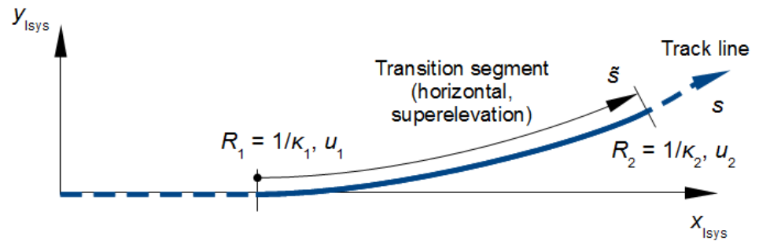

**Figure 3. Schematic of degree of curvature, arc length, and chord length.**

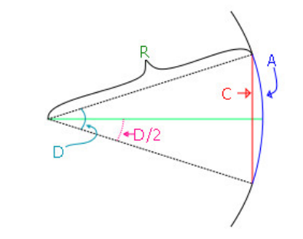

**Table 1. Horizontal Cartographic Track segment types.**

**STR**

Straight (tangent) track

**CIR**

Circular arc

**CLO**

Clothoid transition, the curvature increases or decreases linearly from 1/R1 to 1/R2 When using degree of curvature for curvature definition, D1 and D2 are converted to R1 and R2 respectively where with D in radians: arc length Ri=(A)/(Di) or chord length Ri=(C/2)/sin(Di×90/pi)

**Bloss（BLO）过渡曲线**

Bloss transition, the curvature increases or decreases according to the formula

$\kappa\left(\tilde{s}\right)=-2\frac{\kappa_2-\kappa_1}{L^3}\tilde{s}^3+3\frac{\kappa_2-\kappa_1}{L^2}\tilde{s}^2+\kappa_1$

providing a smoother transition to the previous and next segment than a clothoid. (Note that an additional smoothing is still required because the second derivative is still not continuous.) The curvature κi=1/Ri (degree of curvature is converted to a radius as described above).

**Superelevation Direction**

- L is the segment length, projected in the horizontal x-y plane.

-u is the superelevation (a length, see Track Line and the additional superelevation settings in Cartographic Track: User Interface below).

- u1 and u2 are the initial and end superelevation of a transition segment, see also Figure 2 above.

Note: A positive superelevation corresponds to a right-hand curve, a negative superelevation to a left-hand curve.

Table 2. Superelevation Cartographic Track segment types.

**CST**

Constant superelevation

**Linear（LIR）线性超高坡**

Linear ramp, the superelevation increases or decreases linearly from u1 to u2

**BLO** 与 Bloss 曲线类似，只是把“曲率差”换成了“超高差”。

Bloss ramp, the superelevation increases or decreases according to the formula

$$u\left(\tilde{s}\right)=-2\frac{u_2-u_1}{L^3}\tilde{s}^3+3\frac{u_2-u_1}{L^2}\tilde{s}^2+u_1$$

providing a smoother transition to the previous and next segment than a linear ramp. (Note that an additional smoothing is still required because the second derivative is still not continuous.)

**Vertical Direction**

- L is the segment length, projected in the horizontal x-y plane.

- p is the slope.

- p1 and p2 are the initial and end slope of a transition segment, see also [Figure 4](qthelp://com.simpack.doc/spckdoc/English/SpckEleUserMap/spckele-c-lib-trcks-kindsexcts-carto-desc.htm#spckele-c-lib-trcks-kindsexcts-carto-desc__spckref-fig-ele-lib-trcks-kindsexcts-carto-desc-transvert).

The slope is the vertical tangent 'as is', i.e. a slope of 0.1 means a level change by 10 m over 100 m track line (10 % grade). Note that, due to the different directions of the zz-axis, a positive slope in an automotive Track usually means upwards and in a rail Track downwards.

Figure 4. Parameter and coordinate definition in horizontal and superelevation transition segments.

Table 4. Vertical Cartographic Track segment types.

Abbr.

Description Par. 1 Par. 2 Par. 3

CSL Constant slope L p

PL2 Parabolic transition, the slope increases or decreases linearly from p1 to p2 L p1 p2

CIR Circular arc transition defined by the length and the initial and end slope, the slope increases or decreases according to the formula

$$p\left(\tilde{s}\right)=\frac{\tilde{s}}{\sqrt{R^2-\tilde{s}^2}}+p_1$$

The (projected) length L to be entered is related to the transition radius R by

$$L=2R\cos\left(\frac{\theta_1+\theta_2}{2}\right)\sin\left(\frac{\theta_2-\theta_1}{2}\right)\approx2R\cos\left(\frac{p_1+p_2}{2}\right)\sin\left(\frac{p_2-p_1}{2}\right)$$

for small slopes, where pi=tanθi≈θi.

下面这份总结面向刚开始接触 SIMPACK “轨道定义”(Track Definition) 的读者，试图用较通俗的方式把主要内容、建模原理和关键概念快速串起来。希望能帮助你在脑海中形成清晰的整体思路，并且在实践中（例如 Python 原型代码中）也能对照实现。

## 1. 什么是 SIMPACK 轨道？

在 SIMPACK 的多体仿真里，“轨道”(Track) 是一条在 3D 空间中的带姿态(Orientation)的曲线，用来模拟**车辆行驶**或**轮轨/车轮接触**的**几何参考**。它不仅包含了中心线的几何位置 {x(s),y(s),z(s)}\{x(s),y(s),z(s)\}{x(s),y(s),z(s)}，还定义了沿曲线的旋转角度 {ψ(s),θ(s),ϕ(s)}\{\psi(s),\theta(s),\phi(s)\}{ψ(s),θ(s),ϕ(s)}（即偏航、俯仰、横滚）。由于车辆常常需要知道当前位置、方向、甚至左右轮高度差，所以轨道在 SIMPACK 中扮演重要“几何基准”角色。

## 2. Cartographic Track：分方向的“分段+过渡”定义

SIMPACK 提供多种“Track Kinds”，其中 **Cartographic Track** 对应典型的线路/道路设计做法：将轨道分为**四个方向**(horizontal / superelevation / widening / vertical)，每个方向再由若干段拼起来。

**Horizontal Direction（水平）**

定义曲线在平面 x-yx\text{-}yx-y 上的走向。可使用**直线**、**圆弧**、**缓和曲线(Clothoid/Bloss)**等分段。

在内部，水平方向的关键参数是“曲率 κ\kappaκ”，或等效地用“半径 RRR”来描述。

**Superelevation Direction（超高）**

描述曲线外侧/内侧的抬升量 uuu。在轨道动力学中也叫“外轨超高”或“横向倾斜”。

在 SIMPACK 中，超高可以分段定义（常值段、线性变化段、Bloss 过渡等），最终会转换成轨道的**横滚角** ϕ≈arcsin[u/bref]\phi\approx\arcsin\bigl[u/b_{\mathrm{ref}}\bigr]ϕ≈arcsin[u/bref​]。

约定了正值对应某一侧（如在 rail 场景下，正超高对应“右弯”）。

**Widening Direction（加宽）**

在铁路曲线处，有时要加宽轨距或双线间距，这部分也可用分段描述。

如果不需要加宽，可置为零或忽略。

**Vertical Direction（垂向）**

用于定义路/轨道的**坡度** p=dz/dsp=\mathrm{d}z/\mathrm{d}sp=dz/ds、以及竖向曲线（抛物线或圆曲线）。

Rail 模型里，通常把 zzz 轴向下取正，因此正坡度表示“向下倾斜”。在 Automotive 模型里则多是 zzz 轴向上。

**分段+过渡的意义**：  
真实铁路/公路通常不会在转弯处直接从“直线”跳到“圆弧”——而是插入**缓和曲线**(clothoid、bloss)或渐变超高段，以保证车辆行驶平顺。Cartographic Track 便提供了“按段”把这些要素串起来的接口。

## 3. 分段衔接与 smoothing

**名义分段**：在横向(例如 CIR、BLO)或超高方向(例如 CST、BLO)都可以写出一套原始公式，让参数在段内从初值到末值过渡。

**拼接处的平滑处理（**LsmoL_\mathrm{smo}Lsmo​）**：SIMPACK 在相邻段交界处往往会叠加一小段内部的“smoothing”。这样可以让曲率/超高的导数(k′k'k′、u′u'u′)在交界处保持连续，减少动力学中的激烈变化。

**注**：Bloss 本身是一种带三次多项式的缓和曲线，但它依然与 smoothing 并行：Bloss 保证段**内部**曲率比较柔和，而 smoothing 又让段与段之间更光滑（尤其在二阶导数上）。

## 4. 三维坐标与欧拉角

Cartographic Track 的“主参数” s 是轨道**在平面** x-yx\text{-}yx-y **的投影长度**。在每个 s 处，SIMPACK 组合四个方向的结果，得到：

水平走向（偏航角 ψ\psiψ）

垂向高度变化（俯仰角 θ\thetaθ）

横向倾斜（横滚角 ϕ\phiϕ），由超高  u\,uu 转换而来

最终形成**完整的 3D 位置** {x(s),y(s),z(s)}\{x(s),y(s),z(s)\}{x(s),y(s),z(s)} **与朝向** {ψ,θ,ϕ}\{\psi,\theta,\phi\}{ψ,θ,ϕ}。车辆、车轮、关节等都可以“跟踪”这一轨道来进行仿真。

## 5. 同样的方法也可在 Python 原型中实现

为了**验证**或**预处理**，很多用户会在 SIMPACK 之外（比如 Python）构建一个小工具来：

**分段定义**（STRAIGHT, CIRCLE, BLOSS 等），手工写原始公式（曲率/超高等）

**在段交界处用五次多项式(smoothing)衔接**，保证整体的C2\mathcal{C}^2C2连续

**数值积分**曲率 κ(s)\kappa(s)κ(s) 得到 2D/3D 坐标，并可视化

**同步对超高** u(s)u(s)u(s) 做分段，生成 ϕ(s)=arcsin⁡[u(s)/bref]\phi(s)=\arcsin[u(s)/b_{\mathrm{ref}}]ϕ(s)=arcsin[u(s)/bref​]，绘制左右钢轨

这样得到的**轨道几何**，与 SIMPACK 内部的 Cartographic Track 十分接近。如果需要**精确对比**，可将 SIMPACK 输出的轨道样条(如 .trm/.trc) 与自己的代码做数值比对。

## 6. 其他提示

**注意各方向段的“总长度”**

如果水平方向定义到 s=1600s=1600s=1600 米、但超高方向只定义到 s=1500s=1500s=1500 米，SIMPACK 会自动把后面没定义的超高做外插，可能导致意料外的结果。

一般建议让四个方向“至少覆盖同样的里程范围”，或者在末段加一小段“常值”预留，以防车辆跑到定义范围之外。

**Bloss + smoothing 并不会“重复”**

Bloss 本身是让一段内曲率更平滑，而 smoothing 则是让**段与段**在拼接处的衔接平滑。二者是不同层次，可以同时启用以得到较平顺的整条线。

**Cartographic Track 不支持“垂直面中绕环”**

因为它的 sss 是投影到平面后测量的长度，无法出现竖向翻转或环形过山车那种情形。若需模拟极端 3D 情形，可考虑换成 Measured Track (format 4) 等方式。

**Rail vs. Automotive 类型**

轨道在 Rail 类型中常用 zzz 轴向下为正，超高/曲率正负号也有不同的约定。

不平顺(轨道激励)在 Rail Track 里可以直接定义，在 Automotive 里则通常在 Road 模块中定义。

## 7. 总结

**Cartographic Track** 是 SIMPACK 里常见的轨道定义方式，通过**分段描述**(水平、超高、轨距加宽、竖向)再加上**过渡段**(clothoid、bloss、线性 ramp 等)和**smoothing**，构造出在工程实践中非常常见的道路/铁路几何。

对于初学者而言，先理解“**段落 + 过渡曲线 + smoothing**”这三点，就能大体掌握 Cartographic Track 的原理。

之后再结合**Python 等外部脚本**，你就可以先行验证轨道几何，在 SIMPACK 中导入或直接在 GUI 里输入同样参数，让仿真车辆沿着这条 3D 轨道行驶。

这样，你便完成了从“概念理解”到“数值实现”的飞跃，也能更好地运用 SIMPACK 提供的轨道功能来建模铁路/公路车辆的真实动态行为。祝学习顺利!

Vertical Direction

* L is the segment length, projected in the horizontal x-y plane.
* p is the slope.
* p1 and p2 are the initial and end slope of a transition segment, see also Figure 4.

The slope is the vertical tangent 'as is', i.e. a slope of 0.1 means a level change by 10 m over 100 m track line (10 % grade). Note that, due to the different directions of the z-axis, a positive slope in an automotive Track usually means upwards and in a rail Track downwards.

**Figure 4. Parameter and coordinate definition in horizontal and superelevation transition segments.**

|  |  |  |  |  |
| --- | --- | --- | --- | --- |
| **Table 4. Vertical Cartographic Track segment types.** | | | | |
| Abbr. | Description | Par. 1 | Par. 2 | Par. 3 |
| CSL | Constant slope | L | p | 无 |
| PL2 | Parabolic transition, the slope increases or decreases linearly from p1 to p2 | L | p1 | p2 |