**Act of kindness**

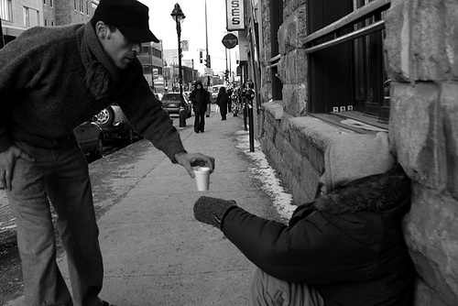

Lance Sebastian R. Peninsula