**Pregunta 1**

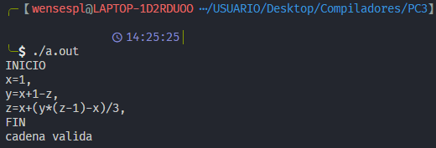

Reconoce el ejemplo como valido

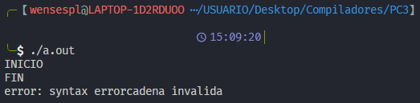

Mínimo una asignación

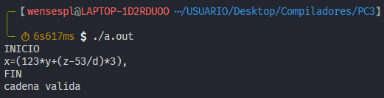

**Pregunta 2**

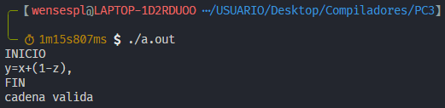

Vemos que lo reconoce como valido, veamos ahora el proceso de shift/reduce.

|  |  |
| --- | --- |
| Estados | Cadena |
|  | INICIO y=x+(1-z), FIN |
| 0 (INI shift, and go to state 1) | INI ID ‘=’ ID ‘+’ ‘(’ NUM ‘-’ ID ‘)’ ‘,’ FIN |
| 01 (ID shift, and go to state 3) | ID ‘=’ ID ‘+’ ‘(’ NUM ‘-’ ID ‘)’ ‘,’ FIN |
| 013 ('=' shift, and go to state 7) | ‘=’ ID ‘+’ ‘(’ NUM ‘-’ ID ‘)’ ‘,’ FIN |
| 0137 (ID shift, and go to state 10) | ID ‘+’ ‘(’ NUM ‘-’ ID ‘)’ ‘,’ FIN |
| 0137 10 ($default reduce using rule 13 (term2)) | ‘+’ ‘(’ NUM ‘-’ ID ‘)’ ‘,’ FIN |
| 0137 (term2 go to state 15) | ‘+’ ‘(’ NUM ‘-’ ID ‘)’ ‘,’ FIN |
| 0137 15 ($default reduce using rule 10 (term)) | ‘+’ ‘(’ NUM ‘-’ ID ‘)’ ‘,’ FIN |
| 0137 (term go to state 14) | ‘+’ ‘(’ NUM ‘-’ ID ‘)’ ‘,’ FIN |
| 0137 14 ($default reduce using rule 7 (expr)) | ‘+’ ‘(’ NUM ‘-’ ID ‘)’ ‘,’ FIN |
| 0137 (expr go to state 13) | ‘+’ ‘(’ NUM ‘-’ ID ‘)’ ‘,’ FIN |
| 0137 13 ('+' shift, and go to state 18) | ‘+’ ‘(’ NUM ‘-’ ID ‘)’ ‘,’ FIN |
| 0137 13 18 ('(' shift, and go to state 12) | ‘(’ NUM ‘-’ ID ‘)’ ‘,’ FIN |
| 0137 13 18 12 (NUM shift, and go to state 11) | NUM ‘-’ ID ‘)’ ‘,’ FIN |
| 0137 13 18 12 11 ($default reduce using rule 12 (term2)) | ‘-’ ID ‘)’ ‘,’ FIN |
| 0137 13 18 12 (term2 go to state 15) | ‘-’ ID ‘)’ ‘,’ FIN |
| 0137 13 18 12 15 ($default reduce using rule 10 (term)) | ‘-’ ID ‘)’ ‘,’ FIN |
| 0137 13 18 12 (term go to state 14) | ‘-’ ID ‘)’ ‘,’ FIN |
| 0137 13 18 12 14 ($default reduce using rule 7 (expr)) | ‘-’ ID ‘)’ ‘,’ FIN |
| 0137 13 18 12 (expr go to state 17) | ‘-’ ID ‘)’ ‘,’ FIN |
| 0137 13 18 12 17 ('-' shift, and go to state 19) | ‘-’ ID ‘)’ ‘,’ FIN |
| 0137 13 18 12 17 19 (ID shift, and go to state 10) | ID ‘)’ ‘,’ FIN |
| 0137 13 18 12 17 19 10 ($default reduce using rule 13 (term2)) | ‘)’ ‘,’ FIN |
| 0137 13 18 12 17 19 (term2 go to state 15) | ‘)’ ‘,’ FIN |
| 0137 13 18 12 17 19 15 ($default reduce using rule 10 (term)) | ‘)’ ‘,’ FIN |
| 0137 13 18 12 17 19 (term go to state 24) | ‘)’ ‘,’ FIN |
| 0137 13 18 12 17 19 24 ($default reduce using rule 6 (expr)) | ‘)’ ‘,’ FIN |
| 0137 13 18 12 (expr go to state 17) | ‘)’ ‘,’ FIN |
| 0137 13 18 12 17 (')' shift, and go to state 22) | ‘)’ ‘,’ FIN |
| 0137 13 18 12 17 22 ($default reduce using rule 11 (term2)) | ‘,’ FIN |
| 0137 13 18 (term2 go to state 15) | ‘,’ FIN |
| 0137 13 18 15 ($default reduce using rule 10 (term)) | ‘,’ FIN |
| 0137 13 18 (term go to state 23) | ‘,’ FIN |
| 0137 13 18 23 ($default reduce using rule 5 (expr)) | ‘,’ FIN |
| 0137 (expr go to state 13) | ‘,’ FIN |
| 0137 13 ($default reduce using rule 4 (stm)) | ‘,’ FIN |
| 01 (stm go to state 5) | ‘,’ FIN |
| 015 (',' shift, and go to state 9) | ‘,’ FIN |
| 0159 ($default reduce using rule 2 (stm_lst)) | FIN |
| 01 (stm_lst go to state 4) | FIN |
| 014 (FIN shift, and go to state 8) | FIN |
| 0148 ($default reduce using rule 1 (prog)) | $ |
| 0 (prog go to state 2) | $ |
| 02 ($end shift, and go to state 6) | $ |
| 026 ($default accept) | accept |