附录1

表1-1 ARIMA模型相关检验与参数值

|  |  |  |  |  |  |  |  |
| --- | --- | --- | --- | --- | --- | --- | --- |
| 数据 | ADF检验 | 自相关检验 | | | | p | q |
| 1 | 2 | 3 | 4 |  |  |
| 上证指数 | 6.56*10-25 | 2.73*10-3 | 9.29*10-5 | 3.71*10-7 | 4.20*10-14 | 13a | 9a |
|  |  |  |  |  |  | 14b | 9b |
| 标普500 | 0.0 | 4.72*10-5 | 2.10*10-6 | 7.49*10-6 | 9.69*10-6 | 14a | 2a |
|  |  |  |  |  |  | 14b | 2b |

注：表中为ADF检验和自相关检验的p值。从表中ADF检验的p值可以知道差分后的序列是平稳的序列，从自相关检验的p值我们知道差分后的序列不是白噪声序列。a表示第三章的值，b表示第四章的值。

附录2

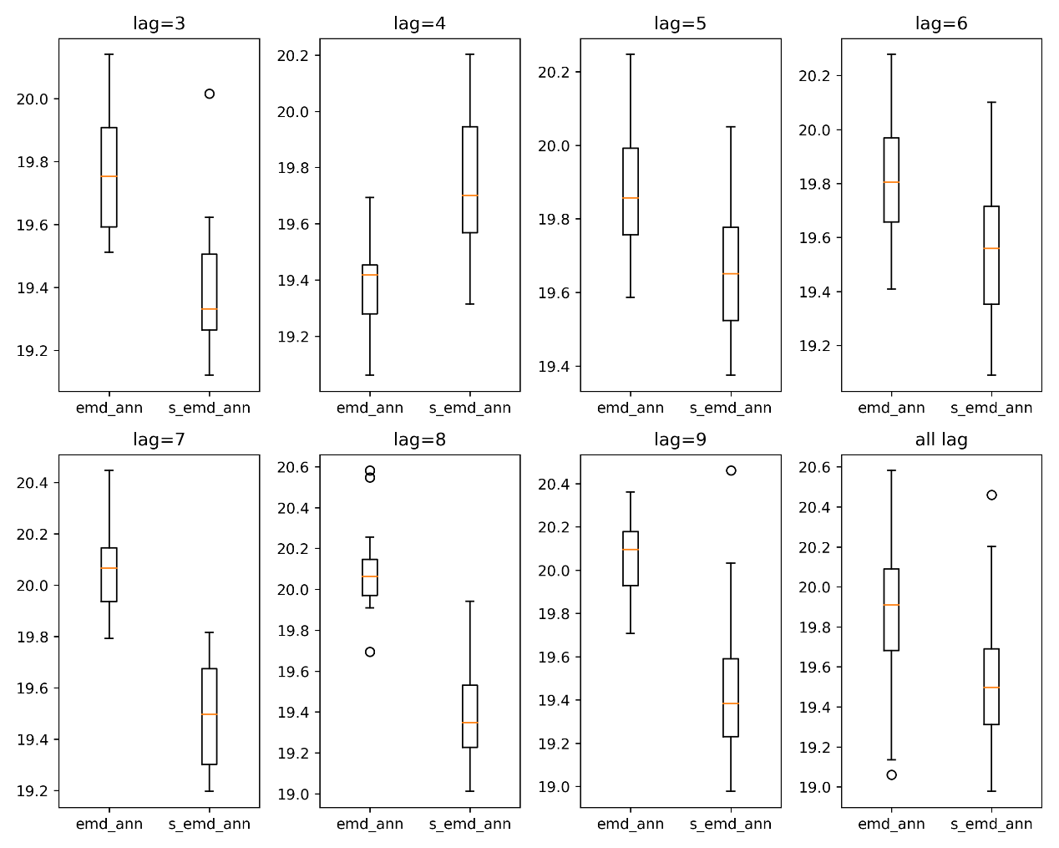

图2-1 上证指数数据中EMD-ANN与S-EMD-ANN模型的MAE指标值

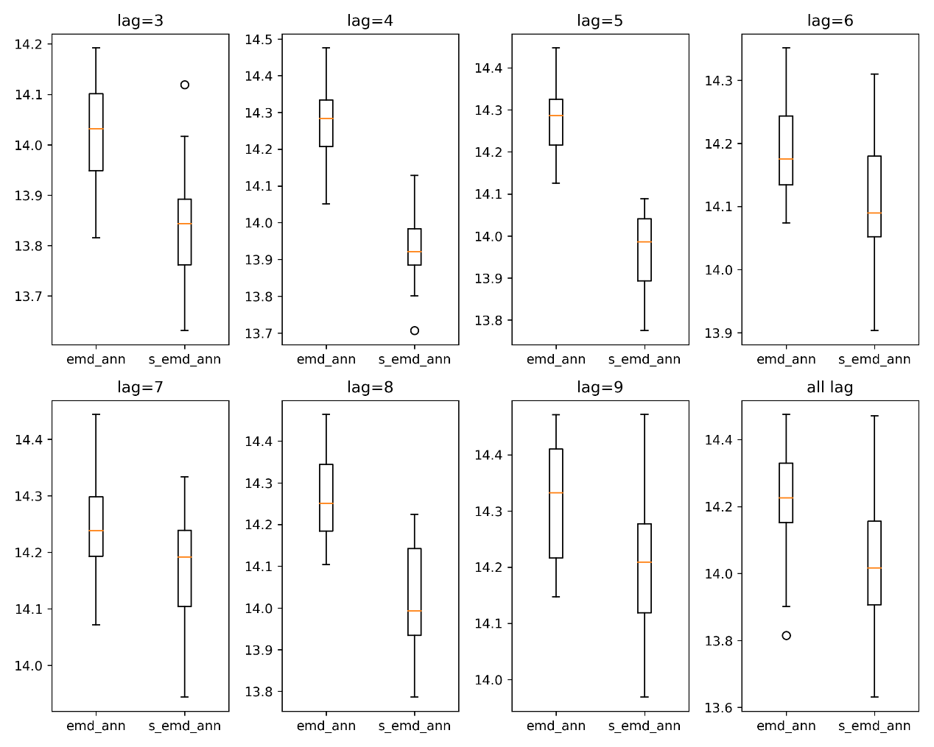

图2-2 标普500指数数据中EMD-ANN与S-EMD-ANN模型的MAE指标值

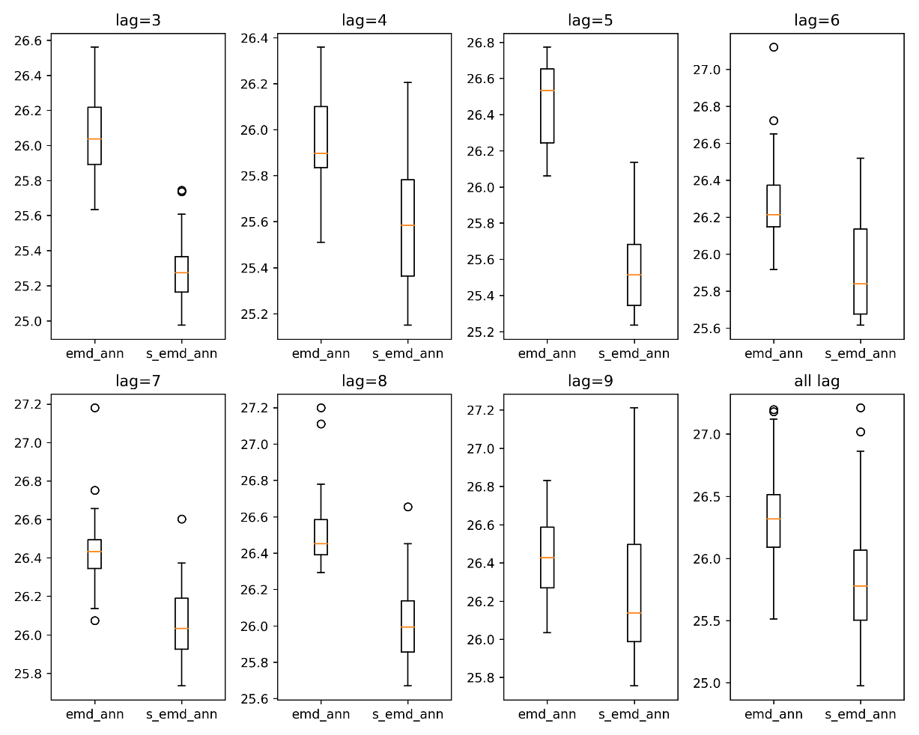

图2-3 上证指数数据中EMD-ANN与S-EMD-ANN模型RMSE指标值

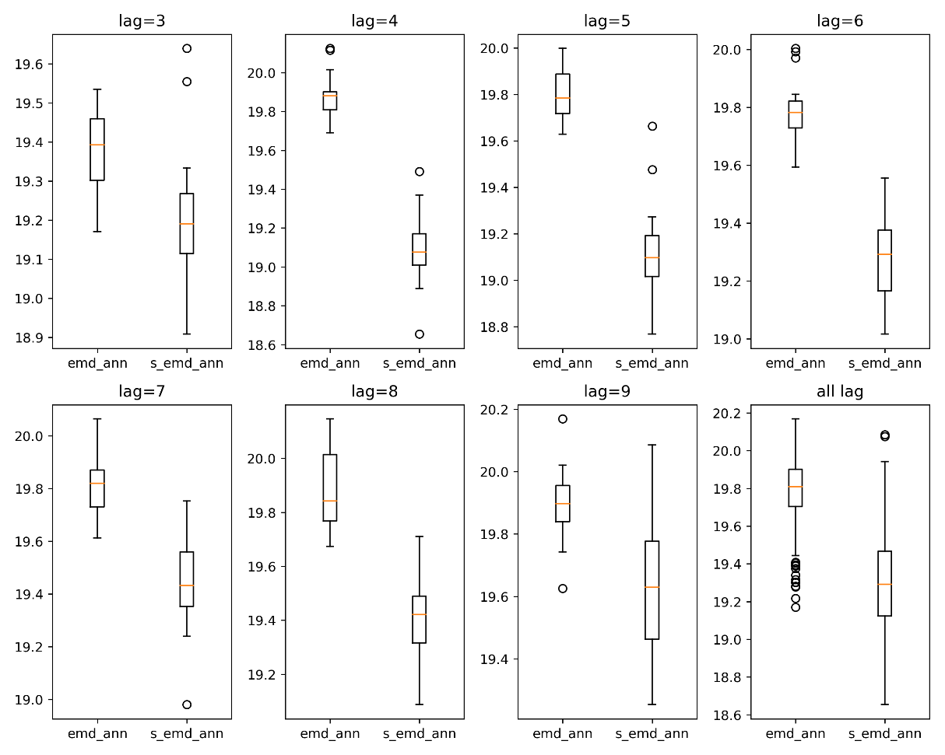

图2-4 标准普尔500指数数据中EMD-ANN与S-EMD-ANN模型RMSE指标值

附录3

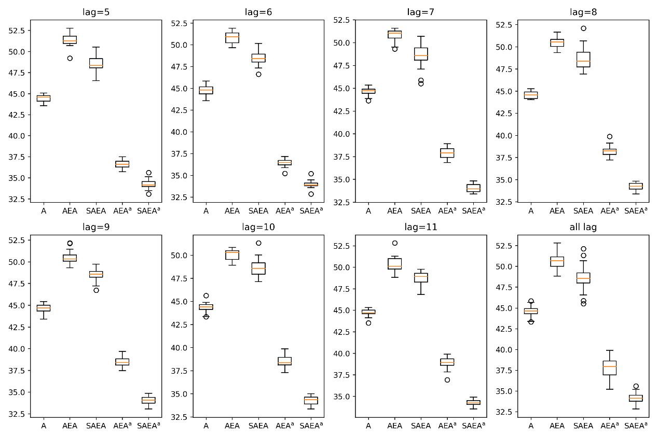

图3-1 上证指数数据中剔除前瞻性偏差后模型的MAE指标值

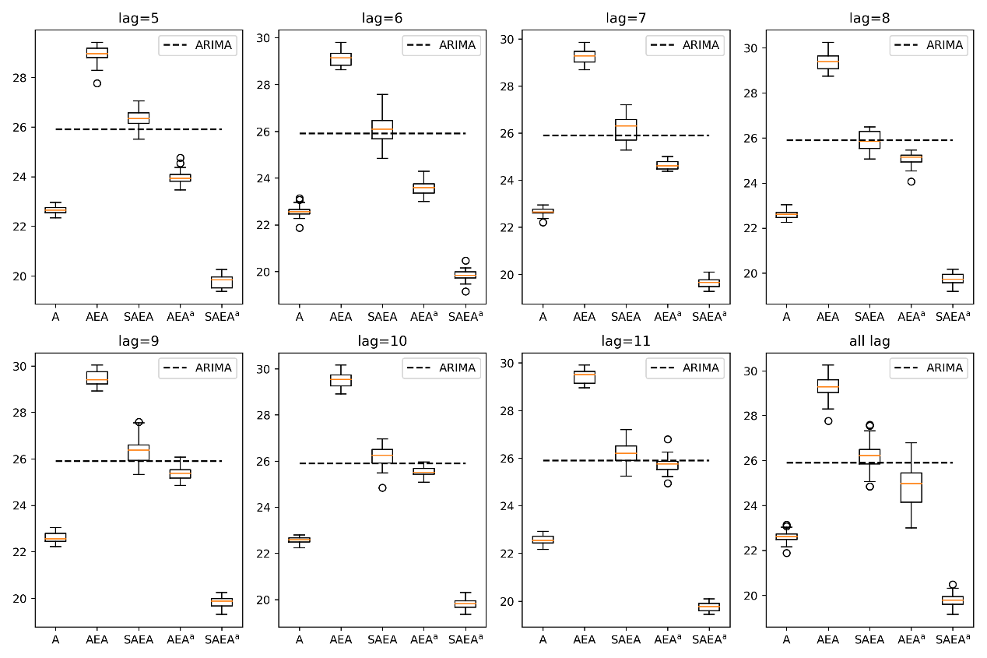

图3-2 标准普尔500指数数据中剔除前瞻性偏差后模型的MAE指标值

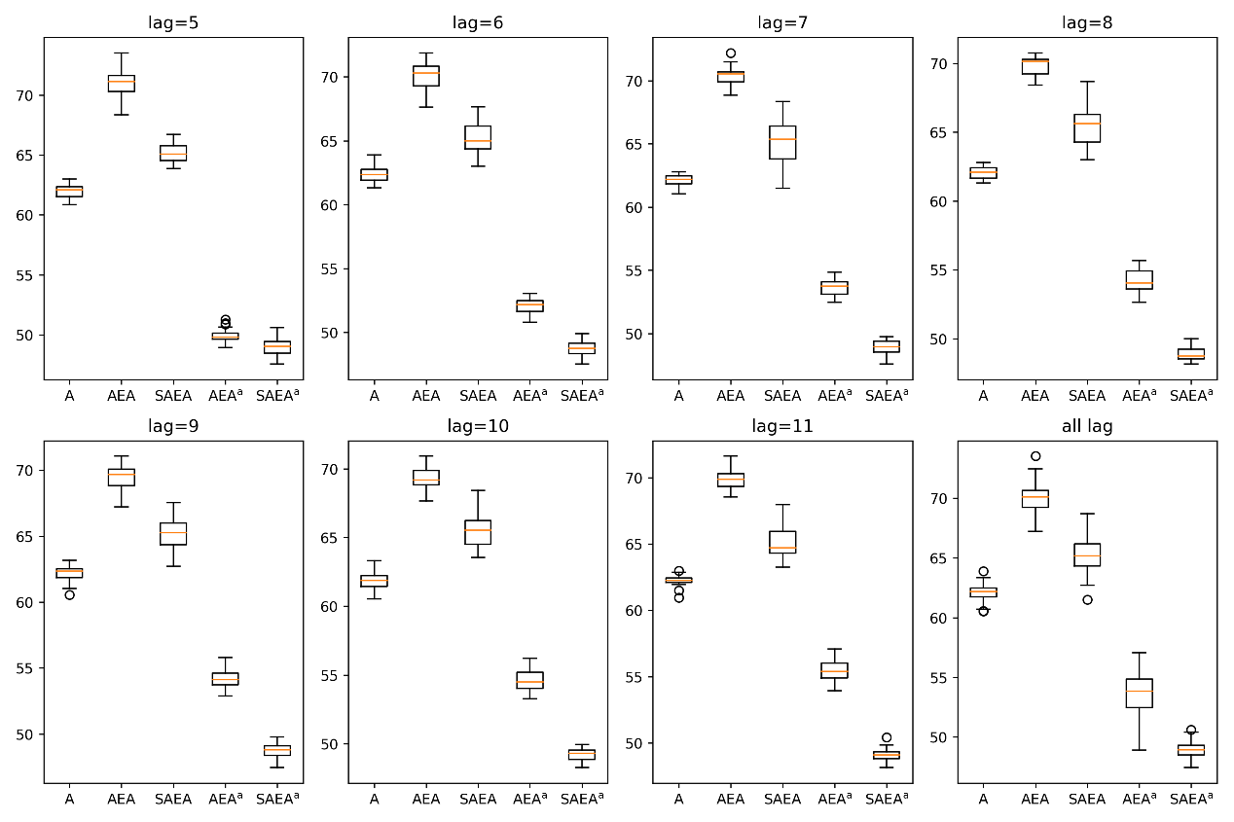

图3-3 上证指数数据中剔除前瞻性偏差后模型的RMSE指标值

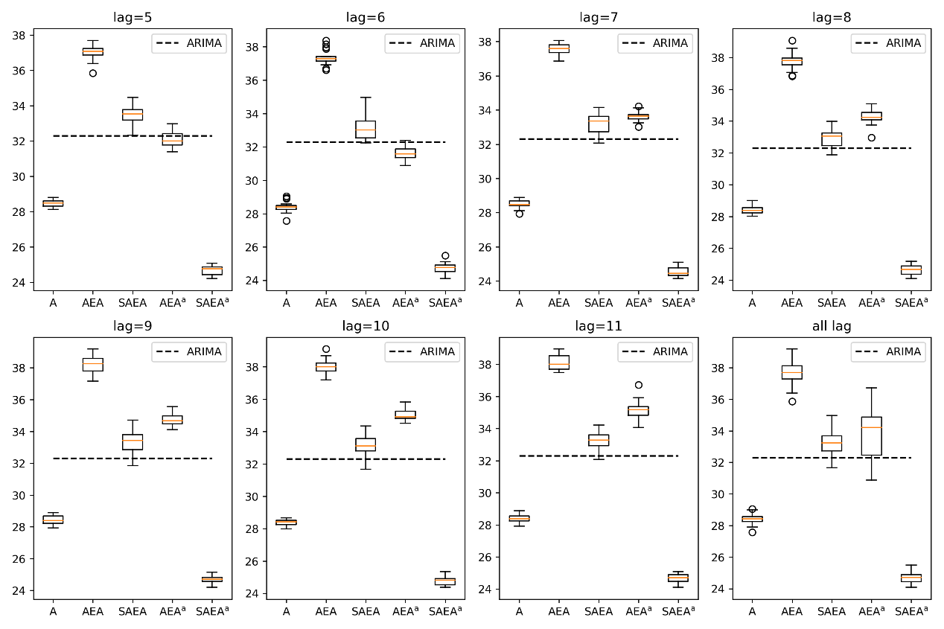

图3-4 标准普尔500指数数据中剔除前瞻性偏差后模型的RMSE指标值

附录4

表4-1 不同自适应模型下上证指数的预测表现结果

|  |  |  |  |  |  |  |  |  |  |
| --- | --- | --- | --- | --- | --- | --- | --- | --- | --- |
| Model |  | Lag | | | | | | | |
|  | 5 | 6 | 7 | 8 | 9 | 10 | 11 | Mean |
| S-AE-Aa | MAPE | 1.181 | 1.172 | 1.173 | 1.180 | 1.174 | 1.181 | 1.181 | 1.177 |
|  | MAE | 34.26 | 33.97 | 34.02 | 34.23 | 34.06 | 34.26 | 34.26 | 34.15 |
|  | RMSE | 49.03 | 48.72 | 48.96 | 48.87 | 48.74 | 49.21 | 49.10 | 48.94 |
|  | (1, T) | 5.344 | 4.983 | 5.057 | 5.136 | 5.097 | 5.104 | 5.106 | 5.118 |
| S-AE-La | MAPE | 1.136 | 1.120 | 1.130 | 1.131 | 1.120 | 1.124 | 1.132 | 1.127 |
|  | MAE | 32.91 | 32.47 | 32.78 | 32.78 | 32.47 | 32.57 | 32.81 | 32.68 |
|  | RMSE | 46.60 | 46.22 | 46.40 | 46.27 | 45.92 | 45.91 | 46.43 | 46.25 |
|  | (1, T) | 41.48 | 41.59 | 41.10 | 41.26 | 41.07 | 41.86 | 42.30 | 41.52 |

表4-2 不同自适应模型下标普500指数的预测表现结果

|  |  |  |  |  |  |  |  |  |  |
| --- | --- | --- | --- | --- | --- | --- | --- | --- | --- |
| Model |  | Lag | | | | | | | |
|  | 5 | 6 | 7 | 8 | 9 | 10 | 11 | Mean |
| S-AE-Aa | MAPE | 0.717 | 0.720 | 0.713 | 0.716 | 0.720 | 0.719 | 0.717 | 0.717 |
|  | MAE | 19.77 | 19.84 | 19.65 | 19.74 | 19.83 | 19.82 | 19.76 | 19.77 |
|  | RMSE | 24.69 | 24.75 | 24.54 | 24.63 | 24.71 | 24.77 | 24.67 | 24.68 |
|  | (1, T) | 4.278 | 4.164 | 4.159 | 4.178 | 4.164 | 4.169 | 4.183 | 4.185 |
| S-AE-La | MAPE | 0.619 | 0.621 | 0.627 | 0.618 | 0.623 | 0.628 | 0.613 | 0.621 |
|  | MAE | 17.07 | 17.12 | 17.29 | 17.03 | 17.17 | 17.31 | 16.91 | 17.13 |
|  | RMSE | 21.99 | 22.02 | 22.17 | 22.08 | 22.13 | 22.36 | 21.95 | 22.10 |
|  | (1, T) | 42.00 | 42.24 | 42.12 | 41.77 | 42.08 | 42.18 | 42.38 | 42.11 |