1. Display film categories in Home page’s select option list.

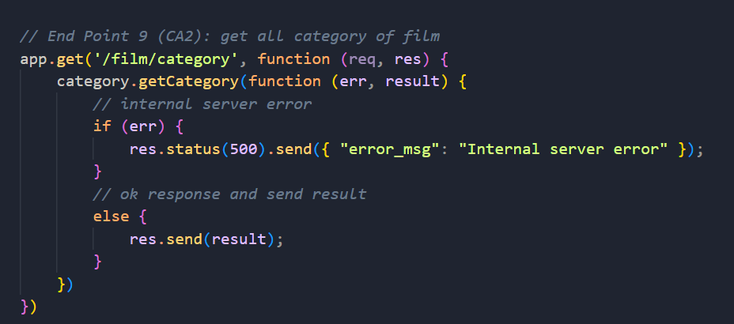

2. Display all film in Home page after press search button.

3. Display film details on Details page.

4. Display all comments about the film on Details page. (Additional features)

5. Insert new comments on AddComment page. (Additional features)

6. Display store address in AddCustomer page’s select option list.

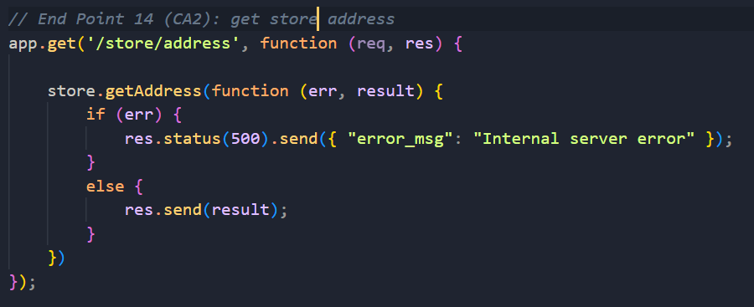

7. To handle admin login post request on Login page.

8. Display all city name in AddCustomer page’s select option list.

9. To handle customer post login request on CustomerLogin page. (Additional features)

10. To reset customer account’s password on ResetPassword page. (Additional feature)

11. To reset staff account’s password on ResetPassword page. (Additional features)

