--dataset cifar10 --norm Linf

--dataset cifar10 --norm L2

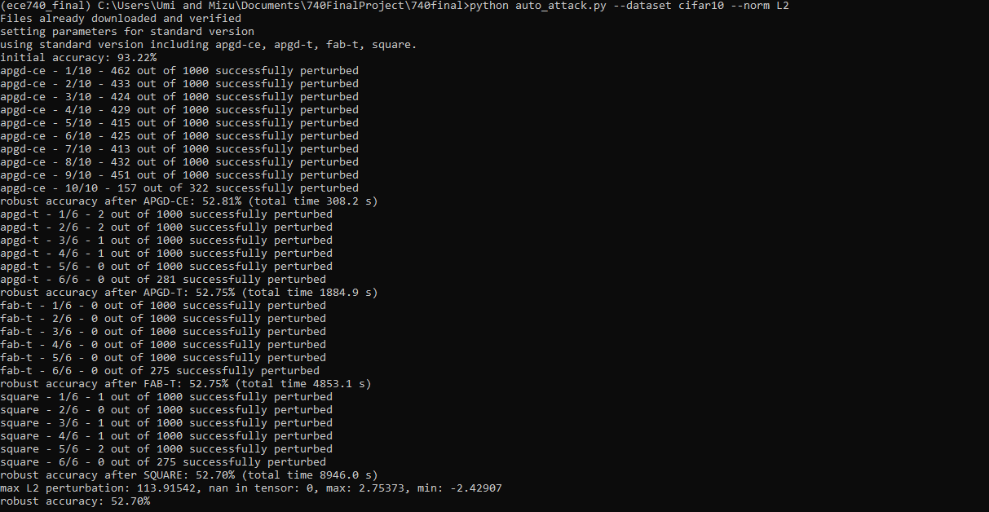

--dataset cifar100 --norm Linf

--dataset cifar100 --norm L2

