analysis (black), data (red)

n2_n6_m5_w15.png – n2_n6_m20_w15.png

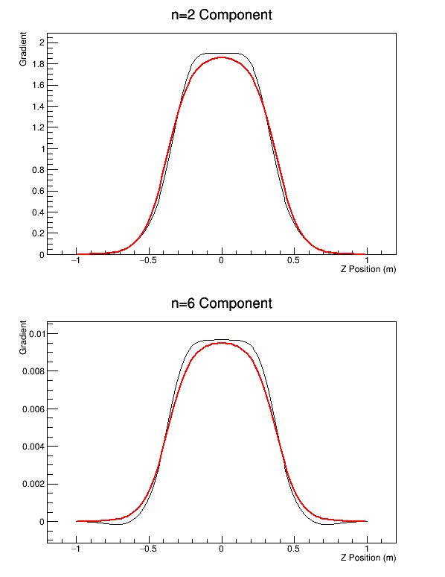

m5

w5 w15 w25 w50

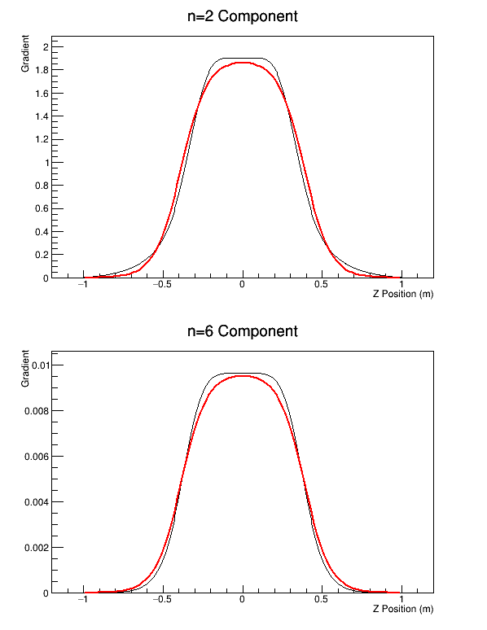  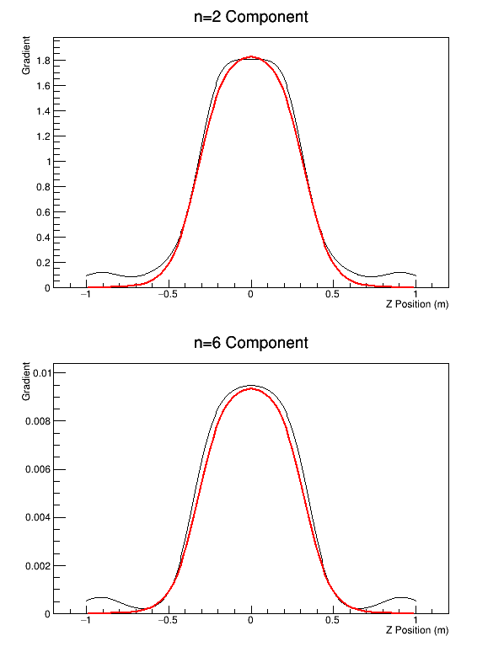 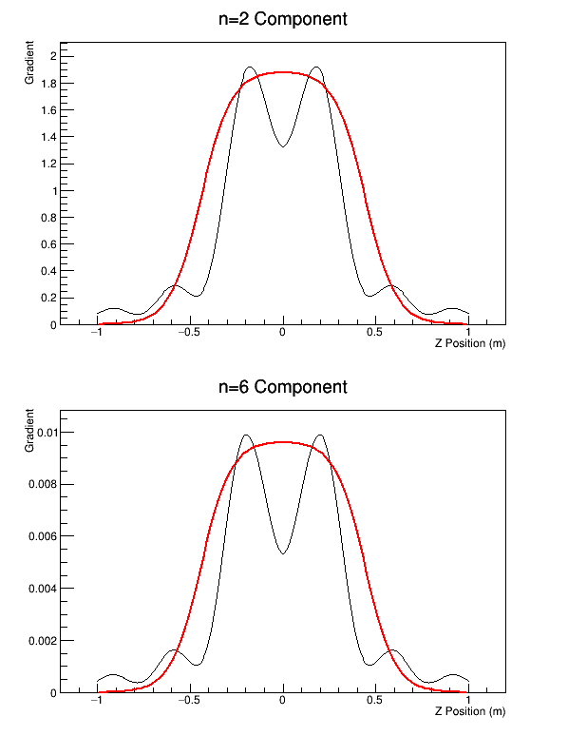

m20

w5 w15 w25 w50

  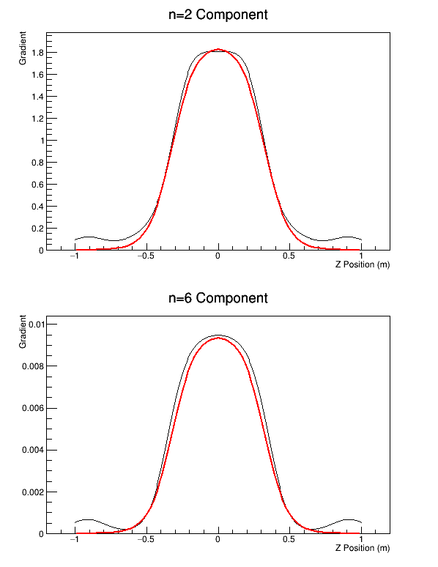 

Results show weak sensitivity to m (m_max). Closest result seems to be at about w15 for any m.