Optimization of *W* and *m_max* in Fourier Analysis for Gradient Data

# General Procedure

We varied the constants **W** and **m_max** to optimize the analysis of magnetic field data. Note that **W** is related to **kmax** by **kmax = 40*(W/z_max)** where **z_max = 1**. Specifically, we intended to minimize the double hump structure seen in the generated on-axis gradient data stemming from the **W** and **m_max** constants. We created a program to analyze multiple values of the constants and find the residuals squared of the simulated on-axis gradient points and the generated points.

# Varying *m_max*

By varying **m_max** and keeping **W** constant, we found that the residuals do not change in any noticeable manner. Shown below are plots of the simulated and generated on-axis gradients for three different **m_max** values (**15**, **20**, and **50** respectively) and a constant **W** value of **10**. The plots show the quadrupole and duodecapole field components. The red line shows the simulated values while the black shows the values generated using Fourier analysis.

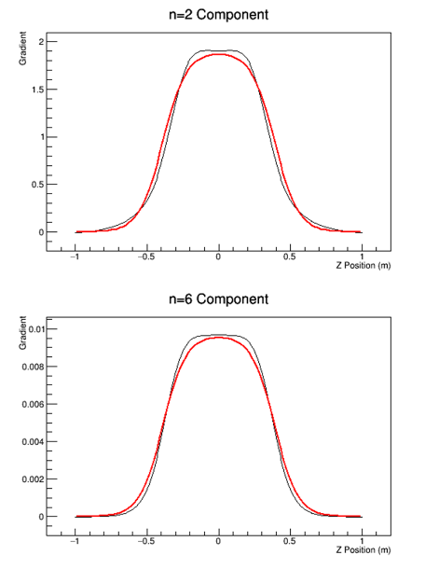

Additionally, a plot of residuals for **n=2** and **n=6** as a function of **m_max** is shown. The plot was made using a constant **W** value of **20**, but the behavior holds true for all **W** values tested.

The results indicate that including only a few terms in the Fourier series essentially maximizes the accuracy. This is because a large percentage of the pole is of quadrupole form, and higher order terms are nearly negligible, save the duodecapole term.

# Varying *W*

By varying **W**, we did in fact achieve a reduction in residuals. Shown below are three plots corresponding to **W** values of **15**, **20**, and **50**. The plots show the quadrupole and duodecapole field components. The red line indicates the simulated values while the black indicates the values generated using Fourier analysis.

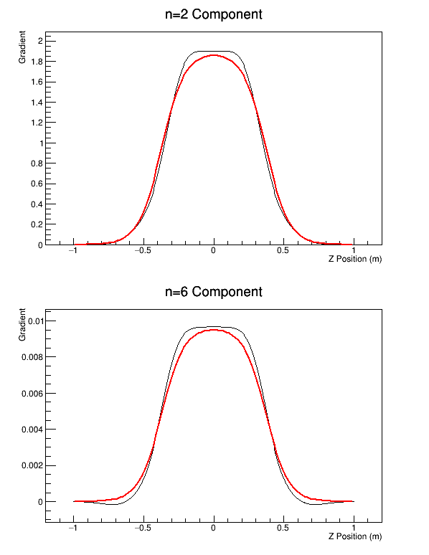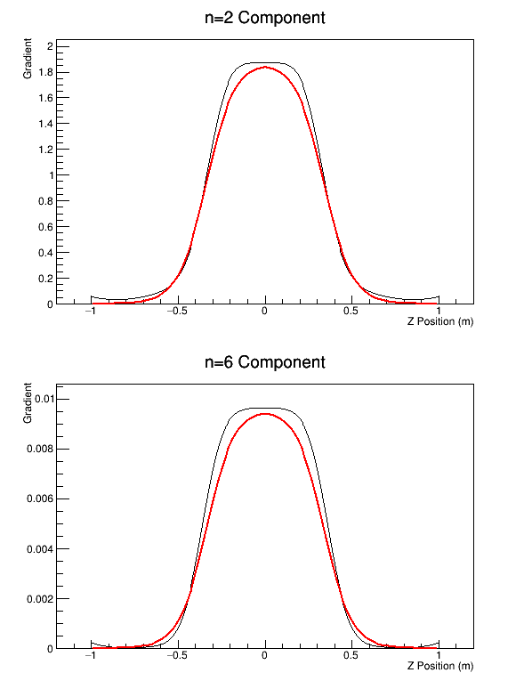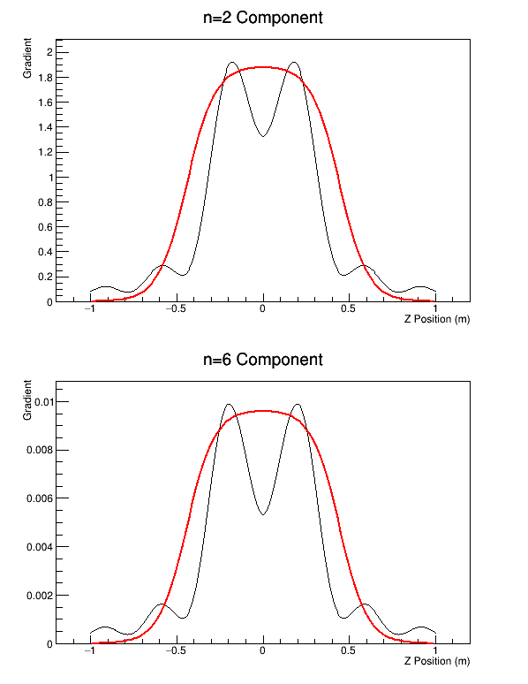

We can see simply from the plots that larger values of **W** lead to larger residuals between the plots. In fact, as shown in the plot below, the optimal value for **W** is **15**. However, changing the value of **W** does not change the results significantly until it is raised above approximately **30**.

Likely the reason for the decrease in accuracy for a higher value of **W** is a result of the fixed number of steps in the integral used to evaluate the Fourier coefficients. Although increasing **W** does increase the bounds on this integral (**k_max**, **k_min**), there are a fixed number of steps in the integral. Therefore, increasing the bounds increases the step size and thereby decreases the accuracy.

# Varying Step Size

Initially, the step size **dk** was determined using the equation **dk = (k_max – k_min)*W/ (Nk – 1)**. Here **Nk** represented the total number of steps on the interval. Therefore, as **W** increased, the step size increased leading to a decrease in fit accuracy. To account for this, we tested the effects of increasing the total number of steps on the interval, **Nk**. We increased the number of steps to five times its initial value and observed the results. Shown below are plots for both high and low **W** with both the initial number of steps and the increased number of steps.

Increasing the number of steps and decreasing the step size significantly reduced the residuals in the case of higher **W** values. However, for lower values of **W** the change in residual was insignificant. Furthermore, increasing the number of steps increased the computation time. All this to say, it is advisable to keep **W** at a low value (approximately **10-15**) and maintain a low number of steps (**Nz**).

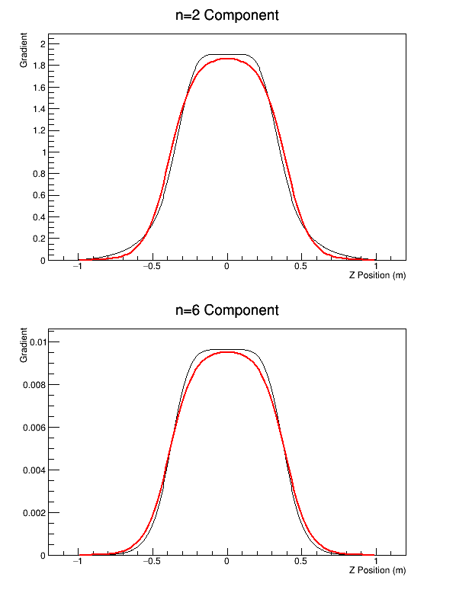

Shown above are plots for m_max = 10 and W = 15. The left plot shows the analysis with 5 x Nz number of steps. The right plot shows the analysis with Nz number of steps. In both cases, the red line represents the simulated on-axis gradient and the black line shows the calculated on-axis gradient.

Shown below are the same plots with W = 55. Again, the left plot shows the results for step number equal to 5 x Nz and the right shows the results for the step number equal to Nz.

