電通二乙微處理器實驗 實驗結報

實驗名稱 | LCD
組別 | 30 | 組員 | 李文韡

- 實驗目的
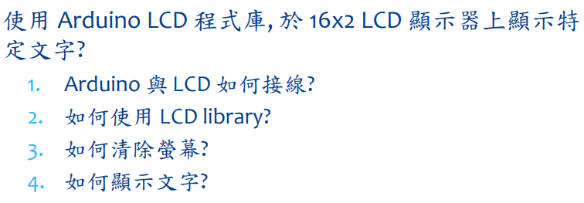
- 實驗步驟
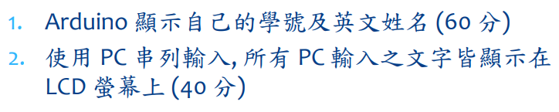
- 程式碼
/*
* LCD RS pin to digital pin 12
* LCD Enable pin to digital pin 11
* LCD D4 pin to digital pin 5
* LCD D5 pin to digital pin 4
* LCD D6 pin to digital pin 3
* LCD D7 pin to digital pin 2
* LCD R/W pin to ground
* 10K resistor:
* ends to +5V and ground
* wiper to LCD VO pin (pin 3)
*/
#include <LiquidCrystal.h> // include the library code
LiquidCrystal lcd(12, 11, 5, 4, 3, 2); // initialize interface pins
void setup() {
lcd.begin(16, 2); // set up the LCD's number of columns and rows:

}
void loop() {
//set the cursor to column 0, line 1
// (note: line 1 is the second row, since counting begins with 0):
lcd.setCursor(0, 1);
lcd.print(millis()/1000); // print the number of seconds since reset:
lcd.print("05051010 sean"); // Print a message to the LCD.
}

#include <LiquidCrystal.h>
LiquidCrystal lcd(12,11,5,4,3,2);
void setup()
{
lcd.begin(20,2);
Serial.begin(9600);
}
void loop()
{
char a;
if(Serial.available())
{
a=Serial.read();
lcd.print(a);
}
}

- 實驗結果及分析
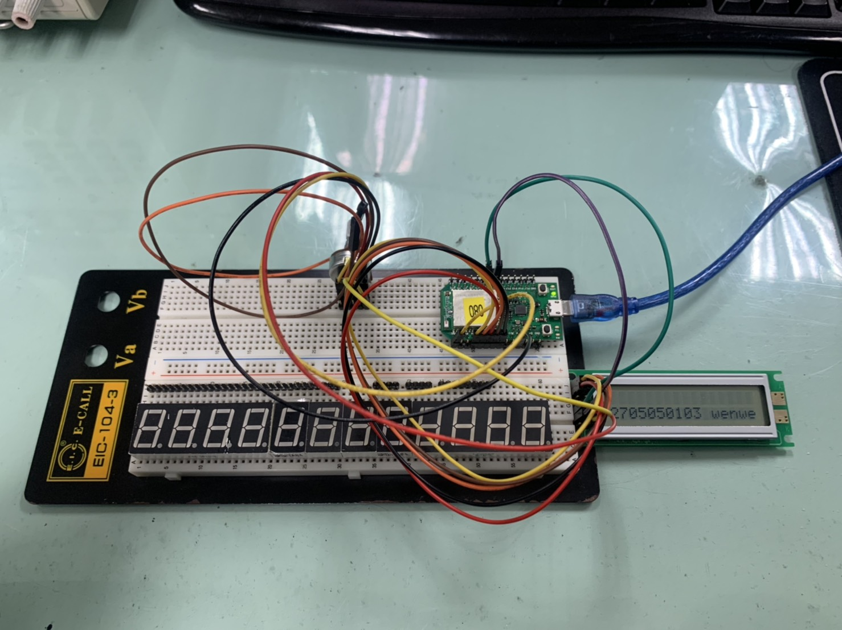
- 心得討論
終於做完了
- 修正電路圖
- 修正程式碼

