電通二乙微處理器實驗 實驗結報

實驗名稱 | Lab-01
組別 |  | 組員 | 李文韡

- 實驗目的
使用Tinkercad 模擬 Arduino UNO電路及程式
繪製電路圖
觀察Arduino UNO之輸出
學習將程式碼及實驗報告上傳至Github
- 實驗步驟
- 啟動Arduino IDE 載入Blink程式碼
- 至www.tinkercad.com註冊帳號 啟動Arduino模擬器
- 接上LED電路
- 修改程式 將LED輸出改成PIN 9
- 觀察LED之閃爍間隔
- 修改程式使LED閃爍間格分別增加為2倍及1/2倍重新量測並截圖
- 畫出電路圖
- 程式碼
void setup()
{
pinMode(9, OUTPUT);
}

void loop()
{
digitalWrite(9, HIGH);
delay(100); // Wait for 1000 millisecond(s)
digitalWrite(9, LOW);
delay(100); // Wait for 1000 millisecond(s)
digitalWrite(9, HIGH);
delay(100); // Wait for 1000 millisecond(s)
digitalWrite(9, LOW);
delay(100); // Wait for 1000 millisecond(s)
digitalWrite(9, HIGH);
delay(100); // Wait for 1000 millisecond(s)
digitalWrite(9, LOW);
delay(100); // Wait for 1000 millisecond(s)

digitalWrite(9, HIGH);
delay(300); // Wait for 1000 millisecond(s)
digitalWrite(9, LOW);
delay(100); // Wait for 1000 millisecond(s)
digitalWrite(9, HIGH);
delay(300); // Wait for 1000 millisecond(s)
digitalWrite(9, LOW);
delay(100); // Wait for 1000 millisecond(s)
digitalWrite(9, HIGH);
delay(300); // Wait for 1000 millisecond(s)
digitalWrite(9, LOW);
delay(100); // Wait for 1000 millisecond(s)

digitalWrite(9, HIGH);
delay(100); // Wait for 1000 millisecond(s)
digitalWrite(9, LOW);
delay(100); // Wait for 1000 millisecond(s)
digitalWrite(9, HIGH);
delay(100); // Wait for 1000 millisecond(s)
digitalWrite(9, LOW);
delay(100); // Wait for 1000 millisecond(s)
digitalWrite(9, HIGH);
delay(100); // Wait for 1000 millisecond(s)
digitalWrite(9, LOW);
delay(300); // Wait for 1000 millisecond(s)
}
- 實驗結果及分析
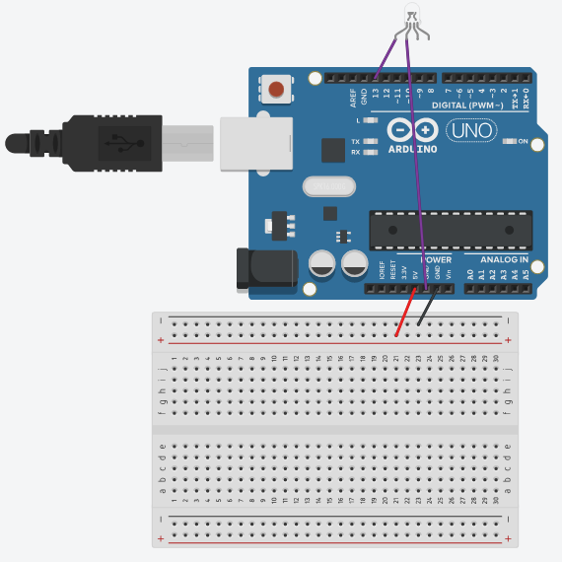
- 心得討論

學到很多
- 修正電路圖
