電通二乙微處理器實驗 實驗結報

實驗名稱
組別 | 30 | 組員 | 李文韡

- 實驗目的

- 實驗步驟

- 程式碼
const byte ledPin =13;
int val=0;
void setup() {
// put your setup code here, to run once:
Serial.begin(9600);
pinMode(13,OUTPUT);
}

void loop() {
// put your main code here, to run repeatedly:
while(Serial.available())
{
val = Serial.read();
if(val=='1')
{
digitalWrite(13, HIGH);
Serial.println("LED ON");
}
else if(val=='0')
{
digitalWrite(13, LOW);
Serial.println("LED OFF");
}
}
}

const byte ledPin =14;
int val=0;
void setup() {
Serial.begin(9600);
pinMode(14,INPUT);
}

void loop() {
int value = analogRead(A0);

Serial.print("Input voltage: ");
// LinkIt 7697 ADC spec: 12-bit, 0~2.5V range
Serial.print(value * 2500 / 4095);
Serial.println("mV");

delay(100);
}

- 實驗結果及分析

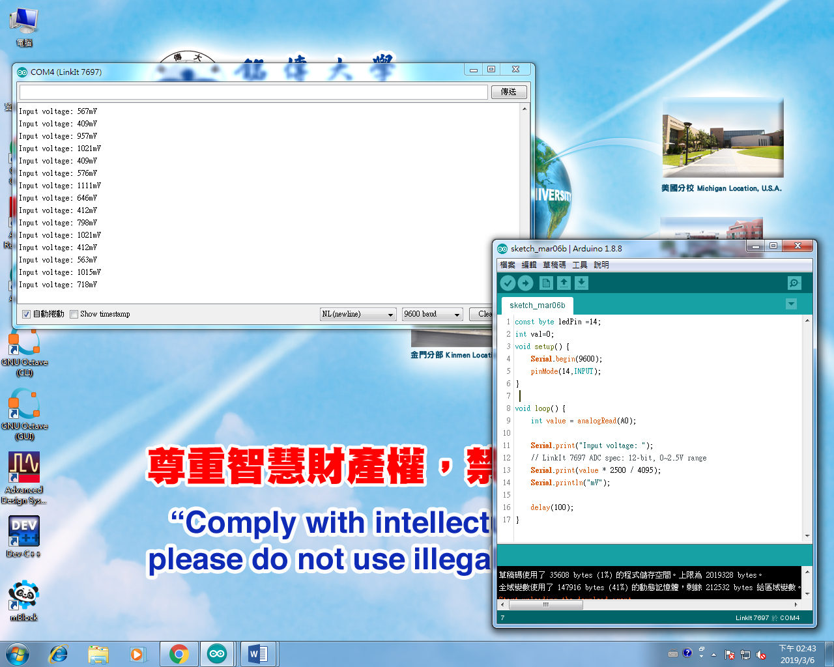
實際電壓 | 讀值 | 推測電壓
0 | 13.23 | 0.01
0.5 | 722.38 | 0.44
1 | 1667.22 | 1.02
1.5 | 2493.08 | 1.52
2 | 3330.78 | 2.03
2.5 | 4095.00 | 2.50

可變電阻 | 讀值 | 推測電壓 | 推測電阻 | 輸出
0 | 793.93 | 3 | 0 | 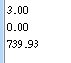
0.105M | 811.56 | 0.99 | 0.201M | 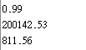
0.394M | 3090.58 | 3.77 | 0.762M | 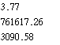
0.595M | 3311.56 | 4.04 | 0.816M | 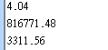
0.8184 | 4095.00 | 5 | 1.01M | 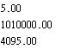
1.01M | 4095.00 | 5 | 1.01M | 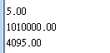

- 心得討論

