電通二乙微處理器實驗 實驗結報

實驗名稱 | Arduino 接一 4x 4 鍵盤
組別 |  | 組員 | 李文韡

- 實驗目的

- 實驗步驟

- 程式碼
#include <Keypad.h>
const byte ROWS = 4;
const byte COLS = 4;

char keys[ROWS][COLS] = {
{'F', 'E', 'D', 'C'},
{'B', '3', '6', '9'},
{'A', '2', '5', '8'},
{'0', '1', '4', '7'}
};

byte rowPins[ROWS] = {5, 4, 3, 2};

byte colPins[COLS] = {11,10,9,8};

Keypad keypad =Keypad( makeKeymap(keys), rowPins,colPins, ROWS, COLS );
void setup()
{
Serial.begin(9600);
}
void loop()
{
char key = keypad.getKey();
if (key != NO_KEY)
{
Serial.println("The first number is ");
Serial.println(key);
}
}

#include <Keypad.h>
const byte ROWS = 4;
const byte COLS = 4;

char keys[ROWS][COLS] = {
{'F', 'E', 'D', 'C'},
{'B', '3', '6', '9'},
{'A', '2', '5', '8'},
{'0', '1', '4', '7'}
};

byte rowPins[ROWS] = {5, 4, 3, 2};

byte colPins[COLS] = {11,10,9,8};

Keypad keypad =Keypad( makeKeymap(keys), rowPins,colPins, ROWS, COLS );
void setup()
{
Serial.begin(9600);
}
void loop()
{

char key;
key= keypad.getKey();

do{
key = keypad.getKey();
}
while (key==NO_KEY);
Serial.println("The first number is ");
Serial.println(key);

do{
key = keypad.getKey();
}
while (key==NO_KEY);
Serial.println("The second number is ");
Serial.println(key);
}

#include <Keypad.h>
const byte ROWS = 4;
const byte COLS = 4;

char keys[ROWS][COLS] = {
{'F', 'E', 'D', 'C'},
{'B', '3', '6', '9'},
{'A', '2', '5', '8'},
{'0', '1', '4', '7'}
};

byte rowPins[ROWS] = {5, 4, 3, 2};

byte colPins[COLS] = {11,10,9,8};

Keypad keypad =Keypad( makeKeymap(keys), rowPins,colPins, ROWS, COLS );
void setup()
{
Serial.begin(9600);
}
void loop()
{

char key;
key= keypad.getKey();

do{
key = keypad.getKey();
}
while (key==NO_KEY);
Serial.println("The first number is ");
Serial.println(key);

do{
key = keypad.getKey();
}
while (key==NO_KEY);
Serial.println("The second number is ");
Serial.println(key);

do{
key = keypad.getKey();
}
while (key==NO_KEY);
Serial.println("The opertion is ");
// Serial.println(key);

switch(key){
case 'A':
Serial.println("+");
break;
case 'B':
Serial.println("-");
break;
case 'C':
Serial.println("*");
break;
case 'D':
Serial.println("/");
break;

}

}

#include <Keypad.h>
const byte ROWS = 4;
const byte COLS = 4;

char keys[ROWS][COLS] = {
{'F', 'E', 'D', 'C'},
{'B', '3', '6', '9'},
{'A', '2', '5', '8'},
{'0', '1', '4', '7'}
};

byte rowPins[ROWS] = {5, 4, 3, 2};

byte colPins[COLS] = {11,10,9,8};

Keypad keypad =Keypad( makeKeymap(keys), rowPins,colPins, ROWS, COLS );
void setup()
{
Serial.begin(9600);
}
void loop()
{

char key1;
char key2;
char key3;
int ans=ans-96;
key1= keypad.getKey();
key2= keypad.getKey();
key3= keypad.getKey();

do{
key1 = keypad.getKey();
}
while (key1==NO_KEY);
Serial.println("The first number is ");
Serial.println(key1);

do{
key2 = keypad.getKey();
}
while (key2==NO_KEY);
Serial.println("The second number is ");
Serial.println(key2);

do{
key3 = keypad.getKey();
}
while (key3==NO_KEY);
Serial.println("The opertion is ");
// Serial.println(key3);

switch(key3){
case 'A':
Serial.println("+");
ans=key1+key2;
Serial.println(ans-96);
break;
case 'B':
Serial.println("-");
ans=key1-key2;
Serial.println(ans);
break;
case 'C':
Serial.println("*");
ans=key1*key2;
Serial.println(ans/153);
break;
case 'D':
Serial.println("/");
ans=key1/key2;
Serial.println(ans+1);
break;

}

}

- 實驗結果及分析
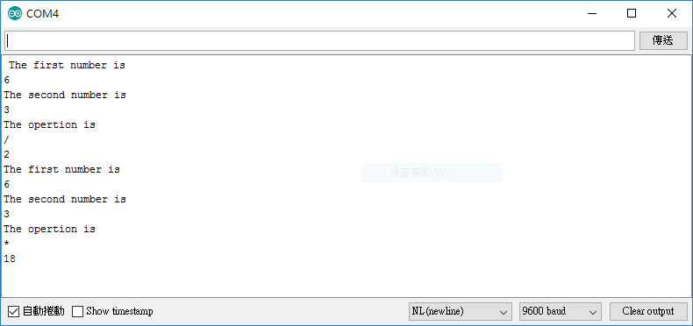
- 心得討論
謝謝老師
- 修正電路圖
- 修正程式碼

