Developing Mobile Application Design

of Virtual Pets for Caring for the Elderly

Hsiu Ching Laura Hsieh^{(&)}

Department of Creative Design,

National Yunlin University of Science and Technology, Douliu, Taiwan
laurarun@gmail.com

Abstract. In the population ageing society, the companionship and care of the elderly, the medical system, and the consumer trend cannot be neglected. The contact with the external and the ones caring about oneself is essential for the elderly. This study aims to develop application with the functions of healthcare and accompanying, and the accessibility design is included in the interface, where virtual pets are the major communication media to assist the elderly in using mobile application. The required functions and contents in mobile application as well as the preference for the interface and models of interaction for the elderly are investigated in this study. It aims to ease and convince the elderly of the easy use. In the process of cultivating and training the virtual pet mobile application, the elderly could be accompanied and reduced the sense of loneliness; in the further use and interaction with virtual pet mobile application, the physical and metal conditions of the elderly could be real-time monitored and recorded to assist monitoring stations in managing the physical conditions of the elderly and nursing personnel in periodical checks. This research is preceded as following. First, literatures are reviewed. Second, Focus Group Interview is utilized for concluding the application contents and functions and the requirements and preference of the elderly for virtual pets. Third, an application experimental prototype is designed according to such requirements and preference. Fourth, the questionnaire, aiming to test the usability of the elderly, is filled. Fifth, the principles and suggestions for mobile application design suitable for the elderly are concluded based on the test results and anal-yses. The research outcome would assist in and contribute to the accessibility design of mobile application and the application to medical care by providing possible solutions for insufficient caring manpower in ageing societies and uneven distribution of medical resources.

Keywords: Mobile application Virtual pet Virtual elder care Accessibility

1 Introduction

According to the research of World Health Organization, population ageing is a global problem in the 21st century. Taiwan has stepped in the ageing society since 1993 and the aged population above the age of 60 was 17.4 % of total population in 2013. The Executive Yuan estimated that the ratio would reach 37.5 % by 2056 [4]. In the population ageing society, the companionship and care of the elderly, the medical

© Springer International Publishing Switzerland 2015

J. Zhou and G. Salvendy (Eds.): ITAP 2015, Part II, LNCS 9194, pp. 269–277, 2015.

DOI: 10.1007/978-3-319-20913-5_25

270 H.C.L. Hsieh

system, and the consumer trend cannot be neglected. The contact with the external and the ones caring about oneself is essential for the elderly. Jive Software, a famous software company in the USA, indicated in 2011 that the probability of the elderly suffering from dementia in poor social networking environment was 60 % higher than the others in active environments [7]. To solve the problems of senses of accompanying and security, a lot of people choose pets to be the companions. Plenty of research on animal-assisted therapy has been studied in the world. In addition to real pets, the application and development of virtual pets could also be transferred into an option of senior care. To solve insufficient medical human capital and resources, the software which allows the elderly applying the mobile application to the medical network real-time interaction software is developed to observe the physical and mental condi-tions of the elderly. It could be a kind of highly feasible nursing in the future. Inte-grating virtual pets to replace inflexible machines or nursing personnel allows developing handy mobile application contents for nursing and accompanying the elderly.

The elderly healthcare in Taiwan has become critical as the aging society is forming. Nevertheless, the uneven distribution of physicians between rural and urban has resulted in the lack of medical resources in remote areas [2]. According to the physical conditions of the elderly, it is not easy for them leaving houses for health checks. Besides, the elderly loneliness is caused by the children not being able to take care of their parents because of work or residence in different places. The elderly with self-care functions could effectively reduce the health problems and enhance the health and welfare [6]. For this reason, a virtual pet-based mobile application for caring for the elderly with the functions of self-care and company is developed in this study. It allows the elderly knowing the health conditions, real-time sharing the results with friends and relatives through smartphones, and reducing the loneliness by raising virtual pets. The mobile application prototype is designed, according to the elderly characteristics, for the experimental test to discuss whether the user interface and functions conform to the elderly demands. In this study, the interface characteristics of satisfaction, memora-bility, error rate, and efficiency are discussed.

2 Literature Review

2.1 Mind and Body Functions of the Elderly

Lee [8] concluded the degenerating functions of the elderly with the age as below.

- Motive function: Easy to fall due to reducing strength, low balance, longer oper-ation time for the elderly than for the youth, but less errors because the elderly request higher operation accuracy than operation speed; however, the antagonistic relationship between operation speed and accuracy could not be used for explaining the reason of the elderly being sluggish.

- Perception function: (1)Vision. By increasing the time, the errors increase in the green-blue area, especially with low illuminance, while the error rate is lower in the red-yellow area. The elderly perceive narrower chroma that the color discrimination is worse when the color value is close. (2) Hearing. The elderly do not comprehend

Developing Mobile Application Design of Virtual Pets | 271

the computer voice, cannot distinguish the location of high frequency and tempo-rary sound, but could distinguish low frequency and temporary sound. 3) Haptic perception. Convex marks are more easily recognized than concave marks with haptic perception.

- Cognitive function: The elderly could reduce the dependence on work memory through practice. The use of event-oriented prospective memory interface could enhance the compatibility between interface elements.

2.2 The Principles of Mobile Application Interface Design

Shneiderman [9] proposed this collection of principles that are derived heuristically from experience and applicable in most interactive systems after being properly refined, extended, and interpreted. (1) Strive for consistency. (2) Enable frequent users to use shortcuts. (3) Offer informative feedback. (4) Design dialog to yield closure. (5) Offer simple error handling. (6) Permit easy reversal of actions. (7) Support internal locus of control. (8) Reduce short-term memory load.

2.3 The Usability of Interaction Design

Based on Nielsen [2], the usability is defined as the following. (1) Learnability: has to do with how quickly and easily users can begin to do productive work with a system, which is new for them. Learnability is how quickly and easily users can reach a level of proficiency in using the system. (2) Efficiency: Efficiency is the number of tasks per unit of time that the user can perform using the system. (3) Satisfaction: is the sub-jective opinion that users form about the system (or about some parts of it). It is the most elusive usability attribute, as it is completely dependent on subjective opinion of users. (4) Error rate: This refers to the errors made during the use of the system and how easy it is to recover from them [2]. (5) Memorability: This refers to the ease of remembering the way a system must be operated. Nielsen [2] describes this as the characteristic of a system that allows the user to return to the system after some period of not having used it, without having to learn everything all over again. According to above statements, the mobile application prototype of virtual pets for caring and accompanying the elderly is constructed. The application interface is further tested to conform to the demands of the elderly in Taiwan. The user interface char-acteristics of satisfaction, errors, learnability, and efficiency are tested in this experiment.

3 Methods

The methods are introduced as following. First, literatures are reviewed. Second, Focus Group Interview is utilized for concluding the mobile application contents and func-tions and the requirements and preference of the elderly for virtual pets. Third, an mobile application experimental prototype is designed according to such requirements

272 H.C.L. Hsieh

and preference. Fourth, the questionnaire, aiming to test the usability of the elderly, is filled. Fifth, the principles and suggestions for application design suitable for the elderly are concluded based on the test results and analyses.

3.1 Focus Group Interview

Focus Group Interview is utilized for concluding the elderly demands and preference for the mobile application functions and virtual pets. Six elderly participants (aged above 65) are living in Taiwan. From the Focus Group Interview results, the elderly need to tell the mobile application from other programs that pop-up windows are better for the reminder. In regard to the preference for virtual pets, most elderly prefer dogs and cats, especially small dogs with big eyes and big ears. In terms of functions, the reminders of medication and exercise records are favored, and menu records are convenient for the elderly rapidly finding the demands. Most elderly are satisfied with the function to contact the friends and relatives and expect virtual pets to present the functions of looking after the house, security guard, and emergency treatment.

3.2 Constructing Mobile Application Prototype and Questionnaire Design

The prototype of mobile application is constructed and the questionnaire is designed according to the elderly demands and preference in the previous step. Figure 1 shows the application test structure. The test in this study combines care records with pets.
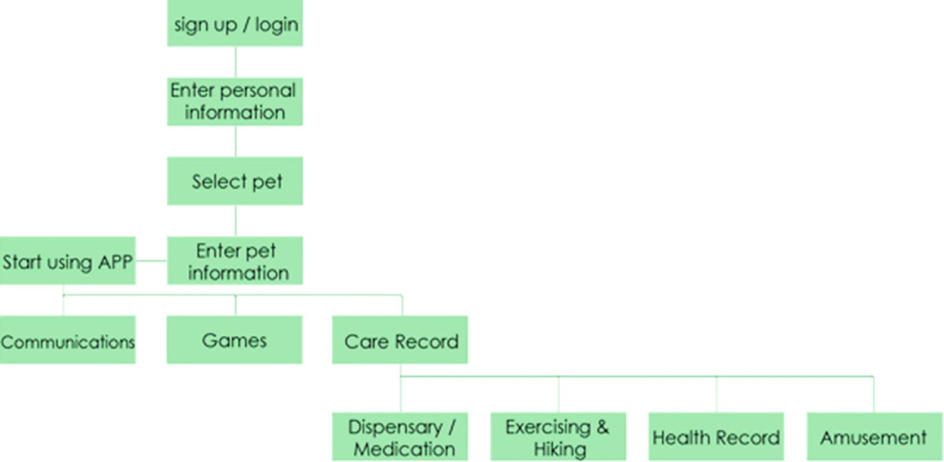

Fig. 1. Mobile application structure

Developing Mobile Application Design of Virtual Pets | 273

When starting using the application, the major function is divided into communication, games, and care record, where the pet is the helper of such functions.

- Communication: After accumulating for a period of time, it would remind the user to contact with the friends and relatives.

- Games: The brain training games are utilized for slowing down functional degeneration.

- Care record: It is classified into four categories.

  - Pharmaceutical Dispensary/Medication: It is used for selecting the variety of medication and recording time. Pet feedback would be acquired after com-pleting the task (Fig. 2).

  - Exercise and Hiking: It is used for selecting exercise or pet walking and recording time. Pet feedback would be acquired after completing the task (Fig. 2).
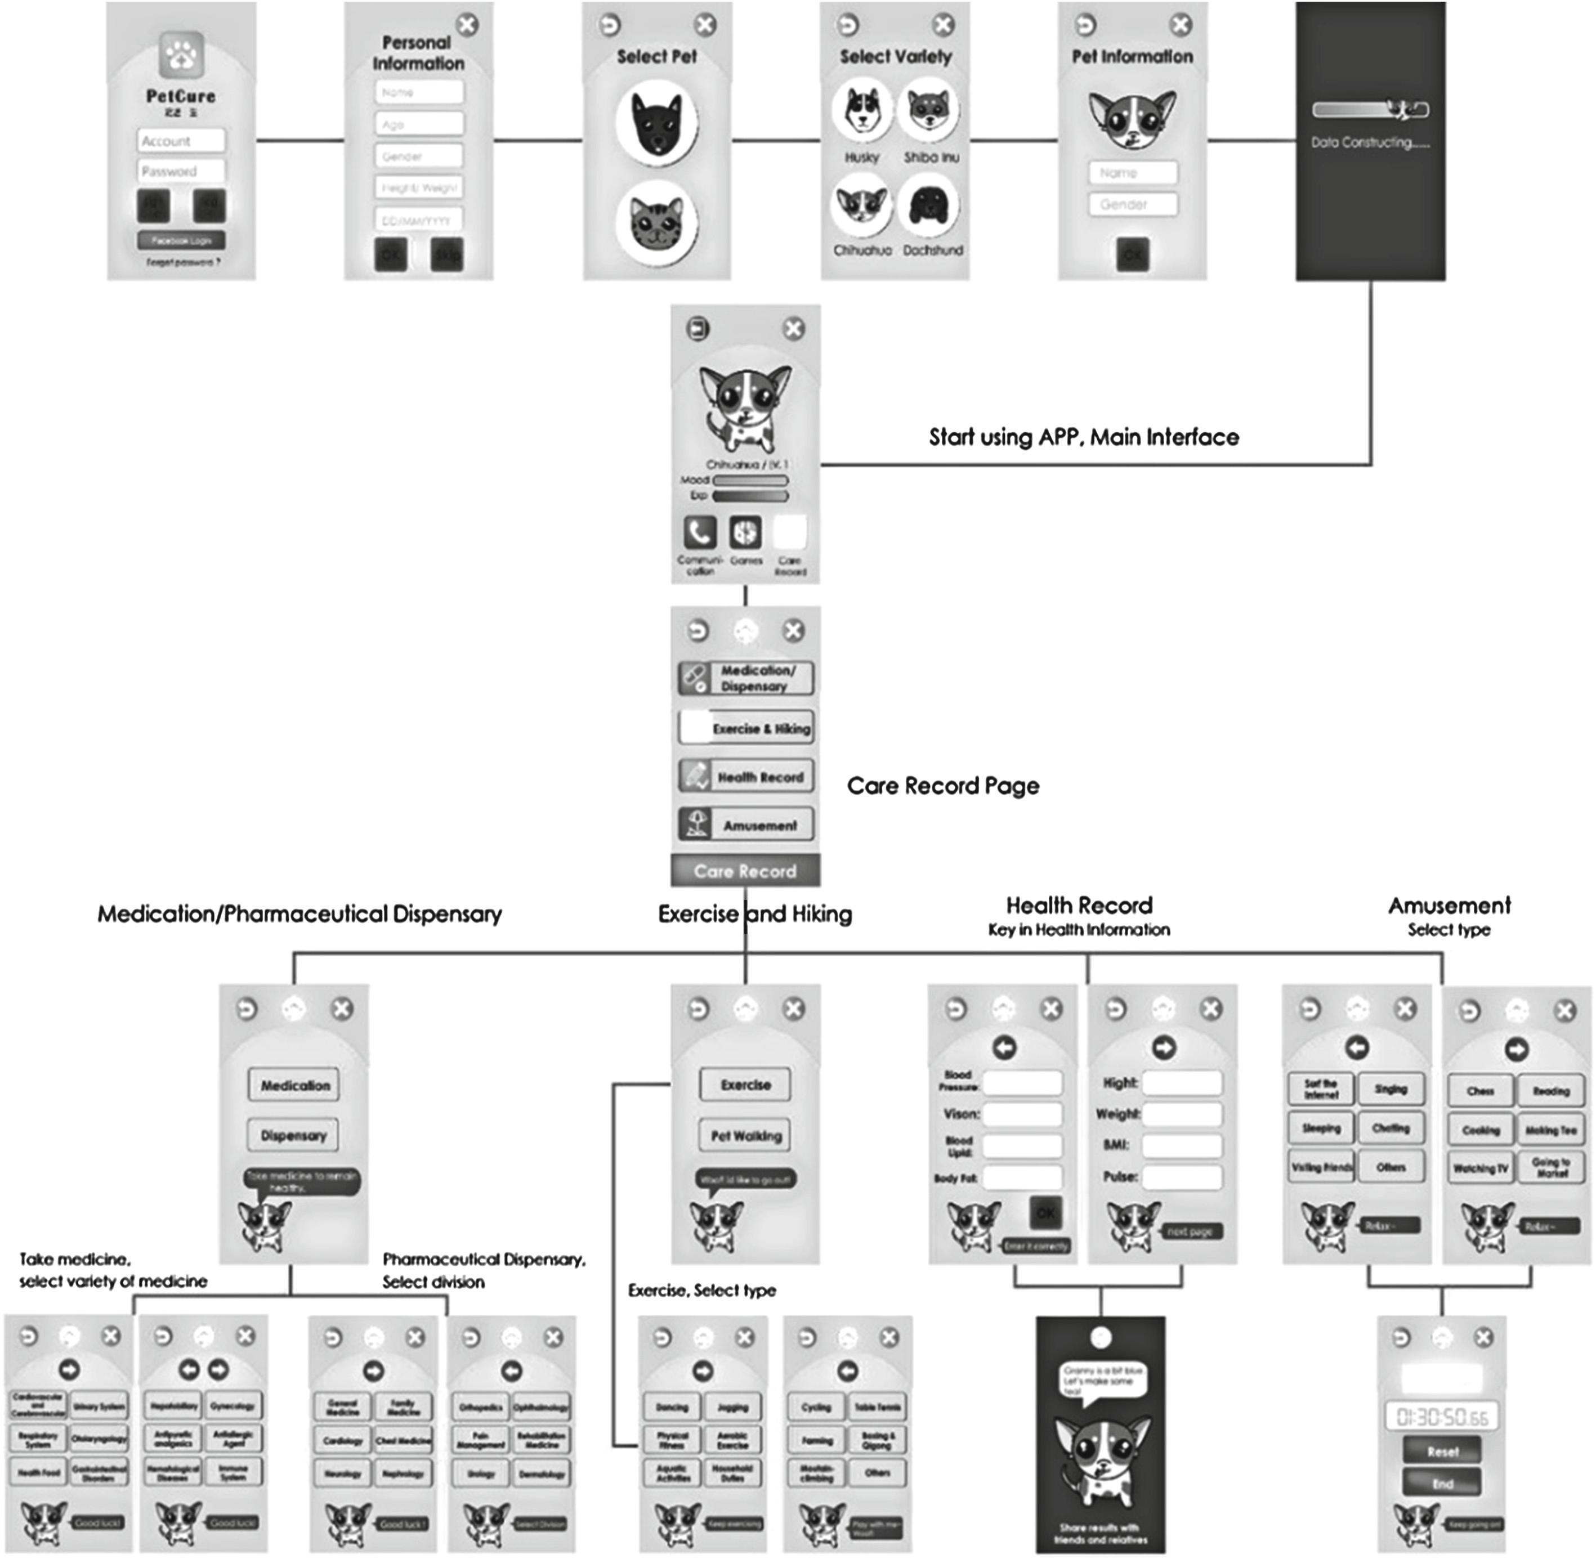

Fig. 2. Mobile application prototype

- H.C.L. Hsieh

  - Health Record: It is used for inputting personal health record, and pet feedback would be acquired (Fig. 2).

  - Amusement: It is used for selecting amusement and recording time, and pet feedback would be acquired (Fig. 2).

3.2.1 Task Assigned

Total eight tasks are executed by the participants. A testing staff would inform the participants about the tasks, while the other testing staff would record the process. All the tasks are preceded by time and count (Table 1).

Table 1. Task assigned

Task 1 Please try to find the “Care Record” page

Task 2 Please try to find the “Medication/Dispensary” button

Task 3 Please try to find the medication “Antiallergic”

Task 4 Please try to find the “Exercise” button

Task 5 Please try to finish the exercise “Jogging”

Task 6 Please try to find the “Pause” button

Task 7 Please try to find the “Health Record” button

Task 8 Please try to find the “Log out” button

3.2.2 Questionnaire Design

The users are requested to answer the following questions after completing the tasks so as to understand the user’s subject opinions with the prototype. Likert Scale, containing the options of Extremely Agree, Agree, Uncertain, Disagree, Extremely Disagree, is applied.

– Q 1. Is the typeface clear?

– Q 2. Is the typeface large enough?

– Q 3. Is the button which you intend to use easy to find?

– Q 4. Do you like the figure design of pets?

– Q 5. Does the button icon look comfortable and understandable?

– Q 6. Are you comfortable with the comprehensive picture?

– Q 7. Is the menu input in the test convenient?

– Q 8. Would you consider it more convenient to save sound, through speech, as the record?

– Q 9. Do you think it being less boring to interact with virtual pets?

– Q 10. Would the design of virtual pets have you be willing to use the software?

– Q 11. Would you increase the use intention by recording the medication habit and enhancing the pet friendship?

Developing Mobile Application Design of Virtual Pets | 275

– Q12. Would you be happy when the pet learns new skills (sitting down, shaking hands, and so on)?

– Q13. Hence, would you be more motivated to use the application program?

– Q14. Could the pet reminder help you remember to take medicine?

– Q15. Do you think the reminder function being convenient?

– Q16. Do you need the pet reminder function?

3.3 Participants in User Test

Among the total 12 participants, 2 of them are below 60-year-old and 10 are above 65-year-old. The average age is 66.5. All of the elderly live in Taiwan, and 6 of them have the experiences in using smart phones, while the rest 6 do not.

3.4 Results of User Test

Table 2 shows the test results of efficiency and learnability. For Task 1, the carebutton is searched with text explanation. The tested interface efficiency reveals the average speed 3.1 s, with certain efficiency. Tasks 2–7 contain the horizontal menu with the same information structure that the operation procedures are similar. From Table 2, the time for the participants executing from Tasks 2–3 to Tasks 4–6 and then Task 7 decreases obviously. It presents the easy learnability of the interface system for the participants learning the standard procedure in the similar operations. Task 8 relates to the testing efficiency, from which the average speed appears 15.6 s, and most partic-ipants could not immediately find the log-out button, because the icon does not show additional text explanation. Additional texts or icon improvement therefore are required for the low readability.

Table 2. Analysis of user task by time

 | Subject | Subject | Subject | Subject | Subject | Subject | Subject | Subject | Subject | Subject | Subject | Subject | Average
 | 01 | 02 | 03 | 04 | 05 | 06 | 07 | 08 | 09 | 10 | 11 | 12
Task 1 | 1 | 1 | 1 | 5 | 6 | 1 | 1 | 6 | 9 | 3 | 2 | 1 | 3.1
Task 2 | 9 | 12 | 4 | 5 | 4 | 4 | 9 | 17 | 6 | 5 | 6 | 11 | 7.7
Task 3 | 1 | 2 | 1 | 2 | 2 | 2 | 6 | 1 | 2 | 2 | 2 | 2 | 2.1
Task 4 | 10 | 12 | 2 | 7 | 5 | 5 | 6 | 4 | 5 | 3 | 9 | 5 | 6.1
Task 5 | 2 | 1 | 2 | 1 | 1 | 2 | 4 | 2 | 1 | 1 | 1 | 1 | 1.6
Task 6 | 2 | 1 | 1 | 1 | 1 | 1 | 1 | 1 | 1 | 1 | 1 | 1 | 1.1
Task 7 | 1 | 2 | 6 | 5 | 1 | 1 | 2 | 2 | 2 | 1 | 1 | 1 | 2.1
Task 8 | 6 | 9 | 8 | 12 | 3 | 30 | 56 | 10 | 12 | 5 | 16 | 20 | 15.6

Table 3 displays the test results of error rate and learnability. No error appears on Task 1, revealing that a button with icon and text is the optimal design. Horizontal menus with the same information structure are used for Tasks 2–7 that the operation procedures are similar. Errors merely appear on Tasks 2–3, but not on Tasks 4–7 that the learnability is also proven. Merely icons, without text explanation, are shown for the buttons in Task 8 that the error rate is high. Comparing Task 1 and Task 8, text explanations might be as important as icons for the elderly.

276 | H.C.L. Hsieh
 |  |  |  | Table 3. Analysis of user task by count
 | Subject | Subject |  | Subject | Subject | Subject | Subject | Subject | Subject | Subject | Subject | Subject | Subject
 | 01 | 02 |  | 03 | 04 | 05 | 06 | 07 | 08 | 09 | 10 | 11 | 12
Task 1 | 1 | 1 |  | 1 | 1 | 1 | 1 | 1 | 1 | 1 | 1 | 1 | 1
Task 2 | 2 | 3 |  | 2 | 2 | 2 | 2 | 2 | 2 | 2 | 2 | 3 | 2
Task 3 | 1 | 1 |  | 1 | 1 | 1 | 1 | 1 | 1 | 1 | 1 | 1 | 1
Task 4 | 2 | 2 |  | 2 | 2 | 2 | 2 | 2 | 2 | 2 | 2 | 2 | 2
Task 5 | 1 | 1 |  | 1 | 1 | 1 | 1 | 1 | 1 | 1 | 1 | 1 | 1
Task 6 | 1 | 1 |  | 1 | 1 | 1 | 1 | 1 | 1 | 1 | 1 | 1 | 1
Task 7 | 1 | 1 |  | 1 | 1 | 1 | 1 | 1 | 1 | 1 | 1 | 1 | 1
Task 8 | 1 | 1 |  | 2 | 1 | 1 | 2 | 2 | 2 | 2 | 1 | 1 | 1

Table 4 shows the questionnaire result, which is divided into usability and inter-active emotion. Questions 1–7 in the first part are related to usability (typeface, button, pet figure, icon, comprehensive picture, and menu input), while questions 8–16 in the last part are related to interactive emotion (demands for sound record, pet interactivity, and pet reminder). With Likert 5-point Scale, the questions are scored 1–5 for the options of Extremely Disagree to Extremely Agree for the satisfaction. Overall speaking, the average score is above 4, presenting that the mobile application conforms to the elderly demands and satisfaction.

Table 4. Analysis of overall questionnaire result

Question | Subject | Subject | Subject | Subject | Subject | Subject | Subject | Subject | Subject | Subject | Subject | Subject | Mean
No | 01 | 02 | 03 | 04 | 05 | 06 | 07 | 08 | 09 | 10 | 11 | 12
1 | 4 | 4 | 4 | 4 | 4 | 4 | 4 | 4 | 4 | 4 | 4 | 5 | 4.1
2 | 4 | 4 | 4 | 4 | 5 | 4 | 4 | 4 | 4 | 4 | 4 | 4 | 4.1
3 | 4 | 4 | 4 | 4 | 4 | 4 | 4 | 4 | 4 | 4 | 4 | 5 | 4.1
4 | 5 | 4 | 4 | 4 | 5 | 3 | 4 | 4 | 5 | 4 | 4 | 4 | 4.2
5 | 5 | 4 | 4 | 4 | 4 | 4 | 4 | 4 | 4 | 4 | 4 | 4 | 4.1
6 | 5 | 4 | 4 | 4 | 4 | 4 | 4 | 4 | 5 | 4 | 4 | 5 | 4.3
7 | 5 | 3 | 4 | 4 | 4 | 4 | 4 | 4 | 5 | 4 | 4 | 5 | 4.2
8 | 5 | 4 | 4 | 5 | 5 | 5 | 4 | 4 | 4 | 4 | 4 | 4 | 4.3
9 | 4 | 4 | 4 | 4 | 4 | 4 | 4 | 4 | 3 | 4 | 4 | 5 | 4.0
10 | 5 | 4 | 4 | 4 | 4 | 4 | 4 | 4 | 4 | 4 | 4 | 5 | 4.2
11 | 5 | 4 | 4 | 4 | 5 | 5 | 3 | 4 | 4 | 4 | 4 | 5 | 4.3
12 | 5 | 4 | 4 | 4 | 4 | 4 | 4 | 4 | 4 | 4 | 4 | 5 | 4.2
13 | 5 | 3 | 4 | 4 | 4 | 4 | 4 | 4 | 5 | 4 | 4 | 5 | 4.2
14 | 5 | 4 | 4 | 4 | 4 | 4 | 4 | 4 | 4 | 4 | 4 | 4 | 4.1
15 | 5 | 4 | 4 | 4 | 4 | 5 | 4 | 4 | 5 | 4 | 4 | 5 | 4.3
16 | 5 | 4 | 4 | 4 | 4 | 4 | 4 | 4 | 4 | 4 | 4 | 4 | 4.1

4 Discussion and Conclusion

After the test, the experimental result and the predicted effect are generally satisfactory. It is found that images marked with texts are more easily recognized by the user to enhance the efficiency of interface use. As a result, texts might be more important than images for the elderly. When preceding tasks with the same model, the time spent would be reduced and the error rate is also decreased, showing that the mobile application prototype interface conforms to the elderly demands and preference. The overall

Developing Mobile Application Design of Virtual Pets | 277

learnability is high. Having the participants look for images without texts, it is found that the elderly can hardly recognize the function of such images that the error rate is high. It is suggested that image should be added texts in the successive interface design to decrease the error rate. The overall questionnaire survey reveals high satisfaction of the participants with the interface. Besides, the designed image of the visual pet is friendly that it indeed could enhance the participants’ pleasure using the interface.

According to the experimental result, the participants commonly consider voice records or direct use of button being more convenient than text input. Pet interactivity could enhance the participants’ use motivation. The questionnaire data show the demands for the prompt function of medical treatment, exercise, and contact which therefore could be completed. In regard to the final suggestion, the elderly in Taiwan reveal distinct opinions about pet functions, with which looking after the house, security guard, and emergency rescue could be combined. The experimental results reveal that the design of virtual pets actually could enhance the elderly willingness to use the mobile application, and the elderly indeed have the demands for caring and contact functions. The elderly preference for pet image and interactivity could be further developed and designed. Besides, the elderly in Taiwan can correctly identify the buttons with texts on mobile phones. The research results could help designers and design developers develop interactive interface for the elderly.

References

- Akinagac, S., Tsuneo K.: Healing effect of virtual pet. Psychol. Res. 8, 39–44

- Chen, C.Y., Yang, Y.C.: Taiwan Geriatr. Gerontol. 2(3), 209–224 (2007)

- Díaz-Bossini, J.M., Moreno, L.: Accessibility to mobile interfaces for older people. Procedia Comput. Sci. 27, 57–66 (2014)

- Fan, G.J., Hsu, Y.H.: Socio-economic impacts of population aging in taiwan. Taiwan Geriatr. Gerontol. 5(3), 149–168 (2010)

- Hiroko, K.: What kind of influence does online virtual pets have on people. Jpn. Soc. Educ. Inf. 25(2), 3–14 (2009)

- Hoy, B., Wagner, L., Hall, E.: Self-care as a health resource of elders: an integrative review of the concept. Scand. J. Caring Sci. 21(4), 456–466 (2007)

- Kivimäki, T., Kölndorfer, P, Vainio, A.-M., Pensas, H., Vuorela, T., Garschall, M., Vanhala, J.: User interface for social networking application for the elderly. In: Proceedings of the 6th International Conference on Pervasive Technologies Related to Assistive Environments, Rhodes Island, Greece, 29–31 (2013)

- Lee, C.F.: Product design for the elderly users. J. Des. 11(3), 65–79 (2006)

- Nielson, J.: Why you only need to test with 5 users (2000). http://www.useit.com/alertbox/ 2000319.html

- Shneiderman, B., Plaisant C.: Designing the User Interface: Strategies for Effective Human-Computer Interaction. Addison-Wesley, MA

- Wang, M.T.: Possible design directions of healing toys for caring the aging group. J. Des. 17(2), 1–24 (2012)

12. Wu, K.C., Tsao, H.Y., Tsai, C.Y.: Introduction to tablet PC APP for the elderly.

In: Conference of Gerontechnology and Service Management, 13–14 (2013)

