

毕业设计外文文献翻译

院 系： | 计算机与信息工程学院
年级专业： | 16级软件工程
姓 名： | 邓文武
学 号： | 1632032107
附 件： | Developing Mobile Application Design
 | of Virtual Pets for Caring for the Elderly

指导老师评语：

指导教师签名：
年 月 日

开发照顾老年人的虚拟宠物移动应用设计
【摘要】随着人口老龄化，陪伴和照料老年人，医疗系统以及消费趋势不可忽视。那些与外部接触和关心自己的人对于老年人至关重要。这项研究旨在开发具有医疗保健功能和伴随功能的应用程序，并且在界面中包含了可访问性设计，其中虚拟宠物是协助老年人使用移动应用程序的主要通信媒体。在这项研究中，研究了移动应用程序所需的功能和内容，以及对老年人界面和交互模型的偏爱。其目的是使老年人易于使用并使其信服。在培养和培训虚拟宠物移动应用程序的过程中，可以陪伴老年人并减少孤独感；在进一步使用虚拟宠物移动应用程序并与之交互时，可以实时监控和记录老年人的身体和心理状况，以帮助监测站定期检查老年人和护理人员的身体状况。这项研究如下。首先，回顾文献。其次，利用焦点小组访谈来总结应用内容和功能以及老年人对虚拟宠物的要求和偏好。第三，根据此类要求和偏好设计了应用实验原型。第四，填写了旨在测试老年人可用性的问卷。第五，根据测试结果和分析总结出适合老年人的移动应用设计的原则和建议。该研究成果将提供解决方案，以解决老龄化社会中护理人员不足和医疗资源分配不均的问题，从而有助于移动应用程序的可访问性设计以及医疗应用程序的开发。
【关键字】移动应用虚拟宠物虚拟老年护理辅助功能

1.简介
根据世界卫生组织的研究，人口老龄化是21世纪的全球性问题。台湾从1993年开始步入老龄化社会，2013年60岁以上的老年人口占总人口的17.4％。行政院估计，到2056年，这一比例将达到37.5％^{[4]}。美国著名软件公司Jive Software于2011年指出，处在不良社交网路环境中的老年人罹患痴呆症的几率比其他处在活跃环境中的老年人高60% ^{[7]}。为了解决陪伴感和安全感的问题，许多人选择宠物作为陪伴。世界上已经进行了许多有关动物辅助疗法的研究。除了真正的宠物之外，虚拟宠物的应用和开发也可以转移到高级护理中。为了解决医疗人力资源和资源不足的问题，开发了允许老年人将移动应用程序应用到医疗网络实时交互软件的软件，以观察老年人的身心状况。将来可能是一种高度可行的护理。整合虚拟宠物来代替呆板的机器或护理人员，可以为护理和陪伴老人开发便捷的移动应用内容。随着老龄化社会的形成，台湾的老年人保健已变得至关重要。然而，城乡之间的医生分布不均导致偏远地区缺乏医疗资源^{[2]}。根据老年人的身体状况，他们离开房屋进行健康检查并不容易。此外，老人的寂寞是由于孩子不同地方工作或居住而无法照顾父母。具有自我保健功能的老年人可以有效减少健康问题，增强健康和福利水平^{6]}。因此，本研究开发了一种基于虚拟宠物移动应用程序，该应用程序具有自理和陪伴功能，可照顾老年人。它使老年人了解健康状况，通过智能手机与亲朋好友实时共享结果，并通过饲养虚拟宠物来减少孤独感。根据老年人的特点，设计了移动应用原型，用于实验测试，以讨论用户界面和功能是否符合老年人的需求。在这项研究中，讨论了满意度，可记忆性，错误率和效率的界面特征。

2.文献综述

2.1老年人的身心功能
Lee ^{[8]}总结了以下年龄段老年人的退化功能：
- 动力功能：老年人的力量下降，平衡感差，老年人的操作时间比年轻人要长，因此容易摔倒，但由于老年人要求的操作精度高于操作速度，因此误差较小。但是，操作速度与准确性之间的对立关系不能用来解释老年人呆滞的原因。
- 感知功能：（1）视觉。通过增加时间，尤其是在低照度的情况下，绿蓝色区域中的错误增加，而红黄色区域中的错误率较低。老年人感知较窄的色度，即当其色值接近时，色差会变差。（2）听觉。老人不懂计算机语音，不能区分高频和临时声音发出的位置，但可以区分低频和临时声音。（3）触觉感知。在触觉感知中，凸标记比凹标记更容易识别。。
•认知功能：老年人可以通过练习减少对工作记忆的依赖。面向事件的前瞻记忆接口的使用可以增强接口元素之间的兼容性。
2.2移动应用界面设计原理
Shneiderman ^{[9]}提出了以下这些原则，这些原则是从经验中启发式得出的，并且在经过适当地完善，扩展和解释之后，可应用于大多数交互式系统。（1）力求一致性。（2）使用频率高的用户可以使用快捷方式。（3）提供信息反馈。（4）设计对话框以产生闭合。（5）提供简单的错误处理。（6）允许轻松逆转动作。（7）支持内部控制源。（8）减少短期内存负荷。

2.3交互设计的可用性
Nielsen ^{[2]}对可用性定义如下。（1）可学习性：与用户可以快速便捷地开始使用系统进行生产性工作有关，这对他们来说是新的。可学习性是用户快速而轻松地达到使用该系统的熟练程度。（2）效率：效率是用户可以使用系统执行的每单位时间的任务数。（3）满意度：是用户对系统（或系统的某些部分）形成的主观意见。它是最难以捉摸的可用性属性，因为它完全取决于用户的主观意见。（4）错误率：这是指在系统使用过程中所犯的错误，以及从这些错误中恢复的难易程度^{[2]}。（5）易记性：这是指容易记住系统必须操作的方式。Nielsen ^{[2]}将其描述为系统的特征，该特性使用户可以在一段时间不使用它后返回系统，而不必重新学习所有内容。根据以上陈述，构建了用于照顾和陪伴老年人的虚拟宠物的移动应用程序原型。该应用程序界面经过了进一步测试，以符合台湾老年人的需求。在此实验中测试了满意度、误、学习性和效率的用户界面特征。

3.方法

3.1焦点小组访谈
焦点小组访谈用于总结老年人的需求以及对移动应用程序功能和虚拟宠物的偏爱。台湾有6位年龄在65岁以上的老年参与者。从焦点小组访谈的结果来看，老年人需要从其他程序告诉移动应用程序，弹出窗口更适合于提醒。关于偏爱虚拟宠物，大多数老年人更喜欢猫和狗，特别是大眼睛和大耳朵的小狗。在功能方面，偏爱药物和运动记录的提醒，并且菜单记录便于老年人快速找到需求。大多数老年人对与亲朋好友联系的功能感到满意，并期望虚拟宠物能够提供看屋、安保紧急治疗的功能。

3.2构建移动应用程序原型和问卷设计
在上一步中，根据老年人的需求和偏好，构建了移动应用程序的原型并设计了问卷。图1显示了应用程序测试结构。这项研究中的测试结合了宠物的护理记录。
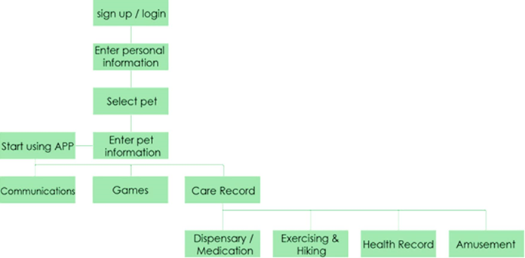
图 1 移动应用结构
开始使用该应用程序时，主要功能分为通讯，游戏和护理记录，其中宠物是此类功能的助手。
- 交流：积累一段时间后，它会提醒用户与亲朋好友联系。
- 游戏：使用脑部训练游戏来减缓功能退化。
- 护理记录：分为四类。
- 药房/药物：用于选择药物种类和记录时间。 完成任务后将获得宠物反馈（图2）。
- 锻炼和远足：用于选择锻炼或宠物散步并记录时间。 完成任务后将获得宠物反馈（图2）。
- 健康记录：用于输入个人健康记录，并会得到宠物的反馈（图2）。
- 娱乐：用于选择娱乐和录制时间，并会获得宠物的反馈（图2）。
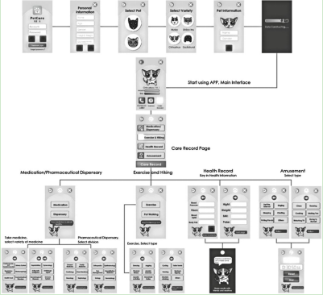
图 2 移动应用程序原型

3.2.1分配的任务
参加者总共执行了八项任务。测试人员将告知参与者有关任务，而其他测试人员将记录过程。所有任务之前都有时间和计数（表1）。
表格 1 分配任务
任务1 | 请尝试找到“护理记录”页面
任务2 | 请尝试找到“药物/药房”按钮
任务3 | 请尝试查找“抗过敏”药物
任务4 | 请尝试找到“锻炼”按钮
任务5 | 请尝试完成“慢跑”练习
任务6 | 请尝试找到“暂停”按钮
任务7 | 请尝试找到“健康记录”按钮
任务8 | 请尝试找到“注销”按钮

3.2.2问卷设计
请用户在完成任务后回答以下问题，以了解用户对原型的意见。使用Likert 测量法，其中包含“极度同意”，“同意”，“不确定”，“不同意”，“极度不同意”选项。
–问题1.字体清晰吗？
–问题2.字体是否足够大？
–问题3.是否易于找到您要使用的按钮？
–问题4.您喜欢宠物的造型吗？
–问题5.按钮图标看起来舒适且易于理解吗？
–问题6.您对总体情况满意吗？
–问题7.测试中的菜单输入是否方便？
–问题8.您是否认为通过语音将声音保存为唱片更方便？
–问题9.您认为与虚拟宠物互动会变得更无聊吗？
–问题10.虚拟宠物的设计是否愿意使用该软件？
–问题11.您会通过记录用药习惯和增进宠物友谊来增加使用意图吗？
–问题12.当宠物学习新技能（坐下，握手等）时，您会感到高兴吗？
–问题13.因此，您会更有动力使用该应用程序吗？
–问题14.宠物提醒可以帮助您记住吃药吗？
–问题15.您认为提醒功能很方便吗？
–问题16.您需要宠物提醒功能吗？

3.3参加用户测试
在12位参与者中，其中2位年龄在60岁以下，10位年龄在65岁以上。平均年龄为66.5岁。所有的老年人都居住在台湾，其中6人有使用智能手机的经验，而其余6人则没有。
3.4用户测试结果
表2显示了效率和可学习性的测试结果。对于任务1，将在搜索按钮中搜索文字说明。经过测试的接口效率显示出平均速度为3.1 s，具有一定的效率。任务2–7包含水平菜单，其信息结构与操作步骤相似。从表2中可以看出，参与者从任务2-3执行到任务4-6然后执行任务7的时间明显减少。它为参加者在类似操作中学习标准程序提供了界面系统的易学性。任务8与测试效率有关，从中可以看到平均速度为15.6 s，大多数参与者无法立即找到注销按钮，因为该图标未显示其他文字说明。因此，为了降低可读性，需要其他文本或图标改进。
表 2 按时间分析用户
 | 目标01 | 目标02 | 目标03 | 目标04 | 目标05 | 目标06 | 目标07 | 目标08 | 目标09 | 目标10 | 目标11 | 目标12 | 平均值
任务1 | 1 | 1 | 1 | 5 | 6 | 1 | 1 | 6 | 9 | 3 | 2 | 1 | 3.1
任务2 | 9 | 12 | 4 | 5 | 4 | 4 | 9 | 17 | 6 | 5 | 6 | 11 | 7.7
任务3 | 1 | 2 | 1 | 2 | 2 | 2 | 6 | 1 | 2 | 2 | 2 | 2 | 2.1
任务4 | 10 | 12 | 2 | 7 | 5 | 5 | 6 | 4 | 5 | 3 | 9 | 5 | 6.1
任务5 | 2 | 1 | 2 | 1 | 1 | 2 | 4 | 2 | 1 | 1 | 1 | 1 | 1.6
任务6 | 2 | 1 | 1 | 1 | 1 | 1 | 1 | 1 | 1 | 1 | 1 | 1 | 1.1
任务7 | 1 | 2 | 6 | 5 | 1 | 1 | 2 | 2 | 2 | 1 | 1 | 1 | 2.1
任务8 | 6 | 9 | 8 | 12 | 3 | 30 | 56 | 10 | 12 | 5 | 16 | 20 | 15.6

表3显示了错误率和可学习性的测试结果。任务1上没有出现错误，表明带有图标和文本的按钮是最佳设计。具有相同信息结构的水平菜单用于任务2–7，操作步骤相似。错误仅出现在任务2–3上，而没有出现在任务4–7上，这也证明了学习能力。对于任务8中的按钮，仅显示图标而没有文字说明，表明错
误率很高。比较任务1和任务8，文本说明可能和老人的图标一样重要。
表 3 按数量分析用户
 | 目标01 | 目标02 | 目标03 | 目标04 | 目标05 | 目标06 | 目标07 | 目标08 | 目标09 | 目标10 | 目标11 | 目标12
任务1 | 1 | 1 | 1 | 1 | 1 | 1 | 1 | 1 | 1 | 1 | 1 | 1
任务2 | 2 | 3 | 2 | 2 | 2 | 2 | 2 | 2 | 2 | 2 | 3 | 2
任务3 | 1 | 1 | 1 | 1 | 1 | 1 | 1 | 1 | 1 | 1 | 1 | 1
任务4 | 2 | 2 | 2 | 2 | 2 | 2 | 2 | 2 | 2 | 2 | 2 | 2
任务5 | 1 | 1 | 1 | 1 | 1 | 1 | 1 | 1 | 1 | 1 | 1 | 1
任务6 | 1 | 1 | 1 | 1 | 1 | 1 | 1 | 1 | 1 | 1 | 1 | 1
任务7 | 1 | 1 | 1 | 1 | 1 | 1 | 1 | 1 | 1 | 1 | 1 | 1
任务8 | 1 | 1 | 2 | 1 | 1 | 2 | 2 | 2 | 2 | 1 | 1 | 1

表4显示了问卷调查结果，分为可用性和互动情感。 第一部分的问题1–7与可用性（字体，按钮，宠物的身材，图标，综合图片和菜单输入）有关，而最后部分的问题8–16与互动情感有关（录音需求， 宠物互动性和宠物提醒）。 使用Likert五点量测量，对于“非常不同意”或“完全同意”的满意度，问题的评分为1-5。 总体而言，平均得分在4以上，表明该移动应用符合老年人的需求和满意度。
表 4 总体问卷结果分析
问 题 | 目标01 | 目标02 | 目标03 | 目标04 | 目标05 | 目标06 | 目标07 | 目标08 | 目标09 | 目标10 | 目标11 | 目标12 | 平均值
1 | 4 | 4 | 4 | 4 | 4 | 4 | 4 | 4 | 4 | 4 | 4 | 5 | 4.1
2 | 4 | 4 | 4 | 4 | 5 | 4 | 4 | 4 | 4 | 4 | 4 | 4 | 4.1
3 | 4 | 4 | 4 | 4 | 4 | 4 | 4 | 4 | 4 | 4 | 4 | 5 | 4.1
4 | 5 | 4 | 4 | 4 | 5 | 3 | 4 | 4 | 5 | 4 | 4 | 4 | 4.2
5 | 5 | 4 | 4 | 4 | 4 | 4 | 4 | 4 | 4 | 4 | 4 | 4 | 4.1
6 | 5 | 4 | 4 | 4 | 4 | 4 | 4 | 4 | 5 | 4 | 4 | 5 | 4.3
7 | 5 | 3 | 4 | 4 | 4 | 4 | 4 | 4 | 5 | 4 | 4 | 5 | 4.2
8 | 5 | 4 | 4 | 5 | 5 | 5 | 4 | 4 | 4 | 4 | 4 | 4 | 4.3
9 | 4 | 4 | 4 | 4 | 4 | 4 | 4 | 4 | 3 | 4 | 4 | 5 | 4.0
10 | 5 | 4 | 4 | 4 | 4 | 4 | 4 | 4 | 4 | 4 | 4 | 5 | 4.2
11 | 5 | 4 | 4 | 4 | 5 | 5 | 3 | 4 | 4 | 4 | 4 | 5 | 4.3
12 | 5 | 4 | 4 | 4 | 4 | 4 | 4 | 4 | 4 | 4 | 4 | 5 | 4.2
13 | 5 | 3 | 4 | 4 | 4 | 4 | 4 | 4 | 5 | 4 | 4 | 5 | 4.2
14 | 5 | 4 | 4 | 4 | 4 | 4 | 4 | 4 | 4 | 4 | 4 | 4 | 4.1
15 | 5 | 4 | 4 | 4 | 4 | 5 | 4 | 4 | 5 | 4 | 4 | 5 | 4.3
16 | 5 | 4 | 4 | 4 | 4 | 4 | 4 | 4 | 4 | 4 | 4 | 4 | 4.1

4.讨论与结论
试验后，实验结果和预期效果总体上令人满意。发现用文本标记的图像更容易被用户识别从而增强了界面使用的效率。结果，对于老年人来说，文本可能比图像更重要。当使用相同的模型执行先前的任务时，将减少花费的时间，并且错误率也将降低，这表明移动应用程序原型界面符合老年人的需求和偏好。总体学习能力很高。通过让参与者寻找没有文本的图像，发现老年人几乎不能识别出错误率高的图像的功能。建议在连续的界面设计中添加图像以减少错误率。总体问卷调查显示，参与者对界面的满意度很高。此外，视觉宠物的设计图像非常友好，它确实可以使用界面提高参与者的乐趣。
根据实验结果，参与者通常认为语音记录或直接使用按钮比输入文本更方便。宠物互动可以增强参与者的使用动机。问卷数据显示对医疗，运动和联系的迅速功能的需求，因此可以完成。关于最后的建议，台湾的老人对宠物的功能有不同的见解，可以结合照顾房屋，保安和紧急救援。实验结果表明，虚拟宠物的设计实际上可以增强老年人使用移动应用程序的意愿，并且老年人确实对护理和接触功能有需求。老年人对宠物形象和互动性的偏好可以进一步发展和设计。此外，台湾老人可以正确识别手机上带有文字的按钮。研究结果可以帮助设计师和设计开发商开发老年人互动界面。

Developing Mobile Application Design of Virtual Pets for Caring for the Elderly

Hsiu Ching Laura Hsieh(&)
Department of Creative Design,
National Yunlin University of Science and Technology, Douliu, Taiwan
laurarun@gmail.com

Abstract. In the population ageing society, the companionship and care of the elderly, the medical system, and the consumer trend cannot be neglected. The contact with the external and the ones caring about oneself is essential for the elderly. This study aims to develop application with the functions of healthcare and accompanying, and the accessibility design is included in the interface, where virtual pets are the major communication media to assist the elderly in using mobile application. The required functions and contents in mobile application as well as the preference for the interface and models of interaction for the elderly are investigated in this study. It aims to ease and convince the elderly of the easy use. In the process of cultivating and training the virtual pet mobile application, the elderly could be accompanied and reduced the sense of loneliness; in the further use and interaction with virtual pet mobile application, the physical and metal conditions of the elderly could be real-time monitored and recorded to assist monitoring stations in managing the physical conditions of the elderly and nursing personnel in periodical checks. This research is preceded as following. First, literatures are reviewed. Second, Focus Group Interview is utilized for concluding the application contents and functions and the requirements and preference of the elderly for virtual pets. Third, an application experimental prototype is designed according to such requirements and preference. Fourth, the questionnaire, aiming to test the usability of the elderly, is filled. Fifth, the principles and suggestions for mobile application design suitable for the elderly are concluded based on the test results and anal-yses. The research outcome would assist in and contribute to the accessibility design of mobile application and the application to medical care by providing possible solutions for insufficient caring manpower in ageing societies and uneven distribution of medical resources.

Keywords: Mobile application Virtual pet Virtual elder care Accessibility

1 Introduction
According to the research of World Health Organization, population ageing is a global problem in the 21st century. Taiwan has stepped in the ageing society since 1993 and the aged population above the age of 60 was 17.4 % of total population in 2013. The Executive Yuan estimated that the ratio would reach 37.5 % by 2056 [4]. In the population ageing society, the companionship and care of the elderly, the medical system, and the consumer trend cannot be neglected. The contact with the external and the ones caring about oneself is essential for the elderly. Jive Software, a famous software company in the USA, indicated in 2011 that the probability of the elderly suffering from dementia in poor social networking environment was 60 % higher than the others in active environments [7]. To solve the problems of senses of accompanying and security, a lot of people choose pets to be the companions. Plenty of research on animal-assisted therapy has been studied in the world. In addition to real pets, the application and development of virtual pets could also be transferred into an option of senior care. To solve insufficient medical human capital and resources, the software which allows the elderly applying the mobile application to the medical network real-time interaction software is developed to observe the physical and mental condi-tions of the elderly. It could be a kind of highly feasible nursing in the future. Inte-grating virtual pets to replace inflexible machines or nursing personnel allows developing handy mobile application contents for nursing and accompanying the elderly.
The elderly healthcare in Taiwan has become critical as the aging society is forming. Nevertheless, the uneven distribution of physicians between rural and urban has resulted in the lack of medical resources in remote areas [2]. According to the physical conditions of the elderly, it is not easy for them leaving houses for health checks. Besides, the elderly loneliness is caused by the children not being able to take care of their parents because of work or residence in different places. The elderly with self-care functions could effectively reduce the health problems and enhance the health and welfare [6]. For this reason, a virtual pet-based mobile application for caring for the elderly with the functions of self-care and company is developed in this study. It allows the elderly knowing the health conditions, real-time sharing the results with friends and relatives through smartphones, and reducing the loneliness by raising virtual pets. The mobile application prototype is designed, according to the elderly characteristics, for the experimental test to discuss whether the user interface and functions conform to the elderly demands. In this study, the interface characteristics of satisfaction, memora-bility, error rate, and efficiency are discussed.

2 Literature Review

2.1 Mind and Body Functions of the Elderly
Lee [8] concluded the degenerating functions of the elderly with the age as below.
- Motive function: Easy to fall due to reducing strength, low balance, longer oper-ation time for the elderly than for the youth, but less errors because the elderly request higher operation accuracy than operation speed; however, the antagonistic relationship between operation speed and accuracy could not be used for explaining the reason of the elderly being sluggish.

- Perception function: (1)Vision. By increasing the time, the errors increase in the green-blue area, especially with low illuminance, while the error rate is lower in the red-yellow area. The elderly perceive narrower chroma that the color discrimination is worse when the color value is close. (2) Hearing. The elderly do not comprehend the computer voice, cannot distinguish the location of high frequency and tempo-rary sound, but could distinguish low frequency and temporary sound. 3) Haptic perception. Convex marks are more easily recognized than concave marks with haptic perception.
- Cognitive function: The elderly could reduce the dependence on work memory through practice. The use of event-oriented prospective memory interface could enhance the compatibility between interface elements.

2.2 The Principles of Mobile Application Interface Design
Shneiderman [9] proposed this collection of principles that are derived heuristically from experience and applicable in most interactive systems after being properly refined, extended, and interpreted. (1) Strive for consistency. (2) Enable frequent users to use shortcuts. (3) Offer informative feedback. (4) Design dialog to yield closure. (5) Offer simple error handling. (6) Permit easy reversal of actions. (7) Support internal locus of control. (8) Reduce short-term memory load.

2.3 The Usability of Interaction Design
Based on Nielsen [2], the usability is defined as the following. (1) Learnability: has to do with how quickly and easily users can begin to do productive work with a system, which is new for them. Learnability is how quickly and easily users can reach a level of proficiency in using the system. (2) Efficiency: Efficiency is the number of tasks per unit of time that the user can perform using the system. (3) Satisfaction: is the sub-jective opinion that users form about the system (or about some parts of it). It is the most elusive usability attribute, as it is completely dependent on subjective opinion of users. (4) Error rate: This refers to the errors made during the use of the system and how easy it is to recover from them [2]. (5) Memorability: This refers to the ease of remembering the way a system must be operated. Nielsen [2] describes this as the characteristic of a system that allows the user to return to the system after some period of not having used it, without having to learn everything all over again. According to above statements, the mobile application prototype of virtual pets for caring and accompanying the elderly is constructed. The application interface is further tested to conform to the demands of the elderly in Taiwan. The user interface char-acteristics of satisfaction, errors, learnability, and efficiency are tested in this experiment.

3 Methods
The methods are introduced as following. First, literatures are reviewed. Second, Focus Group Interview is utilized for concluding the mobile application contents and func-tions and the requirements and preference of the elderly for virtual pets. Third, an mobile application experimental prototype is designed according to such requirements
and preference. Fourth, the questionnaire, aiming to test the usability of the elderly, is filled. Fifth, the principles and suggestions for application design suitable for the elderly are concluded based on the test results and analyses.

3.1 Focus Group Interview
Focus Group Interview is utilized for concluding the elderly demands and preference for the mobile application functions and virtual pets. Six elderly participants (aged above 65) are living in Taiwan. From the Focus Group Interview results, the elderly need to tell the mobile application from other programs that pop-up windows are better for the reminder. In regard to the preference for virtual pets, most elderly prefer dogs and cats, especially small dogs with big eyes and big ears. In terms of functions, the reminders of medication and exercise records are favored, and menu records are convenient for the elderly rapidly finding the demands. Most elderly are satisfied with the function to contact the friends and relatives and expect virtual pets to present the functions of looking after the house, security guard, and emergency treatment.

3.2 Constructing Mobile Application Prototype and Questionnaire Design
The prototype of mobile application is constructed and the questionnaire is designed according to the elderly demands and preference in the previous step. Figure 1 shows the application test structure. The test in this study combines care records with pets.
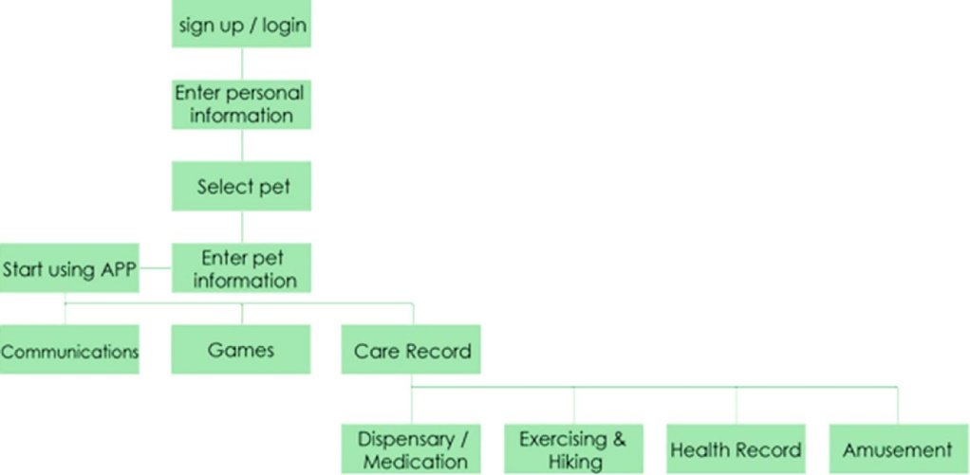
Fig. 1. Mobile application structure
When starting using the application, the major function is divided into communication, games, and care record, where the pet is the helper of such functions.
- Communication: After accumulating for a period of time, it would remind the user to contact with the friends and relatives.
- Games: The brain training games are utilized for slowing down functional degeneration.

- Care record: It is classified into four categories.
(1) Pharmaceutical Dispensary/Medication: It is used for selecting the variety of medication and recording time. Pet feedback would be acquired after com-pleting the task (Fig. 2)
(2) Exercise and Hiking: It is used for selecting exercise or pet walking and recording time. Pet feedback would be acquired after completing the task (Fig. 2).
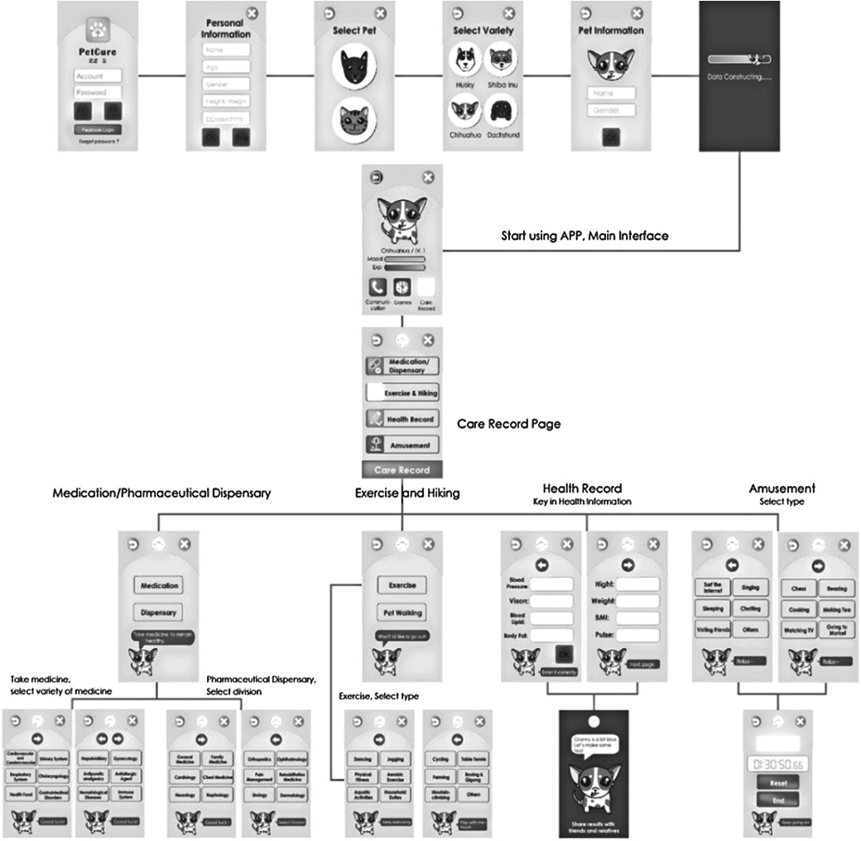
Fig. 2. Mobile application prototype
(3) Health Record: It is used for inputting personal health record, and pet feedback would be acquired (Fig. 2).
(4) Amusement: It is used for selecting amusement and recording time, and pet feedback would be acquired (Fig. 2).

3.2.1 Task Assigned
Total eight tasks are executed by the participants. A testing staff would inform the participants about the tasks, while the other testing staff would record the process. All the tasks are preceded by time and count (Table 1).
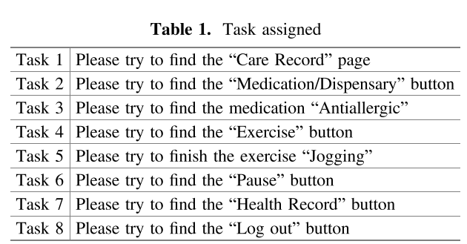

3.2.2 Questionnaire Design
The users are requested to answer the following questions after completing the tasks so as to understand the user’s subject opinions with the prototype. Likert Scale, containing the options of Extremely Agree, Agree, Uncertain, Disagree, Extremely Disagree, is applied.
– Q 1. Is the typeface clear?
– Q 2. Is the typeface large enough?
– Q 3. Is the button which you intend to use easy to find?
– Q 4. Do you like the figure design of pets?
– Q 5. Does the button icon look comfortable and understandable?
– Q 6. Are you comfortable with the comprehensive picture?
– Q 7. Is the menu input in the test convenient?
– Q 8. Would you consider it more convenient to save sound, through speech, as the record?
– Q 9. Do you think it being less boring to interact with virtual pets?
– Q 10. Would the design of virtual pets have you be willing to use the software?
– Q 11. Would you increase the use intention by recording the medication habit and enhancing the pet friendship?
Developing Mobile Application Design of Virtual Pets 275
– Q12. Would you be happy when the pet learns new skills (sitting down, shaking hands, and so on)?
– Q13. Hence, would you be more motivated to use the application program?
– Q14. Could the pet reminder help you remember to take medicine?
– Q15. Do you think the reminder function being convenient?
– Q16. Do you need the pet reminder function?

3.3 Participants in User Test
Among the total 12 participants, 2 of them are below 60-year-old and 10 are above 65-year-old. The average age is 66.5. All of the elderly live in Taiwan, and 6 of them have the experiences in using smart phones, while the rest 6 do not.

3.4 Results of User Test
Table 2 shows the test results of efficiency and learnability. For Task 1, the carebutton is searched with text explanation. The tested interface efficiency reveals the average speed 3.1 s, with certain efficiency. Tasks 2–7 contain the horizontal menu with the same information structure that the operation procedures are similar. From Table 2, the time for the participants executing from Tasks 2–3 to Tasks 4–6 and then Task 7 decreases obviously. It presents the easy learnability of the interface system for the participants learning the standard procedure in the similar operations. Task 8 relates to the testing efficiency, from which the average speed appears 15.6 s, and most partic-ipants could not immediately find the log-out button, because the icon does not show additional text explanation. Additional texts or icon improvement therefore are required for the low readability.
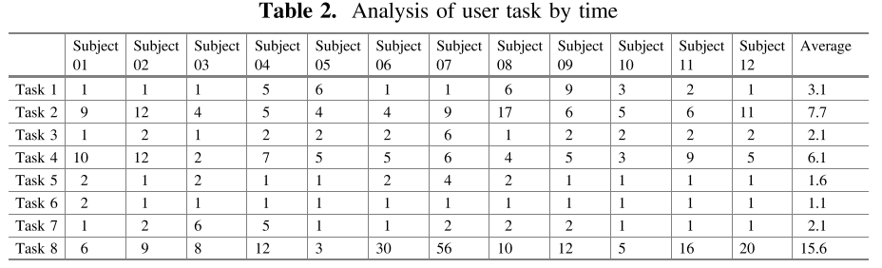
Table 3 displays the test results of error rate and learnability. No error appears on Task 1, revealing that a button with icon and text is the optimal design. Horizontal menus with the same information structure are used for Tasks 2–7 that the operation procedures are similar. Errors merely appear on Tasks 2–3, but not on Tasks 4–7 that the learnability is also proven. Merely icons, without text explanation, are shown for the buttons in Task 8 that the error rate is high. Comparing Task 1 and Task 8, text explanations might be as important as icons for the elderly.
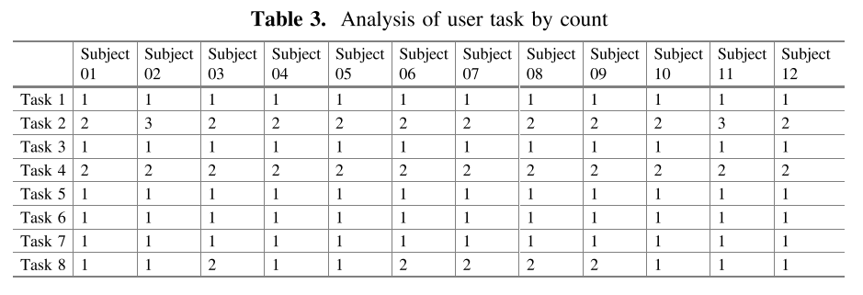
Table 4 shows the questionnaire result, which is divided into usability and inter-active emotion. Questions 1–7 in the first part are related to usability (typeface, button, pet figure, icon, comprehensive picture, and menu input), while questions 8–16 in the last part are related to interactive emotion (demands for sound record, pet interactivity, and pet reminder). With Likert 5-point Scale, the questions are scored 1–5 for the options of Extremely Disagree to Extremely Agree for the satisfaction. Overall speaking, the average score is above 4, presenting that the mobile application conforms to the elderly demands and satisfaction.
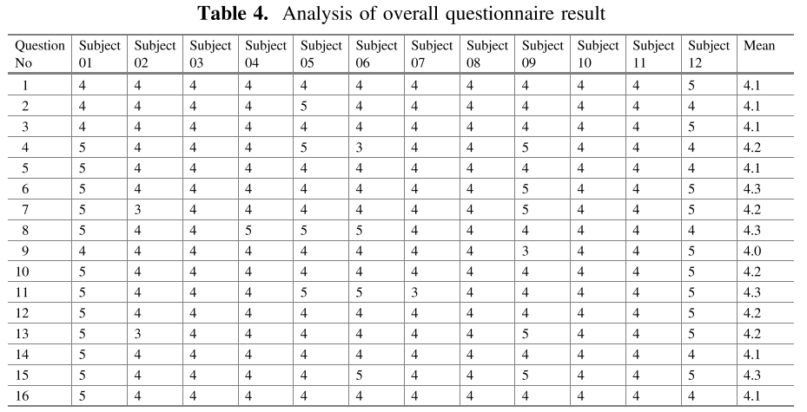

4 Discussion and Conclusion
After the test, the experimental result and the predicted effect are generally satisfactory. It is found that images marked with texts are more easily recognized by the user to enhance the efficiency of interface use. As a result, texts might be more important than images for the elderly. When preceding tasks with the same model, the time spent would be reduced and the error rate is also decreased, showing that the mobile application prototype interface conforms to the elderly demands and preference. The overall
learnability is high. Having the participants look for images without texts, it is found that the elderly can hardly recognize the function of such images that the error rate is high. It is suggested that image should be added texts in the successive interface design to decrease the error rate. The overall questionnaire survey reveals high satisfaction of the participants with the interface. Besides, the designed image of the visual pet is friendly that it indeed could enhance the participants’ pleasure using the interface.
According to the experimental result, the participants commonly consider voice records or direct use of button being more convenient than text input. Pet interactivity could enhance the participants’ use motivation. The questionnaire data show the demands for the prompt function of medical treatment, exercise, and contact which therefore could be completed. In regard to the final suggestion, the elderly in Taiwan reveal distinct opinions about pet functions, with which looking after the house, security guard, and emergency rescue could be combined. The experimental results reveal that the design of virtual pets actually could enhance the elderly willingness to use the mobile application, and the elderly indeed have the demands for caring and contact functions. The elderly preference for pet image and interactivity could be further developed and designed. Besides, the elderly in Taiwan can correctly identify the buttons with texts on mobile phones. The research results could help designers and design developers develop interactive interface for the elderly.
References
- Akinagac, S., Tsuneo K.: Healing effect of virtual pet. Psychol. Res. 8, 39–44

- Chen, C.Y., Yang, Y.C.: Taiwan Geriatr. Gerontol. 2(3), 209–224 (2007)

- Díaz-Bossini, J.M., Moreno, L.: Accessibility to mobile interfaces for older people. Procedia Comput. Sci. 27, 57–66 (2014)

- Fan, G.J., Hsu, Y.H.: Socio-economic impacts of population aging in taiwan. Taiwan Geriatr. Gerontol. 5(3), 149–168 (2010)

- Hiroko, K.: What kind of influence does online virtual pets have on people. Jpn. Soc. Educ. Inf. 25(2), 3–14 (2009)

- Hoy, B., Wagner, L., Hall, E.: Self-care as a health resource of elders: an integrative review of the concept. Scand. J. Caring Sci. 21(4), 456–466 (2007)

- Kivimäki, T., Kölndorfer, P, Vainio, A.-M., Pensas, H., Vuorela, T., Garschall, M., Vanhala, J.: User interface for social networking application for the elderly. In: Proceedings of the 6th International Conference on Pervasive Technologies Related to Assistive Environments, Rhodes Island, Greece, 29–31 (2013)

- Lee, C.F.: Product design for the elderly users. J. Des. 11(3), 65–79 (2006)

- Nielson, J.: Why you only need to test with 5 users (2000). http://www.useit.com/alertbox/ 2000319.html

- Shneiderman, B., Plaisant C.: Designing the User Interface: Strategies for Effective Human-Computer Interaction. Addison-Wesley, MA

- Wang, M.T.: Possible design directions of healing toys for caring the aging group. J. Des. 17(2), 1–24 (2012)
  - 12. Wu, K.C., Tsao, H.Y., Tsai, C.Y.: Introduction to tablet PC APP for the elderly.
In: Conference of Gerontechnology and Service Management, 13–14 (2013)

