Document-based Process Model Explorer

Introduction

1.1 Motivation
Why are we doing it?

Process Model is important

It is used by: requirements engineers (SE), process designers that work through interviews of stake holders or domain experts (more generic). process designers that work through regulation documents

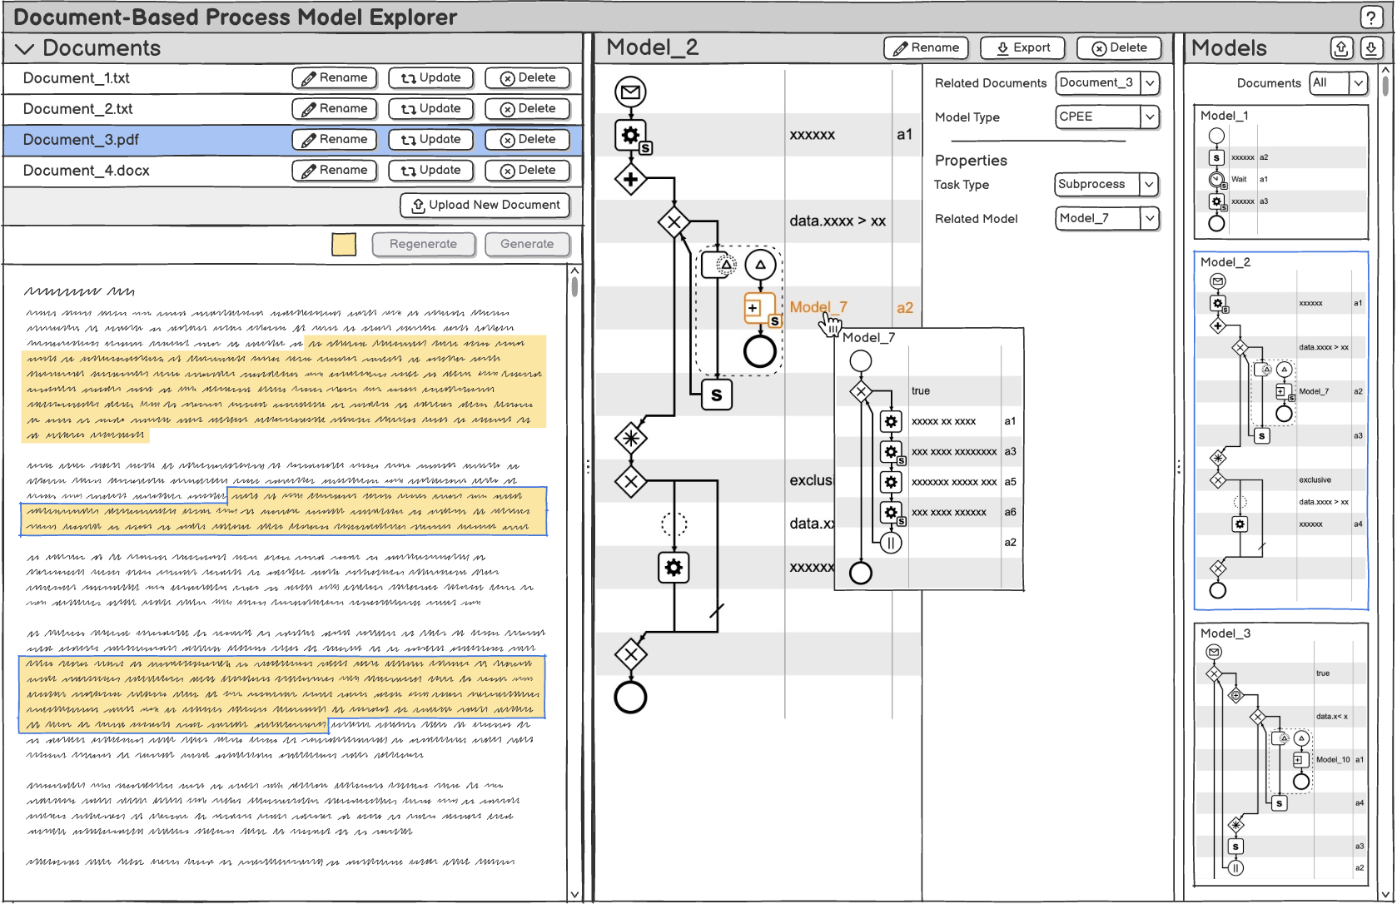

1.2 Research Questions
RQ1 Related Work:

RQ2 Tool Usability & User Experience

RQ3 Evaluation: How does the use of such tools affect process modeling in real-world case studies?

1.3 Contribution

1.4 Methodology
Design Science in Information System (Hevner). How are we doing research?
(1) Summary what design science is (it uses stakeholders, artefacts, steps, ...). (2) What are the stakeholders, artefacts, steps for MY case.

1.5 Evaluation
How will I evaluate that my proposal is good. This ties into the research questions.

1.6 Structure
Which chapters will my thesis have, and what are they all about.

5

Related Work

CPEE

NotebookLM
https://notebooklm.google.com/notebook/3f25c0b5-7509-440d-83c4-37a5a0183356

4.

