MAP Process Guide – Stage 1 and Stage 2

Process Architecture

The MAP process follows a stage-gate structure. Stage 1 frames and sizes the opportunity, produces the one-pager and project charter, and ends with Gate 1. If approved, Stage 2 develops the stakeholder and need architecture, identifies drivers and constraints, resolves conflicts, and prepares the project for Gate 2.

Stage-Gate Architecture

The process architecture in the source workbook shows a gate decision pattern in which project rating feeds the decision gate, which then results in approval to proceed or rejection.

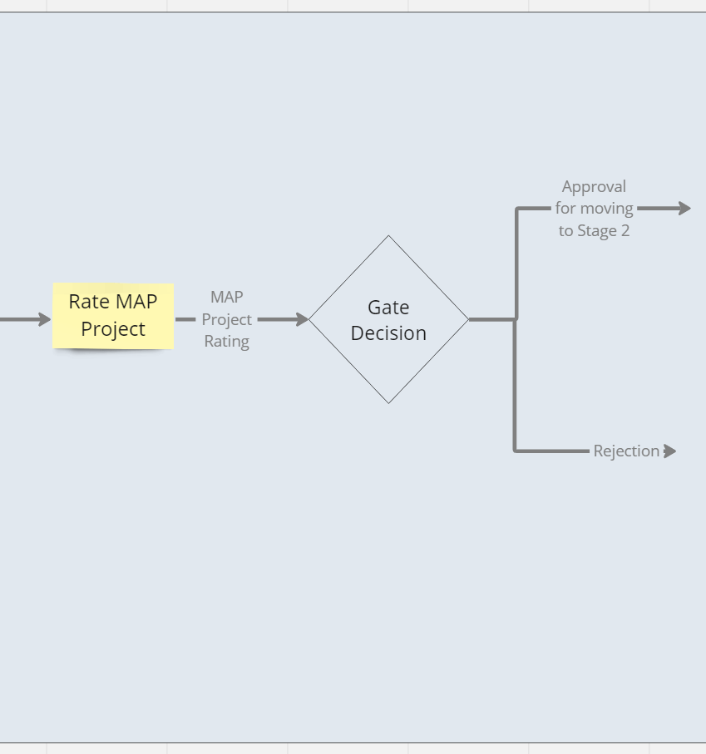

Figure 1. Generic stage-gate decision logic used in MAP.

Detailed Process Flow

The workbook also includes a detailed process flow for Stage 2, showing the parallel workstreams for stakeholder needs and drivers & constraints, followed by conflict identification, risk assessment, project rating, and Gate 2 decision.

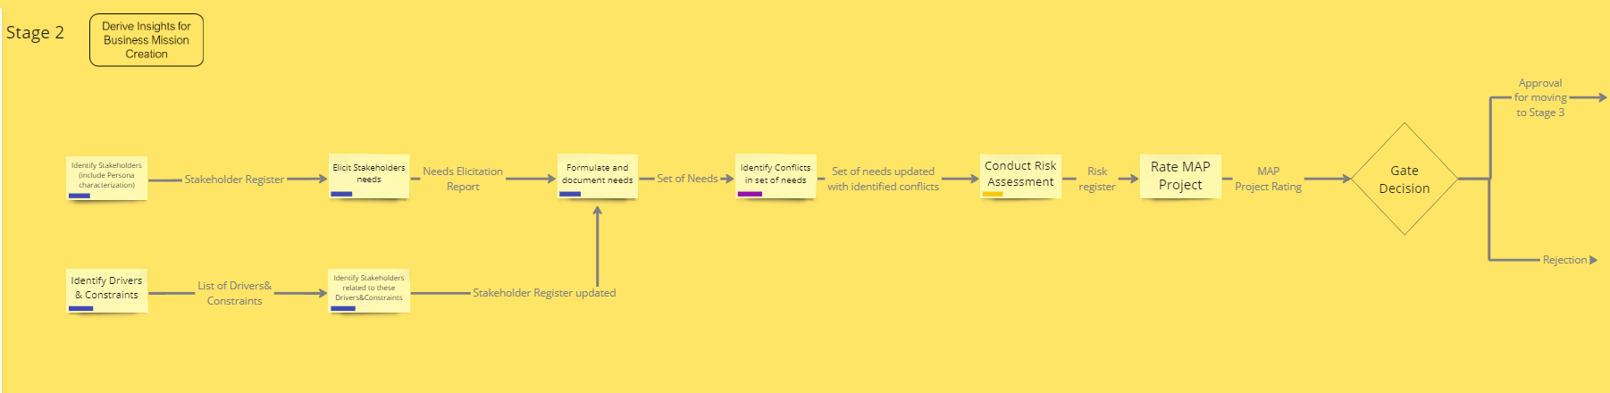

Figure 2. Stage 2 process architecture from the MAP workbook.

Organizational Architecture

The organizational chart below identifies the key roles surrounding the MAP process, including Brand & Portfolio Management, PMO, Aftersales, Business Insights, and Sales functions. These roles complement the RACI assignments listed in the workbook.

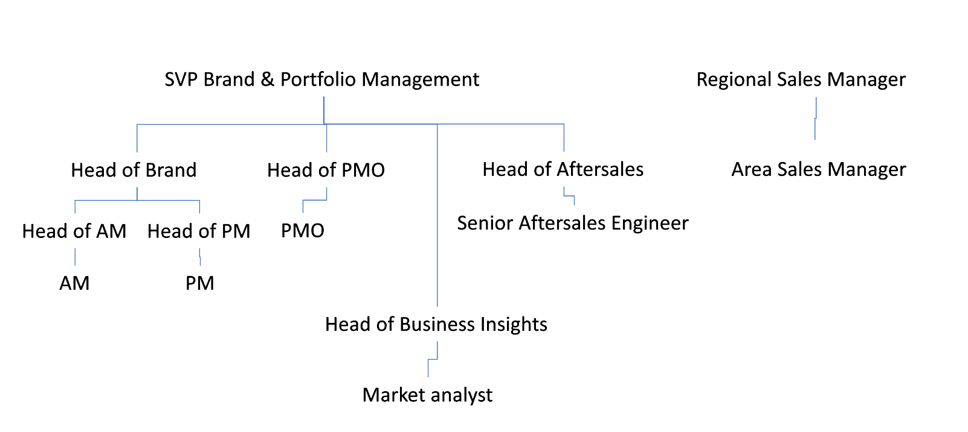

Figure 3. Supporting organizational architecture for MAP.

Stage 1

Activity 1 — Review Market

Input
Idea description
Output
Market Review report

Activity 2 — Review Portfolio

Input
Idea description.
Output
Portfolio Review report

Activity 3 — Perform Competitive Analysis

Input
Idea description.
Output
Competitor Analysis report

Activity 4 — Analyzing underlying problem/opportunity/threat

Input
Market Review report
Portfolio Review report
Competitor Analysis report
Output
Problem Canvas

Activity 5 — Define Mission, Goals and Objectives

Input
Problem Canvas
Output
Mission One Pager

Activity 6 — Estimate Project Size, Impact and Strategic Fit

Input
Mission One Pager
Output
Project Estimation

Activity 7 — Define High Level Risks

Input
Mission One Pager
Project Estimation
Output
Project Charter

Activity 8 — Estimate resources to MAP project

Input
Mission One Pager
Project Estimation
Output
MAP Resources I (Fields: Type of resources, Resource usage)

Activity 9 — Allocate team members for MAP project

Input
MAP Resources I (Fields: Type of resources, Resource usage)
Output
MAP Resources II (Fields: Ressources allocation)

Activity 10 — Estimate MAP Project Duration

Input
Mission One Pager
Project Estimation
MAP Resources II (Fields: Ressources allocation)
Output
MAP Duration

Activity 11 — ONE PAGER TEMPLATE COMPLETED

Input
Problem Canvas
Mission One Pager
Project Estimation
Output
One Pager Template

Activity 12 — Elaborate MAP Project Charter

Input
Mission One Pager
Project Charter
MAP Resources II (Fields: Ressources allocation), MAP Duration
Output
MAP Project Charter

Activity 13 — Rate MAP project (Stage 1)

Input
One Pager Template
MAP Project Charter
Output
MAP Project Rating Gate 1

Gate 1 — Gate 1 decision

Input
MAP Project Rating Gate 1
MAP Project Charter
Output
Gate 1 decision: Approval for moving to Stage 2 OR Rejection

Stage 2

Activity 1 — Identify Stakeholders
Description
Identify stakeholders involved in or affected by the potential project.
Input: One Pager Template
Output: Stakeholder

Activity 2 — Characterize Persona
Description
Develop personas representing key stakeholder roles and perspectives.
InputStakeholder
Output
- Persona

Activity 3 — Elicit Stakeholder Needs
Description
Collect stakeholder needs through interviews, workshops, or discussions.
Input
- Stakehoder
- Persona
Output
- Needs elicitation outcome

Activity 4 — Formulate and document Stakeholder Needs
Description
Structure and document stakeholder needs in a clear and traceable format.
Input
- Needs elicitation outcome
Output
- Need statement
- Owner
- Originator
- Supporting documentation

Activity 5 — Identify Drivers & Constraints
Description
Identify drivers and constraints influencing the potential project.
Input
- One Pager Template
Output
- Drivers & Constraints

Activity 6 — Identify Stakeholders related to Drivers&Constraints
Description
Identify stakeholders related to specific drivers and constraints.
Input
- Drivers & Constraints
Output
- Stakeholder

Activity 7 — Formulate needs related to these Drivers & Constraints and document them
Description
Input
- Drivers & Constraints
- Stakeholder
Output
*Need Statement
*trace to source
*Originator/Author
*Owner
*Criticality
*Rationale/Reason Why
*Allocation / Budgeting

Gate 2
Description
Gate 2 evaluates the outputs generated during Stage 2 and determines whether the MAP process proceeds to the next stage.
Input
- Stage 2 outputs
Output
- Gate 2 decision

