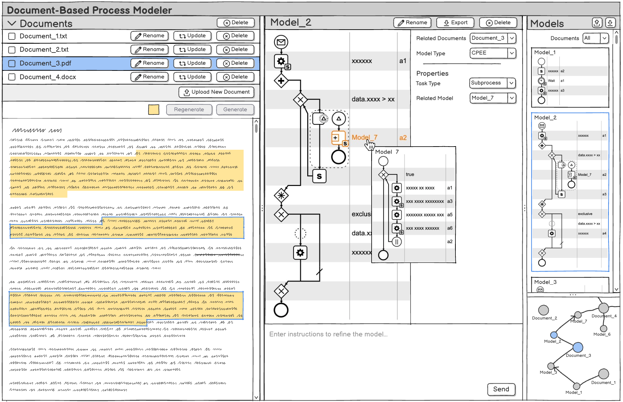
- Project Garph
- Model List
- Model Editor
- Document Viewer
- Document List

