# User Guide of CCNBR

The initial interactive interface of CCNBR is shown below. The software mainly includes two functions: one for predicting ordinary cocrystal coformer and the other for predicting drug-drug cocrystals. Users need to locate GUI.exe under the Software folder and double-click to run the software. CCNBR does not require registration or login, and there are no limitations on usage. It is a simple and efficient standalone software. Users can also directly use the provided GUI.py file to add and modify software features.

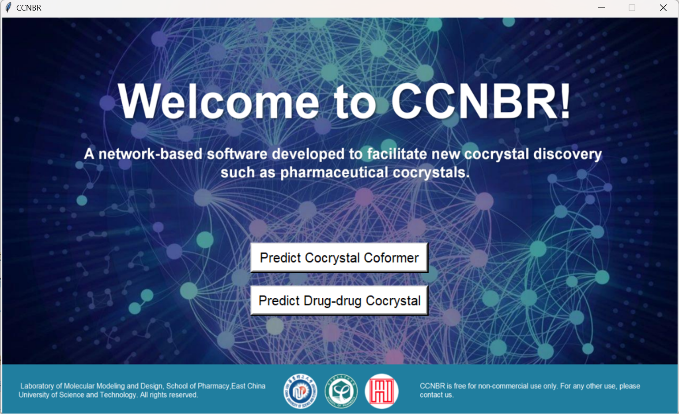

Figure 1. The initial interface of CCNBR.

# Function 1: Predicting Cocrystal coformer

The working interface is shown below, followed by specific steps:

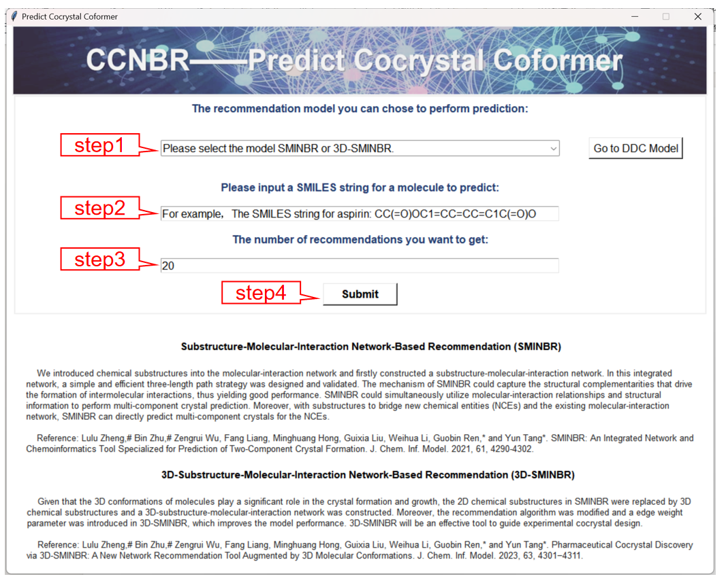

Figure 2. The interface of function1

* **Model Selection:** Users first need to select the model type. The options are SMINBR and 3D-SMINBR, with the main difference being that the models use 2D molecular fingerprints and 3D molecular fingerprints, respectively. Experimental results have shown that 3D-SMINBR performs better than SMINBR, as 3D fingerprints can preserve the 3D features of substructures, considering more structural information with the same 1024-bit length. However, we also recommend using both models and taking the intersection of the results, as this can further increase the reliability of the predictions.
* **Enter the SMILES:** Enter the SMILES of the molecule to be predicted.
* **Enter the number:** Enter the number of CCFs needed.
* **Submit:** Click the "Submit" button, and the screening results will be saved on the user's desktop.

# Function 2: Predicting DDC

The working interface is shown below, followed by specific steps:

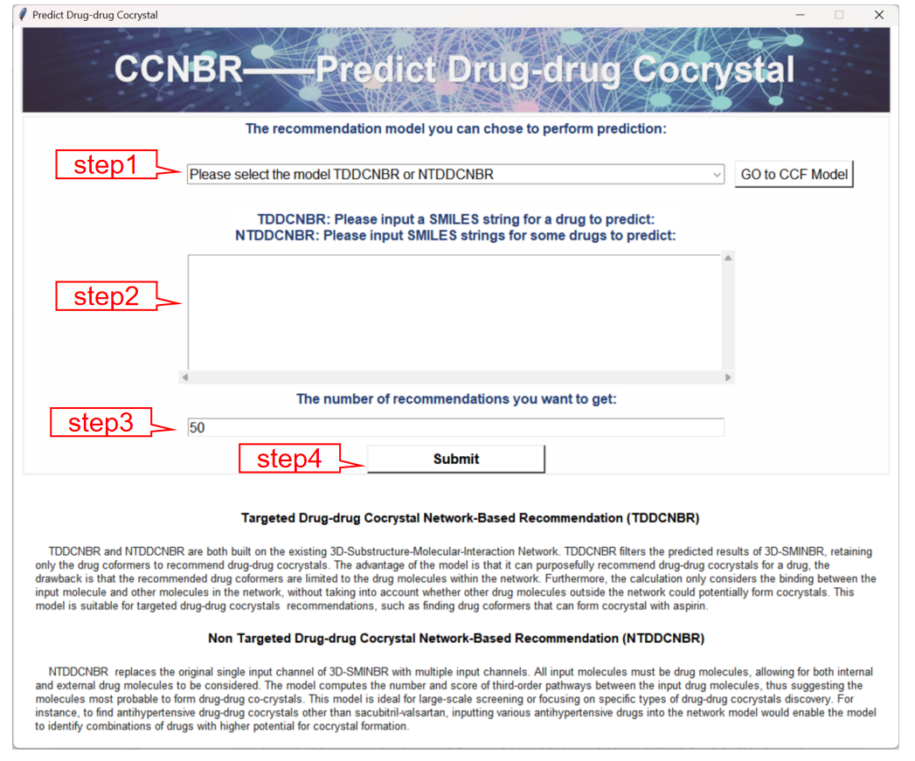

Figure 3. The interface of function2

* **Model Selection:** We provide two models, TDDCNBR and NTDDCNBR, for predicting DDC of single drug molecules and drug-drug combinations, respectively. Users can choose the appropriate model based on their needs. For multi-target drug combination screening in specific disease areas, NTDDCNBR should be used.
* **Enter the SMILES:** If you select TDDCNBR, please enter a single target drug; If you select NTDDCNBR, please enter multiple target drugs, with each molecule on a new line. Ensure the last line is not empty.
* **Enter the number:** Enter the number of results needed.
* **Submit:** Click the "Submit" button, and the screening results will be saved on the user's desktop.