In real world, making tailored clothes requires the measurements from customers and those measurements are usually acquired by using tape ruler handled by an experienced tailor. Followed by the high speed development of 3D scanning technology, human body in a defined posture can be measured automatically by using 3D scanner such as ${[TC]}^{2}$ in order to provide the measurements for the virtual clothing.

In computer animation, characters are created and acts in virtual environment. Dressing animation characters by producing the physical model for those characters to acquire the body measurements is not only costly but also redundant. Moreover, 3D body scanner often requires the subject in a defined posture to get accurate measurements.

During the creation of animation character, “T-Pose” is the standard character posture for modeling. In this posture, the character stands straight and its arm stretched horizontally. The straight body and stretched limbs provides many conveniences for the production process such as ragging and texturing. Unfortunately, the definition of the “T-pose” is different across different animation studios or even across different character designs. Some of them has stretched straight arm and leg other has bent arm and back. Therefore, the non-unified body postures of animation characters cause current anthropometric data accusation method resulting incorrect measurements.

When tailor measures customer, they hold the two end of the tape ruler and position them onto the desired location on the body while apply tension on the ruler. The final reading of the measuring is the length of tape ruler which follows the profile of the body. Geodesic path on a polygon surface shares similar property. It is the shortest path between two vertices and it also follows the profile of polygon surface. Here, a geodesic path based animation character measuring method is proposed for create tailored cloth for animation character.

The body measuring for cloth making acquires two types of measurements, length and circumference. The geodesic path measuring method is used for acquire the length measurement.

Measuring process:

1. The datum point on the character is defined by user
2. Run our geodesic algorithm

Advantages:

1. Approximate algorithm provides a fast measuring solution for high resolution character model which has became increasing popular.
2. Geodesic path measuring method allows animation character in a various posture and still able to output measurements with high consistency( i.e the length of arm in both straight and bend position, the measurement different is less than 1% )

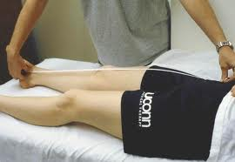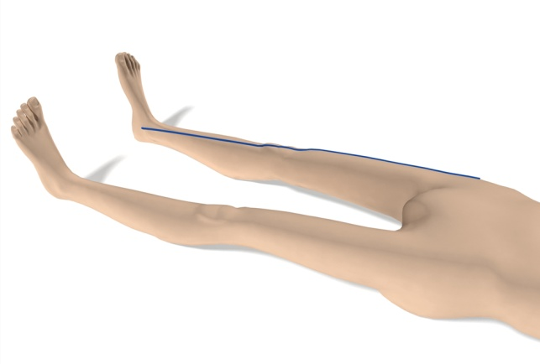

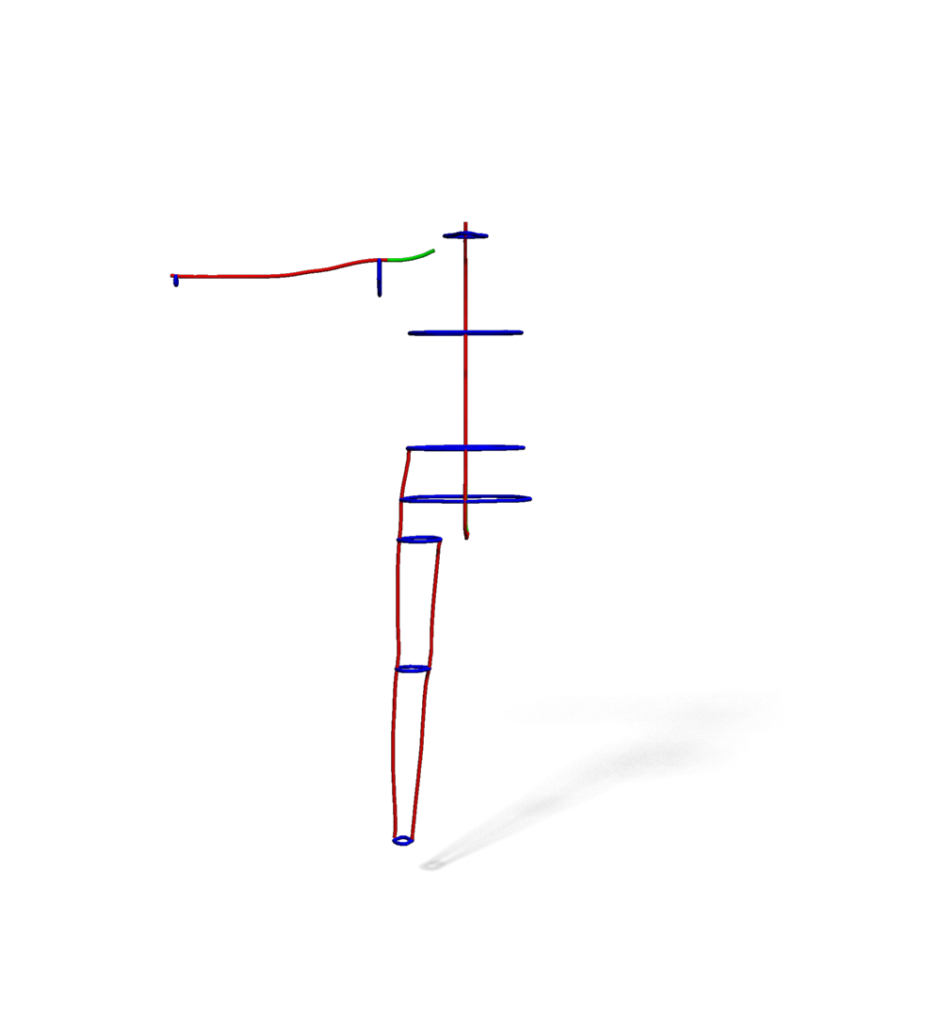

Tape measuring geodesic path measuring

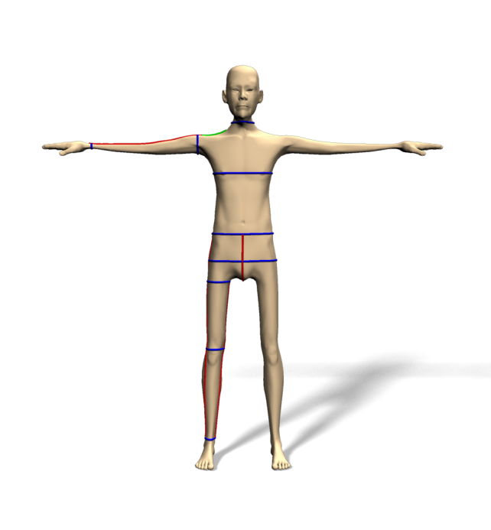

The red curve is the geodesic path used for measuring character.