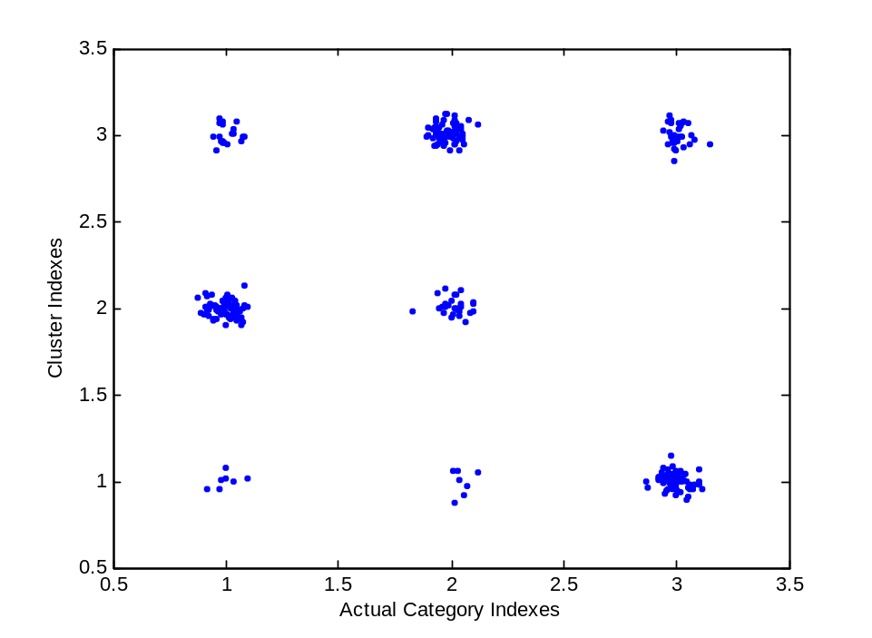
where some noise has been added to both variables tstcat and idxs in order to better appreciate the amount of data samples that are present at each index-pair location.

