**Wenwen Xu**

**Programming languages Project 1**

**User's Manual**

**Setup and Compilation**

1. Download and unzip the submission from eLearning on a Linux box in the multi-platform lab. 2. The submission includes:

- main.c

- makefile

- proj.c

- proj.h

- symbol.c

- symbol.h

- test.txt

3. Environment: This program has been tested terminal window though command lines.

4. Compiling:

**command:** “make test main.c && ./test legal1.txt && ./test legal2.txt && ./test legal3.txt && ./test legal4.txt && ./test illegal1.txt && ./test illegal2.txt && ./test illegal3.txt && ./test illegal4.txt”

**•with the above statement, you can run the files and there is NO other script needed.**

**Running the program**. Be sure the txt file and the source coude are in the same folder.

**Output:**

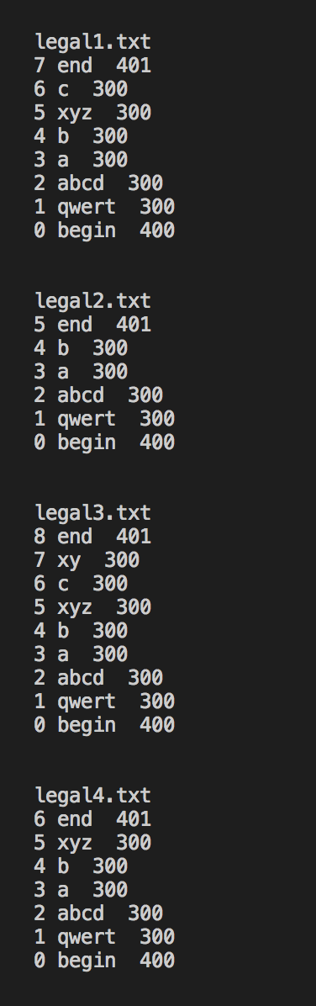

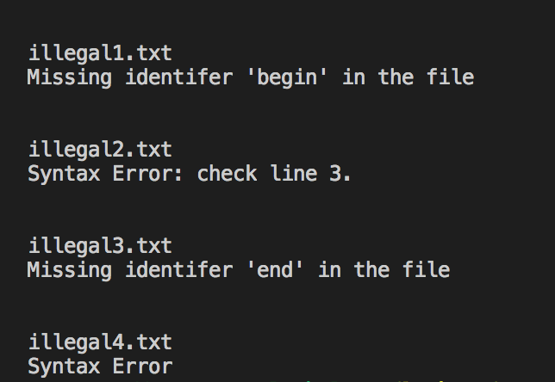

*Note: If output goes to a file, the name of the file should be mentioned. If the user chooses the name of the file, that fact should be mentioned in the user interaction section above.*