Computer Vision I _2018

Homework assignment #10

R07522717機械所製造組碩一 林温雅

Part1（此次作業僅one part）

Description:

implement 2 Laplacian Mask, Minimum Variance Laplacian, Laplacian of Gaussian, and Difference of Gaussian(inhibitory sigma=1, excitatory sigma=3, kernel size 11x11 [1][1])

Algorithm:

根據不同的edge detector所使用的kernel，對影像做convolution。最後自行挑選合適的threshold，對影像做reverse thresholding(黑白轉換一下方便看)。

Parameters:

i,j #迴圈計數用參數

original_img #原始圖檔

ker #各式不同kernel

rows, cols #圖檔的長與寬

temp_img #擴大後的圖檔，為了convolution邊界所製作

temp #在迴圈中擷取影像中和kernel一樣大的矩陣，以方便計算

new_img #用來接收新data的輸出圖檔

Principal code fragment:

*def* Laplacian(*img*, *mode*=*None*):  
 # mode1 是第一種kernel、mode2 是第二種、 mode3是minimum-variance  
 #ker = None  
 *if mode*==1:  
 ker = np.array([[0,1,0],[1,-4,1],[0,1,0]])  
 *elif mode*==2:  
 ker = np.array([[1,1,1],[1,-8,1],[1,1,1]]) / 3  
 *elif mode*==3:  
 ker = np.array([[2,-1,2],[-1,-4,-1],[2,-1,2]]) / 3  
  
 rows, cols = *img*.shape  
 temp_img = cv2.copyMakeBorder(src=*img*, top=1, bottom=1, left=1, right=1, borderType=cv2.BORDER_REPLICATE)  
 new_img = *img*.copy().astype(float)  
 *for* i *in* range(rows):  
 *for* j *in* range(cols):  
 temp = temp_img[i:i + 3, j:j + 3]  
 new_img[i, j] = np.sum(ker * temp)  
 *return* new_img  
  
*def* Laplacian_Gaussian(*img*):  
 ker = np.array([[ 0, 0, 0, -1, -1, -2, -1, -1, 0, 0, 0],  
 [ 0, 0, -2, -4, -8, -9, -8, -4, -2, 0, 0],  
 [ 0, -2, -7,-15,-22,-23,-22,-15, -7, -2, 0],  
 [ -1, -4,-15,-24,-14, -1,-14,-24,-15, -4, -1],  
 [ -1, -8,-22,-14, 52,103, 52,-14,-22, -8, -1],  
 [ -2, -9,-23, -1,103,178,103, -1,-23, -9, -2],  
 [ -1, -8,-22,-14, 52,103, 52,-14,-22, -8, -1],  
 [ -1, -4,-15,-24,-14, -1,-14,-24,-15, -4, -1],  
 [ 0, -2, -7,-15,-22,-23,-22,-15, -7, -2, 0],  
 [ 0, 0, -2, -4, -8, -9, -8, -4, -2, 0, 0],  
 [ 0, 0, 0, -1, -1, -2, -1, -1, 0, 0, 0]])  
  
 rows, cols = *img*.shape  
 temp_img = cv2.copyMakeBorder(src=*img*, top=5, bottom=5, left=5, right=5, borderType=cv2.BORDER_REPLICATE)  
 new_img = *img*.copy().astype(float)  
 *for* i *in* range(rows):  
 *for* j *in* range(cols):  
 temp = temp_img[i:i+11, j:j+11]  
 new_img[i, j] = np.sum(ker * temp)  
 *return* new_img  
  
  
*def* Difference_Gaussian(*img*):  
 ker = np.array([[ -1, -3, -4, -6, -7, -8, -7, -6, -4, -3, -1],  
 [ -3, -5, -8,-11,-13,-13,-13,-11, -8, -5, -3],  
 [ -4, -8,-12,-16,-17,-17,-17,-16,-12, -8, -4],  
 [ -6,-11,-16,-16, 0, 15, 0,-16,-16,-11, -6],  
 [ -7,-13,-17, 0, 85,160, 85, 0,-17,-13, -7],  
 [ -8,-13,-17, 15,160,283,160, 15,-17,-13, -8],  
 [ -7,-13,-17, 0, 85,160, 85, 0,-17,-13, -7],  
 [ -6,-11,-16,-16, 0, 15, 0,-16,-16,-11, -6],  
 [ -4, -8,-12,-16,-17,-17,-17,-16,-12, -8, -4],  
 [ -3, -5, -8,-11,-13,-13,-13,-11, -8, -5, -3],  
 [ -1, -3, -4, -6, -7, -8, -7, -6, -4, -3, -1]])  
  
 rows, cols = *img*.shape  
 temp_img = cv2.copyMakeBorder(src=*img*, top=5, bottom=5, left=5, right=5, borderType=cv2.BORDER_REPLICATE)  
 new_img = *img*.copy().astype(float)  
 *for* i *in* range(rows):  
 *for* j *in* range(cols):  
 temp = temp_img[i:i+11, j:j+11]  
 new_img[i, j] = np.sum(ker * temp)  
 *return* new_img

Kernels & Thresholds:

Laplacian1:

Kernel: ([[0,1,0],[1,-4,1],[0,1,0]])

Threshold:30

Laplacian2:

Kernel: ([[1,1,1],[1,-8,1],[1,1,1]]) / 3

Threshold:25

Minimum-Variance Laplacian:

Kernel: ([[2,-1,2],[-1,-4,-1],[2,-1,2]]) / 3

Threshold:25

Laplacian of Gaussian:

Kernel: ([[ 0, 0, 0, -1, -1, -2, -1, -1, 0, 0, 0],

[ 0, 0, -2, -4, -8, -9, -8, -4, -2, 0, 0],

[ 0, -2, -7,-15,-22,-23,-22,-15, -7, -2, 0],

[ -1, -4,-15,-24,-14, -1,-14,-24,-15, -4, -1],

[ -1, -8,-22,-14, 52,103, 52,-14,-22, -8, -1],

[ -2, -9,-23, -1,103,178,103, -1,-23, -9, -2],

[ -1, -8,-22,-14, 52,103, 52,-14,-22, -8, -1],

[ -1, -4,-15,-24,-14, -1,-14,-24,-15, -4, -1],

[ 0, -2, -7,-15,-22,-23,-22,-15, -7, -2, 0],

[ 0, 0, -2, -4, -8, -9, -8, -4, -2, 0, 0],

[ 0, 0, 0, -1, -1, -2, -1, -1, 0, 0, 0]])

Threshold:7000

Difference of Gaussian:

Kernel: ([[ -1, -3, -4, -6, -7, -8, -7, -6, -4, -3, -1],  
 [ -3, -5, -8,-11,-13,-13,-13,-11, -8, -5, -3],  
 [ -4, -8,-12,-16,-17,-17,-17,-16,-12, -8, -4],  
 [ -6,-11,-16,-16, 0, 15, 0,-16,-16,-11, -6],  
 [ -7,-13,-17, 0, 85,160, 85, 0,-17,-13, -7],  
 [ -8,-13,-17, 15,160,283,160, 15,-17,-13, -8],  
 [ -7,-13,-17, 0, 85,160, 85, 0,-17,-13, -7],  
 [ -6,-11,-16,-16, 0, 15, 0,-16,-16,-11, -6],  
 [ -4, -8,-12,-16,-17,-17,-17,-16,-12, -8, -4],  
 [ -3, -5, -8,-11,-13,-13,-13,-11, -8, -5, -3],  
 [ -1, -3, -4, -6, -7, -8, -7, -6, -4, -3, -1]])

Threshold:11000

Resulting Image:

Laplacian1_30

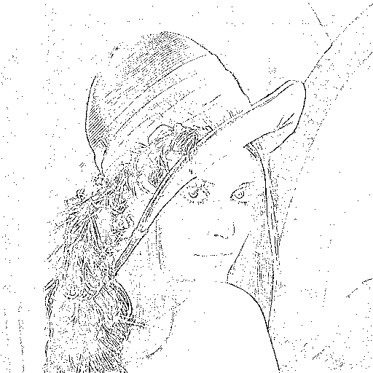

Laplacian2_25

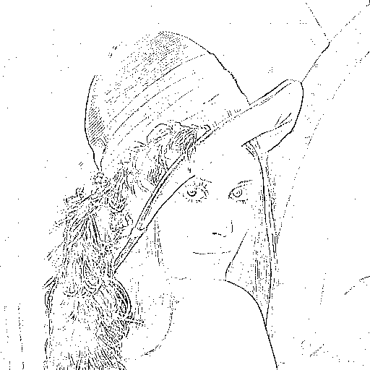

minimum_variance_Laplacian_20

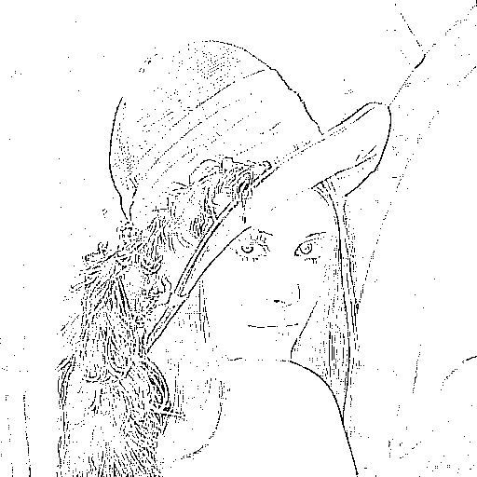

Laplacian_of_Gaussian_7000

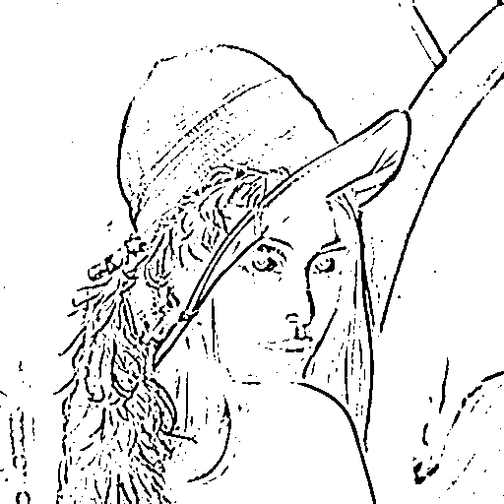

Difference_of_Gaussian_11000

