Computer Vision I _2018

Homework assignment #3

R07522717機械所製造組碩一 林温雅

Part1（此次作業僅one part）

Description:

Write a program to do histogram equalization using

$s_{k}=255\sum_{j=0}^{k}{\frac{n_{j}}{n}}$, where

$k=0,1,…,255$

$n_{j}=$ number of pixels with intensity j

$n=$ total number of pixels

for every pixel if $I(im, I, j)=k$

then $I(imhe, I, j)=sk$

Algorithm:

先將原始圖檔資料記錄在count中，計算原始的histogram資料，接著利用count、總pixels數numberofpixels…等計算equalized後的s陣列，最後再用此陣列繪製histogram

Parameters:

original #讀取原始圖檔

count #原始histogram資訊

I, j #迴圈內計數用變數

equalized_histogram#儲存equalized後的圖檔資訊

rows, columns #計算原始圖檔的行與列數

numberofpixels #計算原始圖檔的總pixel數

s #equalized後，與count相對應的陣列

summationnow #計算s時迴圈內使用的參數

denominator #計算s時迴圈內使用的參數

Principal code fragment:

#histogram equalization

#先new一個空numpy array來接收equalization後的圖，cv2的image可以直接接收numpy array

#算一下equlized後的s陣列，還有總pixels數numberofpixels

equalized_histogram = np.zeros([512,512], int)

#計算s用相關參數

rows, columns = original.shape

numberofpixels = rows * columns

s = np.zeros(256)

summationnow = 0

denominator = 255 / float(numberofpixels)

#計算s

for i in range (256):

summationnow += count[i]

s[i] = summationnow * denominator

#把s轉進二階矩陣以便輸出equalized後之lena

for i in range (512):

for j in range (512):

equalized_histogram[i, j] = int(round(s[original[i,j]]))

#儲存equalized_lena.jpg

cv2.imwrite("equalized_lena.jpg", equalized_histogram)

Resulting images

Equalized後之histogram

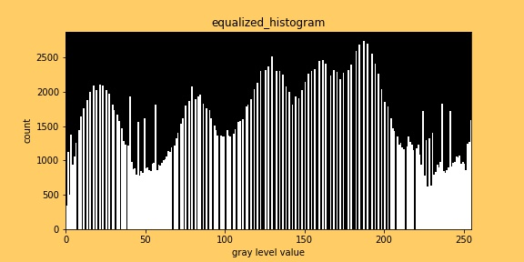

Equalized後之lena

