Computer Vision I _2018

Homework assignment #9

R07522717機械所製造組碩一 林温雅

Part1（此次作業僅one part）

Description:

Write programs to generate the following gradient magnitude images and choose proper thresholds to get the binary edge images:

* Roberts operator
* Prewitt edge detector
* Sobel edge detector
* Frei and Chen gradient operator
* Kirsch compass operator
* Robinson compass operator
* Nevatia-Babu 5X5 operator

Algorithm:

根據不同的edge detector所使用的kernel，對影像做convolution。

在roberts、perwitt、sobel、frei & chen中，將不同kernel的convolution值進行平方後相加開根號處理，設為新影像的值。而在kirsch、robinson、nevatia-babu中，將不同kernel的convolution值做比較，挑選max值設為新影像的值。

最後自行挑選合適的threshold，對影像做reverse thresholding(黑白轉換一下方便看)。

Parameters:

i,j #迴圈計數用參數

original_img #原始圖檔

ker_XX #各式不同kernel

list_XX #儲存kernel用的list

rows, cols #圖檔的長與寬

temp_img #擴大後的圖檔，為了convolution邊界所製作

temp #在迴圈中擷取影像中和kernel一樣大的矩陣，以方便計算

new_img #用來接收新data的輸出圖檔

max #用來計算最大值的參數

Principal code fragment:

*def* roberts(*img*):  
 ker_r1 = np.array([[-1, 0],[0, 1]])  
 ker_r2 = np.array([[0, -1],[1, 0]])  
 rows, cols = *img*.shape  
 # for center在左上角  
 temp_img = cv2.copyMakeBorder(src=*img*, top=0, bottom=1, left=0, right=1, borderType=cv2.BORDER_REPLICATE)  
 new_img = *img*.copy().astype(float)  
 *for* i *in* range(rows):  
 *for* j *in* range(cols):  
 temp = temp_img[i:i+2, j:j+2]  
  
 new_img[i,j] = np.sqrt(np.sum(np.multiply(ker_r1, temp))**2 + np.sum(np.multiply(ker_r2, temp))**2)  
 #new_img[i,j] = np.abs(np.sum(np.multiply(ker_r1, temp))) + np.abs(np.sum(np.multiply(ker_r2, temp)))  
  
 *return* new_img

*def* krisch(*img*):  
 ker_k0 = np.array([[-3,-3,5], [-3,0,5], [-3,-3,5]])  
 ker_k1 = np.array([[-3,5,5], [-3,0,5], [-3,-3,-3]])  
 ker_k2 = np.array([[5,5,5], [-3,0,-3], [-3,-3,-3]])  
 ker_k3 = np.array([[5,5,-3], [5,0,-3], [-3,-3,-3]])  
 ker_k4 = np.array([[5,-3,-3], [5,0,-3], [5,-3,-3]])  
 ker_k5 = np.array([[-3,-3,-3], [5,0,-3], [5,5,-3]])  
 ker_k6 = np.array([[-3,-3,-3], [-3,0,-3], [5,5,5]])  
 ker_k7 = np.array([[-3,-3,-3], [-3,0,5], [-3,5,5]])  
 list_kn = [ker_k0, ker_k1, ker_k2, ker_k3, ker_k4, ker_k5, ker_k6, ker_k7]  
 rows, cols = *img*.shape  
 temp_img = cv2.copyMakeBorder(src=*img*, top=1, bottom=1, left=1, right=1, borderType=cv2.BORDER_REPLICATE)  
 new_img = *img*.copy().astype(float)  
 *for* i *in* range(rows):  
 *for* j *in* range(cols):  
 temp = temp_img[i:i+3, j:j+3]  
 max=0 # 初始化max值  
 *for* ker *in* list_kn:  
 temp_sum = np.sum(ker * temp)  
 *if* temp_sum > max:  
 max = temp_sum  
 new_img[i, j] = max  
  
 *return* new_img

*def* reverse_thresholding(*img*, *threshold*=128):  
 new_img = np.empty(*img*.shape)  
 new_img.fill(255)  
 mask = *img* >= *threshold* new_img[mask] = 0  
 *return* new_img

Resulting Image:

roberts_30

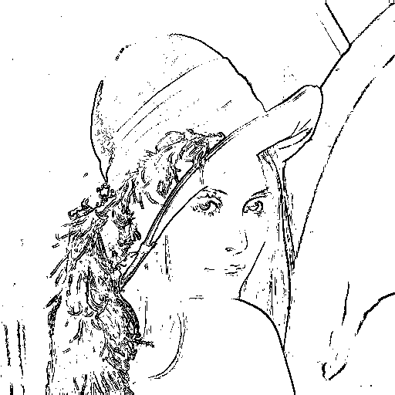

perwitt_90

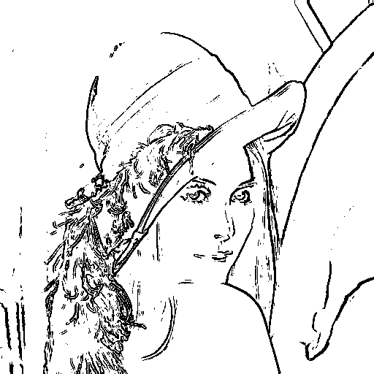

sobel_130

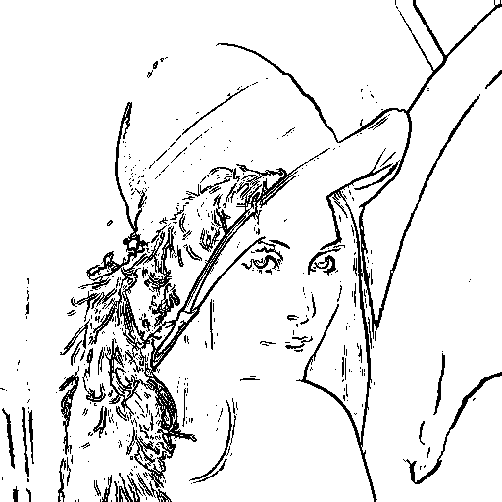

frei_chen_110

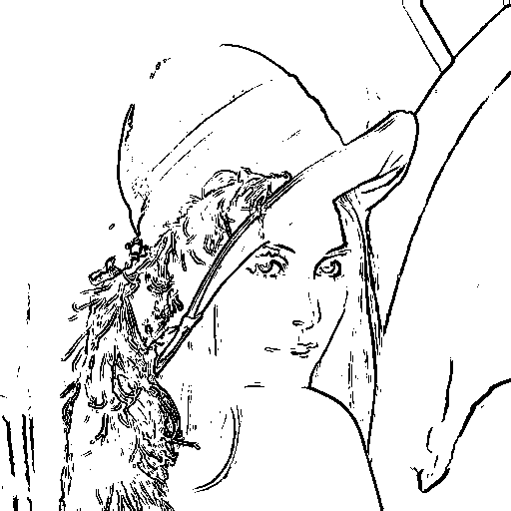

krisch_230

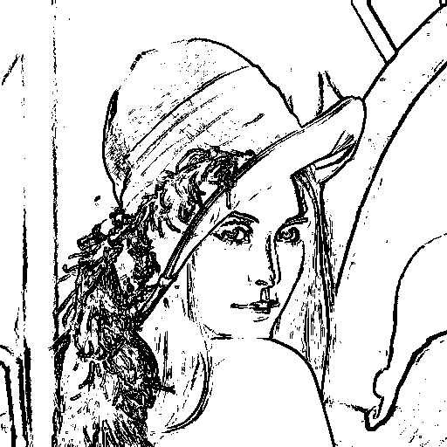

robinson_120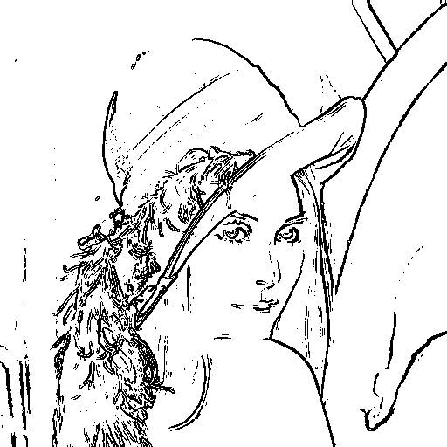

nevatia_babu_30000

