Cast It — Architecture Overview
Production-ready Django platform for automated podcast production: news ingestion, episode planning, script generation (LLM), audio synthesis (TTS), FFmpeg post-processing, and publishing.

Tech Stack
Python 3.13+, Django 5+, DRF · PostgreSQL 16 + pgvector · Redis · Celery + Beat · Ollama (LLM/embeddings) · Chatterbox (TTS) · FFmpeg · Docker Compose · Gunicorn/Nginx (production).

1. System Context
High-level view of Cast It and its external dependencies. Staff use the Operations UI; API clients integrate via REST. The platform runs in Docker (web, Celery worker/beat, PostgreSQL, Redis) and connects to Ollama, Chatterbox TTS, news feeds, FFmpeg, and YouTube.
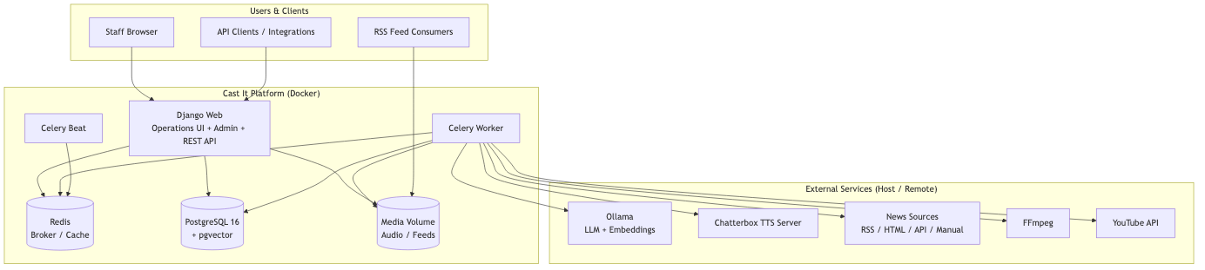

2. Layered Architecture
Clean architecture separation: presentation (Operations, Admin, API) calls application services in services/, which use domain types and infrastructure adapters for external I/O. Django models in apps/ persist data.
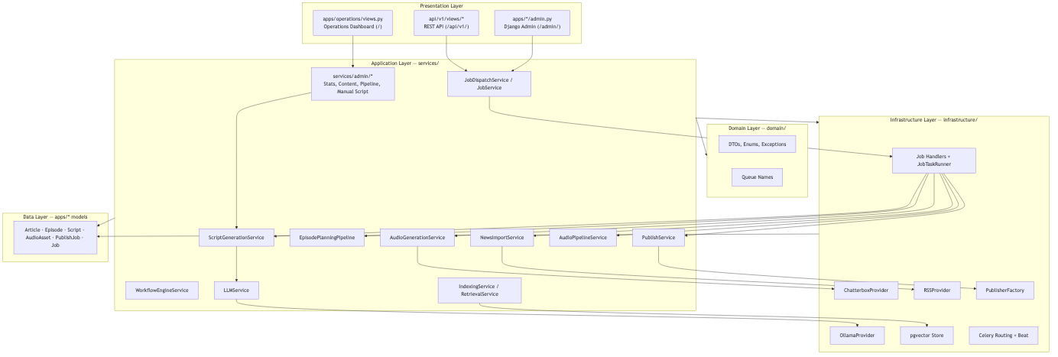

3. Content Pipeline
End-to-end podcast production flow: NewsSource → Article → Episode → Script/ScriptSegment → AudioAsset → PipelineRun → PublishedEpisode/RSS feed.

4. Async Job Backbone
All long-running work is dispatched via JobDispatchService, tracked as Job records, and executed by Celery workers through registered handlers on dedicated queues (ingestion, llm, tts, audio, publishing, monitoring).
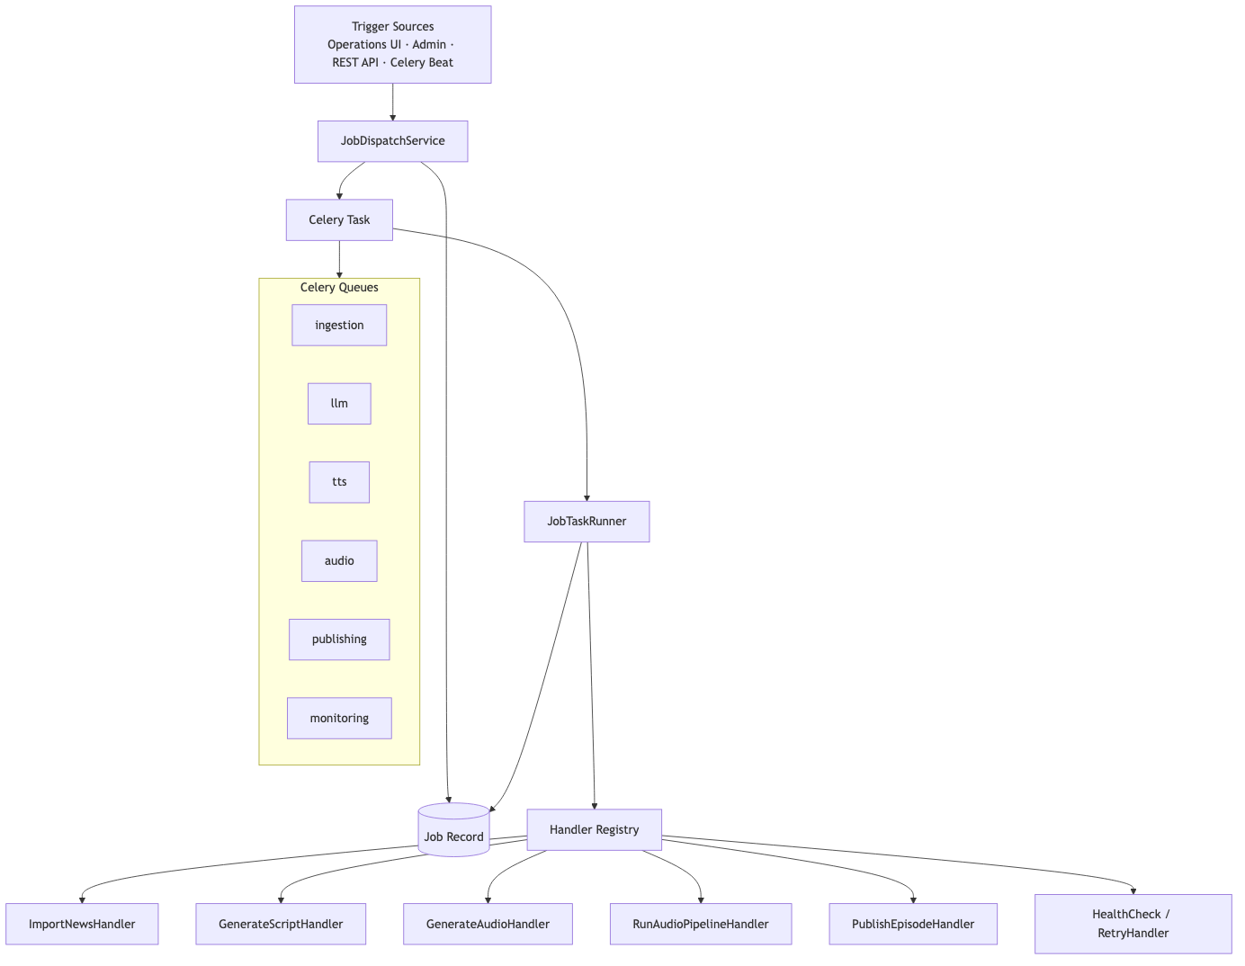

5. Django Apps & Data Ownership
Django apps own domain models. operations/ has no models — it is a staff dashboard only. scheduler/ tracks background jobs; knowledge/ supports RAG.
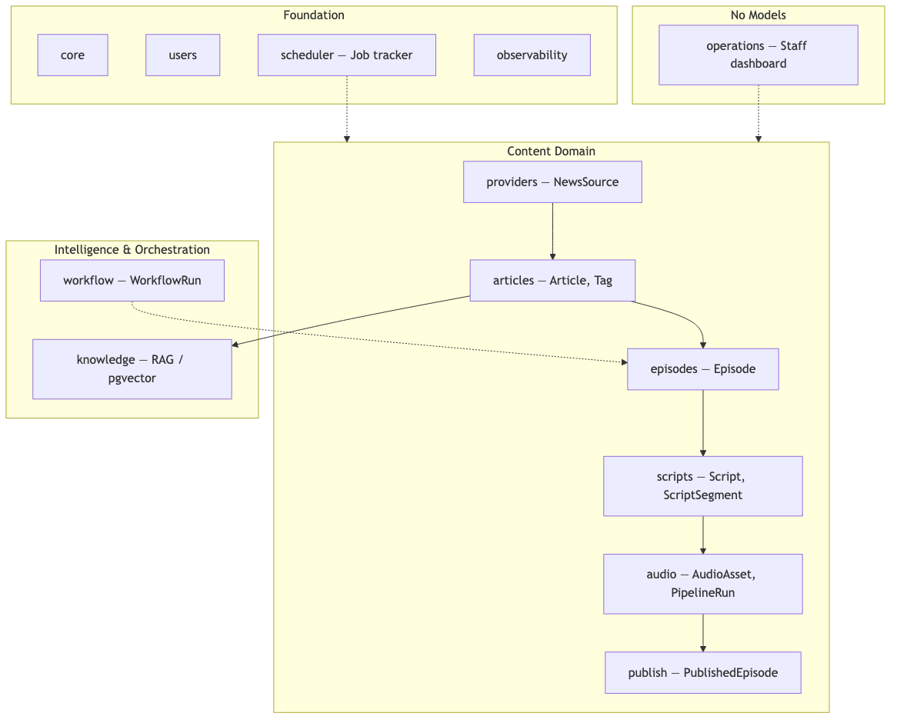

6. Operations UI vs Admin vs API
Three entry points share JobDispatchService. Operations UI additionally uses facades under services/admin/ and polls GET /api/jobs/{id}/ for progress.
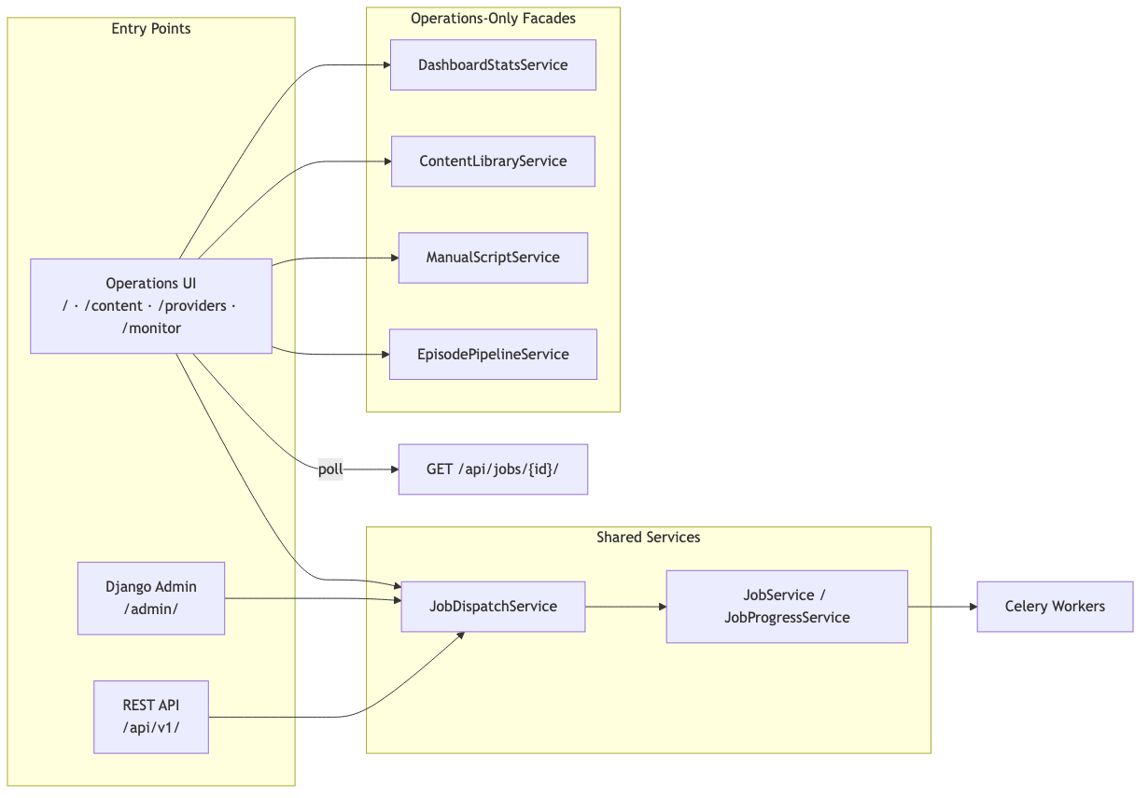

7. Docker Deployment (Local Dev)
docker-compose.yml runs web, celery-worker, celery-beat, db (pgvector), and redis. Ollama and Chatterbox run on the host and are reached via host.docker.internal from containers.
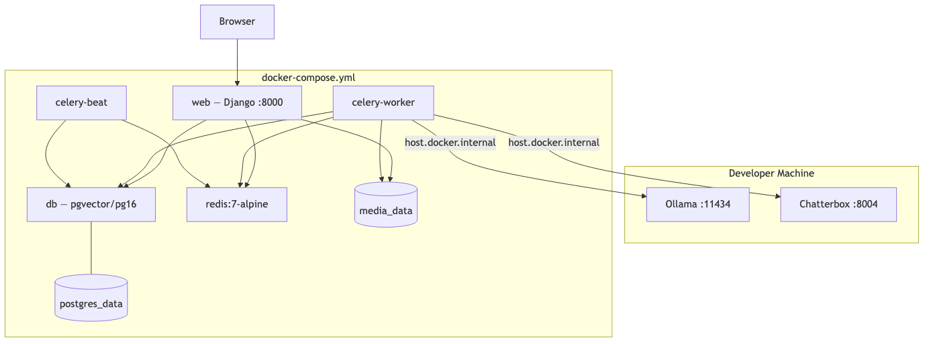

8. RAG Side Path
Optional knowledge-base path: articles are chunked and embedded via Ollama, stored in pgvector, and retrieved to enrich script generation context.

Celery Queue Reference
Queue | Job Types | Primary Service
ingestion | import_news | NewsImportService
llm | summarize_article, classify_article, episode_planning, generate_script | LLMService, ScriptGenerationService
tts | generate_audio | AudioGenerationService
audio | run_audio_pipeline | AudioPipelineService
publishing | publish_episode | PublishService
monitoring | health_check, retry_job | CeleryHealthService, JobService

Layer Summary
Concern | Location
Business logic | services/
External I/O | infrastructure/
Pure types / contracts | domain/
Persistence | apps/*/models.py
Staff UI | apps/operations/ + templates/operations/
Machine API | api/v1/
Background work | apps/scheduler/tasks/ + Celery
Config | config/settings/

Diagram Sources
Mermaid source files: docs/architecture/diagrams/. Re-run scripts/generate_architecture_docx.py to regenerate this document.

